GOVERNOR'S MESSAGE
Important District Meetings To Bring To Your Attention
By Pat and Skip Doyle

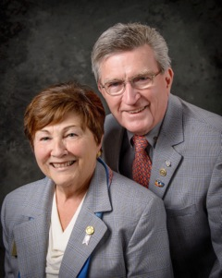
This past week's meetings reminded us of two things. One, we only have four months left as your district governors. And two, those four months are packed with district events and the meetings needed to plan them.

The meeting we would like to bring to your attention today is the Council Meeting with our past district governors, held last Thursday. Nine PDGs met with us, District Governor-Nominee Steve Sager and District Governor-Nominee-Designate Pam Anastasi. Our past district governors don't get a lot of mention and some might say they don't get a lot of attention, either. Finding an appropriate role in the years following a term as governor can be a challenge.

PDGs have knowledge, connections, training, experience - and lots of good ideas. The challenge is translating that passion into action. Or, to quote a Rotary Zone 24/32 publication, having a PDG means having a "proactive, dynamic guide rather than past district governor."

Rotary International spends a great deal of time and money training those of us in the district-governor track. The training we were exposed to at Zone Institutes and the International Assembly was of the highest caliber and we are sure RI expects us to continue to put this training to use for the good of our district, our zone and RI.

The PDGs we met with last Thursday evening represented 27 years of training and action. We thank them for sharing their guidance and wisdom. Many of the readers of this Governor's Message are newer members who have not had the privilege of meeting many of our PDGs. For this reason, we will be adding a column similar to <eet the Presidents, called meet the Past District Governors. PDG Carol Toomey's interview is below.

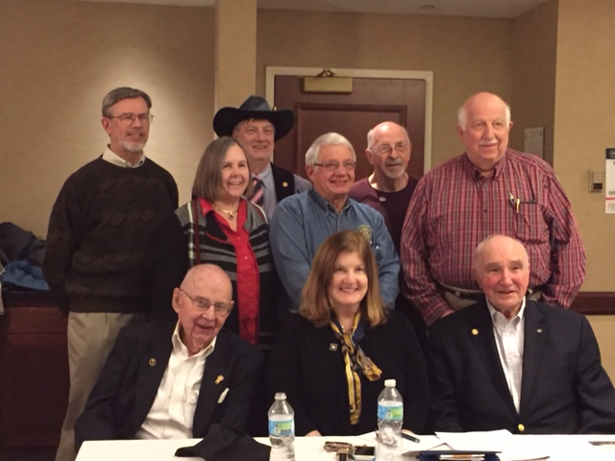Shown, front, left to right, are PDGs Ed Hall, Val Callahan, and Roger Frost

Shown back, left to right, are PDGs Klaus Hachfeld, Carol Toomey, Carl Kalisczski, Jim Fusco, Ed King and Bob Cassidy

QuadCon Call

Int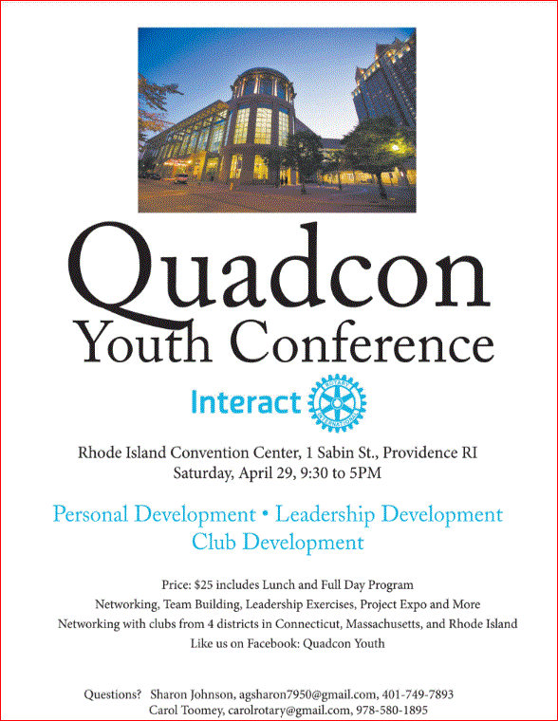eractors from all over the District 7910 are getting excited about theYouth Conference to be held as part of the Multi District Conference - QuadCon, for short - this April in Providence. Check Quadcon web page for updates.

Four important things to know:

1. The weekly submission deadline for the Newsletter is Friday. As usual, text content must be submitted in Word format, and image content, in either JPEG or PDF format. Continue to submit your content to Immediate Past District Governor/Newsletter Editor Jim Fusco at jim.fusco2@gmail.com.

2. Rotary Youth Leadership Awards: The RYLA Club Pack has been updated and posted on RYLA7910.org. When you download it, you will notice changes from last year. Please read the material carefully and direct your questions to Christine Pinney, chair of the RYLA Committee,who may be reached at christine@christinepinney.com. The RYLA season has begun and the RYLA Committee is working to make RYLA 2017 the "best RYLA ever." (See RYLA article, right-hand column.)

3. Club Planning Worksheet: To download the Club Planning Worksheet, click here.This worksheet is made available to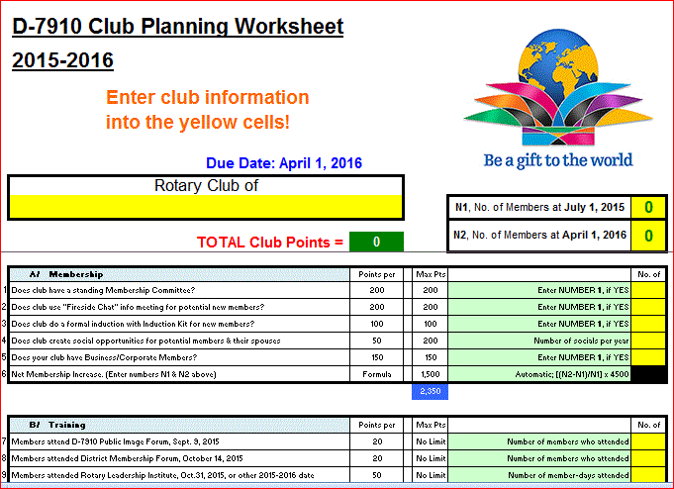 clubs so they can gauge their progress in achieving the goals they set last July. This month is a good time to review the worksheet and see how far you have come and how much farther you need to go as a club. You may surprise yourselves and realize that you are well on the way to earning district recognition. We recommend the club president appoint the president-elect to be the "champion" of the Worksheet, and to use it as a guide for the club, and to report monthly to the club's membership and board on the club's progress.

4. As your district governors, we have resolved to: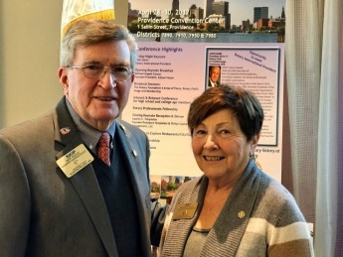
- Revisit as many clubs as possible in the next few months.
- Help our clubs achieve the goals they set in July
- Do all we can to build membership in the district
- Plan a grand event to celebrate our Million Dollar Foundation Journey
- "Move the ball forward," in harmony, with District Governor-ElectKarin Gaffney, District Governor-Nominee Steve Sager and District Governor-Nominee-Designate Pamela Anastasi
- Celebrate all of this at our Multi-District Conference this April in in Providence
'GOVERNOR'S MESSAGE' PAGE (in case you want to share a link to this article)

District Governors Pat and Skip Doyle (shown, right) may be reached
at pwdoyle2@verizon.net and skipdoyle2@verizon.net, respectively.

Click here to submit content for the Tuesday, March 14 issue.
The submission deadline for this issue is Friday, March 10.

Click here for past issues.

WELCOME, NEW ROTARIANS
Alphabetical, by last name

- Robert Boley, Westford
- Margaret Grenier, Worcester
- Jin Huang, Westborough
- David Park, Newton
- Claudia Pietrewicz, Milford
- Chanel Prunier, Worcester

Remember to ask ... ask ... ask!

DISTRICT SCHOLARSHIP DEADLINE: EXTENDED TO APRIL 15
New Deadline: April 15

Applications Sought for David and Eleanor Morley Endowed Global Grant Scholarship

To learn more about the Morley Scholarship, click here.
To download the Morley Scholarship flyer in PDF format, click here.

CLUB MEMBERSHIP GROWTH, ’16-‘17
We share with you the results of club-membership growth in our district during Rotary year 2016-2017, which began July 1.

This is a unique opportunity for Rotarians and friends to discuss partnering on humanitarian projects affecting our local communities.

READ MORE

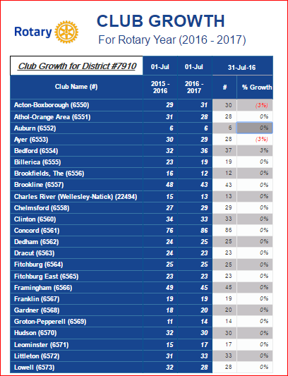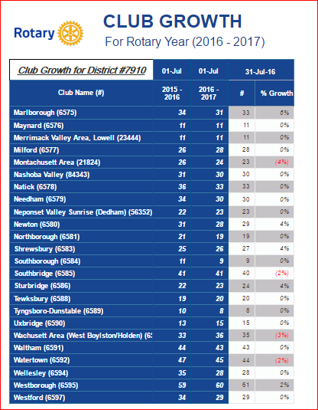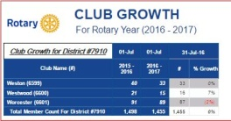

INTERVIEWS WITH PDGS
Carol Toomey, Nashoba Valley

Past District Governor, 2009-2010

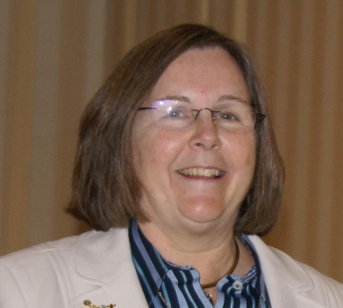

Please tell us what factors helped you decide to join Rotary.

I met PDG Bob Erickson when I moved my Action Unlimited office from Marlboro to Maynard in 1970. My office was next door to his and I used to tease him about how much nicer his office was than mine. I started running ads in my paper for the pancake breakfast that the Acton Rotary had. In the ad, it said all the good things they did with the money. I went to them and asked if I could join. Little did I know that women weren’t allowed.

READ MORE

DISTRICT & CLUB ROUNDS
Auburn Leverages 'Free Media' to Promote Fundraiser

Check out the Rotary Club of Auburn's 1/4-page, four-color ad (page 3; shown, above left) and article (page 29, shown, above right) in the March 3 issue of the weekly Yankee Xpress/Blackstone Valley Xpress as part of a media sponsorship of Auburn Rotary and Friends of Auburn Music Education's upcoming 20176 St. Patrick's Day Music & Wine Fundraiser for Education. The ad and article will run again in the March 17 issue.This is one of many "free media" ways to promote your club's events and activities.

To learn more on Auburn Rotary, click here.

In Support of Polish-Ukrainian Rotary project
By Roy Balfour
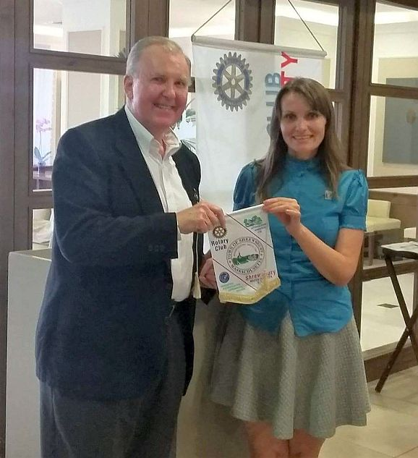

Westborough Donates to Good Shepard Lutheran Church for Food-Packing Event

Lett to right: Pastor Jeff Goodrich; Club Giving Chair Betsy Moquin; and President Gerry Gross
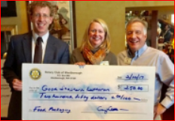

Montachusett Area Hears from AG Kevin Fry on Hero's Cup Hockey
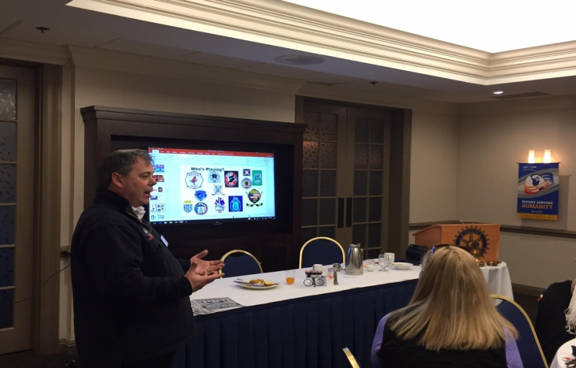

Assistant Governor Kevin Fry is shown addressing the membership at a recent meeting of the Rotary Club of Montachusett Area at the DoubleTree Hotel in Leominster. He spoke aboutHero's Cup Hockey on April 21 to 23.

The weekend-long event designed to bring firefighters, police officers, EMS, and military members together in a fun weekend to raise money and awareness for multiple charities. Each team will be playing for the charity of their choice, with a cash prize going to the winning teams charity of each division.

LEARN MORE

Nashoba Valley Celebrates 5th Birthday

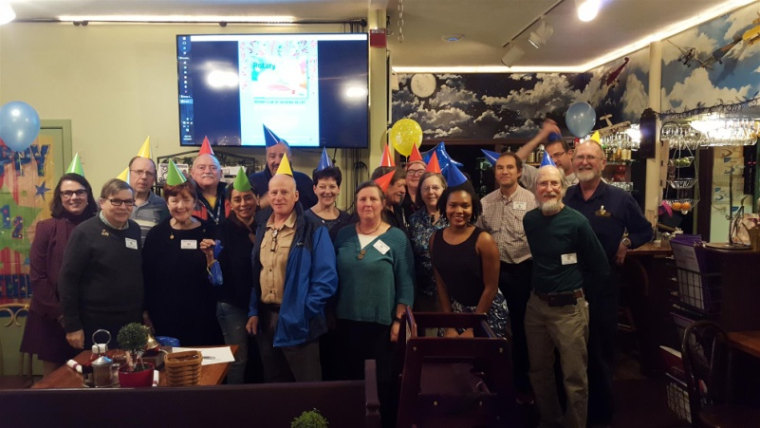

The Rotary Club of Nashoba Valley celebrated its 5th birthday on February 23, which happened to be Rotary International’s 112th birthday. The club, which was chartered on February 24, 2012, celebrated with party games, cake, decorations, video highlights from the past five years, and a speaker from Boston Gleaners. Check out the Facebook photo album for more pictures, including a rousing game of Simon Says.

To learn more on Nashoba Valley Rotary, click here.

Westborough Welcomes Exchange Student

Left to right: Marcia Davis, chair of District 7910's Eastern States Student Exchange Committee; Exchange Student YukaIchihawa; Jeanne Reimonn; and President Gerry Gross.

READ MORE
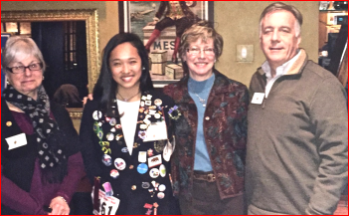

To learn more on Westborough Rotary, click here.

D7910 Well-Represented at Zone 24/32 Coordinator Training in Evanston

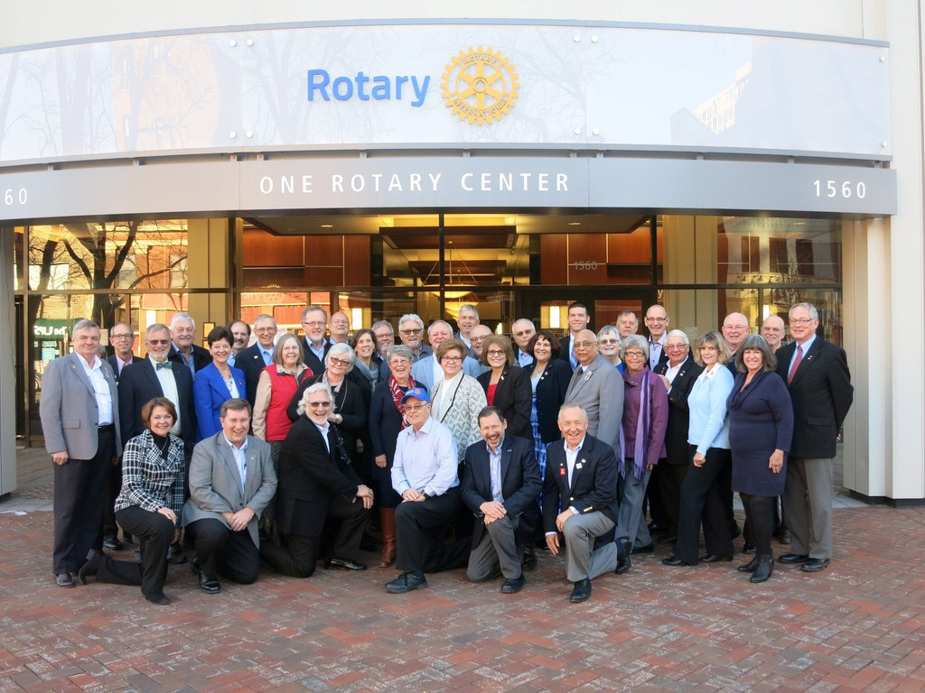Among the people shown posing at the entrance to RI headquarters are District 7910 Rotarians who have appeared in our weekly newsletter and/or have spoken at D7910 events.

CAN YOU FIND THEM?

They are: Immediate Past District Governor Jim Fusco; Past District Governor Carol Toomey; District PR Chair Laura Spear; Past District Governor Greg Roche; Carolyn Johnson, of District 7780; Rotary International Director Dean Rohrs; Incoming RI Director Jeffery Cadorette; and Past RI Director Bryn Styles.

Montachusett Area Sponsors New Interact Club

Members of the Ro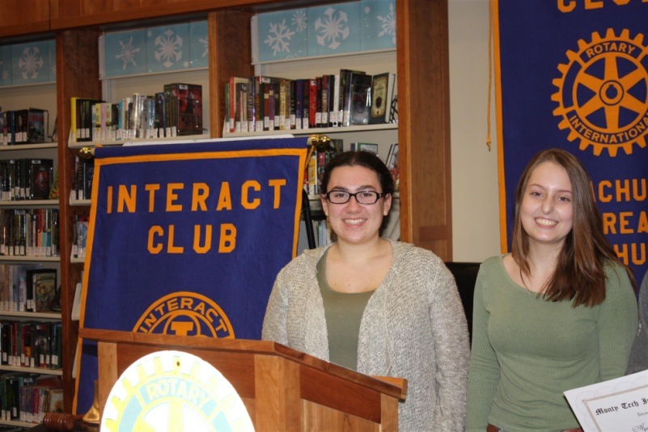tary Club of Montachuset Area gathered together on February 15 to celebrate Charter Night for the new Interact Club at Montachusett Regional Vocational Technical High School. Present at this celebration were many members of Montachusett Area Rotary.

District Interact Chair Bob Anthony, a Wellesley Rotarian, addressed the group as well as Monty Tech Principal Thomas Browne and Monty Tech Superintendent Dr. Sheila Harrity.

The Interact club, which has 20 members, was born because Co-Presidents Kayla Gerry (shown, left) and Casey Szlosek (shown, right) learned about Interact during RYLA 2016 and wanted to form a club.

To learn more on Montachusett Area Rotary, click here.

Our Co-DGs Reunite with ESSEX Student

Co-District Governors Pat Doyle (seated, right) and Skip Doyle(seated, left) pose with, left to right, Alex Incorvia (daughter of the host mom), Host Mom Stacy Incorvia, and former ESSEX StudentMarilia Lomani.

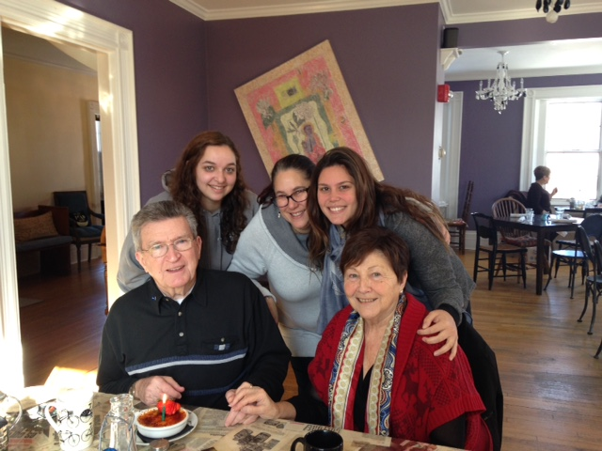

To learn more on ESSEX, click here.

Dean College Rotaract Organizes, Holds Blood Drive

During a recent blood drive by the Interact Club of Dean College, more than 40 people pre-registered to donate.

Left to right, sitting: Dean College Rotaractors Dean Bennettand Elizabeth Donahue
Left to right ,standing: Dean College Rotaract President Nua Toy-Giles and Franklin Rotary President Terry Katsaros

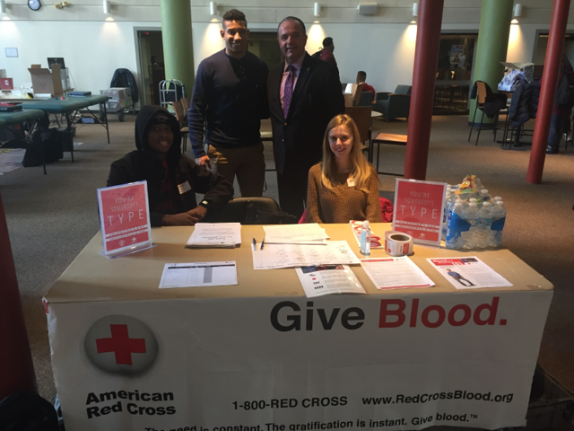

Uxbridge Donates $500 to Tri-County Meals On Wheels

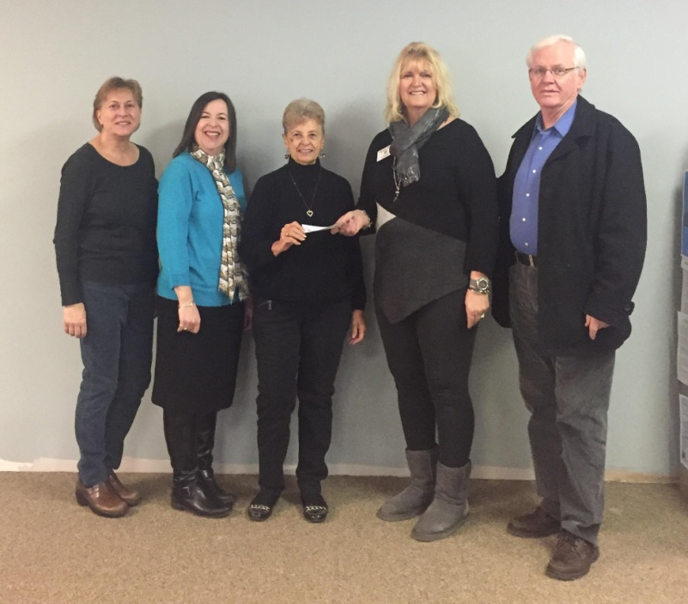

On February 7, the Rotary Club of Uxbridge presented a $500 check to Tri County Meals on Wheels.

Left to right: Joan MacKinnon; Bev Clarke, fundraiser; Kristen McCarthy, President Linn Doll-Butler and Mike Rooney.

To learn more on Uxbridge Rotary, click here.

Needham, National Honor Society Join Forces for Food Packaging

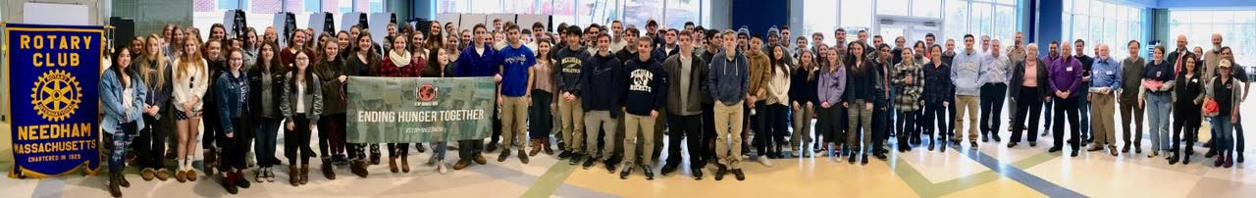

The Rotary Club of Needham recently joined forces with 80 students from Needham High School's National Honor Society. They teamed up with Stop Hunger Now.

To view the event's photo album, click here.

READ MORE

To learn more on Needham Rotary, click her

Multi-Club Power Play: Needham Teams Up with Framingham, Newton, Waltham and Watertown on India Solar-Power Project

The Rotary Clubs of Needham, Framingham, Newton, Waltham and Watertown have partnered to fund a $6,000 solar-power project (shown, left) for Film Nagar High School in Hyerabad, India. The host club there is the Rotary Club of Jubilee Hills, in District 3150.

Needham paid $3,000 of the $6,000 - $1,500 of which should come back as District Grant match. Watertown, Waltham, Newton and Framingham paid $500 each.

READ MORE

To learn more about:
- Framingham Rotary, click here
- Jubilee Hills Rotary, click here
- Needham Rotary, click here
- Newton Rotary, click here
- Waltham Rotary, click here
- Watertown Rotary, click here

Bedford Gears Up for April Meal-Packing Event

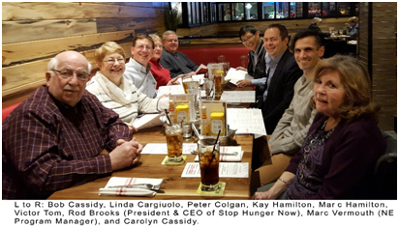

Members of the Rotary Club of Bedford were recently invited to speak with Rod Brooks, president and CEO, and the Marc Vermouth, New England program manager of Stop Hunger Now. Held at the Red Heat Tavern in Bedford, the meeting was in recognition of Bedford Rotary’s enduring (annually since 2013) and successful meal-packing programs (more than one-quarter-million total meals packaged to date) in the Bedford area assisted by other Rotary clubs and industry partners. Rod Brooks congratulated and thanked Bedford Rotarians for their efforts, and revealed expanded directions for Stop Hunger Now, including water, agriculture and educational programs to combat worldwide hunger. In the next few weeks, Stop Hunger Now will announce a new global branding and logo to reflect this focus.

For 2017, Bedford Rotary has secured the morning of Saturday, April 8 at Middlesex Community College (Bedford Campus) for this year’s exciting meal-packing event. The club plans to have again multiple Rotary club and industry partners, including BAE Systems as the major corporate sponsor. If you are interested in joining this year’s event, please contact this year’s chair, Past District Governor Bob Cassidy, at rac011846@comcast.net.

Shown right: During Bedford Rotary's 2016 meal-packing event, volunteers from Rotary, industry and nearby communities had fun fighting world hunger, with assembly lines running from raw rice, in the foreground, to packaged boxes, in the background.

To learn more about Bedford Rotary, click here.

Great Fundraising Tool for All Clubs: Westborough uses PayPal to raise nearly $2,000 for Polio Plus

READ MORE

To research charities that have a registered 501(c)3 account with PayPal, click here.

To learn more about Westborough Rotary, click here.

District Highlights Fundraising Goals in Video

We are all well aware that The Rotary Foundationis celebrating its 100th anniversary in 2017.Steve Kirk, president of the Rotary Club of Concord, has produced a five-minute video that outlines our own district’s fundraising goals for the current Rotary year, which ends next June 30.

WATCH VIDEO

To learn more about The Rotary Foundation, click here.

Video Now Available: Governor Baker addresses district Rotarians

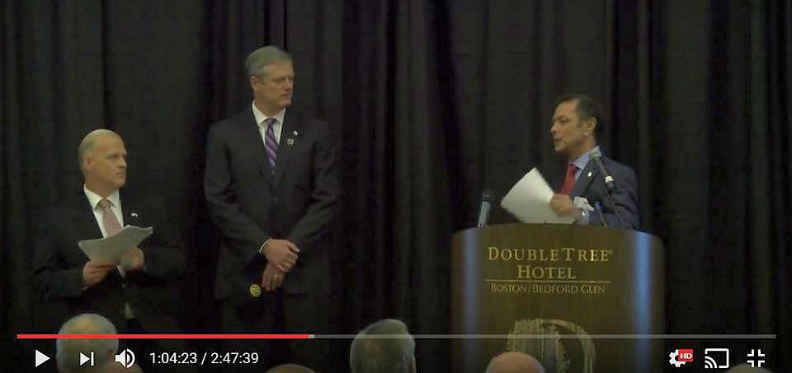

The Rotary Club of Billerica has provided a video of Governor Charlie Baker's address to District 7910 Rotarians on September 27 at the DoubleTree Hotel in Bedford. To watch the two-hour-47-minute video, click here.

The Rotary Clubs of Bedford, Billerica, Lowell, Newton and Shrewsbury sponsored the event, which was a unique opportunity for Rotarians and friends to discuss partnering on humanitarian projects affecting our local communities. To view event photos, click here.

Great Fundraising Idea for All Clubs: Milford distributes '16 Tab to 13,000 homes with record sales, 94 photos, 334 smiling faces

To read the Milford RotaryTab, click here.

To learn more about Milford Rotary, click here.

On to Atlanta in 2017: Register now!

For more information on the RI Convention, click here

Planning to attend? Contact District RI Convention Chair Steve Glines.

To learn more, click here.

To register for the 2017 RI Convention in Atlanta, click here.

Pat and Skip Doyle Installed as '16-'17 DGs

To watch a video of the installation, click here.

District Banners Available

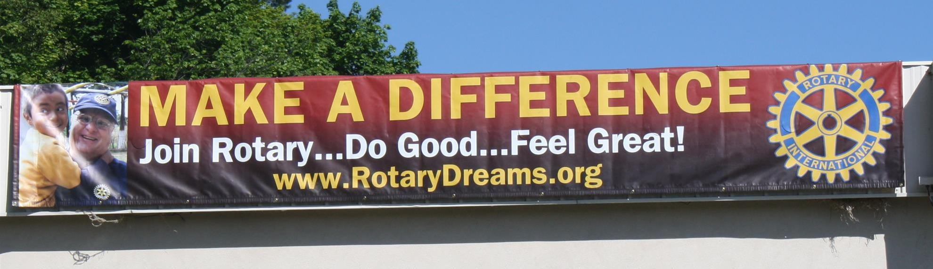

Our district banners are available for your use when you have an upcoming event or fundraiser.

If you want to reserve one of the banners, please contact PR Chair Laura Spear at laura@spear.net.

MAJOR DISTRICT & CLUB HAPPENINGS: WINTER & SPRING 2017

Friday, March 10: Hudson - 'LOL Comedy Night'

For more information, click here

Saturday, March 11: Uxbridge - 'Wine and Chocolate Tasting'

To visit and "like" our Facebook page, click here

To download event flyer, click here

Saturday, April 15: District 7910 - 'Extended Deadline for Morley Scholarship Applications'

To learn more, click here

To download revised flyer in PDF format, click here

Friday, March 17: Auburn - 'St. Patrick's Day Music & Wine Fundraiser'

To learn more, and to purchase tickets, click here

To download event flyer in PDF format, click here

To watch one-minute TV PSA, click here

READ MORE

Friday, March 17: Billerica - 'Finnegan's Wake Hilarious'

To download flyer in PDF format, click here

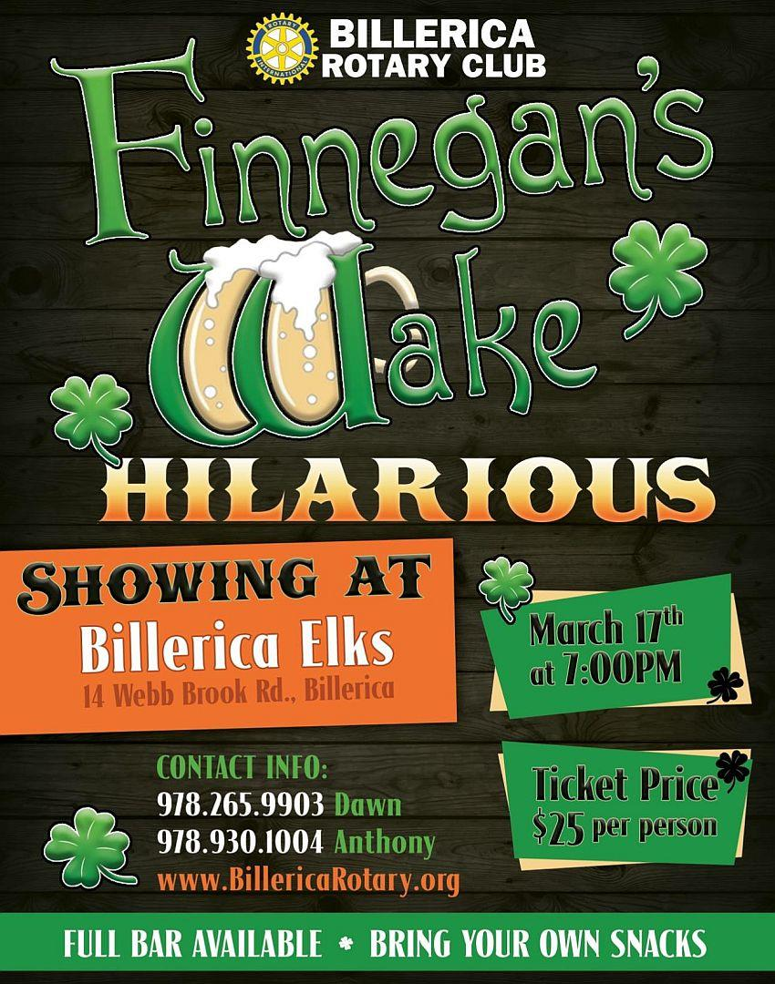

Tuesday, March 21; Thursday, March 23; Tuesday, March 28; or Thursday, Match 30: - District 7910 - 'Membership Workshops'

To register for March 21 in Auburn, click here
To register for March 23 in Acton: click here
To register for March 28 in Wellesley, click here
To register for March 30 in West Boylston, click here

To download flyer in PDF format, click here
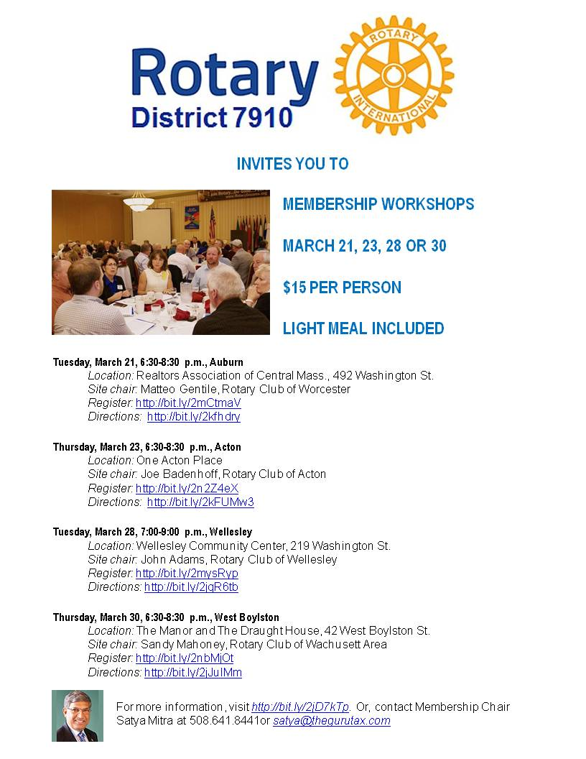

Friday, April 7: Concord - 'Pops for a Playground'

To download event flyer, click here

SUBMIT MAJOR CLUB HAPPENINGS

Send flyers of your club's major events and activities, in either JPEG or PDF format, to Immediate Past District
Governor/Newsletter Editor Jim Fusco at jim.fusco2@gmail.com.

