polio survivors in the U.S. are still with us

By Carl Good III

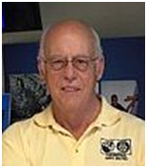We cannot forget that polio survivors in the U.S. are still with us and unfortunately suffer from a reemergence of symptoms as they age. For any people in our district who either are polio survivors or know of those who are, we suggest that they get in contact with Rotary Polio Survivors and/or Post Polio Health International.
Toward a virus-free polio vaccine

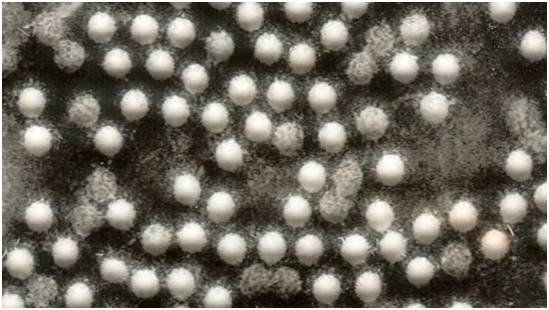Researchers are developing polio vaccines based on the viral capsid, alone. When produced in recombinant systems, these vaccines could eliminate the need to propagate live poliovirus for vaccine production.

To learn more, click here.

Worth a listen

A recent science podcast interviewed Dr. Jay Wenger, MD (shown, right), director of polio-eradication efforts of the Bill and Melinda Gates Foundation. It is one of the best descriptions of the program that I have heard – and is worth a listen.

Dr. Wenger discusses the history of wild poliovirus, including its devastating medical effects as well as the incredible success of the Global Polio Eradication Initiative. (Oral polio vaccination has reduced cases around the world by 99.9 percent since 1988.) In addition, they focus on new cases in Nigeria, and why it is more important than ever to focus on final eradication efforts. To support the End Polio Now effort, click here.

LISTEN NOW

Virtual-reality films bring a new dimension to polio fight

At this year’s World Polio Day celebration in Atlanta, Rotary harnessed the power of virtual-reality technology to build empathy and inspire action in our fight to eradicate polio.

Learn more about the films, click here.

To watch the video of World Polio Day in Atlanta, click here.

If you are had an event for World Polio Day (or Week) last fall, please send me a brief description. We are keeping track of the events.

READ MORE

Carl Good III, chair of the District Polio Subcommittee, may be reached at carlgood@yahoo.com.

Return to March 7 Newsletter

Visit our website
'Like' our Facebook page
'Follow' us on Twitter
Watch our videos
View our photo albums

