PR RESOURCES ARE ONLY A CLICK AWAY
By Laura Spear

You can find training and customizable sample materials on the District website, in the "Public Relations" section of the top navigation bar. These take advantage of the resources available from Rotary Brand Center, which requires your member login, and at rotary.org.

Key "resources and reference" links from the Rotary International website include:
- Lead Your Club: Public Relations Committee
- Media Crisis Handbook
- Rotary fact sheet
- What’s Rotary wallet cards
- Impact Begins With Your Brochure
- RI Visual Identity Guide
- Global Outlook: A Rotarian’s Guide to Advocacy for Polio Eradication
- End Polio Now website
Key "tools" links from the Rotary International website include:
- Find promotional ads in the Rotary Brand Center
- Download a template:
  - District governor appointment release template
  - RI Convention release template
  - RI president's visit news release template
  - Rotary Day news release template
  - Sample proclamation
  - World Polio Day sample press release template
- Get the Rotary Marks
- Register for a webinar
- Watch the video This Is Rotary and Doing Good in the World
You have probably noticed that as of last July 1, we have not distributed any flyers, notices, or announcements that use the old Rotary logo. We want to avoid confusion, build awareness and trust in our Rotary brand, and through consistency, attract new members, donors, and community support.
You should be doing the same. Use only this "new" Rotary logo and branding.

To learn more, click here and click here.

To learn more in Rotary Voice and Visual Identity Guidelines, click here.

To learn more about PR for your club, click on the Public Relations section of the navigation bar of the District 7910 website.

Laura Spear, chair of District 7910's Public Relations Committee, may be reached at laura@spear.net.

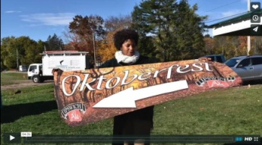Click here for an excellent example of a club-event promotional video by Concord President Steve Kirk.

Return to March 7 Newsletter

Visit our website
'Like' our Facebook page
'Follow' us on Twitter
Watch our videos
View our photo albums

