COMMITTEE REPORTS
RI President Ian Riseley Announces '17-'18 Rotary Theme ...
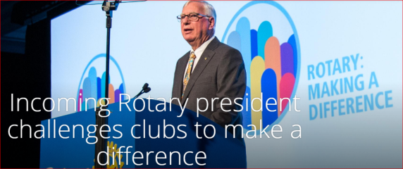
... And Here It Is
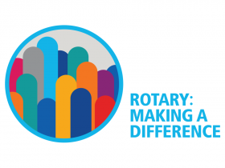

Governor-Elect Report: NEPETS, March 9-11, Framingham

RI President-Elect Ian Riseley to be Keynote Speaker

By Karin Gaffney

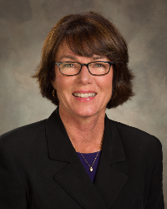

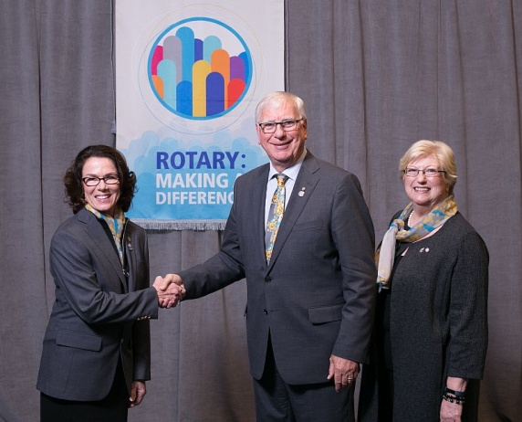
Rotary International President-Elect Ian Riseley and his wife, Juliet Riseley - shown (middle and right) recently posing at the International Assembly in San Diego with District Governor-Elect Karin Gaffney (left).

Get a chance to meet Ian and Juliet Riseley when they attend the 2017 Northeast Presidents-Elect Training Seminar, where Ian will be the keynote speaker on the evening of Thursday, March 9.

To watch the promotional video for Ian Riseley's talk, click here.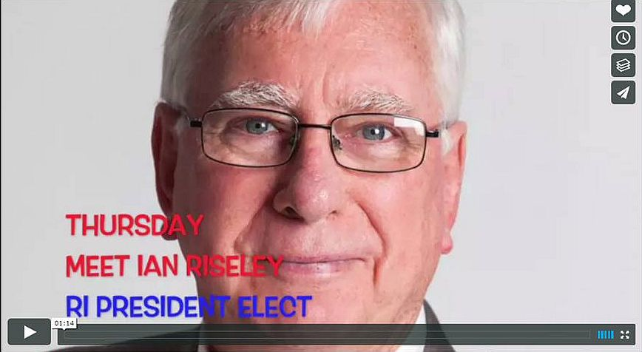

To learn more about Ian Riseley, click here.

Who, What, When, Where, Why and How of Rotary Leadership Institute

By David Kaiser



READ MORE

Join Us at the RLI Breakfast at April's RI Convention in Atlanta

REGISTER AND PAY

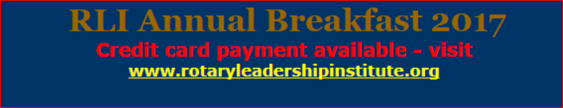

Foundation-Giving Scorecard as of March 3

By Sanjay Deshpande

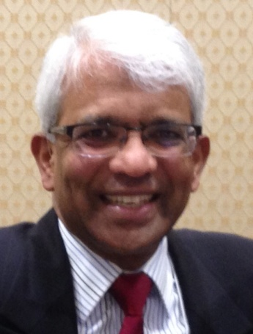

READ MORE

Blogs From Honduras: Our first work day

By Dick Manelis

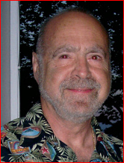

READ MORE

Million Dollar Dinner: $850,000 raised so far

By Satya Mitra

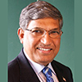

READ MORE

Membership Corner: Mark your calendar for March Membership Workshops

By Tom Sturiale
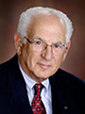

READ MORE

To learn how the Rotary Club of Melbourne in Victoria, Australia does corporate membership, click here

To learn about District 7910 Membership Workshops in October, click here.
Membership Materials On Sale: Order now!
To order, click here


RYLA Right Now: Register right now
By Christine Pinney

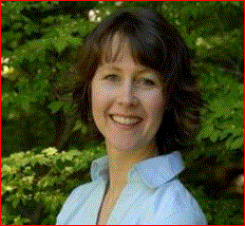

READ MORE

To download the RYLA information flyer, click here.

Polio Plus Update: Polio survivors in the U.S. are still with us

By Carl Good III

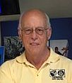
READ MORE

Rotary Has a Polio-Prevention Victory - But Huge Post-Polio Challenges Lie Ahead

By Ron Goodenow

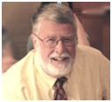

READ MORE

Nominations Call: Needed - Qualified trustee applicants

By Mike Ellis

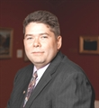

READ MORE

ESSEX Examples: Who's behind making us best



READ MORE

PR Tips: Know what role your club plays in the community
By Laura Spear
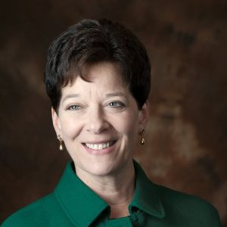

READ MORE
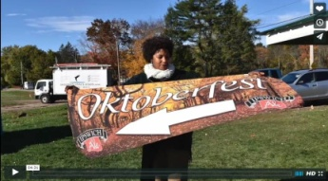Click here for an excellent example of a club-event promotional video by Concord President Steve Kirk.

RLI Leads: Upcoming events in our region

By David Kaiser

- March 18, Wells, Maine
- March 25, Lincoln , Rhode Island
READ MORE - GET EVENT SCHEDULE & REGISTRATION

FAQs about RLI: Click here

What are the courses? Click here
To download the brochure with all of the RLI Northeast America classes for 2016-2017, click here.

For the complete RLI Northeast America schedule, click here.

'17 RI Convention in Atlanta: Register now!

By Steve Glines

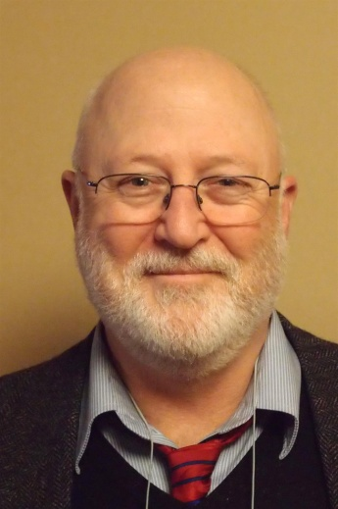

For more information on the RI Convention, click here.

To register now for the Beyond Borders Dinner on June 11, click here.

Bill Gates to be keynote speaker

READ MORE


More than 100 breakout sessions

There will be more than 100 breakout sessions at the RI Convention in Atlanta. Help us plan the sessions by taking a survey: TAKE SURVEY
Here's a letter from Steve Glines (shown, above), chair of the District International Convention Promotion Committee: READ LETTER

To register and find hotel options, click here.

For more information on the 2017 RI Convention in Atlanta, click here

Interact Actions: Interact teens invited to help in Providence and Atlanta
By Bob Anthony
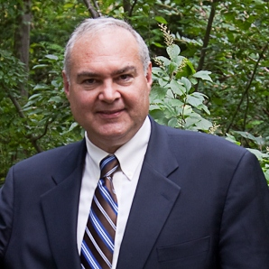

READ MORE

How to launch an Interact club

WATCH VIDEO

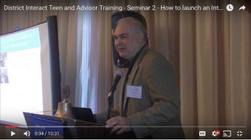

Our Interact family is growing

The Interact Club of Montachusett Vocational Technical High School was chartered by the Rotary Club of Montachusett Area on February 15.

Club Central: Short video on how to post your club goals

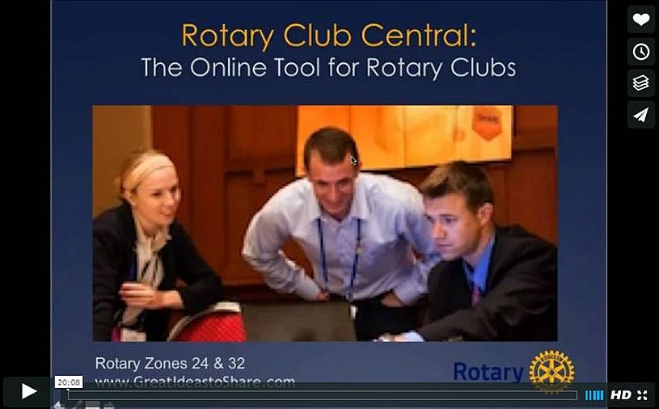
This 20-minute webinar recording is designed for club leaders to assist in posting goals on Rotary Club Central. Bob Wallace and Ian Lancaster, facilitators from Rotary Zone 24 East, provide practical start-up information. CLICK HERE

RAAGNE Newsletter: Update on visioning process
By Klaus Hachfeld



READ MORE

Treasurer's Report: All Clubs have been sent their District and RI invoices

By Jack Hoell

If it has not been received, contact Jack Hoell ASAP!

District and RI dues are billed in July and in January.

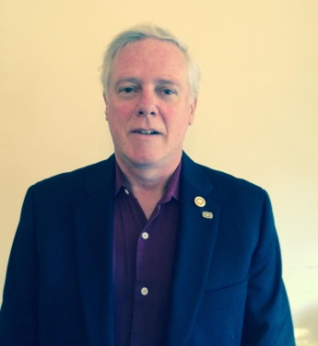

READ MORE

Speaker's Bureau: Looking for good speaker for your club?

By Steve Levitsky

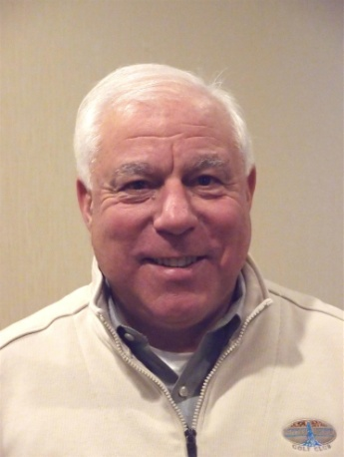

It's not always easy to come up with ideas week after week. We have many suggestions for you. Here are just a few:

- Power of the mind: Bob Martel - Newest topic addition to our list
- Rwandan genocide: Carine Boggis
- Elevator-pitch tips: Andy Winig
- Differentiation and game-changing simplicity: Stephen Melanson
VIEW MORE

District Charity Fund: How does DCF operate?

By Karin Gaffney

READ MORE

Communications Link: Seeking club photo, video albums
By Steve Jones-D'Agostino
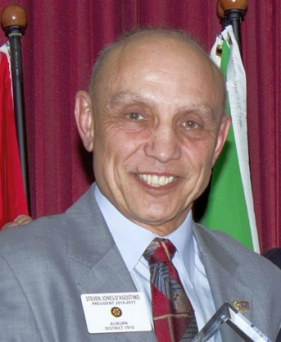

READ MORE

SUBMIT CONTENT
To submit content for consideration for the Tuesday, March 14 issue of Rotary District 7910 Newsletter, please e-mail it to Immediate Past District Governor and Newsletter Editor Jim Fusco at jim.fusco2@gmail.com.

The submission deadline for that issue is Friday, March 10. All text must be in Word format. All images must be in either JPEG or PDF format.
Please, please please... identify the people, left to right, who are shown in your photos, including their first and last name as well as their club or other title.

PAST ISSUES
To view past issues of the weekly Rotary District 7910 Newsletter, click here

D7910 ONLINE
Visit Our Website

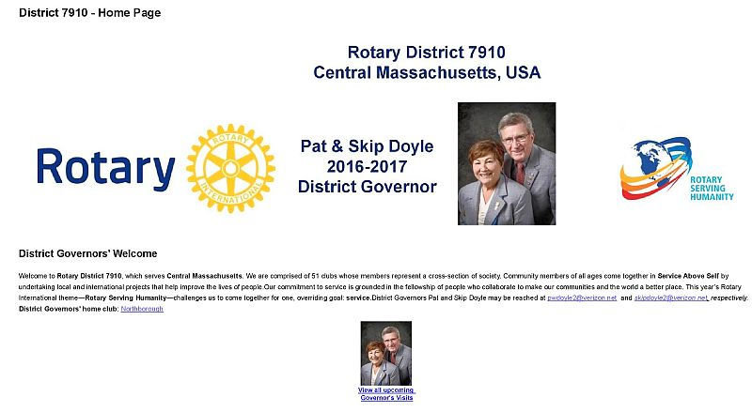
Click on each one






'Like' And Share Us On Facebook

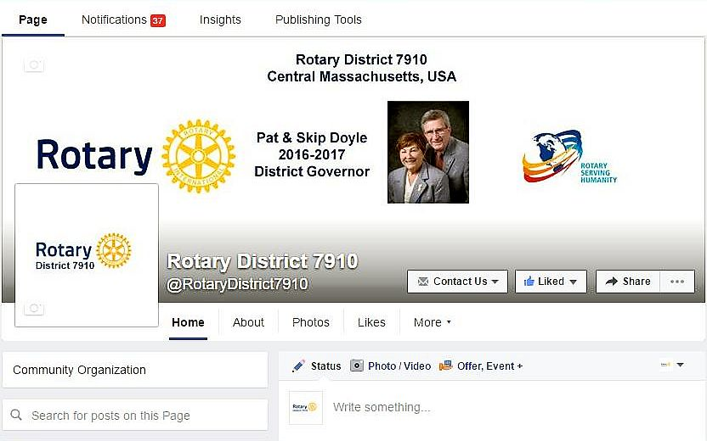

'Follow' Us On Twitter

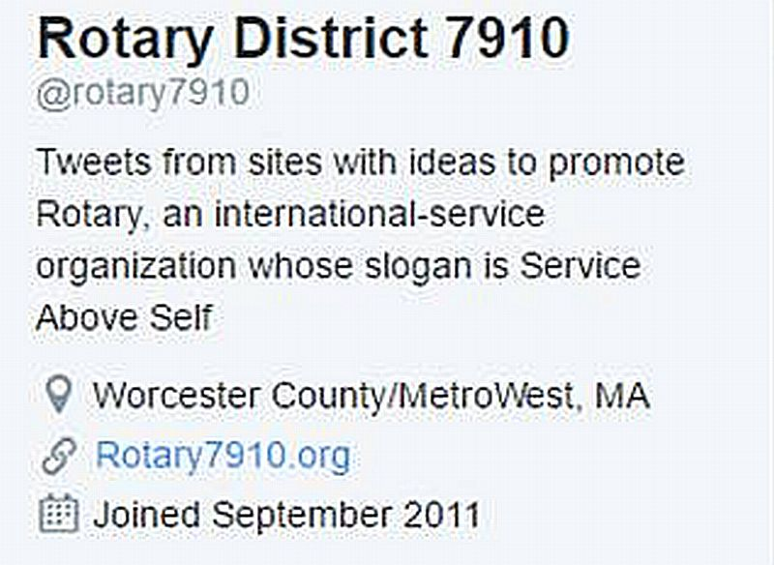

Watch Our Videos
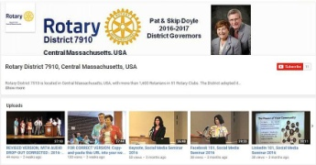

View Our Photos
Archived on Google Photos, since May 2015; and on ClubRunner, before May 2015
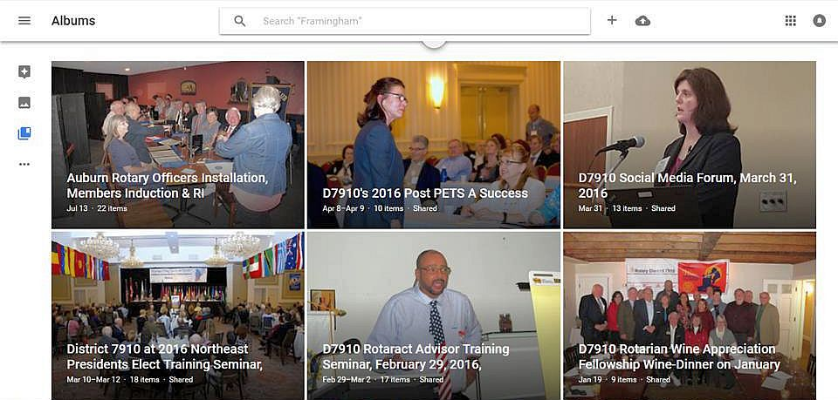

CONTACT US
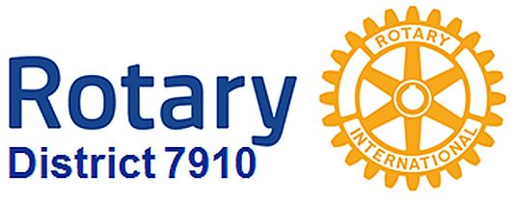

Jim Fusco, Immediate Past District Governor and Newsletter Editor
​jim.fusco2@gmail.com
Steve Jones-D'Agostino, District Webmaster and Newsletter Copyeditor
​srdagostino@icloud.com
© Copyright 2017-2018 - Rotary District 7910, Central Massachusetts, USA

