
P.O. Box 186 Marlborough, MA 01752
PRESS RELEASE
____________________________________________________________________________________

September 12, 2015

For Immediate Release

Marlborough Rotary Club exhibited at Business Expo

The Marlborough Rotary club successfully exhibited at the Marlborough Regional Chamber of Commerce Business Expo, which was held on Thursday, September 10, at the Marriott Courtyard Hotel in Marlborough.

“This was part of our ongoing public image campaign,” noted Marlborough Rotary Club President Michael Lashua. “Of course, we hoped to gain interest from potential members, but it was also aimed at making a positive image statement in the business community,”

The Marlborough Rotary Club exhibit included a large, colorful display of photos showing Marlborough Rotarians working in service projects, fundraising projects, presenting contributions, and enjoying their fellowship. Additionally, there were club membership brochures, club Foundation Corporate Membership brochures, flyers and posters heralding the upcoming Recycling event on October 17, and of course – the secret weapon – lots of chocolate.

Club Publicity Chair Peggie Thorsen said, “A staple of marketing has always been face-to-face personal selling. Many people stopped by our table. All of them were impressed by the breadth of the club’s accomplishments and accomplishments. A handful of them showed genuine interest. One of them, a young intern at the Chamber of Commerce, is an excellent candidate for our community Rotaract Club.” All those (about 5) showing interest in membership were given a ticket to come to lunch.
The club has exhibited at the Chamber’s Business Expo for several years, but this was the most visibly successful year, yet.

(PHOTO)
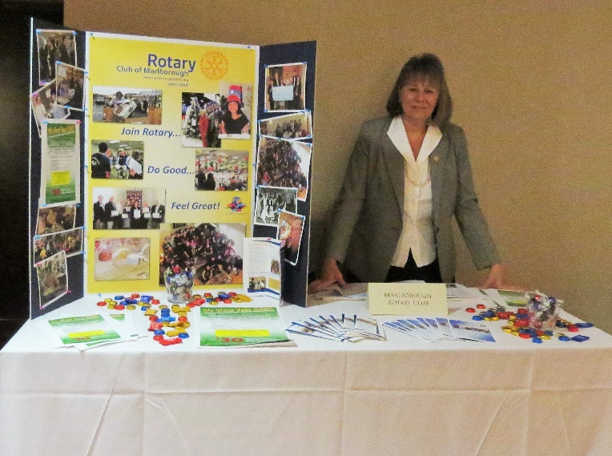

Publicity Committee Member Elaine McDonald, who helped staff the exhibit, used the opportunity to make the rounds, distributing Recycling Day fliers to the other exhibitors.

--30 –

Peggie Thorsen
Publicity Chair
Marlborough Rotary Club
Home: 508-481-5453 mathorsen@verizon.net



