Membership Workshops recap
By Tom Sturiale

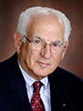District 7910 conducted a total of four regional Membership Workshops on October 24, 25 and 26. The workshops were a response to many requests for meeting locations nearer club bases and more interactive discussions rather than a forum-speech format. The workshops were well-attended and the discussions were wide-ranging and very interesting. The comments are being summarized and will be distributed to all participants.

A few observations follow. It is certainly encouraging to know there is much interest and energy being devoted to improving club memberships. Some clubs are more successful while several still struggle with membership. One reaction expressed by many is that membership is a multifaceted issue and requires considerable time, talent and energy to develop a successful effort. It was interesting to hear of the many efforts of some clubs to gather prospective members and yet not succeed in bringing them in as members. Why might this be happening? It is not simply an issue of attracting and inducting a few members occasionally.

An effective membership effort demands a critical assessment of the club’s vision, objectives and value proposition. Clubs need to align their vision, objectives and value proposition with the membership – both current and projected. Unless a Rotary club has a value proposition that satisfies its current members and is attractive to potential members, it will tend to lose current members and not attract new members. Most folks do not join an organization just because of the aura of the name and reputation. They need to have a reason to join. Our job is to ensure we have a necessary and sufficient reason and that we are articulating the reason clearly. We tend to assign a membership chair and hope they will bring in new members. It is not that easy and indeed may be the most difficult task of a Rotary club. Membership requires a major effort of the club leadership to critically assess and reassess the nature of their club and how it may have to change in order to grow.

Another interesting point discussed was the recognition that attracting new members is only 50 percent of the effort. Retaining new and current members is another 50 percent of the effort. Early engagement, involvement, welcoming and fellowship activities are critical to a high retention rate. People will sense almost immediately the warmth, welcoming and acceptance nature of a club. It is not their responsibility to become accepted – it is the responsibility of the members!

Although there are so many stories to relate about membership, there is one more that I thought humorously but clearly demonstrates the difference between millennials, whom we are trying to attract, and the more senior type of Rotarians. One young man demonstrated his technique of recording and maintaining an iPhone database of all current and prospective members. His spreadsheet had names, numbers, attendance, dues and fees and several other data points. The other table participants sat in awe of this modern manner of maintaining information at one’s fingertips. One response that clearly points out the difference in generations was that one individual utilized a chisel and a granite block to record his data. Of course, I’m sure he meant paper and pencil, but you get the point. We had better start bringing in more of these tech-savvy millennials before we get any older and greyer. Of course, that led to further discussions of how to bring in millennials. Rotary International has opened the doors for clubs to modify their venues, meeting times, frequency and attendance to meet the challenges of changing society. It is up to you to determine what you need to do to grow and prosper.

If you did not attend the Membership Workshop in your area, you missed a great opportunity to learn from others or to share your expertise in membership issues.

Shown: The Membership Workshop on October 25 at Chuck's Steak House in Auburn, which was attended by members of the Auburn, Brookfields, Marlborough, Northborough, Shrewsbury, Southborough, Southbridge, Sturbridge, Uxbridge, Westborough and Worcester clubs.

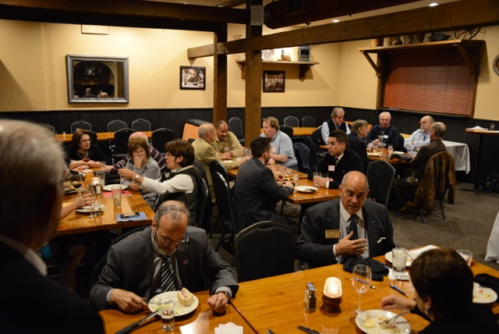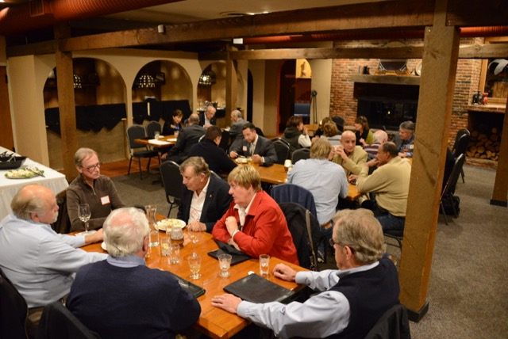

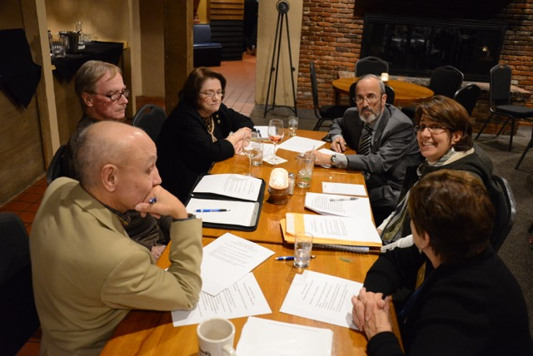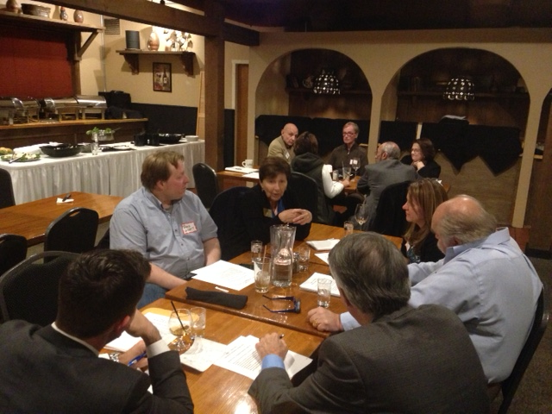

Tom Sturiale, chair of District 7910's Visioning Committee and vice chair of its Membership Committee, may be reached at tsturiale36@gmail.com.

For more information on Rotary memberships:
- Rotary Individual Membership Application - Word Format
- Rotary Corporate Membership Application - Word Format
- Rotary Corporate Membership Opportunity - Word Format
- Rotary Corporate Membership Information - Word Format

September 2016 'Membership Corner' articles:
- September 5: Corporate memberships In Rotary
- September 19: What are our Rotary objectives? Membership! Membership! Membership!
- September 26: Rotary club objectives

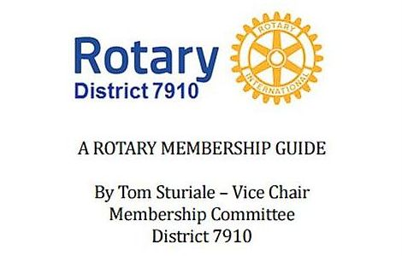"A Rotary Membership Guide" is a collection of "Membership Corner" articles written for this weekly newsletter during the 2015-2016 Rotary year, which began last July 1. It is intended to offer an idea or thought each week aimed at stimulating discussions, questions and actions to effectively increase membership at all our clubs. Click here, to download this 52-page "Guide," in Word format.

Return to October 31 Newsletter

View past issues
Visit our website
'Like' our Facebook page
'Follow' us on Twitter

