Membership Workshops start in 14 days
By Tom Sturiale

Instead of a District Membership Forum this year, we are featuring Membership Workshops in each of our district's four areas. They are shown in date order.

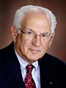
- Area D: Monday, October 24, 6:30-8:30 p.m., Brookline VFW, Brookline. To register, click here
- Area B: Monday, October 24, 6:30-8:30 p.m., Concord Academy, Concord. To register, click here
- Area C: Tuesday, October 25, 6:30-8:30 p.m., Chuck's Steak House, Auburn. To register, click here
- Area A: Wednesday, October 26, 6:30-8:30 p.m., The Manor, West Boylston. To register, click here
To find your club's area, click here.

Tom Sturiale, chair of District 7910's Visioning Committee and vice chair of its Membership Committee, may be reached at tsturiale36@gmail.com.

For more information on Rotary memberships:

- Rotary Individual Membership Application - Word Format
- Rotary Corporate Membership Application - Word Format
- Rotary Corporate Membership Opportunity - Word Format
- Rotary Corporate Membership Information - Word Format
August 2016 'Membership Corner' articles:
- August 1: What would Paul Harris do?
- August 8: Where will we find new members?
- August 15: How do we approach prospective members?
- August 22: Visioning
- August 29: Unique Approach to Publicize Rotary by Northborough
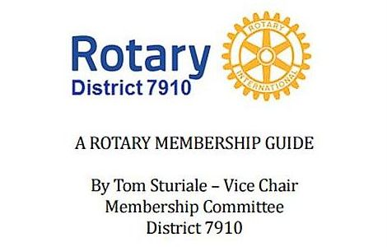"A Rotary Membership Guide" is a collection of "Membership Corner" articles written for this weekly newsletter during the 2015-2016 Rotary year, which began last July 1. It is intended to offer an idea or thought each week aimed at stimulating discussions, questions and actions to effectively increase membership at all our clubs. Click here, to download this 52-page "Guide," in Word format.

Return to October 10 Newsletter

View past issues
Visit our website
'Like' our Facebook page
'Follow' us on Twi

