Many Rotary Clubs have challenges with membership growth. Despite high satisfaction among Rotarians, effective engagement of prospective members is low. Rotary is a global network of 1.2 million people with passion, energy, and intelligence that take ACTION for good. What could 2 million accomplish?
Goal – To provide inspiration alongside actionable training to existing Rotary Club members that will reinforce “the WHY” while providing “the HOW” to increase membership in 2020 and beyond.
Opportunity: Invest an hour that could change your Club’s membership trajectory in a fast-paced, interactive session with Don Wilson, renowned sales educator, featured TedX speaker and author of “What’s YOUR Woobie? – Simple Strategies on Your Uncomfortable Path to New Opportunities.”

Benefits:
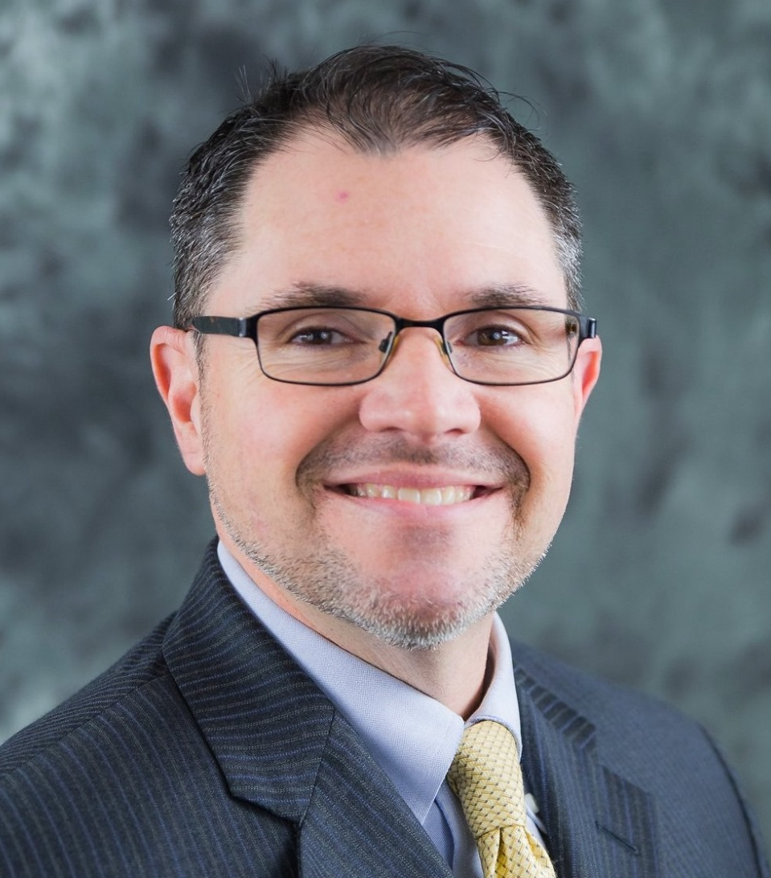
- You get a memorable experience and training to use in Rotary and life.
- Your Club gets training focussed on membership growth and a copy of Don’s book.
- Polio Now receives 50% of the $50 registration fee that covers every member of your Club.

Features & Key Points
- Why? Rotary is a global network of 1.2 million people with passion, energy, and intelligence that take ACTION for good. What could 2 million accomplish? Apply that to your Club’s local impact!
- What? - Rotary members must be invited to join, so Rotarians need to be able to articulate your story. Why Rotary for you? Why Rotary for others? How did Rotary affect your life and your business?
- How? - Don Wilson will teach the value of a specific ASK and create one that you can use the next day!

Logistics
- When: Wednesday, September 16. 6:00-7:00 p.m. EDT on Zoom.
- Cost: $50 per Club for attendance by an unlimited number of Rotary Club members. Scholarships are available upon request. Please register first and then send an email to the Event Organizers.

