New Tools For Membership Tool Belt

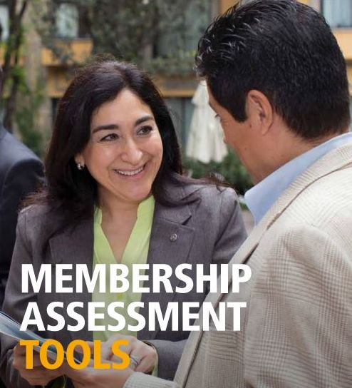

Looking to enhance your club membership experience? Do you want to find opportunities for growth in your club? Club and district leaders now have a set of updated Membership Assessment Tools (formerly Club Assessment Tools) to help them strengthen club membership and add value to your club membership experience, so that more people will join and fewer members will leave.

For your convenience, you can download the entire publication, or just the individual assessments that are most relevant to your club.
The individual assessments, which walk users through evaluation and development of an action plan, include:
- Representing Your Community’s Professions: A Classification Assessment
- Diversifying Your Club: A Member Diversity Assessment
- Finding New Club Members: A Prospective Member Exercise
- Improving Your Member Retention: A Retention Assessment and Analysis
- Enhancing the Club Experience: Member Satisfaction Survey
- Understanding Why Members Resign: Exit Survey
Historical trends show that there’s an increase in membership soon after the new year, so this is the perfect time to consider how you welcome new members into your club. Read how one club is using our New Member Welcome Kits to enhance their welcome and orientation.

