Dear $NICK_NAME$,

It is our pleasure to share with you the November 14 issue of Rotary District 7910 Newsletter.

For the complete issue, click here.

To explore past issues, click here.

Highlights of November 14 issue:

Governor's Message: Our District Food Packaging Event was a solid success - By Pat and Skip Doyle

Athol-Orange's Al Bowers: ‘Veteran gave in Vietnam and continues to give today’ - By Thomas Farragher, The Boston Globe

Foundation Note: District drive to add $1 million to TRF Endowment Fund in ‘16-‘17 - By Sanjay Deshpande and Satya Mitra

Rotary Means Business: First meeting on December 7 - By Ron Bott

Membership Corner: Rotary clubs honor veterans - By Tom Sturiale

PR Tips: Package your experts - By Laura Spear

PolioPlus Update: Our clubs have been busy - Auburn raised $700, Groton-Pepperell pledged $500 - By Carl Good III

RAAGNE Newsletter: Update on visioning process - By Klaus Hachfeld

Interact Actions: How to launch an Interact club - By Bob Anthony

Speakers Bureau: Do you need a speaker for your club? By Steve Levitsky
Treasurer's Report: Message about your dues - By Jack Hoell

District Charity Fund: How does DCF operate? - By Al Bowers

Communications Link: Seeking club photo, video albums - By Steve Jones-D'Agostino

Our next newsletter will come out on Monday, November 21. The submission deadline is this Friday, November 18. Text content must be submitted in Word format. Image content must be submitted in either JPEG or PDF format. Send your content submissions to Immediate Past District Governor/Newsletter Editor Jim Fusco at jim.fusco2@gmail.com.

Governors Pat & Skip

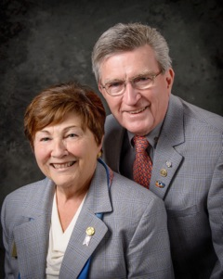Pat and Skip Doyle
2016-2017 Governors
Rotary District 7910
pwdoyle2@verizon.net
skipdoyle2@verizon.net

