Rotary clubs honor veterans
By Tom Sturiale

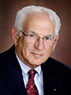
Each year on the 11th hour of the 11th day of the 11th month, we celebrate and honor all the veterans - those alive and those who sacrificed their lives - throughout our history. November 11 was once honored as Armistice Day, the day on which World War One, the “war to end all wars,” ended in the surrender of Germany to the allies in 1918 in a small railroad car in Compeigne, France. Twenty-two years later, a vengeful Germany forced a humiliated France to surrender after only six weeks of war in the very same railroad car – so began World War Two, and so much for the “war to end all wars.”

Since that time, millions more young Americans served our country in Korea, Vietnam, Iraq, Afghanistan and many other areas. In order to honor more appropriately their service, Armistice Day was converted to Veterans Day in 1975, to begin officially in 1978, by President Gerald Ford.

World War One ended 13 years after Paul Harris, with three other gentlemen, began the Rotary movement, which was aimed at correcting the ills of the world, developing our communities into better places, and serving others above self. During the next 111 years, Rotary developed into the world’s largest humanitarian organization - with 1.2 million Rotarians in almost every country.

Of Rotary's five Avenues of Service, Community Service is the one on which Rotary clubs spend most of their time and energy. Of course, the other Avenues of Service are equally important as we also devote resources toward Club Service, International Service, Vocational Service and Youth Service.

Within the realm of Community Service, there are many constituents including the poor, the hungry, the sick, the indigent, the elderly, the needy, countless community-service organizations, and the veterans. Do we spend enough time thinking about how to help and assist veterans? Many return from foreign battlefields in need of a helping hand, a job, or simply our thanks for a job well done. Many return with deep scars - either mental or physical, or both - and need our help. Every community has a population of veterans whom should be recognized and appreciated.

This month, Rotary clubs organize breakfast or dinner events honoring veterans. Other Rotary clubs held similar events honoring veterans. Honoring our veterans is a wonderful way to serve our communities. It is a way for Rotary clubs to be recognized as servants of the community. And, it is a way for our clubs to improve their public relations and to attract prospective Rotarians.

Let us resolve to increase our focus on veterans next - and every year.

Tom Sturiale, chair of District 7910's Visioning Committee and vice chair of its Membership Committee, may be reached at tsturiale36@gmail.com.

Documents for October 2016 Membership Workshops, in PDF format:
- Participant Comments
- Introductory Notes for Moderators
- Sessions Discussion Points
- Rotary Membership-Development Ideas Sites
To learn about the October 2016 Membership Workshops, click here.

For more information on Rotary memberships:
- Rotary Individual Membership Application - Word Format
- Rotary Corporate Membership Application - Word Format
- Rotary Corporate Membership Opportunity - Word Format
- Rotary Corporate Membership Information - Word Format
September & October 2016 'Membership Corner' articles:
- September 5: Corporate memberships In Rotary
- September 19: What are our Rotary objectives? Membership! Membership! Membership!
- September 26: Rotary club objectives
- October 3: A review of membership best practices from eight of our clubs
- October 10: Membership Workshops start on October 24
- October 31: Membership Workshops recap
To read previous articles for Rotary 2016-2017, click here.

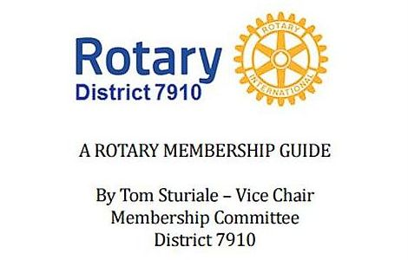"A Rotary Membership Guide" is a collection of "Membership Corner" articles written for this weekly newsletter during the 2015-2016 Rotary year, which began last July 1. It is intended to offer an idea or thought each week aimed at stimulating discussions, questions and actions to effectively increase membership at all our clubs. Click here, to download this 52-page "Guide," in Word format.

Return to November 14 Newsletter

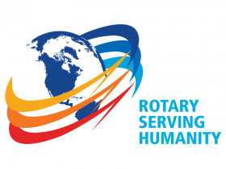
View past issues
Visit our website
'Like' our Facebook page
'Follow' us on Twitter

