GOVERNOR'S MESSAGE

OUR DISTRICT FOOD PACKAGING EVENT WAS A SOLID SUCCESS
By Pat and Skip Doyle

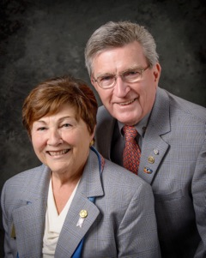
Last week was certainly an amazing one, full of highs and lows. In this Governor's Message, we wish to accentuate the highs.

The week began with the nomination of Pam Anastasi of the Rotary Club of Billerica as District Governor Nominee Designate - or, in Rotary language, the DGND - for the 2018-2019 Rotary year, which begins July 1, 2018. She is known to many of you as the coordinator of district events during the past two years as an assistant governor, a member of the Board of Trustees and the current assistant governor coordinator. We are pleased to welcome Pam to the District Executive Board.

We officially visited two Rotary clubs: Tewksbury and Tyngsborough-Dunstable. These were numbers 49 and 50 of our visits with just one more left - tomorrow in Uxbridge. All of our visits put together have so far been the highlight of our year as district governor. Our plan now is to begin to revisit all of you at a more leisurely pace. Please invite us to your events and ceremonies as we truly wish to continue to build the bonds of friendship between District 7910 and our 51 Rotary clubs.

Thank You! Thank You!! Thank You!!!

Our District Food Packaging Event on November 12 at the Solomon Pond Mall in Marlborough was a solid success.

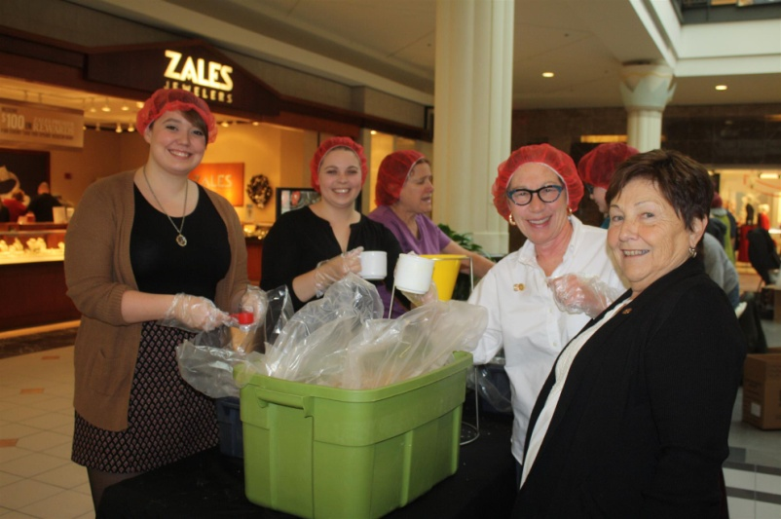More than 100 volunteersfrom around the district packaged 20,000 meals, which will be sent to Haiti to help feed the children left homeless by the hurricane. These volunteers were Rotarians and their friends and families, young and old There were Interactors from local clubs, passersby who wanted to help and past and present participants of Rotary Youth Leadership Awards. We raised more than $4,000 toward our goal of $5,000 - so we are still actively seeking donations.

Shown, are District Governor Pat Doyle (far right) and Susan Rack(second from right) of Brookline Rotary.

It is hard to pick out a highlight from the event, there were so many. One is perhaps the numbers of people with whom we were able to talk about what Rotary is - the reality of Rotary, not the perception. This event puts us a little further toward our goal of making Rotary more visible and more real in our district. Thank you also to the Solomon Pond Mall for allowing us to utilize their space for this event.

In closing, in place of this week's "Our Presidents Speak" article, please read this article about Al Bowers of the Rotary Club of Athol-Orange, which was published in the November 9 edition of TheBoston Globe:

Athol-Orange's Al Bowers 'A Vet Still Giving'

As a young boy in tiny Royalston, Alan Bowers learned early the value of hard work.

He lived across the street from the town library and his great-grandfather – a stern and burly man who ran the local general store – led him there one day in the late 1940s.

READ COMPLETE ARTICLE

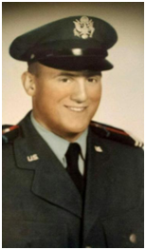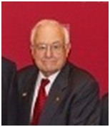

Al Bowers, in 1958 (left) and in 2016 (right)

Always remember, you can call us with questions at 508-393-9031.

District Governors Pat and Skip Doyle may be reached at pwdoyle2@verizon.net and skipdoyle2@verizon.net,
respectively.

Click here to submit content for the November 21 issue. The submission deadline for this issue is November 18.

Click here for past issues.

WELCOME, NEW ROTARIANS
Alphabetical order, by last name

- Lynette Valentine, Fitchburg
- Anthony Vaver, Westborough

CLUB MEMBERSHIP GROWTH, ’16-‘17

We share with you the results of club-membership growth in our district during Rotary year 2016-2017, which began July 1.

This is a unique opportunity for Rotarians and friends to discuss partnering on humanitarian projects affecting our local communities.

READ MORE

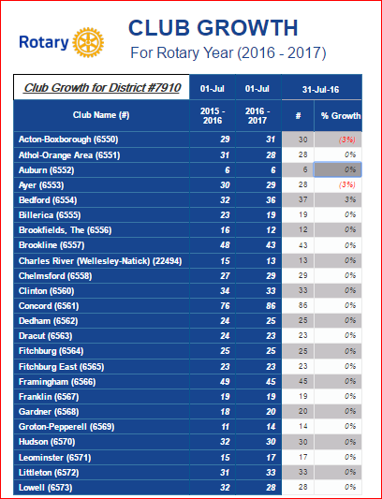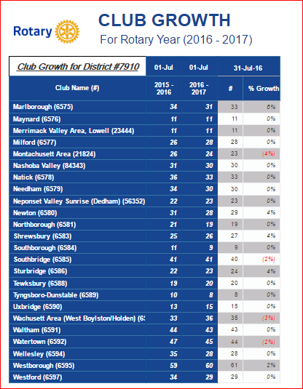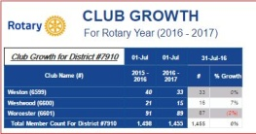

CLUB PLANNING WORKSHEET '16-'17
In both Excel and PDF formats, we share with you the Club Planning Worksheet for Rotary year 2016-2017, which began on July 1.
Please enter your club information in the indicated cells.

Excel Format

PDF Format

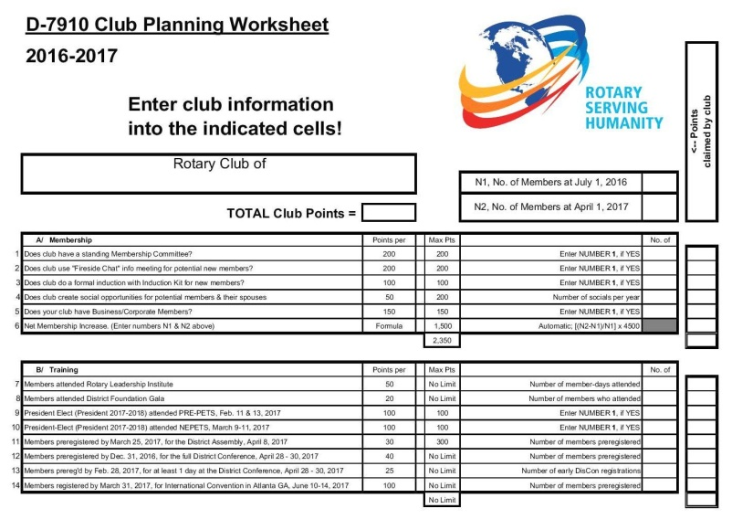

DG VISITS LAST WEEK

Tewksbury (chartered 1961)

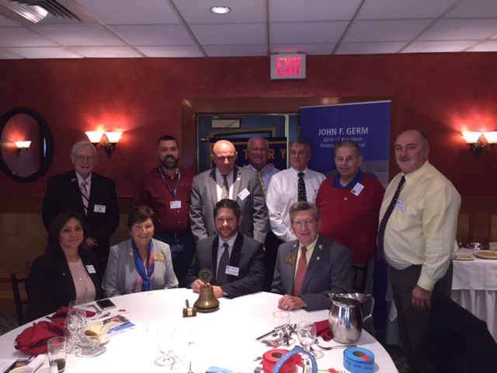

Tyngsborough-Dunstable (chartered 1974)

Standing, left to right: District Governor Skip Doyle, President Bob Guernsey, District Governor Pat Doyle, and Assistant Governor Kevin Sullivan.

Seated: Members Connie Spickler (left) and Beth Craig (right).

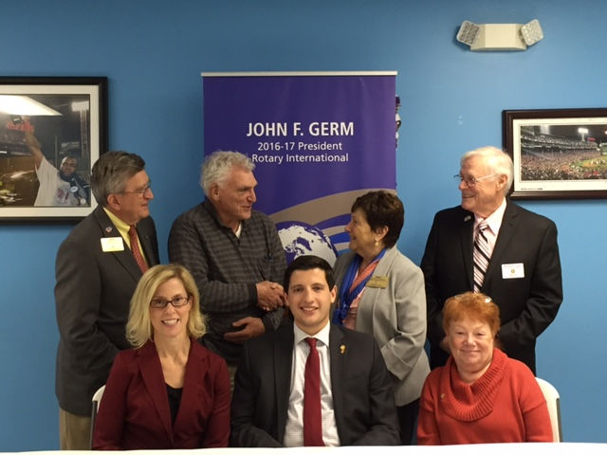

DISTRICT & CLUB ROUNDS

Chelmsford's Comedy Show A Howling Success

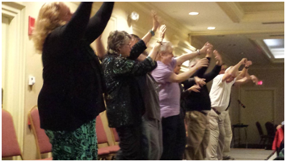

The Rotary Club of Chelmsford's Comedy Show on November 5 at the Radisson Hotel in Chelmsford was both a financial success and a fun-filled evening. Those attending enjoyed snacks and drinks as they viewed a variety of raffle baskets before the show.

Comedian David DiLorenzo opened the show and kept the audience laughing for a half-hour. Then, hypnotist Tommy Vee took over. For about an hour and a half, he hypnotized 20 volunteers and had them keep the audience thoroughly enjoying themselves.

The evening concluded with the basket winners being drawn. The Lowell Five, Enterprise Bank and Village Electric were among sponsors who supported the event.

Chelmsford Serves 54 Lunches to Seniors

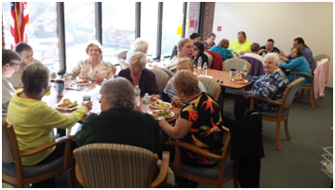

The Rotary Club Chelmsford has provided for and served lunches to senior citizens at two Chelmsford Housing Authority sites during the past three weeks. On October 24, they fed more than 30 seniors at Chelmsford Arms and on November 7, they fed another 24 at McFarlin Manor. Chelmsford Rotary plans to continue this program after the holidays.

Chelmsford Serves Coffee and Donuts at Veterans Park

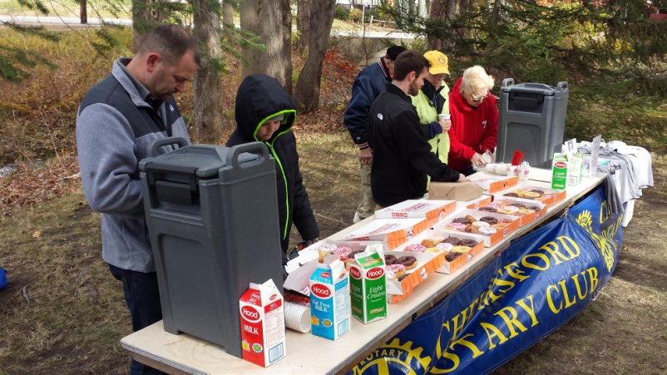

The Rotary Club of Chelmsford served coffee and donuts on November 7 during the Veterans Day ceremonies at Veterans Park in Chelmsford. The club has provided this service for a number of years and those in attendance particularly appreciate the hot coffee on what is often a cool and windy day. The local Dunkin' Donutsdonated coffee and donuts as it has done for a number of years.

Fitchburg Inducts Lynette Valentine

Left to right: Members Paul Gauvin and Lynette Valentine and President Dan Cunningham

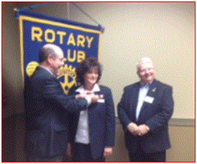

Framingham's Pancake Breakfast A Huge Success

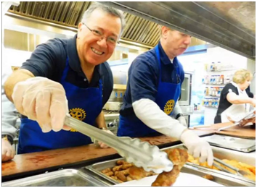

The Rotary Club of Framingham held its fifth annual Pancake Breakfast on November 5 at Joseph P. Keefe Regional Technical School in Framingham. Proceeds from this event will help to purchase air-conditioning units for elderly people living in public housing in Framingham.

WATCH TWO-MINUTE VIDEO

Wellesley Sixth-Graders Students Learn of Rotary Four-Way Test, Interact Global Grant Project

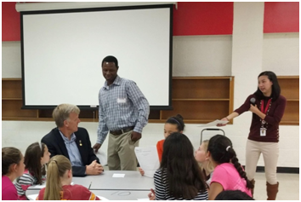

About 80 students from the Wellesley Middle School used a lesson plan developed by English teacher Claire Lee (standing, right) to exercise the iconic Rotary tool for decision-making. The Grade 6 studentswere invited to list good and bad decisions they remembered and weigh them using the Rotary Four-Way Test. They were also invited to participate in a writing contest expanding on the same topic. John Adams (seated, left), Cynthia Sibold and Bob Anthony represented the Rotary Club of Wellesley in offering the writers judged to be the top three prizes valued at $400.

To view the Rotary Four-Way Test Worksheet, click here.

To read the history of the Four-Way Test, click here.

READ MORE

Framingham Helps Students with Real-life Finances

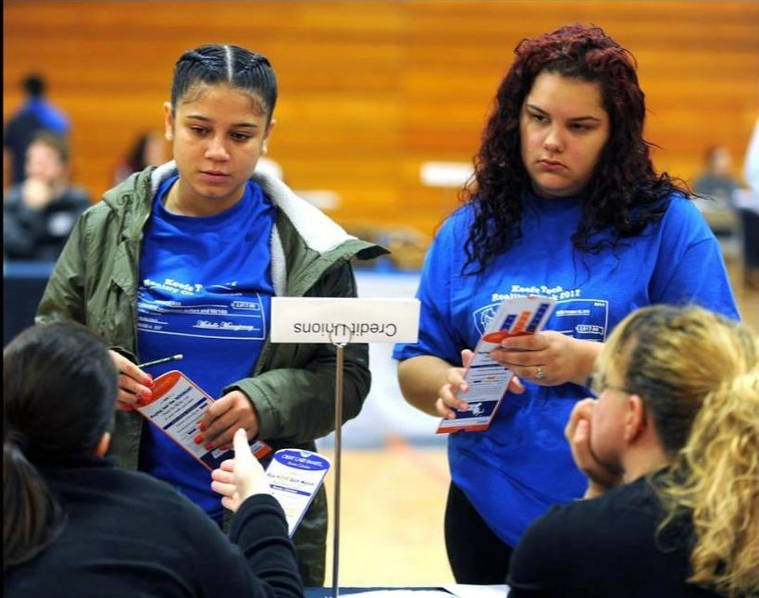

From student-loan debt to the soaring cost of housing, students got a glimpse of what their financial futures might hold during a Reality Check event on October 28 at Keefe Regional Technical School in Framingham. Reality Check is being started by the Rotary Club of Framingham with the assistance of the Keefe Tech chapter of Business Professionals of America and the MetroWest Regional Chamber of Commerce.

Left to right: Raissa Reis and Bianca Rodriquez learn about credit from Framingham Rotarians during Keefe Technical High School’s “2016 Reality Check” for seniors.

Photo: Alan Jung, MetroWest Daily News and Wicked Local.

READ MORE

LEARN MORE

Marlborough Reality Fair Opens Eyes and Doors

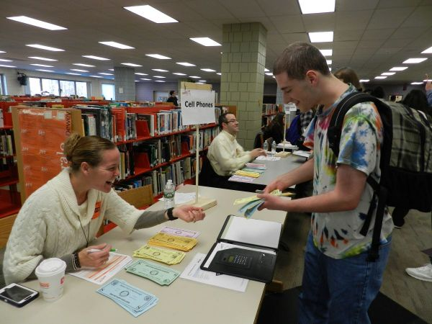

Marlborough High School seniors asked volunteers many career-related questions as they visited the various businesses and organizations at the annual Reality Fair held on November 1 at the high school. In its 12th year, the Reality Fair was brought to the high school by Peggy Thorsen, who established the fair during her first year as the president of the Rotary Club of Marlborough.

Photo: Marlborough Public Schools

READ MORE

Merrimack Valley Holds Eye Clinic in Chelmsford

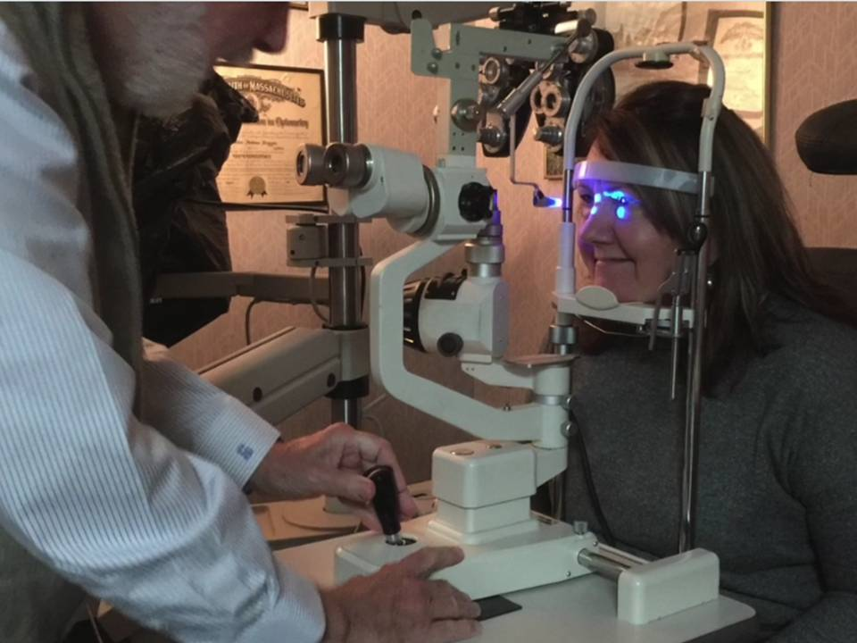

Drs. Florence Bejian and John Duggan of Valley Eye Associates with the help of fellow Rotarians from the Rotary Club of Merrimack Valley, recently provided eye testing and complimentary glasses, care of the generous sponsors Bausch & Lomb, Red Paris Opticaland ABB/Digital Eye Lab, to 18 patients at their office in Chelmsford.

WATCH 1-MINUTE VIDEO (produced by Concord President Steve Kirk

District Membership Workshops a Huge Success
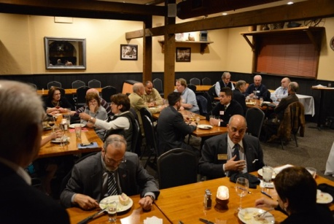
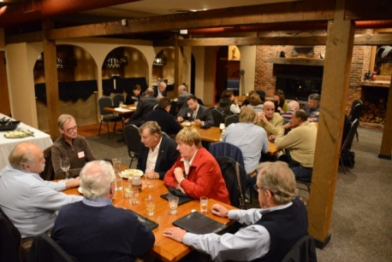

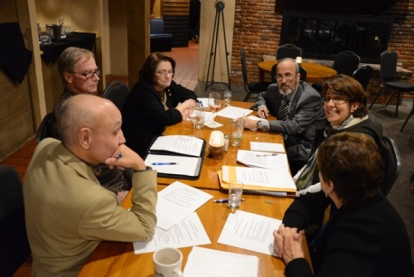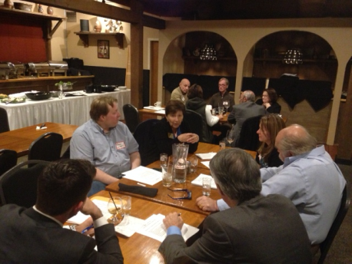

District 7910 conducted a total of four regional Membership Workshops on October 24, 25 and 26. The workshops were a response to many requests for meeting locations nearer club bases and more interactive discussions rather than a forum-speech format. The workshops were well-attended and the discussions were wide-ranging and very interesting. The comments are being summarized and will be distributed to all participants.
Shown: The Membership Workshop on October 25 at Chuck's Steak House in Auburn, which was attended by members of the Auburn, Brookfields, Marlborough, Northborough, Shrewsbury, Southborough, Southbridge, Sturbridge, Uxbridge, Westborough and Worcester clubs.

READ MORE

Franklin Chalks One Up for Charity

To view event photos, click here.

READ MORE

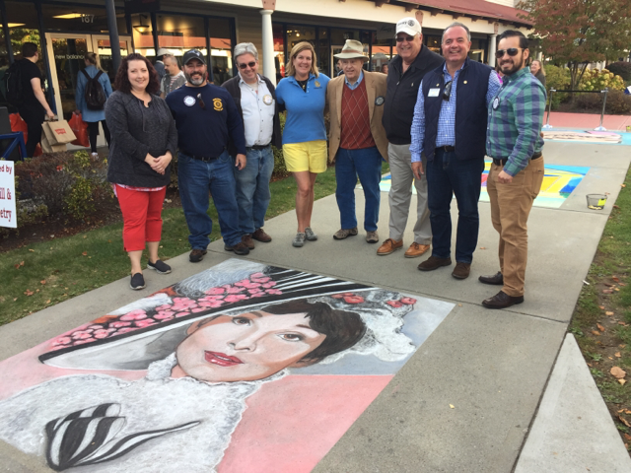

l

Left to right: First-place artist Kerry Wippie; President Elect Scott Martin; Past President and Board Member Fran McKeown; Past President and Vocational Services/RYLA Chair Julie Rougea; Past President Herb Hunter; Past President and Board Member Dan Gentile; President Terry Katsaros; and new Member Carlos Aguilera.

Sturbridge, Stoubridge Celebrate Sister Club ‘Rotary Friendship Day’

Since 1988, the presidents of the Rotary Club of Sturbridge and its Sister Club, the Rotary Club of Stourbridge, U.K., have exchanged letters of greetings and goodwill in October via snail-mail. The chair of the Sturbridge Board of Selectmen also mails a proclamation declaring October 16 as Stourbridge/Sturbridge Rotary Friendship Day and likewise, the mayor of Dudley in the U.K. does the same for the Sturbridge Club.

Shown, left to right: Stourbridge President Rob Franks, Dudley Mayor Mohammed Hanif, and Dudley Mayoress Zabeda Khanam.

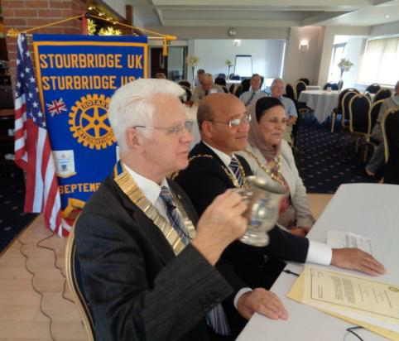

On to Atlanta in 2017: Early-Registration Discount Ends December 15

Planning to attend? Contact District Chair Steve Glines.

More than 43,000 attendees left the Rotary International Convention in South Korea inspired to end polio for good, to celebrate The Rotary Foundation's centennial, and to champion changes that will help Rotary appeal to a broader audience. On the last day, RI President K.R. “Ravi” Ravindran shared a personal story of his mother’s triumph over polio.

To read the story, click here.

To register for the 2017 RI Convention in Atlanta, click here.

Pat and Skip Doyle Installed as '16-'17 DGs

District 7910's 2016 Rotary Youth Leadership Awards were held on June 24 through 26 at Fitchburg State University, ending with the installation of longtime RYLA supporters Pat and Skip Doyle as District Governors for 2016-2017. The three-day RYLA event was attended by 188 sophomores. To learn more about RYLA, visit ryla7910.org.

To watch a video of the installation, click here.

District Banners Available

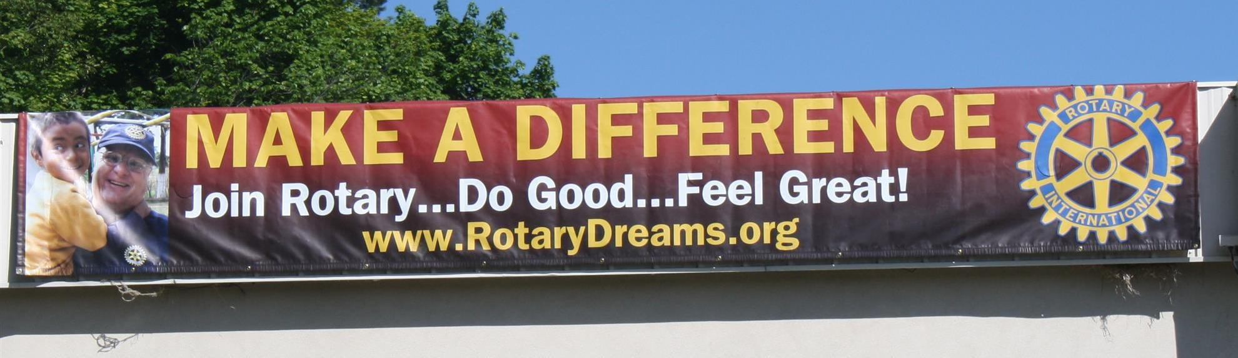

Our district banners are available for your to use when you have an upcoming event or fundraiser.

If you want to reserve one of the banners, please contact PR Chair Laura Spear at laura@spear.net.

MAJOR DISTRICT & CLUB HAPPENINGS: FALL 2016

Saturday, November 19: Ayer - 'Joey & Maria's Comedy Italian Wedding'

Saturday, November 19: Billerica - 'Cribbage Tournament'

For more information, click here, or contact Brian Goguen at 978-667-4595

Saturday, November 19: Marlborough - 'Turkey Shoot'

To learn more, click here.

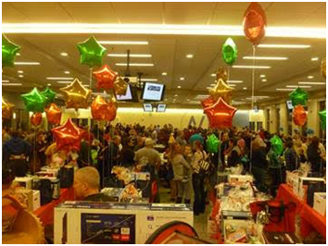

Thursday, November 24: Needham - 'Thanksgiving Dinner'

To learn more, click here.

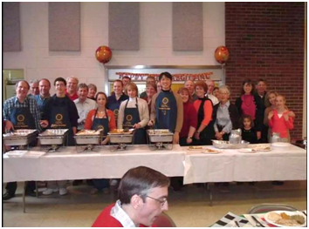

Thursday, November 24: Westborough - 'Thanksgiving Dinner'

To learn more, click here.

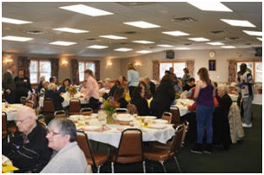

Sunday, November 27 - Westborough - 'Festival of Lights'

To learn more, click here.

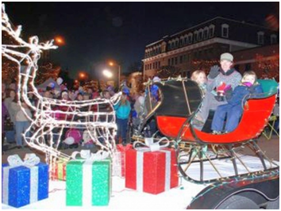

Monday, December 5: Sturbridge Rotary - 'Lottery Ticket Raffle'

To download the event flyer, click here.

Wednesday, December 7: Rotary Means Business - 'Networking Fellowship for Rotarians and Friends'

To download the event flyer, click here.

SUBMIT MAJOR CLUB HAPPENINGS

Send flyers of your club's major events and activities, in either JPEG or PDF format, to Immediate Past District
Governor/Newsletter Editor Jim Fusco at jim.fusco2@gmail.com.

