Package Your experts
By Laura Spear

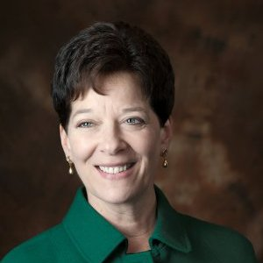
A great way to let a reporter know about your experts is to send them an “Interview Q&A” with the expert on a subject. Additionally, provide a brief bio that outlines your expert's experience in a given subject. If they have media experience, list that as well. (from nonprofitpr.org)

Last week, I discussed how to identify your club's experts. READ ARTICLE

To learn more about PR for your club, click on the "Public Relations" section of the navigation bar of the District 7910 website.

Laura Spear, chair of District 7910's Public Relations Committee, may be reached at laura@spear.net.

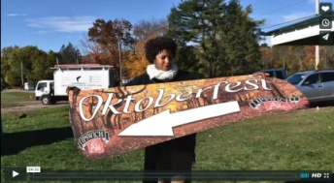Click here for an excellent example of a club-event promotional video by Concord President Steve Kirk.

Return to November 14 Newsletter

View past issues
Visit our website
'Like' our Facebook page
Follow' us on Twitter

