COMMITTEE REPORTS

Foundation Note: District Drive to Add $1 Million to TRF Endowment Fund in ‘16-‘17

By Sanjay Deshpande and Satya Mitra

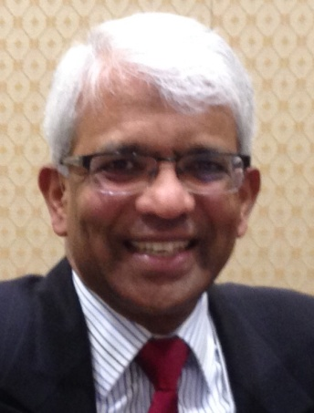

Assistant Governor Satya Mitra(shown, bottom), chair of the District Endowments and Major Gifts Subcommittee, with the encouragement of District Governors Pat and Skip Doyle and the full support of the District Foundation Committee, has launched the drive to add $1 million to The Rotary Foundation Endowment Fund in this Rotary year, which ends next June 30.With the launch of this drive, Satya has been appointed the chair of the District Million Dollar Journey and Celebration, and is pleased to share his first monthly report on this historic and ambitious campaign.

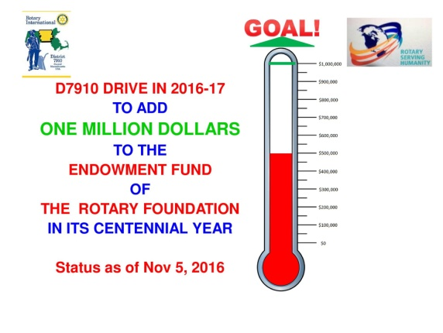

READ MORE

Rotary Means Business: First meeting on December 7

By Ron Bott

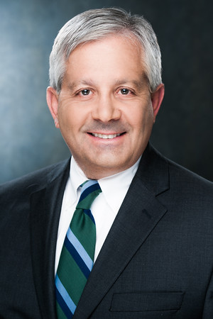

The first Rotary Means Business event in District 7910 will be held on Wednesday, December 7 from 5:30 to 7:30 p.m. at the Sheraton Hotel in Framingham. The cost is $15 for Rotarians and $20 for non-Rotarians. Light appetizers will be served and a cash bar will be available.

READ MORE

Polio Plus Update: Our clubs have been busy - Auburn raised $700, Groton-Pepperell pledged $500

By Carl Good III

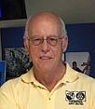

Two of our clubs have been active for Polio Plus: the Rotary Club of Auburn and the Rotary Club of Groton-Pepperell.

READ MORE

Membership Corner: Rotary clubs honor veterans

By Tom Sturiale
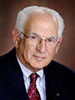

Each year on the 11th hour of the 11th day of the 11th month, we celebrate and honor all the veterans - those alive and those who sacrificed their lives - throughout our history. November 11 was once honored as Armistice Day, the day on which World War One, the “war to end all wars,” ended in the surrender of Germany to the allies in 1918 in a small railroad car in Compeigne, France. Twenty-two years later, a vengeful Germany forced a humiliated France to surrender after only six weeks of war in the very same railroad car – so began World War Two, and so much for the “war to end all wars.”

READ MORE
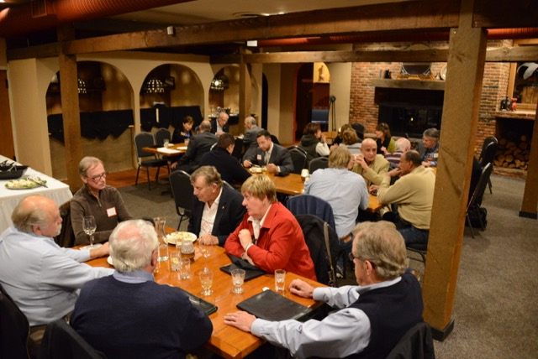To learn about the October 2016 Membership Workshops, click here.

Membership Materials On Sale: Order now!
To order, click here

PR Tips: ???

By Laura Spear
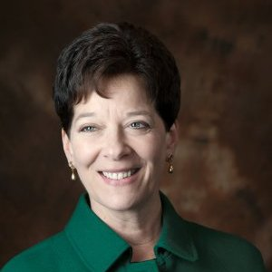

[[INSERT FIRST SENTENCE HERE]]
READ MORE
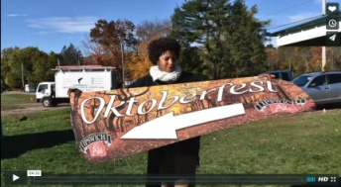

Click here for an excellent example of a club-event promotional video by Concord President Steve Kirk

RAAGNE Newsletter: Update on visioning process

By Klaus Hachfeld

Hello, members and friends of the Rotary Alumni Association of Greater New England! Here is to the latest edition of the RAAGNE newsletter! Over the past year, we went through a visioning process to work out the future direction of RAAGNE.

READ MORE

Speaker's Bureau: Looking for good speaker for your club?

By Steve Levitsky

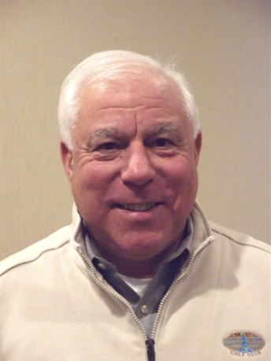

It's not always easy to come up with ideas week after week. We have many suggestions for you. Here are just a few:
- Rwandan genocide: Carine Boggis
- Elevator-pitch tips: Andy Winig
- Positive-results hypnosis: Bob Martel
- Differentiation and game-changing simplicity: Stephen Melanson
VIEW MORE

Interact Actions: How to launch an Interact club
By Bob Anthony
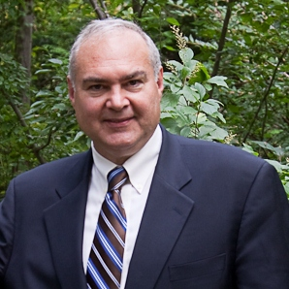

In Seminar 2 of the District Interact Teen and Advisor Training Seminar, held on September 17 in Needham, Bob Anthony, chair of the District Interact Committee, discusses “How to launch an Interact club,” including the certification letter, roles and responsibilities of the president, the Rotary advisor and, in the case of school-based clubs, the faculty advisor.

WATCH VIDEO

Treasurer's Report: Message about your dues

By Jack Hoell
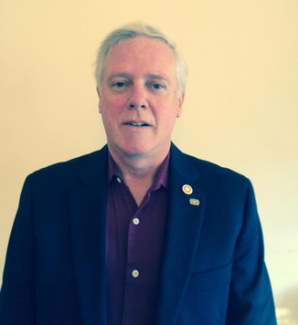

The Rotary International dues bills were e-mailed to the 51 clubs in our District on July 22 and the District dues bills were e-mailed to clubs on July 26.
READ MORE

District Charity Fund: How does DCF operate?

By Al Bowers
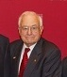

The District Charity Fund is a 501(c)3 charitable, non-profit that can be used by the Rotary clubs in District 7910.
READ MORE

Communications Link: Seeking club photo, video albums
By Steve Jones-D'Agostino
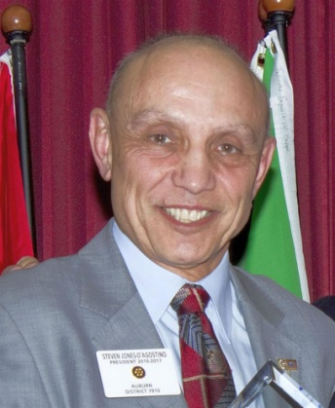

Does your District committee or Club have Rotary-related photo and/or video albums that you'd like to share with other Rotarians?
READ MORE

SUBMIT CONTENT

To submit content for consideration for the Monday, November 14 issue of Rotary District 7910 Newsletter, please e-mail it to Immediate Past District Governor and Newsletter Editor Jim Fusco at jim.fusco2@gmail.com.
The submission deadline for that issue is Friday, November 11. All text must be in Word format. All images must be in either JPEG or PDF format. Please identify the people, left to right, who are shown in your photos, including their first and last name as well as their club or other title.

PAST ISSUES
To view past issues of the weekly Rotary District 7910 Newsletter, click here

DISTRICT 7910 ONLINE

Visit our website
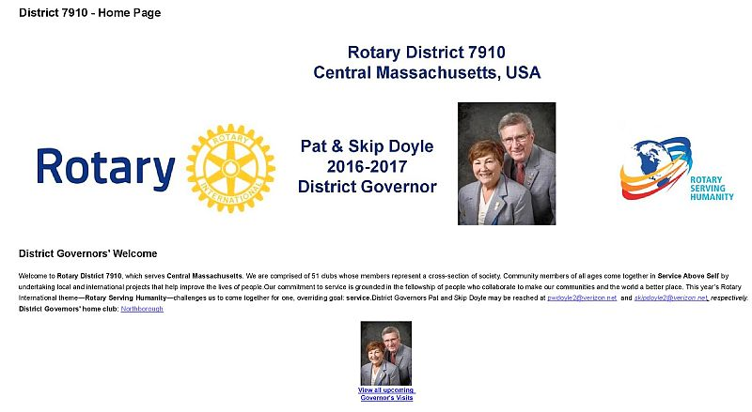

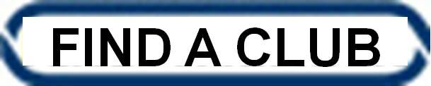

'Like' and share us on Facebook
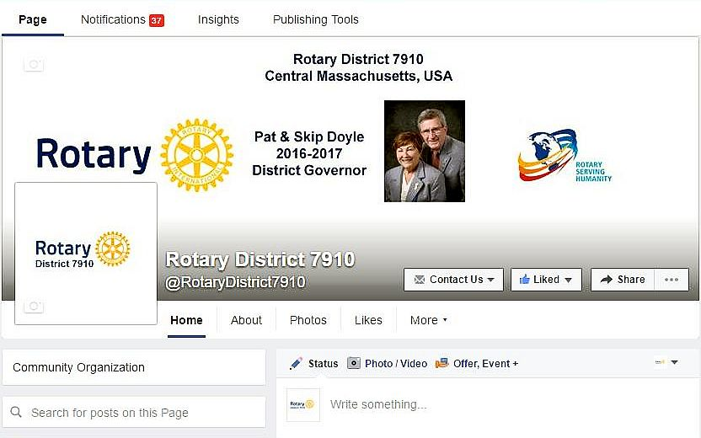

Watch our videos on YouTube
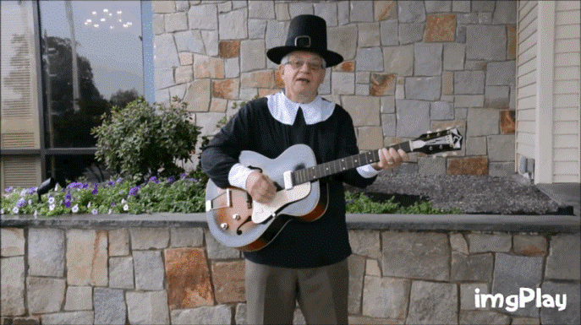

View our photos: on Google Photos, since May 2015; and onClubRunner, before May 2015
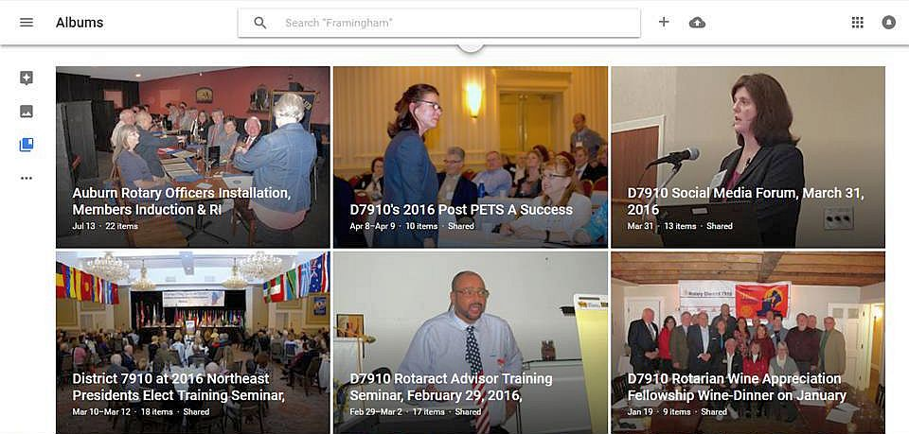

CONTACT US
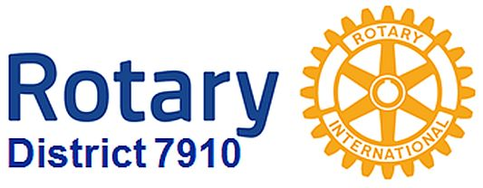

Jim Fusco, Immediate Past District Governor and Newsletter Editor
​jim.fusco2@gmail.com
Steve Jones-D'Agostino, District Webmaster and Newsletter Copyeditor
​srdagostino@icloud.com
© Copyright 2016-2017 - Rotary District 7910, Central Massachusetts, USA

