

Newton Wishes Us Happy Holidays
By Paul Sullivan

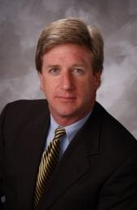Thanksgiving is a time to reflect on all that is good in our lives, to be grateful for our friends and family, and to serve people in need. This year, more than ever, the Rotary Club of Newton urges you to help others this Thanksgiving, and we've got a couple of ideas to assist.

For the past 38 years, Newton Rotary and the Rotary Club of Brookline have come together to host a pre-game Football Luncheon for the football teams of Newton North High School and Brookline High School. Our keynote speaker this year is the Honorable Setti Warren, mayor of Newton. There is a fee to attend the event, and net proceeds support local community-service organizations that do great work in both cities. We collect toiletries at the event for the Newton Food Pantry. If you would like to come by to donate toiletries, whether you attend the Football Luncheon or not, your gifts are greatly appreciated. The luncheon will be held tomorrow, November 22, at 12:00 noon at Brae Burn Country Club in Newton.

Once again this year, Newton Rotary is offering Holiday Raffle Tickets for only $10. We draw one ticket each day in January, for prizes from $100 to $500! Winning tickets go back into the barrel, so each ticket offers 31 chances to win one or more cash prizes! Only 1,000 tickets are sold, and they sell out fast! For purchase information, visit our website. Net proceeds will directly benefit community-service organizations in Newton.

Second Step is a great organization in Newton that has helped women and families recover from domestic violence since 1992. We are assisting Second Step with their annual toy drive to brighten the lives of lots of children this holiday season. For more information, visit our website.

As members of a community-service organization, Rotarians volunteer their time and energy all year to improve the lives of people in our own community and around the world. If you are looking for a way help improve people's lives - and have fun with some terrific people - come join us.

On behalf of the members, friends and supporters of Newton Rotary, we wish you and your family a Happy Thanksgiving and Wonderful Holiday Season!

To learn more about Newton Rotary, click here.

Paul Sullivan, president of the Rotary Club of Newton, may be reached at rotarynewtonma@gmail.com.

Return to November 21 Newsletter

View pa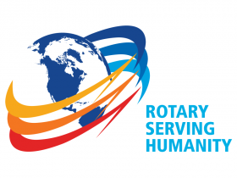st issues
Visit our website
'Like' our Facebook page
'Follow' our Twitter page

