By Karin Gaffney
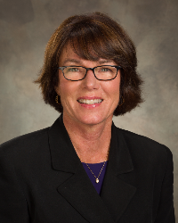
For more information on the 2017 RI Convention in Atlanta, click here.

???, president of ??? Rotary, may be reached at ???.

Next week, I'll have a testimonial from ??? of ??? Rotary.

District Governor-Elect Karin Gaffney may be reached at karin.gaffney@rocklandtrust.com.

Return to November 21 Newsletter

View past issues
Visit our website
'Like' our Facebook page
'Follow' our Twitter page

