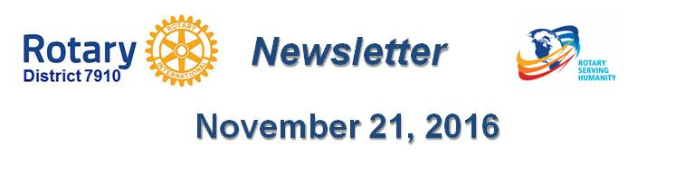

Progress in Our One Million Dollar Journey and Celebration
By Sanjay Deshpande

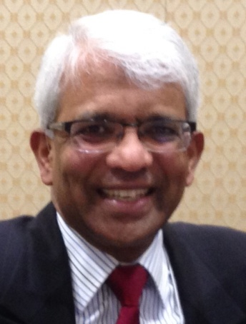
Satya Mitra, chair of our Million Dollar Journey and Celebration, has made progress in the drive to add $1 million to The Rotary Foundation Endowment Fund during Rotary 2016-2017, which ends next June 30, through major gifts and bequest pledges.

On November 17, a training session was held for four of the seven Ambassadors/Table Captains who will assist Satya in this drive. Participating in the training were Past District Governor Val Callahan of Worcester Rotary, President Bob Guernsey of Tyngsborough-Dunstable Rotary, Past President Steve Levitsky of Concord Rotary and Past President John Sbrogna of Montachusett Area Rotary. Other District officers who attended the training were Governor-Nominee-Designate Pam Anastasi, Assistant Governor Bharti Bhakta, Foundation Chair Sanjay Deshpande, District Governors Pat and Skip Doyle, Immediate Past District Governor Jim Fusco, Satya Mitra and Assistant Governor Peggie Thorsen.

The training was provided by Past District Governor Mac Leask of District 7980, who serves as the Zone 32 endowments/major gifts advisor. Also present during the training, was Knut Johnson, who will succeed Mac next July 1, when Mac takes on a different and bigger role in endowments and major gifts for The Rotary Foundation.

The training covered the different stages of securing the major gifts or bequest pledges over the next seven months and beyond. It was explained that the Rotary Foundation officers in charge of Endowments and Major gifts will help with the process, one-on-one with the identified prospects to the extent necessary.

We are off to a very good start and we need to continue the momentum and help Satya meet our district’s goal.

So, what is the Million Dollar Dinner Journey and Celebration Event?

This drive has been launched to create an opportunity for our members and friends to give to the TRF Endowment Fund a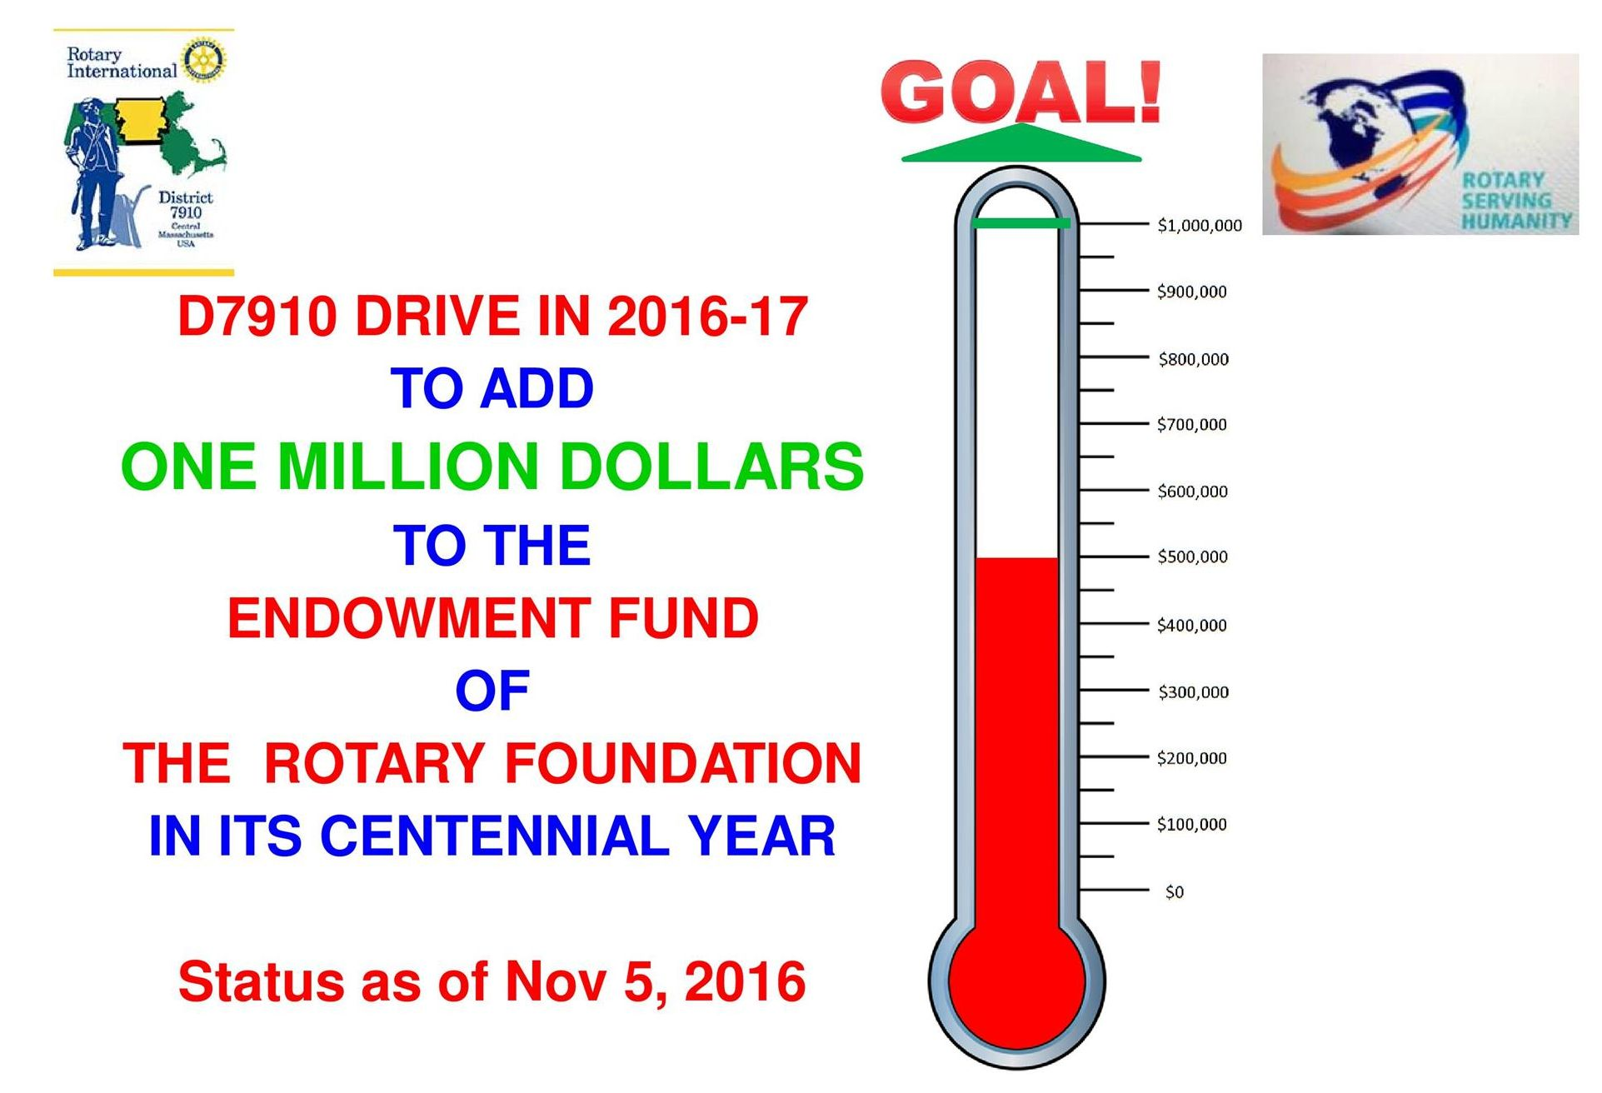 cumulative total of $1 million in the form of:

- An outright contribution - Major Gift - of at least $10,000 in cash or appreciated stock, or
- A bequest of at least $10,000 established through one’s will, or
- The designation of TRF as a beneficiary for at least $10,000 in either a life-insurance policy or a retirement account.
Our district’s goal is to accumulate contributions to the TRF Endowment Fund from these three forms of giving totaling $1 million between last July 1 and next April 30 so that the gala celebratory dinner can be held next May. Million Dollar Dinner events are generally attended by one or more Rotary dignitaries such as Rotary International president, an RI director or a TRF trustee. Our Dinner event is tentatively planned for sometime in May, depending on the availability of an appropriate Rotary dignitary. All Rotary members and friends who become a contributor to the Endowment Fund, achieve Major Donor status or become a Bequest Society member will participate in the Rotary Foundation Centenary and Million Dollar Goal Achievement Dinner event.

We are guided in our drive by the experience of other districts in the U.S. that have successfully completed the Million Dollar Journey. This drive will be led by 10 Ambassadors/Table Captains, each of whom is already a Major Donor or a Bequest Society Member and is trained to approach and convince other Rotarians and their friends to convince them to make a qualifying contribution in one of the three ways described above.

The following Rotarians have agreed to be Ambassadors/Table Captains for this exciting event (alphabetical, by last name):
- Victor Bhakta, Leominster
- Val Callahan, Worcester
- Robert Guernsey, Tyngsborough-Dunstable
- Steve Levitsky, Concord
- Arnie Miller, Brookline
- Tom Polito, Neponset Valley
- John Sbrogna, Montachusett Area
We are looking for three more Rotarians to serve as Ambassadors/Table Captains. If you are interested in this important role of strengthening the Rotary Foundation, please contact Satya Mitra immediately by e-mail at satya@thegurutax.com or by phone at 508-641-8441.

If you have any questions about the District Foundation Committee, contact either District Grants Subcommittee Chair Jorge Yarzebski at yj.rotary@gmail.com or me, District Foundation Committee Chair Sanjay Deshpande, sanjdesh51@aol.com.

For the Foundation Notes archive, click here

Learn more about District 7910 Foundation Grants:
- Rotary Areas of Focus Policy Statements (PDF Format)
- District 7910 Eligible and Ineligible Activities in a District Grant (Word Format)
- Timeline for District 7910 Foundation Grants (Web Page)
- District 7910 Grant Qualification Table (Excel Format)
- District 7910 Grant Proposals and Qualifications Status (Web Page)
- District 7910 2015-2016 Foundation Contributions Report - (Excel Format)
- Foundation Grants in 2016-'17 and Beyond (PDF Format)
- District 7910 2016-2017 District Grant Proposal Template (PDF Format)
- District Grant Proposal Form (Word Format)
- Global Grant Proposal Form (Word Format)
- District 7910 District Grants Scoring Rubric (PDF format)
- District 7910 Club Memorandum of Understanding (PDF Format)
Return to November 21 Newsletter

View pa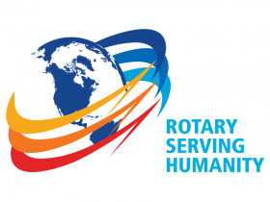st issues
Visit our website
'Like' our Facebook page
'Follow' our Twitter page

