Framingham’s Quilt Auction Supports service-dog Initiative
By Liz Kaprielian
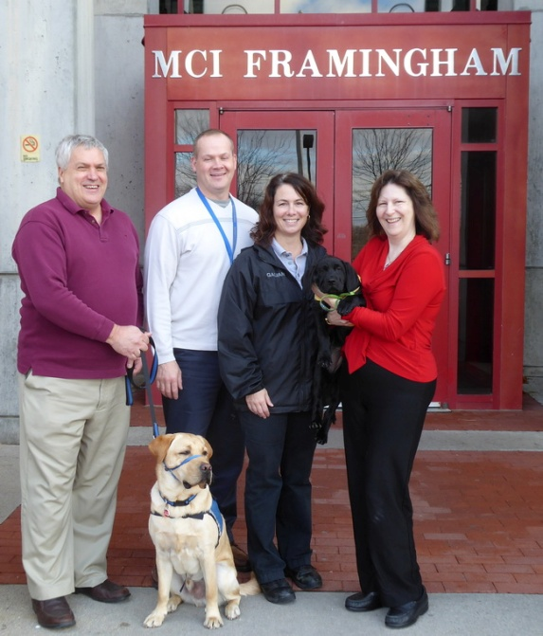
The 45th annual Online Auction fundraiser by the Rotary Club of Framingham, which went live on November 15, includes a very special item. The Delightful Dogs lap quilt, Item No. 124, is a fun and colorful dog-themed quilt. Scattered throughout the quilt are various dogs with fun messages.

The quilt was created as a special auction item to support Framingham Rotary’s Service Dog Initiative. The club is sponsoring puppy Harris and his service-dog training through NEADS (National Education for Assistance Dog Services, also known as Dogs for Deaf and Disabled Americans) and its Prison Pup Partnership at MCI-Framingham.

Shown, left to right, in 2015 are: Peter Harvell, director of veterans services and benefits for the Town of Framingham; Paul Henderson, prison superintendent of MCI Framingham; Laura Galvani, prison programs director of MCI Framingham; and Liz Kaprielian, a director of Framingham Rotary, holding a Prison Pup. Another Prison Pup is shown, sitting.

The quilt (shown, right) measures 48 inches wide by 72 inches tall and is machine-washable. 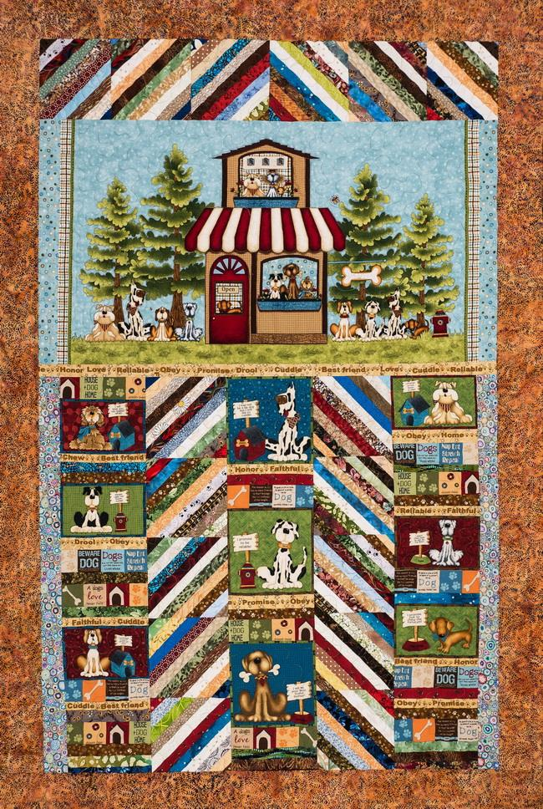Shipping is free to the winning bidder within the continental U.S. To visit Framingham Rotary’s Online Auction, which runs through December 9, click here.

The high bid for the quilt will be used by Framingham Rotary to purchase much-needed dog supplies such as chewing bones, bowls, brushes, and bait bags for MCI-Framingham’s Puppy Prison program.

More than 90 percent of NEADS’ puppies (shown, below) are trained in nine correctional facilities throughout New England, including 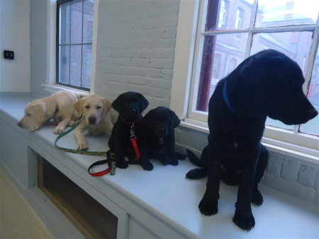MCI-Framingham. Statistics show that, under the guidance of NEADS staff, inmates are able to provide consistent training at a high level simply because of the amount of time they are able to devote to the dogs. At any given time, there are up to 20 service dogs in training at MCI-Framingham, including puppy Harris. It takes a lot of Kibbles 'n Bits to keep all that going!

Framingham Rotary is also donating an additional $200 to further support the purchase of dog supplies for MCI-Framingham.

To view photos and updates about puppy Harris and his training, visit Framingham Rotary’s website or its Facebook page.

To watch a three-minute video about Framingham Rotary’s Service Dog Project, click here.

To learn more about Framingham Rotary, click here.

Liz Kaprielian, a director of the Rotary Club of Framingham, may be reached at lkaprielian@verizon.net.

Return to November 21 Newsletter

View past issues
Visit our website
'Like' our Facebook page
'Follow' our Twitter

