happy thanksgiving to all!
By Pat and Skip Doyle
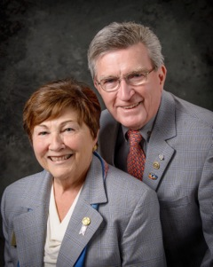
It was another week of daily Rotary events, varied and eventful.

Last Sunday, November 13 saw the Executive Board meet for the first time as a complete group. The district governors, governor-elect, governor-nominee and governor-designate are charged with the duty of moving the district forward - and we are on the way.

Last Monday, the Nominating Committee met again to choose two trustees for the next three years. Chosen were John Tata of the Rotary Club of Fitchburg and Paul Dumouchel of the Rotary Club of Needham. In the near future, the Nominating Committee will meet again to choose a trustee replacement for Pam Anastasi and two trustees for the District Charity Fund.

Last Tuesday, we visited officially the Rotary Club of Uxbridge. This was our 51st and last official visit. What a great club this is with which to end our official visits. They have added many new and active members and they are fully involved in community activities. We wish them and all the clubs in our district the best in the future.

The rest of the week was filled with a Conference Committee meeting, a Public Relations Committee meeting, and a Million Dollar Journey event. Last Thursday, we had the honor of inducting three new young members to the Rotary Club of Groton-Pepperell. We also presented the club with two Rotary International Membership Awards for the 2015-2016 Rotary year: one, for membership growth ;and one, for membership retention.

Meanwhile, Jim Fusco, our immediate past district governor, has been busy visiting clubs to present them with Rotary International Foundation Awards earned during the '15-'16 year. We ended the week with the exciting Turkey Shoot put on by the Rotary Club of Marlborough and the Breakfast with the Bands hosted by the Rotary Club of Fitchburg.

It is our wish that you and your families have a very happy Thanksgiving. Enjoy the day.

Thank You! Thank You!! Thank You!!!

Our District Food Packaging Event on November 12 at the Solomon Pond Mall in Marlborough was a solid success.

More than 100 volunteers from around the district packaged 20,000 meals, which will be sent to Haiti to help feed the children left homeless by the hurricane. These volunteers were Rotarians and their friends and families, young and old There were Interactors from local clubs, passersby who wanted to help and past and present participants of Rotary Youth Leadership Awards. We raised more than $4,000 toward our goal of $5,000 - so we are still actively seeking donations.
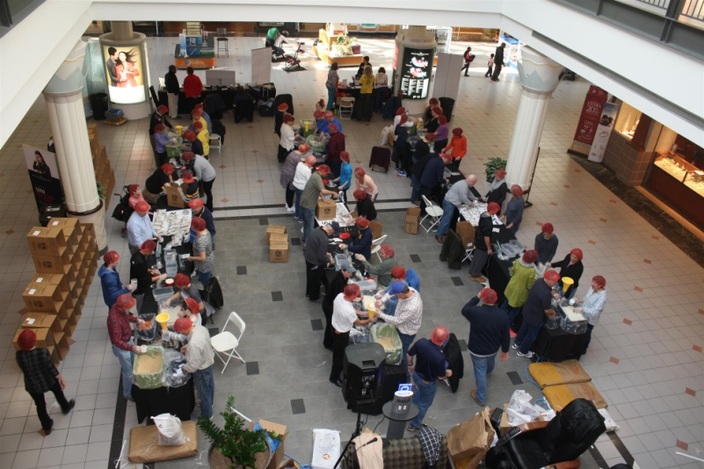
VIEW PHOTOS

It is hard to pick out a highlight from the event, there were so many. One is perhaps the numbers of people with whom we were able to talk about what Rotary is - the reality of Rotary, not the perception. This event puts us a little further toward our goal of making Rotary more visible and more real in our district. Thank you also to the Solomon Pond Mall for allowing us to utilize their space for this event.

Always remember, you can call us with questions at 508-393-9031.

District Governors Pat and Skip Doyle may be reached at pwdoyle2@verizon.net and skipdoyle2@verizon.net,
respectively.

Click here to submit content for the November 28 issue. The submission deadline for this issue is Friday, November 25.

Click here for past issues.

Return to November 21 Newsletter

Visit our website
'Like' our Facebook page
'Follow us on Twitter

