GOVERNOR'S MESSAGE

HAPPY THANKSGIVING TO ALL!
By Pat and Skip Doyle

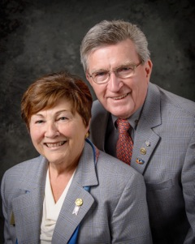
It was another week of daily Rotary events, varied and eventful.

Last Sunday, November 13 saw the Executive Board meet for the first time as a complete group. The district governors, governor-elect, governor-nominee and governor-designate are charged with the duty of moving the district forward - and we are on the way.

Last Monday, the Nominating Committee met again to choose two trustees for the next three years. Chosen were John Tata of the Rotary Club of Fitchburg and Paul Dumouchel of the Rotary Club of Needham. In the near future, the Nominating Committee will meet again to choose a trustee replacement for Pam Anastasi and two trustees for the District Charity Fund.

Last Tuesday, we visited officially the Rotary Club of Uxbridge. This was our 51st and last official visit. What a great club this is with which to end our official visits. They have added many new and active members and they are fully involved in community activities. We wish them and all the clubs in our district the best in the future.

The rest of the week was filled with a Conference Committee meeting, a Public Relations Committee meeting, and a Million Dollar Journey event. Last Thursday, we had the honor of inducting three new young members to the Rotary Club of Groton-Pepperell. We also presented the club with two Rotary International Membership Awards for the 2015-2016 Rotary year: one, for membership growth ;and one, for membership retention.

Meanwhile, Jim Fusco, our immediate past district governor, has been busy visiting clubs to present them with Rotary International Foundation Awards earned during the '15-'16 year. We ended the week with the exciting Turkey Shoot put on by the Rotary Club of Marlboroughand the Breakfast with the Bands hosted by the Rotary Club of Fitchburg.

It is our wish that you and your families have a very happy Thanksgiving. Enjoy the day.

Thank You! Thank You!! Thank You!!!

Our District Food Packaging Event on November 12 at the Solomon Pond Mall in Marlborough was a solid success.

More than 100 volunteers from around the district packaged 20,000 meals, which will be sent to Haiti to help feed the children left homeless by the hurricane. These volunteers were Rotarians and their friends and families, young and old There were Interactors from local clubs, passersby who wanted to help and past and present participants of Rotary Youth Leadership Awards. We raised more than $4,000 toward our goal of $5,000 - so we are still actively seeking donations.

VIEW PHOTOS

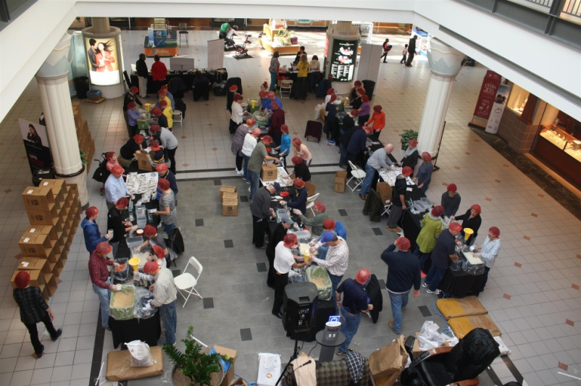
It is hard to pick out a highlight from the event, there were so many. One is perhaps the numbers of people with whom we were able to talk about what Rotary is - the reality of Rotary, not the perception. This event puts us a little further toward our goal of making Rotary more visible and more real in our district. Thank you also to the Solomon Pond Mall for allowing us to utilize their space for this event.

Always remember, you can call us with questions at 508-393-9031.

District Governors Pat and Skip Doyle may be reached at pwdoyle2@verizon.net and skipdoyle2@verizon.net,
respectively.

Click here to submit content for the November 28 issue. The submission deadline for this issue is November 25.

Click here for past issues.

WELCOME, NEW ROTARIANS
Alphabetical order, by last name
- Howard Kendall, Nashoba Valley
- Jan Luchetti, Weston-Wayland
- Mac Spencer, Weston-Wayland

REMEMBERING OUR ROTARIANS

Rocci Elia, Clinton

READ MORE

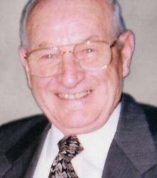

Hot Off the Press! 2016-2017 District Directory

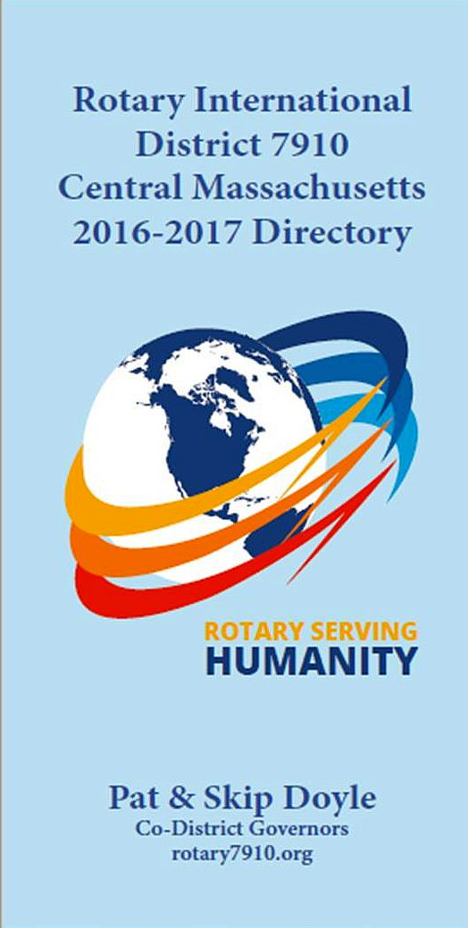

Print copies of our information-packed, 332-page Directoryfor this Rotary year will soon be delivered to your club.

A digital copy is now available for automatic download, in PDF format.

Please note: Member login is required.

Click here, to download

OUR PRESIDENTS SPEAK
Dan Cunningham of Fitchburg Rotary

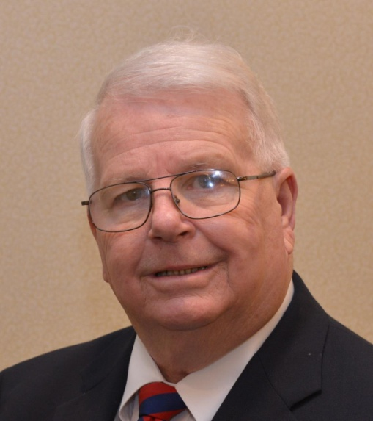

Please tell us what factors helped you decide to join Rotary.

My desire to serve!

READ MORE

DG VISITS LAST WEEK

Uxbridge (chartered 1926)

Left to right: District Governor Pat Doyle; President Linn Doll-Butler; Assistant Governor John Sbrogna; and District Governor Skip Doyle.

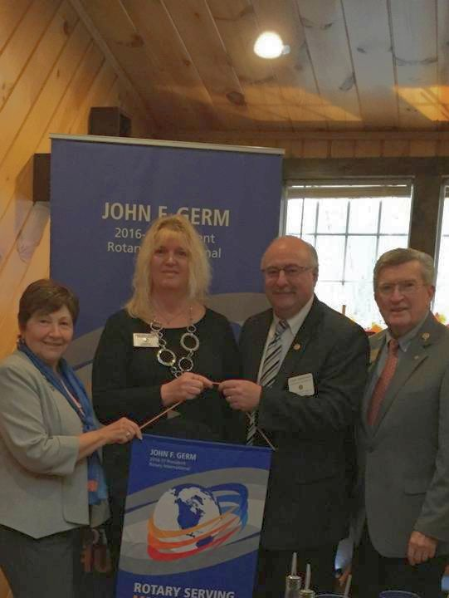

CLUB MEMBERSHIP GROWTH, ’16-‘17

We share with you the results of club-membership growth in our district during Rotary year 2016-2017, which began July 1.

This is a unique opportunity for Rotarians and friends to discuss partnering on humanitarian projects affecting our local communities.

READ MORE

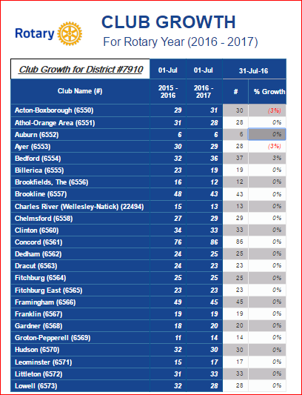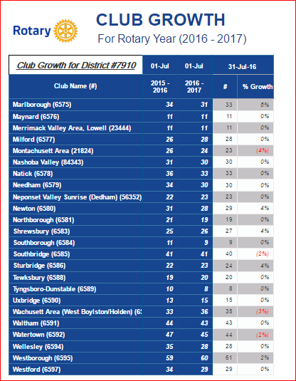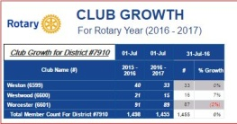

CLUB PLANNING WORKSHEET '16-'17
In both Excel and PDF formats, we share with you the Club Planning Worksheet for Rotary year 2016-2017, which began on July 1.
Please enter your club information in the indicated cells.

Excel Format

PDF Format

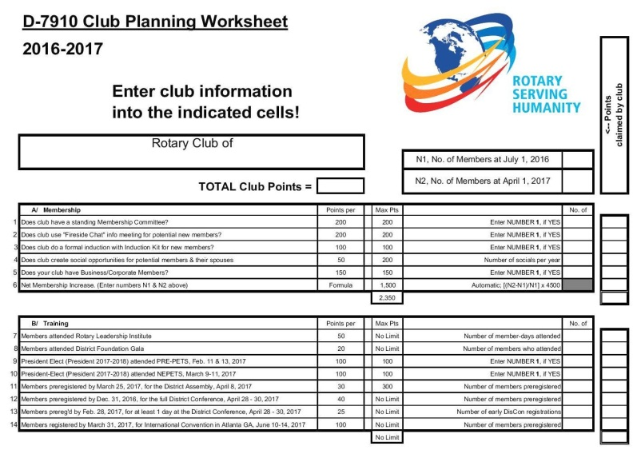

DISTRICT & CLUB ROUNDS

Acton-Boxborough's Veterans Day Breakfast 'Simply Fantastic'

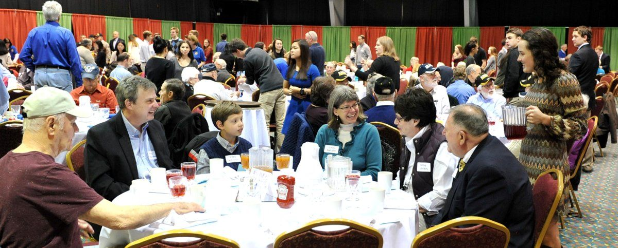

The Rotary Club of Acton-Boxborough held its 2016 Veterans Day Breakfast on November 11 at Acton-Boxborough Regional High School in Acton. The school's Honor Society members who attended the event provided exemplary service and entertainment to the veterans and their family members. Acton-Boxborough Rotarian Frank Sibley, who took this and other event photos, calls the turnout "simply fantastic."

VIEW PHOTOS

To learn more about Acton-Boxborough Rotary, click here.

Auburn's Pancake Breakfast Raises $3,500 for Local High School Scholarships

The Rotary Club of Auburn's annual "Flips for Scholars" Pancake Breakfast on October 23 at Auburn High School raised a net total of $3,500 for scholarships to be awarded to local high school graduates. Over the course of more than 50 years, Auburn Rotary has raised in excess of $420,000 for such scholarships.
Club scholarships awarded at the end of the 2015-2016 school year will be presented on Wednesday, December 21 during a Dinner Ceremony with the four recipients and their parents, which will be held starting at 5:30 p.m. at Chuck’s Steak House, located at 10 Prospect St. (immediately off Route 20) in Auburn.

The recipients are as follows (alphabetical, by last name):
- Thomas Anderson, an Auburn High School graduate who attends Worcester State University
- Abigail Lucas, an Auburn High graduate who attends the University of Connecticut
- Zachary Martins, a Bay Path Regional Vocational Technical High School graduate who attends the University of Northwestern Ohio
- Zachary Randall, an Auburn High graduate who attends the University of Maine
To learn more about Auburn Rotary, click here.

Chelmsford Honors Students of Month for November

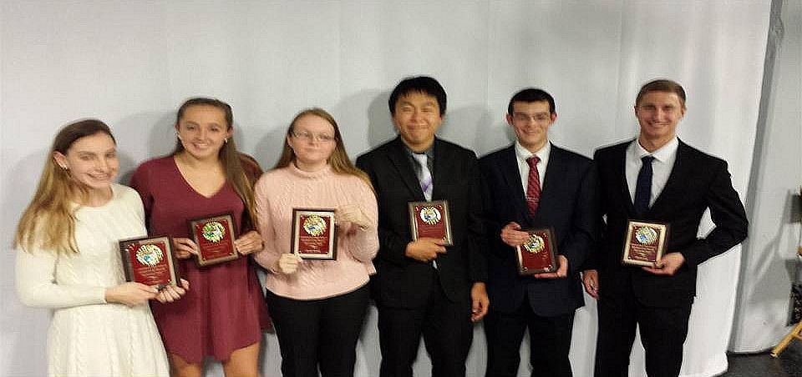

Each month of the school year, Chelmsford High Schooladministrators choose two seniors from each of the school's three houses to be honored by the Rotary Club of Chelmsford for having been significant contributors to their school and community. First, the honorees speak at a club meeting. Then, they are interviewed on "Lions Pride,"
a local cable television show. This month, the honorees are, left to right: Riley Higgins, of Emerson House; Sophia Haywood, of Hawthorne House; Sarah Benda, of Whittier House; Jason Shin, of Whittier House, Eric Miu, of Emerson House; and David Cote, Hawthorne House.

To learn more about Chelmsford Rotary, click here.

Concord’s Bristol Lodge Soup Kitchen Serves Thanksgiving Dinner to Needy

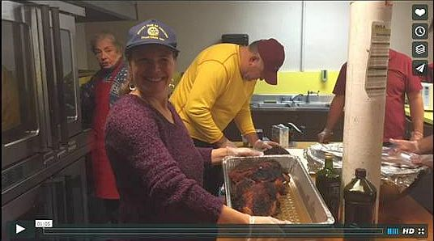

On November 8, the Rotary Club of Concord purchased and prepared a traditional Thanksgiving meal for more than 100 clients at the Bristol Lodge Soup Kitchen. Bristol Lodge has been serving hot, nutritious meals to those in need for the last three decades. Every evening, dedicated volunteers from throughout the Metro Boston area gather to prepare and serve food to up to 100 community members without access to affordable, healthy food.
While volunteer groups range in size and frequency of service, those giving back at the Bristol Lodge Soup Kitchen perform site setup and cleanup and a variety of other tasks to maintain the Soup Kitchen’s cleanliness, organization and overall condition. Soup Kitchen employees oversee the facility each afternoon and evening, ensuring that participants are served nutritious meals in a clean and welcoming environment.
In addition to an ongoing partnership with the Greater Boston Food Bank, the Bristol Lodge Soup Kitchen relies on food donations from volunteer groups and community partners. Donations include a variety of proteins, vegetables, fruits, grains and dairy. With tens of thousands of meals served annually, the Soup Kitchen continues to be a critical resource for individuals and families in Waltham and beyond.

WATCH ONE-MINUTE VIDEO (produced by Steve Kirk, president of Concord Rotary)

To learn more about Concord Rotary, click here.

Fitchburg, Leominster Team Up for 22nd Time for Breakfast for the Bands

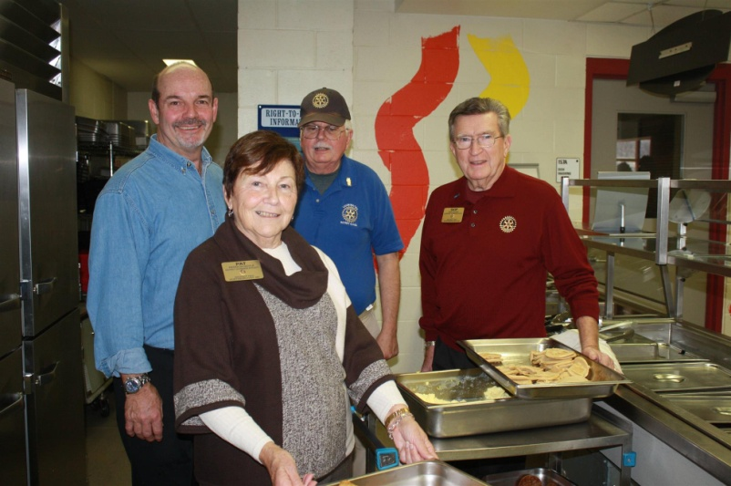

For 22 years, the Rotary Clubs of Fitchburg and Leominster have joined together to sponsor Breakfast for the Bands. Proceeds raised at this event are given to the Fitchburg High and Leominster High school band programs. The bands from both high schools entertained the attendees while members of the schools' football teams help to serve the meals. This Thursday, the two teams will meet again for their 111th time on Thanksgiving Day and their 133d time overall. Leominster holds a five-game lead in this rivalry.

Left to right: Fitchburg Rotary event Chair Paul Gauvin; District Governor Pat Doyle; Leominster Rotary event Chair John Tata; and District Governor Skip Doyle.
READ SENTINEL & ENTERPRISE ARTICLE, WATCH 49- AND 23-SECOND VIDEOS
To learn more about Fitchburg Rotary, click here.

To learn more about Leominster Rotary, click here.

Framingham’s Quilt Auction Supports Service-Dog Initiative

By Liz Kaprielian
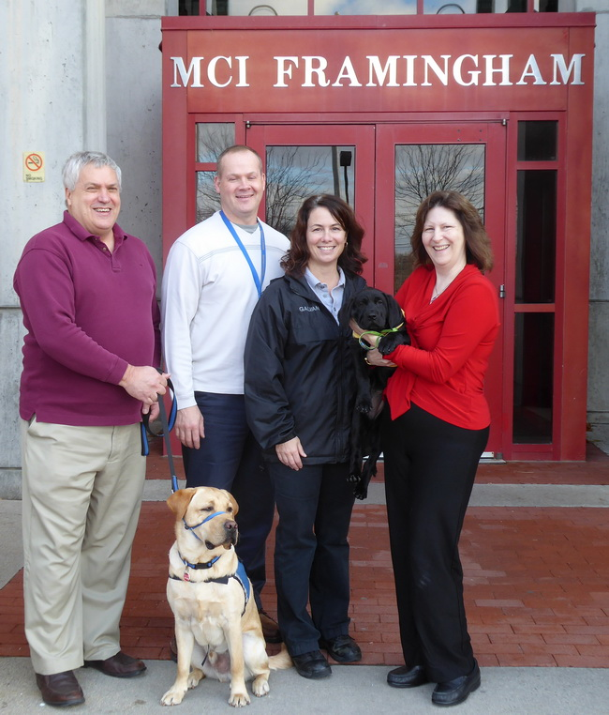

The 45th annual Online Auction fundraiser by the Rotary Club of Framingham, which went live on November 15, includes a very special item. The Delightful Dogs lap quilt, Item No. 124, is a fun and colorful dog-themed quilt. Scattered throughout the quilt are various dogs with fun messages.

The quilt was created as a special auction item to support Framingham Rotary’s Service Dog Initiative. The club is sponsoring puppy Harris and his service-dog trainingthrough NEADS (National Education for Assistance Dog Services, also known as Dogs for Deaf and Disabled Americans) and its Prison Pup Partnership at MCI-Framingham.

Shown, left to right, in 2015 are: Peter Harvell, director of veterans services and benefits for the Town of Framingham; Paul Henderson, prison superintendent of MCI Framingham; Laura Galvani, prison programs director of MCI Framingham; and Liz Kaprielian, a director of Framingham Rotary, holding a Prison Pup. Another Prison Pup is shown, sitting.

READ MORE

To watch a three-minute video about Framingham Rotary’s Service Dog Project, click here.

To learn more about Framingham Rotary, click here.

Groton-Pepperell Inducts Four Members
Left to right: New members Steve Jannes, Matt Evans and Cathy Crowley; President Duncan France; and District Governors Pat and Skip Doyle.

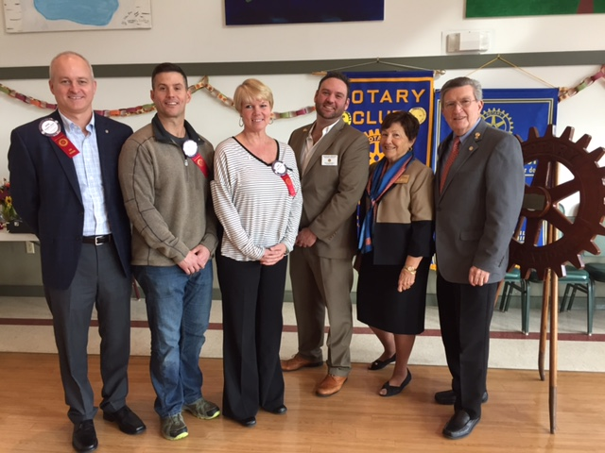

To learn more about Groton-Pepperell Rotary, click here.

Marlborough's Turkey Shoot a Huge Success

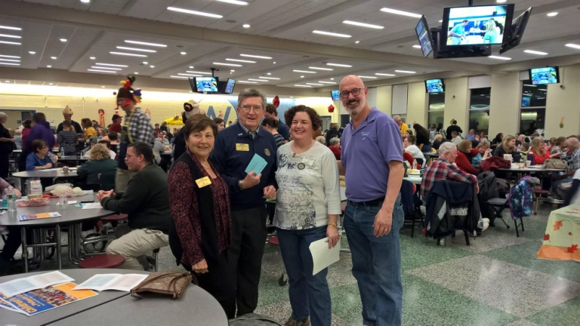

The Rotary Club of Marlborough held its 34rd Annual Turkey Shoot on November 19 at Assabet Valley Regional Technical High School in Marlborough. Through the money raised at the Turkey Shoot, the club can make a special holiday season for deserving children, teens, seniors, and families.

Left to right: District Governors Pat and Skip Doyle pose with President Peggy Shelton and Member Nick Kofosduring the Turkey Shoot. Peggy and Nick co-chaired the event.

To learn more about Marlborough Rotary, click here.

Milford Distributes '16 Tab to 13,000 Homes - Record sales, 94 photos, 334 smiling faces

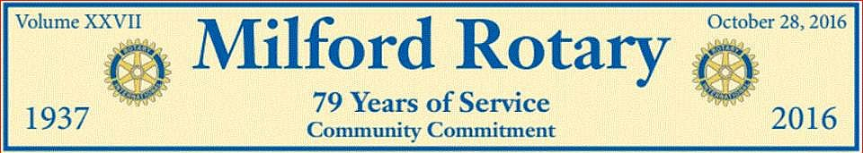

To read the Milford RotaryTab, click here.

Here’s an example of the content in the 2016 issue of Milford Rotary Tab:

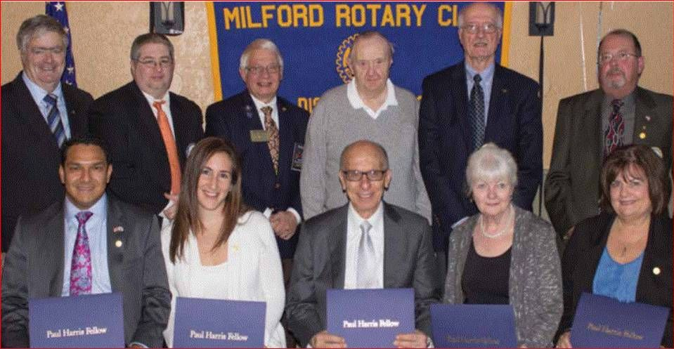

2015 Paul Harris Award Recipients

Front row, left to right: Allan and Lauren Villatoro; Frank Saba, since-retired CEO of Milford Regional Medical Center; Mary Ann Mastroianni; and Susan McWade Surapine.

Back row, left to right: Thomas C. Sawyer, Foundation chair; Michael DiCicco; Jim Fusco, then-district governor; Russ Dennett; Ralph Mastroianni; and Paul Surapine.

To learn more about Milford Rotary, click here.

Nashoba Valley's Breakfast Honors Veterans

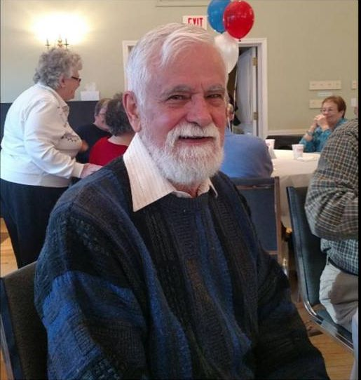

Veterans discussed the recent election and what they planned to do for the rest of the day over pancakes and eggs, at a Veterans Day breakfast at the First Parish Church of Stow and Acton, sponsored by the Rotary Club of Nashoba Valley.
Some reflected about their service.
Robert “Bob” Walrath (shown), 78, was in the 9th Regiment Marine Corps during the Cold War. As he sipped coffee, he spoke of his time in the service.
Photo: Jacquelyn Jarnagin, The Beacon-Villager
READ MORE
To learn more about Nashoba Valley Rotary, click here.

Newton Wishes Us Happy Holidays

By Paul Sullivan

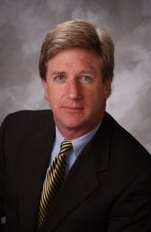

Thanksgiving is a time to reflect on all that is good in our lives, to be grateful for our friends and family, and to serve people in need. This year, more than ever, the Rotary Club of Newton urges you to help others this Thanksgiving, and we've got a couple of ideas to assist.

READ MORE

To learn more about Newton Rotary, click here.

Wachusett Area Rotary, Chamber to Host Economic-Development Breakfast

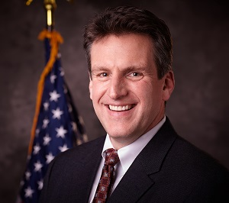

The Rotary Club of Wachusett and the Wachusett Area Chamber of Commerce will co-host an Economic Development Breakfast on Friday, December 2 from 7:30 to 9:00 a.m. at the Manor Banquet Facilities, located at 42 West Boylston St. in West Boylston. The guest speakerwill be Jay Ash (shown), secretary of Housing and Economic Development for the Commonwealth of Massachusetts. The cost is $20 per person. The event is open to the public.

Guests will have an opportunity to hear the latest economic-development news from around the Commonwealth and learn what it means for the Wachusett area. Time will be allotted for questions and discussion. To register, either visit the Chamber’s website or e-mail the Chamber at info@wachusettareachamber.org.

To learn more about Wachusett Area Rotary, click here.

Westborough Salutes Its Club’s War Veterans

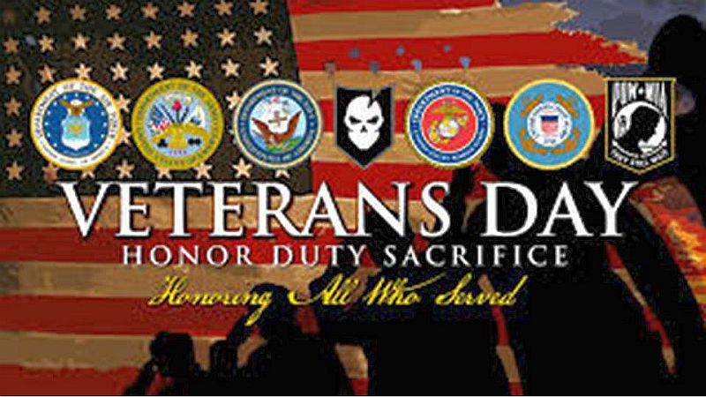

Shortly after the bell rang for the November 9 meeting of the Rotary Club of Westborough, President Gerry Gross took a moment to recognize and thank the club’s war veterans. Westborough Rotary is thankful to be among an honorable group of courageous men who have served our country over the years:
- Paul Gallagher: Army, Infantry, Korea
- Jim O’Connor: Army, New York National Guard, Captain
- Paul Reilly: Army, Captain, Desert Storm
- Jim Tepper: Marines, Colonel, Helicopter pilot, Vietnam
Thank you to these men and all men and women who have served to defend and protect the liberties we enjoy today!

To learn more about Westborough Rotary, click here.

Chelmsford's Comedy Show A Howling Success

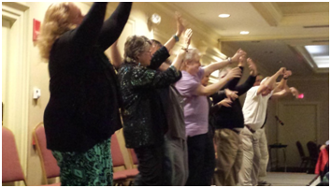

The Rotary Club of Chelmsford's Comedy Show on November 5 at the Radisson Hotel in Chelmsford was both a financial success and a fun-filled evening. Those attending enjoyed snacks and drinks as they viewed a variety of raffle baskets before the show.

Comedian David DiLorenzo opened the show and kept the audience laughing for a half-hour. Then, hypnotist Tommy Vee took over. For about an hour and a half, he hypnotized 20 volunteers and had them keep the audience thoroughly enjoying themselves.

The evening concluded with the basket winners being drawn. The Lowell Five,Enterprise Bank and Village Electric were among sponsors who supported the event.

To learn more about Chelmsford Rotary, click here.

Chelmsford Serves 54 Lunches to Seniors

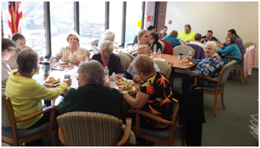

The Rotary Club Chelmsford has provided for and served lunches to senior citizens at two Chelmsford Housing Authority sites during the past three weeks. On October 24, they fed more than 30 seniors at Chelmsford Arms and on November 7, they fed another 24 at McFarlin Manor. Chelmsford Rotary plans to continue this program after the holidays.

To learn more about Chelmsford Rotary, click here.

Chelmsford Serves Coffee, Donuts at Veterans Park

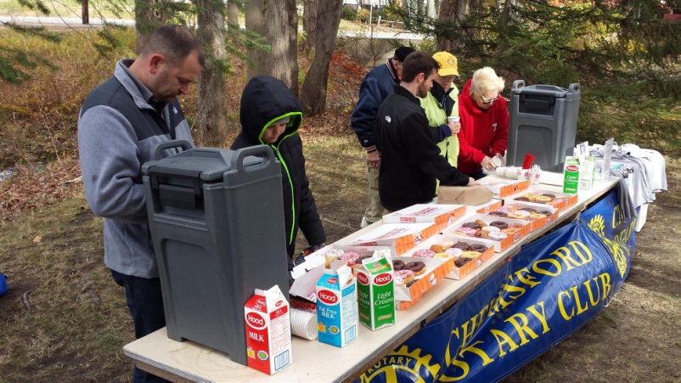

The Rotary Club of Chelmsford served coffee and donuts on November 7 during the Veterans Day ceremonies at Veterans Park in Chelmsford. The club has provided this service for a number of years and those in attendance particularly appreciate the hot coffee on what is often a cool and windy day. The local Dunkin' Donuts donated coffee and donuts as it has done for a number of years.
To learn more about Chelmsford Rotary, click here

Framingham's Pancake Breakfast A Huge Success

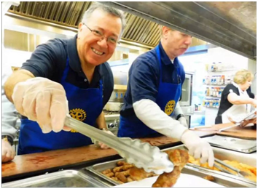

The Rotary Club of Framingham held its fifth annual Pancake Breakfast on November 5 at Joseph P. Keefe Regional Technical School in Framingham. Proceeds from this event will help to purchase air-conditioning units for elderly people living in public housing in Framingham.

WATCH TWO-MINUTE VIDEO

To learn more about Framingham Rotary, click here.

Wellesley Sixth-Graders Students Learn of Rotary Four-Way Test, Interact Global Grant Project

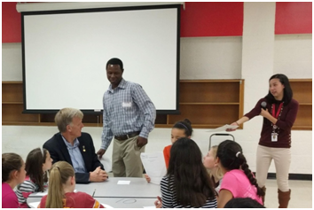

About 80 students from the Wellesley Middle School used a lesson plan developed by English teacher Claire Lee (standing, right) to exercise the iconic Rotary tool for decision-making. The Grade 6 students were invited to list good and bad decisions they remembered and weigh them using the Rotary Four-Way Test. They were also invited to participate in a writing contest expanding on the same topic. John Adams(seated, left), Cynthia Sibold and Bob Anthony represented the Rotary Club of Wellesley in offering the writers judged to be the top three prizes valued at $400.

To view the Rotary Four-Way Test Worksheet, click here.

To read the history of the Four-Way Test, click here.

READ MORE

To learn more about Wellesley Rotary, click here

District's Membership Workshops a Huge Success
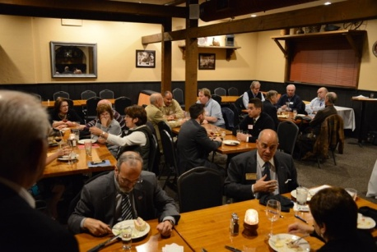
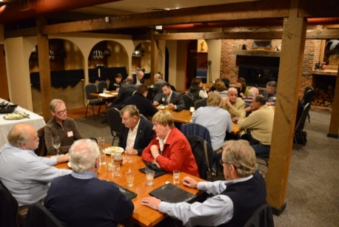

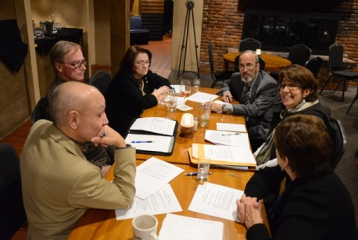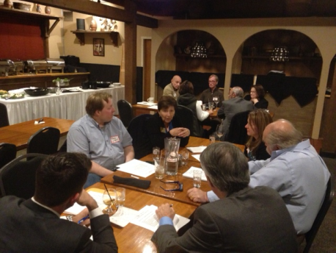

District 7910 conducted a total of four regional Membership Workshops on October 24, 25 and 26. The workshops were a response to many requests for meeting locations nearer club bases and more interactive discussions rather than a forum-speech format. The workshops were well-attended and the discussions were wide-ranging and very interesting. The comments are being summarized and will be distributed to all participants.
Shown: The Membership Workshop on October 25 at Chuck's Steak House in Auburn, which was attended by members of the Auburn, Brookfields, Marlborough, Northborough, Shrewsbury, Southborough, Southbridge, Sturbridge, Uxbridge, Westborough and Worcester clubs.

READ MORE

To learn more about District 7910, click here.

On to Atlanta in 2017: Early-Registration Discount Ends December 15

Planning to attend? Contact District Chair Steve Glines.

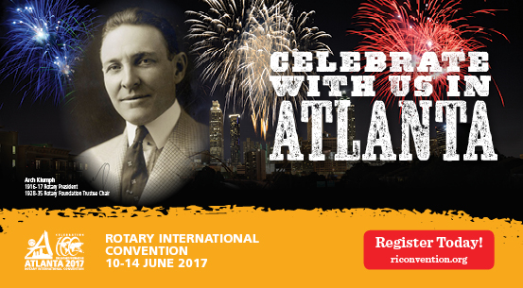

More than 43,000 attendees left the Rotary International Convention in South Korea inspired to end polio for good, to celebrate The Rotary Foundation's centennial, and to champion changes that will help Rotary appeal to a broader audience. On the last day, RI President K.R. “Ravi” Ravindran shared a personal story of his mother’s triumph over polio.

To read the story, click here.

To register for the 2017 RI Convention in Atlanta, click here.

Pat and Skip Doyle Installed as '16-'17 DGs

District 7910's 2016 Rotary Youth Leadership Awards were held on June 24 through 26 at Fitchburg State University, ending with the installation of longtime RYLA supporters Pat and Skip Doyle as District Governors for 2016-2017. The three-day RYLA event was attended by 188 sophomores. To learn more about RYLA, visit ryla7910.org.

To watch a video of the installation, click here.

District Banners Available

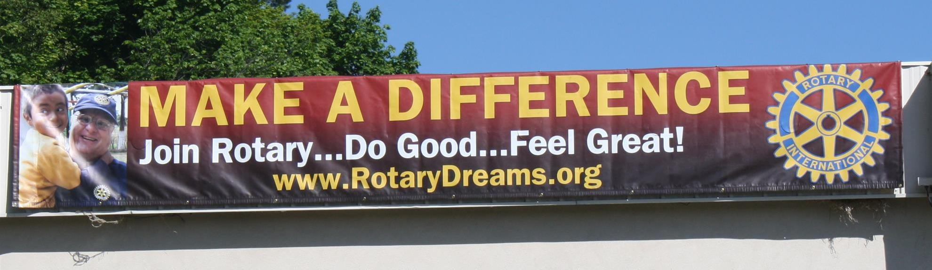

Our district banners are available for your to use when you have an upcoming event or fundraiser.

If you want to reserve one of the banners, please contact PR Chair Laura Spear at laura@spear.net.

MAJOR DISTRICT & CLUB HAPPENINGS: FALL 2016

Thursday, November 24: Needham - 'Thanksgiving Dinner'

To learn more, click here.

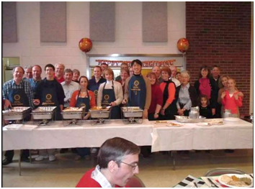

Thursday, November 24: Westborough - 'Thanksgiving Dinner'

To learn more, click here.

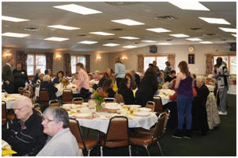

Sunday, November 27 - Westborough - 'Festival of Lights'

To learn more, click here.

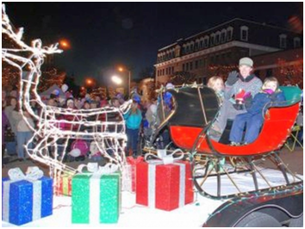

Monday, December 5: Sturbridge Rotary - 'Lottery Ticket Raffle'

To download the event flyer, click here.

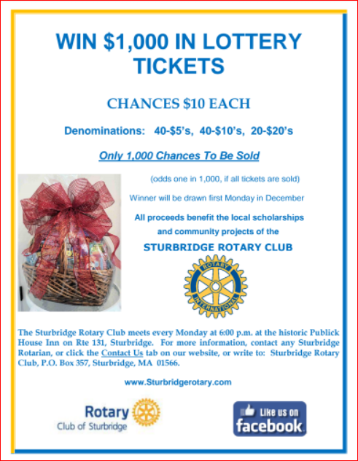

Through Wednesday, December 7: Framingham - 'Click & Bid 2016 Online Auction'

All proceeds benefit Framingham Rotary's community-service efforts.

To learn more and to bid, click here.

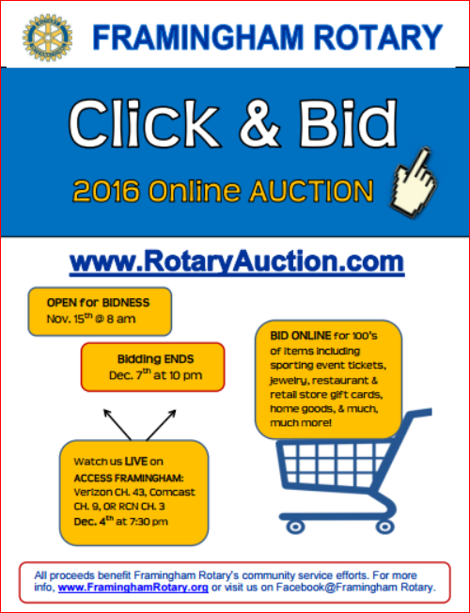

Wednesday, December 7: Rotary Means Business - 'Networking Fellowship for Rotarians and Friends'

To download the event flyer, click here.
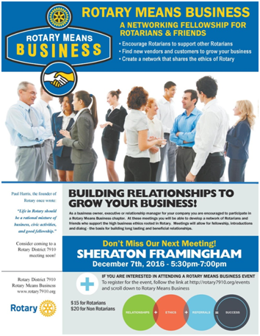

SUBMIT MAJOR CLUB HAPPENINGS

Send flyers of your club's major events and activities, in either JPEG or PDF format, to Immediate Past District
Governor/Newsletter Editor Jim Fusco at jim.fusco2@gmail.com.

