???
By Carl Good III

To watch the video of World Polio Day in Atlanta, click here.

Virtual-reality films bring a new dimension to polio fight

At this year’s World Polio Day celebration in Atlanta, Rotary harnessed the power of virtual-reality technology to build empathy and inspire action in our fight to eradicate polio.

Learn more about the films, click here.

If you are had an event for World Polio Day (or Week), please send me a brief description. We are keeping track of the events.

READ MORE

Thank you for all you do to erase this terrible disease from the face of the Earth.

October was an important month for both The Rotary Foundation and Polio Plus.

READ MORE

For more information on this important month, click here.

Carl Good III, chair of the District Polio Committee, may be reached at carlgood@yahoo.com.

Return to November 21 Newsletter

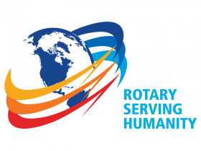
View past issues
Visit our website
'Like' our Facebook page
'Follow' our Twitter page

