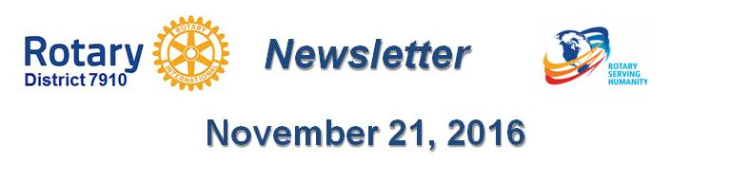

Monitor the news
By Laura Spear

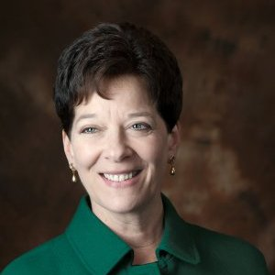
If you want to get in the news, this is pretty obvious – you have to know what is in the news. What’s the latest buzz? Respond to current events in a timely manner, and stay in tune with the news.

Tomorrow is National Hug-A-Tree Day, and your club plants trees? Bingo! A new report was just released that says if you attend summer camp you would be more likely to become president, and your club would provides summer-camp scholarships? Yahtzee!

You get the idea. Be proactive and ready to pitch your experts. (From nonprofitpr.org.)

To learn more about PR for your club, click on the "Public Relations" section of the navigation bar of the District 7910 website.

Laura Spear, chair of District 7910's Public Relations Committee, may be reached at laura@spear.net.

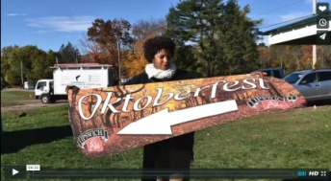Click here for an excellent example of a club-event promotional video by Concord President Steve Kirk.

Return to November 21 Newsletter

View past issues
Visit our website
'Like' our Facebook page
Follow' us on Twitter

