HOT OFF THE PRESS! 2016-2017 ROTARY DISTRICT 7910 DIRECTORY
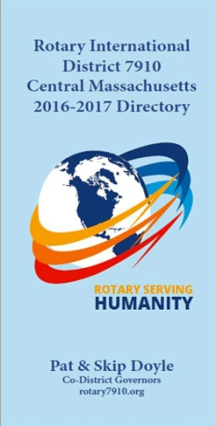Our information-packed, 332-page Directory for this Rotary year is now available for automatic download, in PDF format.

Please note: Member login is required.

Click here, to download

