Auburn Supports Bay Path High’s Participation in Worcester County Coat Drive

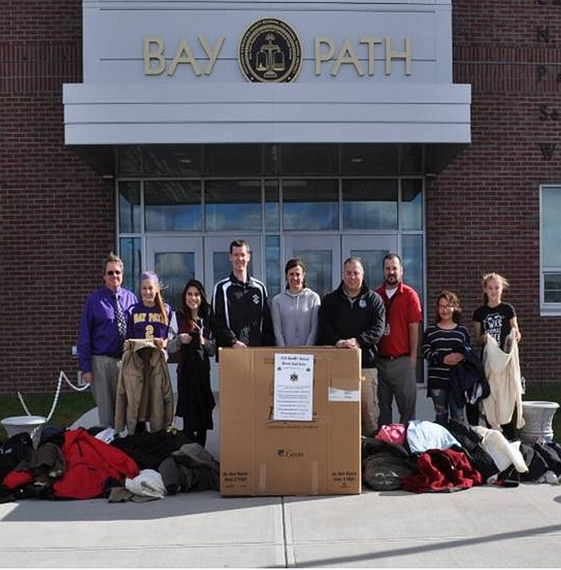The Rotary Club of Auburn supported the participation by Bay Path Regional Vocational Technical High School in the sixth annual Worcester County Coat Drive, which was conducted by the Worcester County Sheriff’s Office. Between mid October and the end of November, Bay Path’s staff members gathered more than 400 gently used coats plus numerous other warm garments since the Coat Drive. That amount is nearly six times the school's overall goal - and more than 11 times its total for last year’s campaign.
Bay Path teachers Rick Carrero and Jennifer Reil, who advise the school's Interact club, organized this year's drive. Southbridge Credit Union, which has a branch at Bay Path and whose president, Jeffrey Davenport, is the Rotary Club of Southbridge's advisor to Bay Path's Interact Club, was highly supportive of the school's Coat Drive.

Shown, are: Bay Path Principal Clifford Cloutier (far left); Bay Path teachers Jennifer Reil (center), who is also an Auburn Rotarian, and Rick Carrero (third from right), both of whom advise Bay Path’s Interact Club; Officer Steven Salovardos (fourth from left) and Community Outreach Director Shawn McKenna (fourth from right) of the Sheriff’s Office; and four of the Bay Path students participating in this year’s Coat Drive.

The Sheriff’s Office has expressed astonishment at the amount of donations of warm gear that Bay Path students have gathered during the past month. Last year, Sheriff Lew Evangelidis and his staff, in conjunction with several community partners, collected more than 3,000 coats for families in need.

"Last year, the students from the Interact Club at Bay Path High collected hundreds of winter jackets, which was a tremendous help to our Annual Coat Drive. In all, over 3,000 new and lightly used jackets were provided to families in need throughout Worcester County,” Sheriff Evangelidis states. “This year, as many families continue to struggle and coat donations are needed more than ever, we are very appreciative that the dedicated students of Bay Path are ready to help us once again. We are also excited to announce a new community partner, the Rotary Club of Auburn, has also joined us in that effort. We look forward to both groups joining us when we deliver and distribute the collected coats in the community, which is always a special day.”

In addition to gathering warm gear, Bay Path students will head to community-outreach centers to help hand out the coats to those in need. “This is a great opportunity for our students to connect with the community and help make a difference,” states Bay Path Principal Clifford Cloutier.

Auburn Rotary is gathering warm gear to donate to Bay Path’s effort. “Because the official motto of Rotary is ‘service above self,’” states club President Steve Jones-D’Agostino, “it is a privilege and an honor for Auburn Rotary to support Bay Path High and the Sheriff’s Office in this wonderful and vital Coat Drive.”

For more information on Bay Path’s participation in the Coat Drive, contact Jennifer Reil, Interact chair of Auburn Rotary and a teacher at Bay Path, at 508-254-1214 or jreil@baypath.net.

To learn more about Bay Path High, click here. To learn more about Interact, click here.
Bay Path’s Interact Club is sponsored by the Rotary Clubs of Auburn and Southbridge. To learn more about Auburn Rotary, click here. To learn more about Southbridge Rotary, click here.

Return to November 28 Newsletter

View past issues
Visit our website
'Like' our Facebook page
'Follow' our Twitter page

