Concord, Town Dedicate USS Concord Bell’s Installation
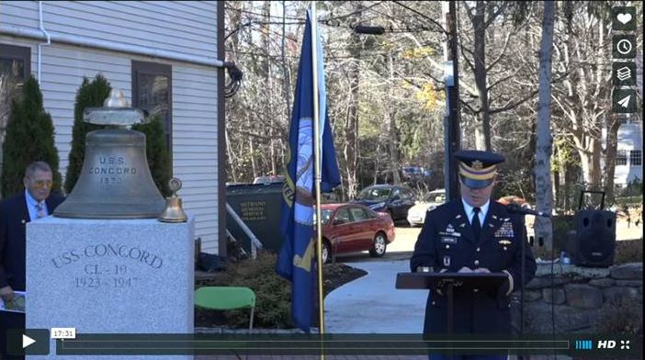The USS Concord Bell Veterans Memorial project was conceived by the Rotary Club of Concord more 15 years ago, revived in 2012, and now, with the generous support of the Town of Concord’s Community Preservation Fund and help from many experts, donors and volunteers, has finally become a reality.

VIEW 17-MINUTE VIDEO (produced by Steve Kirk, president of Concord Rotary)

The USS Concord was an Omaha Class light cruiser serving in the North and South Pacific during World War Two. While Concord has the distinction of firing the first shot of the Revolutionary War, the USS Concord has the distinction of firing the last shot of World War Two on August 15, 1945 in the Sea of Okhotsk. The casualties of that conflict are memorialized on Concord’s Common.
The USS Concord was launched in 1921. Pleased that the U.S. Navy was naming a vessel “Concord,” a consortium of Concord citizens commissioned sculptor Daniel Chester French to create a reduced-sized version of his statue, “Concord Minuteman of 1775,” for the ship. The smaller adaptation is now at the Concord Museum. The Bell itself, presented to the Town of Concord in 1947, first resided at the Concord Free Public Library. It was then moved in 2003 to the basement of the Town House, where it remained virtually unseen until the present.

To learn more about Concord Rotary, click here

Return to November 21 Newsletter

View past issues
Visit our website
'Like' our Facebook page

Concord, Town Dedicate USS Concord Bell’s Installation
The USS Concord Bell Veterans Memorial project was conceived by the Rotary Club of Concord more 15 years ago, revived in 2012, and now, with the generous support of the Town of Concord’s Community Preservation Fund and help from many experts, donors and volunteers, has finally become a reality.
READ MORE
VIEW 17-MINUTE VIDEO (produced by Steve Kirk, president of Concord Rotary)
[[https://youtu.be/ed_L4BWyGXs]]
The USS Concord was an Omaha Class light cruiser serving in the North and South Pacific during World War Two. While Concord has the distinction of firing the first shot of the Revolutionary War, the USS Concord has the distinction of firing the last shot of World War Two on August 15, 1945 in the Sea of Okhotsk. The casualties of that conflict are memorialized on Concord’s Common.
The USS Concord was launched in 1921. Pleased that the U.S. Navy was naming a vessel “Concord,” a consortium of Concord citizens commissioned sculptor Daniel Chester French to create a reduced-sized version of his statue, “Concord Minuteman of 1775,” for the ship. The smaller adaptation is now at the Concord Museum. The Bell itself, presented to the Town of Concord in 1947, first resided at the Concord Free Public Library. It was then moved in 2003 to the basement of the Town House, where it remained virtually unseen until the present.
To learn more about Concord Rotary, click here
[[http://www.rotaryclubofconcord.org/]]

