Update on Club-Qualification Status for Foundation Grants
By Sanjay Deshpande

District 7910 conducted a third Grant Management Training session last week to help clubs, which had not participated in the earlier two training sessions, to qualify for Foundation grants during the rest of Rotary year 2016-2017, which ends next June 30.

As a result of last week’s session, our district now has 25 clubs that are fully qualified for participation in District and Global grants ‘16-‘17. These clubs have met all three eligibility criteria established by our district for such participation:
- Per capita contribution of $100 or more to The Rotary Foundation during the Rotary year that ended last June 30;
- Submission of the signed ‘16-‘17 club Memorandum of Understanding to the District Stewardship Committee; and
- At least one, preferably two, members undergo grant-management training.
To download this table in PDF format, click here.
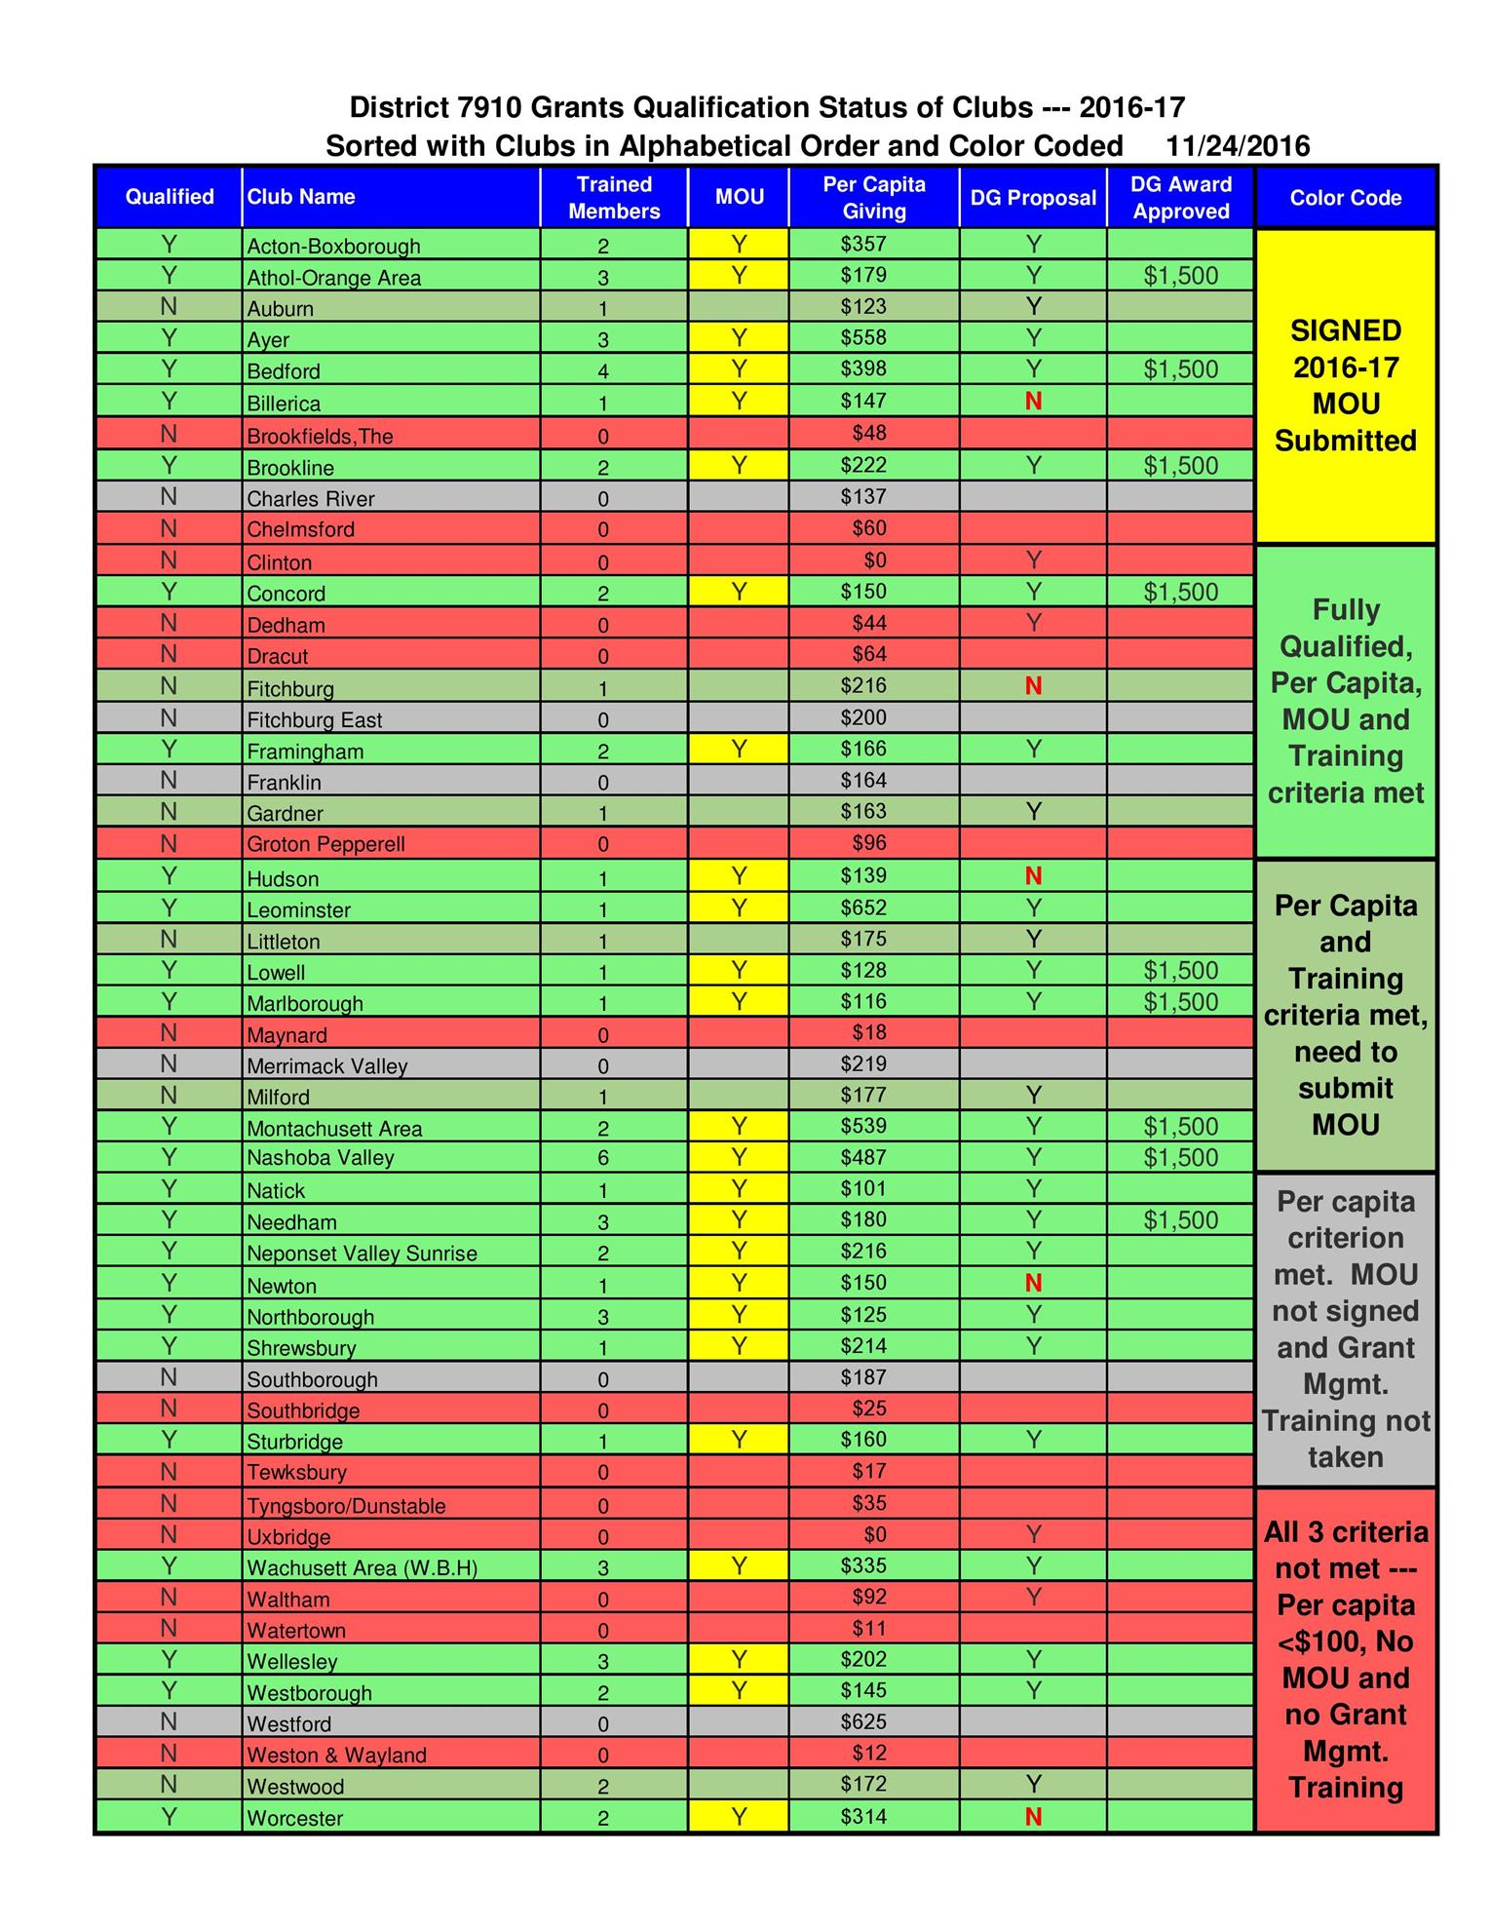

These 25 clubs (see table, top section) can apply for District and Global grants. In fact, nine clubs have already received commitments for $1,500 each in District Grant awards, and two more have been advised to modify their applications so they can clear the threshold set for a District Grant award. Ten more of the clubs that submitted District Grant proposals have been advised by the District Grants Subcommittee to provide more information. The remaining four clubs have so far not submitted District Grant proposals.

Six clubs (see table, upper-middle section) have met the criteria for per-capita contribution and grant-management training but have not submitted a signed ‘16-‘17 club MOU. They must submit this document to complete their qualification. Then, the five of these clubs that have submitted District Grant proposals could complete their online applications and one of them will be able to submit its District Grant proposal.

Another six clubs (see table, lower-middle section) have met the per-capita contribution criterion but have not received grant-management training or submitted their signed club MOU. As a result, they are not qualified as of this November 24. If these clubs submit their signed club MOU and want to participate in District and Global grants, our district would help them by organizing another grant-management training session, provided they request one.

The last group of 14 clubs (see table, bottom section) cannot qualify in ‘16-‘17 because they did not meet the $100 per-capita contribution criterion by last June 30.

District 7910 will close District Grant requests this December 31. Applications for District Grants should be completed by next January 31 and all District Grant projects should preferably be completed by next March 31. Final reports on these District Grants must be submitted by next April 30 along with the submission of all required support documents so that the $1,500 District Grant can be paid to the club.

We wish the clubs all the best in the implementation of their District Grants.

If you have any questions about the District Foundation Committee, contact either District Grants Subcommittee Chair Jorge Yarzebski at yj.rotary@gmail.com or me, District Foundation Committee Chair Sanjay Deshpande, sanjdesh51@aol.com.

For the Foundation Notes archive, click here

Learn more about District 7910 Foundation Grants:
- Rotary Areas of Focus Policy Statements (PDF Format)
- District 7910 Eligible and Ineligible Activities in a District Grant (Word Format)
- Timeline for District 7910 Foundation Grants (Web Page)
- District 7910 Grant Qualification Table (Excel Format)
- District 7910 Grant Proposals and Qualifications Status (Web Page)
- District 7910 2015-2016 Foundation Contributions Report - (Excel Format)
- Foundation Grants in 2016-'17 and Beyond (PDF Format)
- District 7910 2016-2017 District Grant Proposal Template (PDF Format)
- District Grant Proposal Form (Word Format)
- Global Grant Proposal Form (Word Format)
- District 7910 District Grants Scoring Rubric (PDF format)
- District 7910 Club Memorandum of Understanding (PDF Format)
Return to November 28 Newsletter

View pa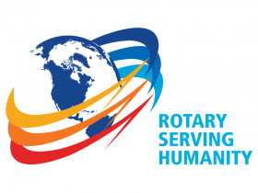st issues
Visit our website
'Like' our Facebook page
'Follow' our Twitter page

