We hope you celebrated Thanksgiving in a meaningful way
By Pat and Skip Doyle
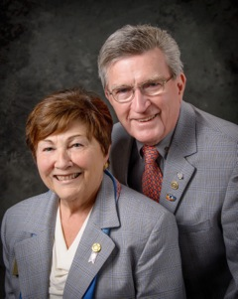
We hope you all celebrated Thanksgiving in a meaningful way. It is a day that is celebrated on many different levels by each one of us. For us, it has always been a day for family.

Our family is a relatively small one and so we celebrate with three generations, including many in-laws and outlaws (as Skip calls them). Our day is always filled with good food and shared memories. Thanksgiving has also signaled the beginning of the magical Christmas season for us.

In the photography business, this was the busiest, happiest season of our year. The day after Thanksgiving, our studio was always packed with families - many, with students home from college - wanting us to capture their Christmas-card memories.

Reflecting back on all of this brought us to thoughts of our Rotary family. We most certainly are thankful for it, but how healthy is it at this time? The latest statistics, unscientific as they may seem, has our Rotary family with a net gain of four members. We have, however, inducted more than 50 members since last July 1.

This statistic should be a red flag for all of us. We all need to look at our own clubs and see what has caused this lack of real growth. Why are we just treading water? Continuing the analogy of how healthy are we as a family, it would seem that we are in need of a check-up. What steps ought we to take?
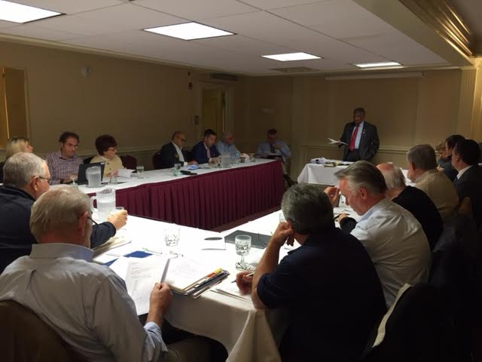

On November 22, the District Membership Committee (shown, right) met and discussed this very topic. The proposal was put forward to continue the successful format of four Membership Workshops in four areas of the district. This additional set of workshops will be held next March on a date to be announced. It was the consensus of the committee that these workshops will be aimed at the generation of an action plan aimed at increasing membership and retention.

This may be the beginning of our path to recovery.

Thank You! Thank You!! Thank You!!!

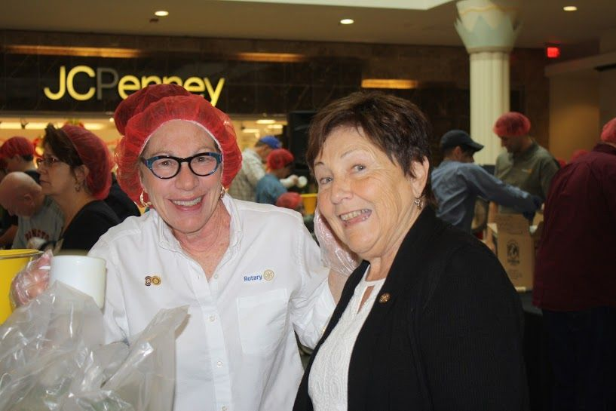Our District Food Packaging Event on November 12 at the Solomon Pond Mall in Marlborough was a solid success.

More than 100 volunteers from around the district packaged 20,000 meals, which will be sent to Haiti to help feed the children left homeless by the hurricane. These volunteers were Rotarians and their friends and families, young and old There were Interactors from local clubs, passersby who wanted to help and past and present participants of Rotary Youth Leadership Awards. We raised more than $4,000 toward our goal of $5,000 - so we are still actively seeking donations.

VIEW ALL PHOTOS

It is hard to pick out a highlight from the event, there were so many. One is perhaps the numbers of people with whom we were able to talk about what Rotary is - the reality of Rotary, not the perception. This event puts us a little further toward our goal of making Rotary more visible and more real in our district. Thank you also to the Solomon Pond Mall for allowing us to utilize their space for this event.
Always remember, you can call us with questions at 508-393-9031.

District Governors Pat and Skip Doyle may be reached at pwdoyle2@verizon.net and skipdoyle2@verizon.net,
respectively.

Click here to submit content for the December 5 issue.
The submission deadline for this issue is Friday, December 2.

Click here for past issues.

Return to November 28 Newsletter

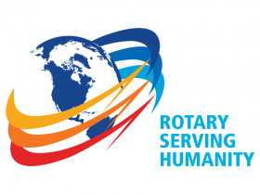Visit our website
'Like' our Facebook page
'Follow us on Twitter

