???
By Tom Sturiale

(This article ran originally in the ??? ???, 2016 issue.)

Tom Sturiale, chair of District 7910's Visioning Committee and vice chair of its Membership Committee, may be reached at tsturiale36@gmail.com.

Documents for October 2016 Membership Workshops, in PDF format:
- Participant Comments
- Introductory Notes for Moderators
- Sessions Discussion Points
- Rotary Membership-Development Ideas Sites
To learn about the October 2016 Membership Workshops, click here.

For more information on Rotary memberships:
- Rotary Individual Membership Application - Word Format
- Rotary Corporate Membership Application - Word Format
- Rotary Corporate Membership Opportunity - Word Format
- Rotary Corporate Membership Information - Word Format
September & October 2016 'Membership Corner' articles:
- September 5: Corporate memberships In Rotary
- September 19: What are our Rotary objectives? Membership! Membership! Membership!
- September 26: Rotary club objectives
- October 3: A review of membership best practices from eight of our clubs
- October 10: Membership Workshops start on October 24
- October 31: Membership Workshops recap
- To read previous articles for Rotary 2016-2017, click here.

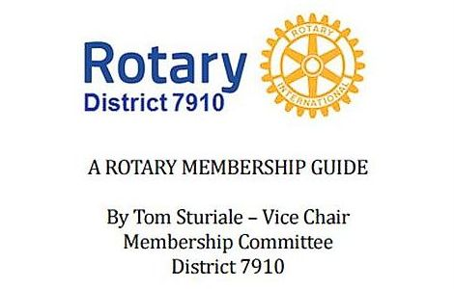"A Rotary Membership Guide" is a collection of "Membership Corner" articles written for this weekly newsletter during the 2015-2016 Rotary year, which began last July 1. It is intended to offer an idea or thought each week aimed at stimulating discussions, questions and actions to effectively increase membership at all our clubs. Click here, to download this 52-page "Guide," in Word format.

Return to November 28 Newsletter

View past issues
Visit our website
'Like' our Facebook page
'Follow' our Twitter page

