GOVERNOR'S MESSAGE

We Hope You Celebrated Thanksgiving in A Meaningful Way

By Pat and Skip Doyle
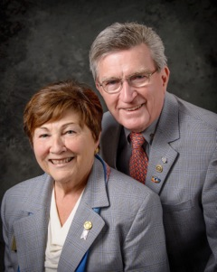
We hope you all celebrated Thanksgiving in a meaningful way. It is a day that is celebrated on many different levels by each one of us. For us, it has always been a day for family.

Our family is a relatively small one and so we celebrate with three generations, including many in-laws and outlaws (as Skip calls them). Our day is always filled with good food and shared memories. Thanksgiving has also signaled the beginning of the magical Christmas season for us.

In the photography business, this was the busiest, happiest season of our year. The day after Thanksgiving, our studio was always packed with families - many, with students home from college - wanting us to capture their Christmas-card memories.

Reflecting back on all of this brought us to thoughts of our Rotary family. We most certainly are thankful for it, but how healthy is it at this time? The latest statistics, unscientific as they may seem, has our Rotary family with a net gain of four members. We have, however, inducted more than 50 members since last July 1.

This statistic should be a red flag for all of us. We all need to look at our own clubs and see what has caused this lack of real growth. Why are we just treading water? Continuing the analogy of how healthy are we as a family, it would seem that we are in need of a check-up. What steps ought we to take?

On November 22, the District Membership Committee (shown, right) met and discussed this very topic. The proposal was put forward 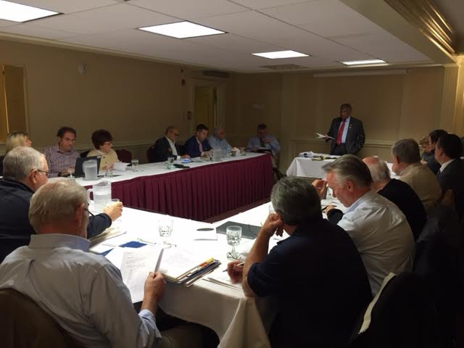to continue the successful format of four Membership Workshops in four areas of the district. This additional set of workshops will be held next March on a date to be announced. It was the consensus of the committee that these workshops will be aimed at the generation of an action plan aimed at increasing membership and retention.

This may be the beginning of our path to recovery.

Thank You! Thank You!! Thank You!!!

Our District Food Packaging Event on November 12 at the Solomon Pond Mall in Marlborough was a solid success.

More than 100 volunteers from around the district packaged 20,000 meals, which will be sent to Haiti to help feed the children left homeless by the hurricane (see article in left hand column). These volunteers were Rotarians and their friends and families, young and old There were Interactors from local clubs, passersby who wanted to help and past and present participants of Rotary Youth Leadership Awards. We raised more than $4,000 toward our goal of $5,000 - so we are still actively seeking donations.

VIEW ALL PHOTOS

It is hard to pick out a highlight from the event, there were so many. One is perhaps the numbers of people with whom we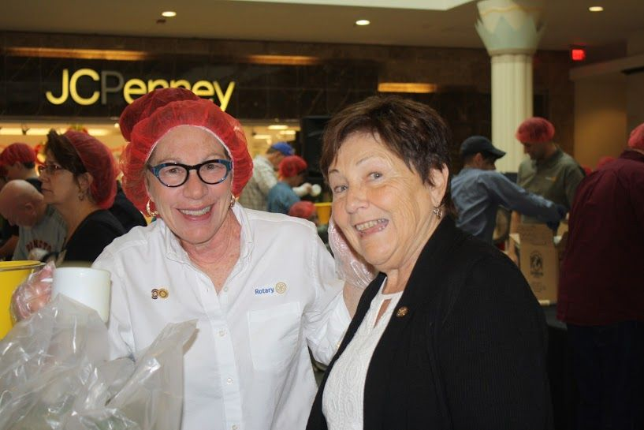were able to talk about what Rotary is - the reality of Rotary, not the perception. This event puts us a little further toward our goal of making Rotary more visible and more real in our district. Thank you also to the Solomon Pond Mall for allowing us to utilize their space for this event.

Always remember, you can call us with questions at 508-393-9031.

District Governors Pat and Skip Doyle may be reached at pwdoyle2@verizon.net and skipdoyle2@verizon.net,
respectively.

Click here to submit content for the December 5 issue. The submission deadline for this issue is December 2.

Click here for past issues.

WELCOME, NEW ROTARIANS

No new members.

Remember to Ask ... Ask ... Ask!

Hot Off the Press! 2016-2017 District Directory

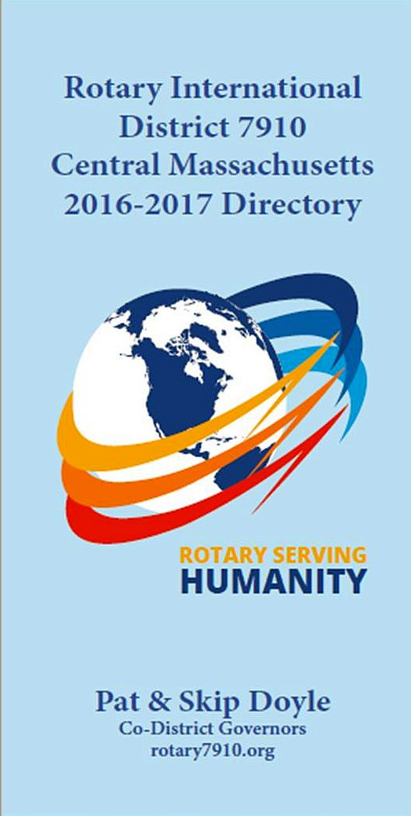

Print copies of our information-packed, 332-page Directory for this Rotary year will soon be delivered to your club.

A digital copy is now available for automatic download, in PDF format.

Please note: Member login is required.

Click here, to download

OUR PRESIDENTS SPEAK
Linn Doll-Butler of Uxbridge Rotary

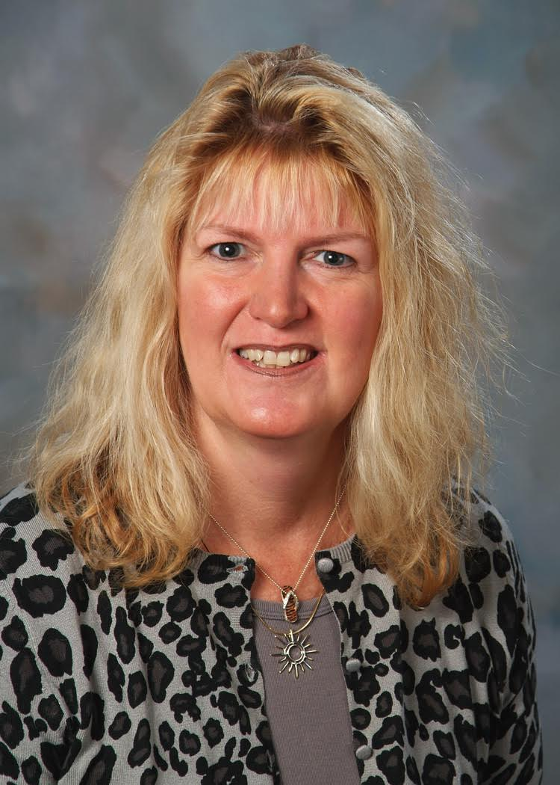

Please tell us what factors helped you decide to join Rotary.

Community and fellowship.

READ MORE

CLUB MEMBERSHIP GROWTH, ’16-‘17
We share with you the results of club-membership growth in our district during Rotary year 2016-2017, which began July 1.

This is a unique opportunity for Rotarians and friends to discuss partnering on humanitarian projects affecting our local communities.

READ MORE

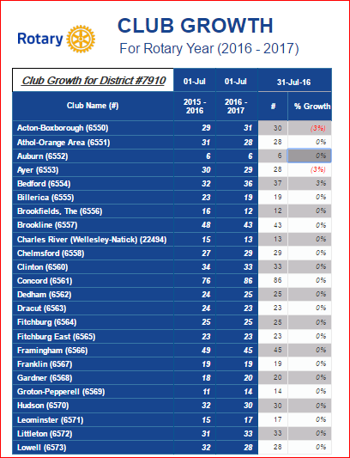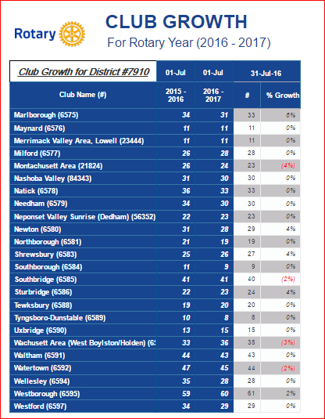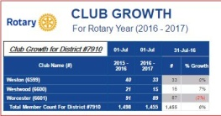

CLUB PLANNING WORKSHEET '16-'17
In both Excel and PDF formats, we share with you the Club Planning Worksheet for Rotary year 2016-2017, which began on July 1.
Please enter your club information in the indicated cells.

Excel Format

PDF Format

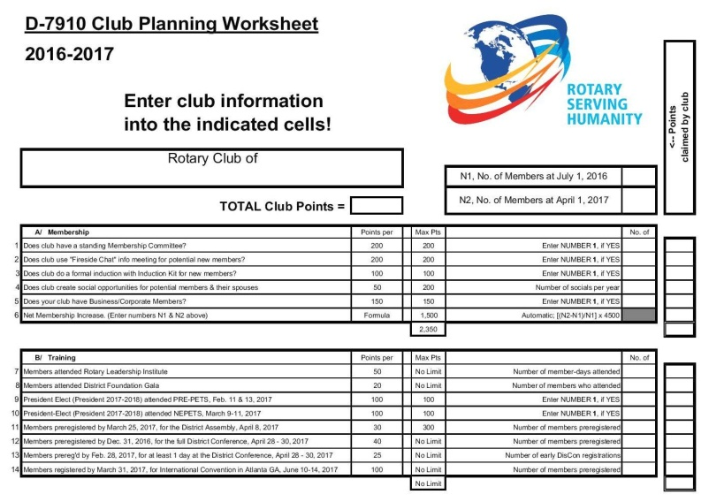

DISTRICT & CLUB ROUNDS
[Auburn Supports Bay Path High’s Participation in Worcester County Coat Drive

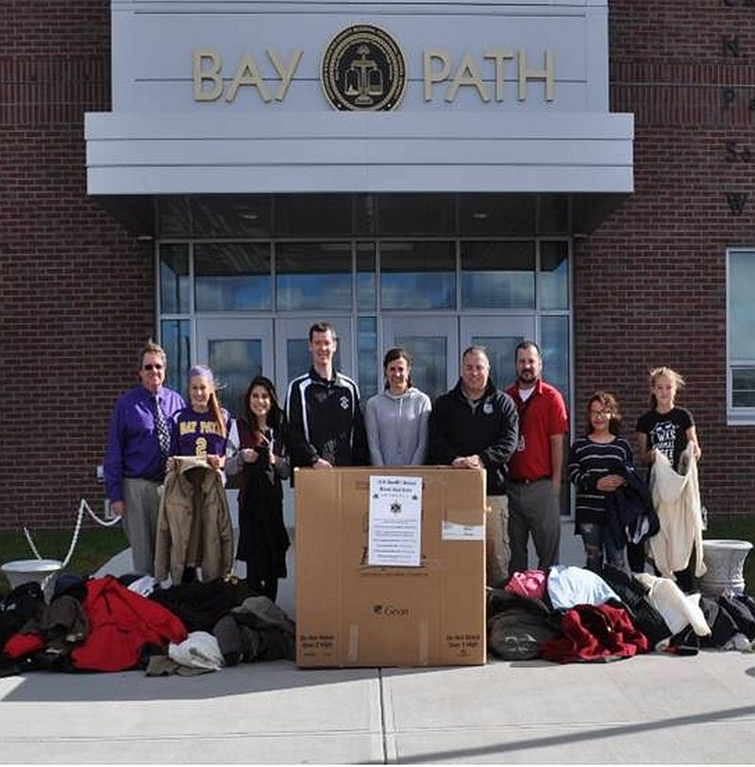The Rotary Club of Auburn supported the participation by Bay Path Regional Vocational Technical High School in the sixth annual Worcester County Coat Drive, which was conducted by the Worcester County Sheriff’s Office. Between mid October and the end of November, Bay Path’s staff members gathered more than 400 gently used coats plus numerous other warm garments since the Coat Drive. That amount is nearly six times the school's overall goal - and more than 11 times its total for last year’s campaign.
Bay Path teachers Rick Carrero and Jennifer Reil, who advise the school's Interact club, organized this year's drive. Southbridge Credit Union, which has a branch at Bay Path and whose president, Jeffrey Davenport, is the Rotary Club of Southbridge's advisor to Bay Path's Interact Club, was highly supportive of the school's Coat Drive.

Shown, are: Bay Path Principal Clifford Cloutier (far left); Bay Path teachers Jennifer Reil (center), who is also an Auburn Rotarian, and Rick Carrero (third from right), both of whom advise Bay Path’s Interact Club; Officer Steven Salovardos (fourth from left) and Community Outreach Director Shawn McKenna (fourth from right) of the Sheriff’s Office; and four of the Bay Path students participating in this year’s Coat Drive.

READ MORE

To learn more about Bay Path High, click here. To learn more about Interact, click here.

Bay Path’s Interact Club is sponsored by the Rotary Clubs of Auburn and Southbridge. To learn more about Auburn Rotary, click here. To learn more about Southbridge Rotary, click here.

Concord, Town Dedicate USS Concord Bell’s Installation

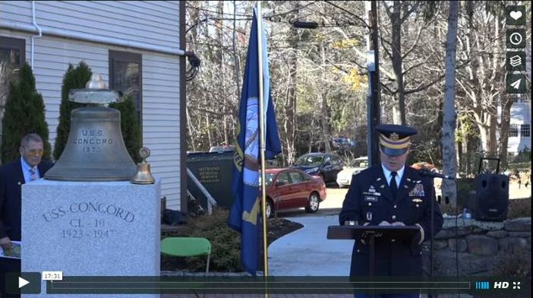
The USS Concord Bell Veterans Memorial project was conceived by the Rotary Club of Concord more 15 years ago, revived in 2012, and now, with the generous support of the Town of Concord’s Community Preservation Fundand help from many experts, donors and volunteers, has finally become a reality.

READ MORE

VIEW 17-MINUTE VIDEO (produced by Steve Kirk, president of Concord Rotary)

READ WICKED LOCAL CONCORD ARTICLE

To learn more about Concord Rotary, click here.

Framingham Rips Apart Cooked Turkeys for Curtis Family Thanksgiving Dinner

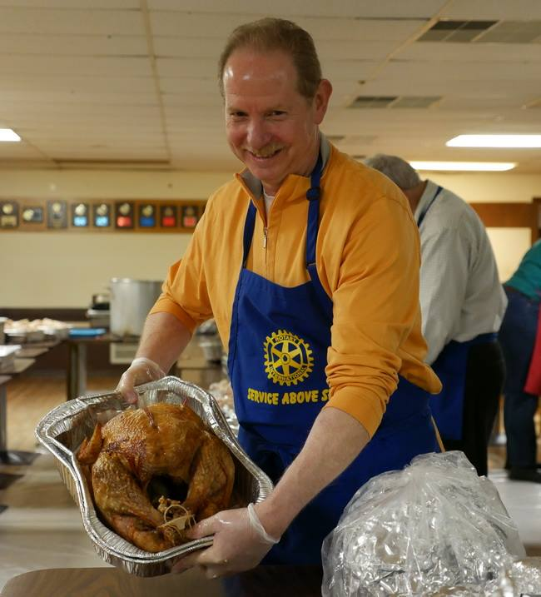

The Rotary Club of Framingham joined other community volunteers on November 23 to help rip apart cooked turkeys for the annual Curtis Family Thanksgiving day dinner. This year’s event provided free meals to more than 2,000 people.

After the Curtis family closed their restaurant, Eagles All-American Grille in Framingham, in 2014, they carried on the tradition of hosting the Curtis Family Thanksgiving. The dinner is held at the Fraternal Order of Eagles hall, located at 55 Park St. in Framingham.

Shown, is Framingham club President Lindsey Morrisdisplaying cooked turkey in a tray.

VIEW ALL PHOTOS

To learn more about Framingham Rotary, click here.

Needham, Wellesley Team Up for Annual Football Banquet

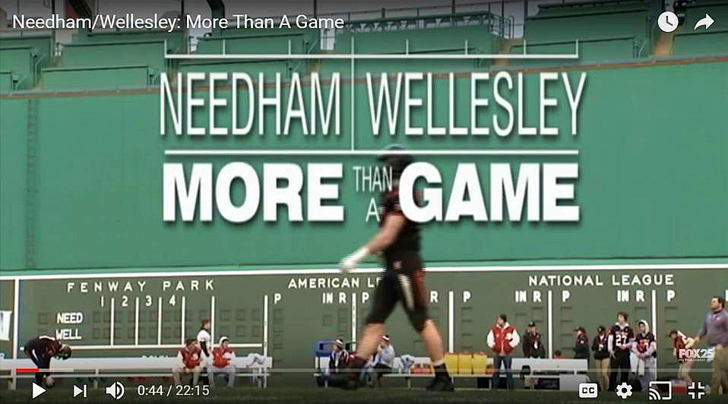

In true Rotary spirit and camaraderie, The Rotary Clubs of Needham and Wellesley gathered recently at the Sheraton Hotel in Needham for their annual Football Banquet, hosted this year by Needham Rotary. After a welcome, the Pledge of Allegiance, song and prayer, Needham President Ted Shaughnessey and Wellesley President Scott Secrestgave the audience the background about Rotary and their respective clubs.

Guests were introduced, including the superintendents, principals and athletic directors of the Needham and Wellesley High Schools. Amid much applause, the head coached introduced their staff and senior players, including the captains.

READ MORE

WATCH VIDEO

To learn more about Needham Rotary, click here.

To learn more about Wellesley Rotary, click here.

Sturbridge Donates Funds for Holiday Meals
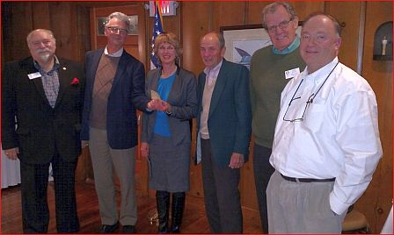
For the ninth consecutive year, the Rotary Club of Sturbridge has donated funds to organizations providing meals for families in need in the Tri-Community area. This year, funds were designated for the Tri-Community Church Collaborative, the Saint John Paul II Food Pantry and for needy families whose children attend Burgess Elementary School in Sturbridge. The latter program is coordinated by Lisa Meunier, school nurse at Burgess. All Rotary funds were donated directly to the Food Pantry, which coordinates the food supplies. Sturbridge Rotary also conducts an annual fundraiser each June to support the Saint John Paul II Food Pantry. One of the club’s goals is to help alleviate hunger in its local communities. So far in 2016, the club has contributed $4,100 toward this goal.
Left to right: President-Elect Dave Zonia; President Otto Prohaska; Lisa Meunier, Burgess Elementary School nurse; Bill Pioppi representing the Food Pantry; Community Service Chair Bob White; and Fundraising Chair Peter Zeh.
To learn more about Sturbridge Rotary, click here.

Watertown Holds $10,000 Raffle to Benefit Local Charities

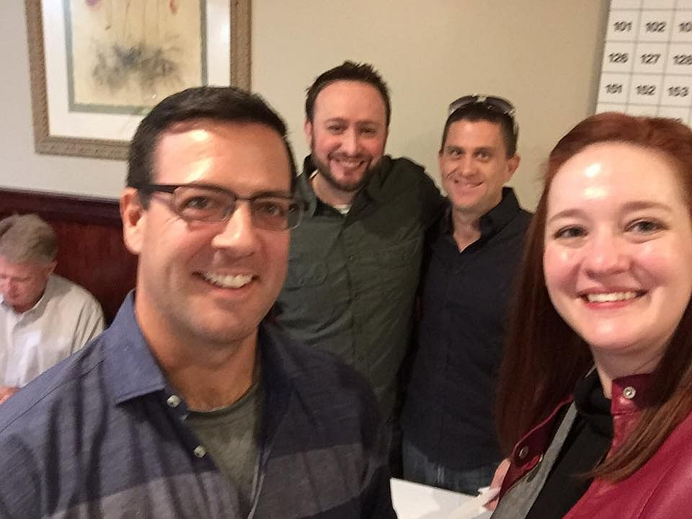

The Rotary Club of Watertown Rotary held its annual $10,000 Raffle on November 4. Tickets were $100 each for a chance to win the First Prize of $10,000 The Second Prize was $500 and the Third through Seventh prizes were $200 each. All proceeds will go to benefit various local charities.

Left to right: John Airasian, membership chair; Anthony Donato, two-time past president; Jesse Wallace, 10K Raffle chair; and Lilia Weisfeldt, president.

To learn more about Watertown Rotary, click here.

Westborough Holds Annual Turkey Trot To Support Town's Public Schools

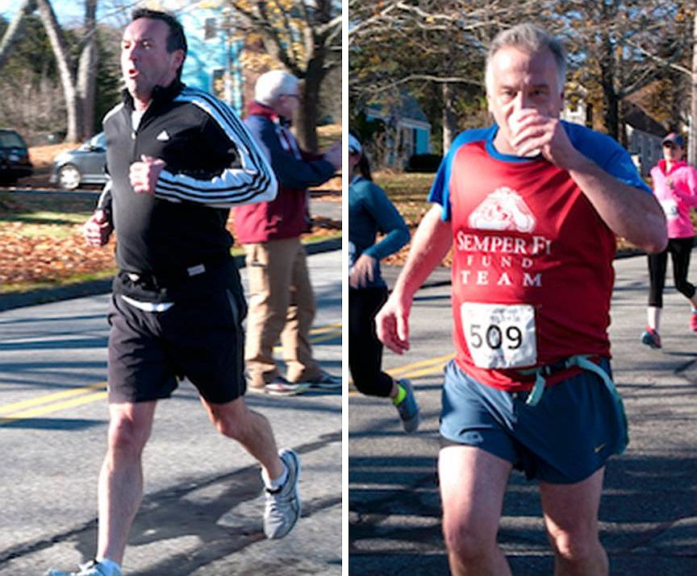

Member Patrick McGrath (left) and President Gerry Gross(right) of the Rotary Club of Westborough hit the pavement on a recent, beautiful Saturday, to run a 5K race in support of Westborough Public Schools.

To learn more about Westborough Rotary, click here.

Westborough Installs New Member

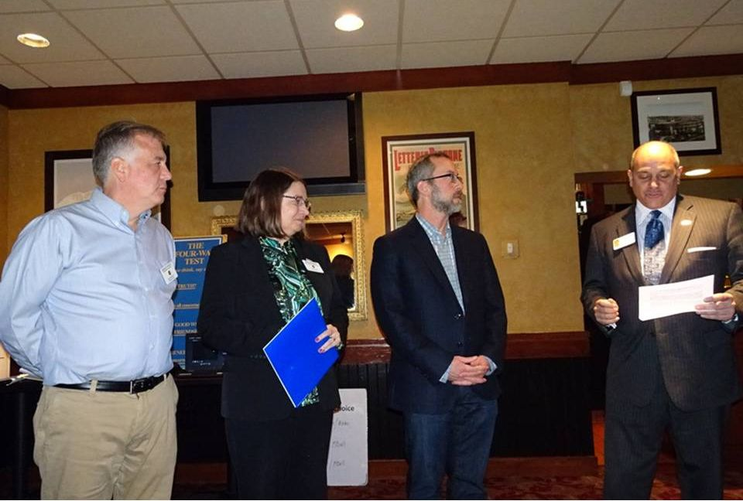

The Rotary Club of Westborough has welcomed and installed its newest member, Tony Vaver (second from right). Sponsored by club Secretary Maureen Ambrosino(second from left), Tony has been a Westborough resident for 10 years, and is the local history librarian at Westborough Public Library.

Tony was installed by District Governor-Nominee Steve Sager (far right), a Westborough Rotarian. Steve reminded his fellow club members that when people become Rotarians, they not only join a particular club, but they also in excess of 35,000 clubs in more than 200 countries around the world that promote Rotary’s mission of ”service above self.”

Also shown is Westborough President Gerry Gross (far left).

To learn more about Westborough Rotary, click here.

Acton-Boxborough's Veterans Day Breakfast 'Simply Fantastic'

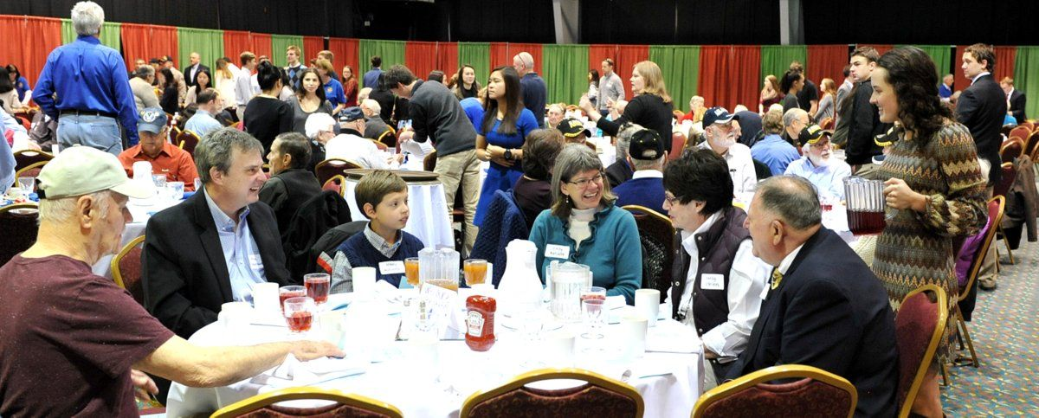

The Rotary Club of Acton-Boxborough held its 2016 Veterans Day Breakfast on November 11 at Acton-Boxborough Regional High School in Acton. The school's Honor Society members who attended the event provided exemplary service and entertainment to the veterans and their family members. Acton-Boxborough Rotarian Frank Sibley, who took this and other event photos, calls the turnout "simply fantastic."

VIEW PHOTOS

To learn more about Acton-Boxborough Rotary, click here.

Auburn's Pancake Breakfast Raises $3,500 for Local High School Scholarships

The Rotary Club of Auburn's annual "Flips for Scholars" Pancake Breakfast on October 23 at Auburn High School raised a net total of $3,500 for scholarships to be awarded to local high school graduates. Over the course of more than 50 years, Auburn Rotary has raised in excess of $420,000 for such scholarships.
Club scholarships awarded at the end of the 2015-2016 school year will be presented on Wednesday, December 21 during a Dinner Ceremony with the four recipients and their parents, which will be held starting at 5:30 p.m. at Chuck’s Steak House, located at 10 Prospect St. (immediately off Route 20) in Auburn.

The recipients are as follows (alphabetical, by last name):
- Thomas Anderson, an Auburn High School graduate who attends Worcester State University
- Abigail Lucas, an Auburn High graduate who attends the University of Connecticut
- Zachary Martins, a Bay Path Regional Vocational Technical High School graduate who attends the University of Northwestern Ohio
- Zachary Randall, an Auburn High graduate who attends the University of Maine
To learn more about Auburn Rotary, click here.

Chelmsford Honors Students of Month for November

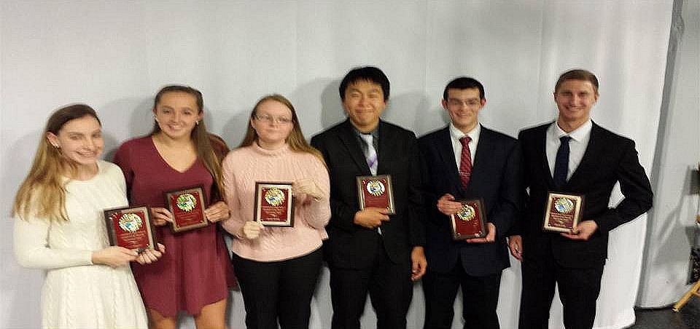

Each month of the school year, Chelmsford High School administrators choose two seniors from each of the school's three houses to be honored by the Rotary Club of Chelmsford for having been significant contributors to their school and community. First, the honorees speak at a club meeting. Then, they are interviewed on "Lions Pride,"
a local cable television show. This month, the honorees are, left to right: Riley Higgins, of Emerson House; Sophia Haywood, of Hawthorne House; Sarah Benda, of Whittier House; Jason Shin, of Whittier House, Eric Miu, of Emerson House; and David Cote, Hawthorne House.

To learn more about Chelmsford Rotary, click here.

Concord’s Bristol Lodge Soup Kitchen Serves Thanksgiving Dinner to Needy

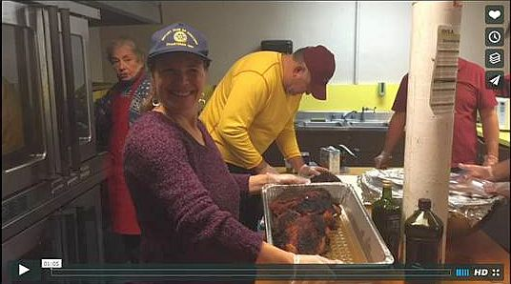

On November 8, the Rotary Club of Concord purchased and prepared a traditional Thanksgiving meal for more than 100 clients at the Bristol Lodge Soup Kitchen. Bristol Lodge has been serving hot, nutritious meals to those in need for the last three decades. Every evening, dedicated volunteers from throughout the Metro Boston area gather to prepare and serve food to up to 100 community members without access to affordable, healthy food.
While volunteer groups range in size and frequency of service, those giving back at the Bristol Lodge Soup Kitchen perform site setup and cleanup and a variety of other tasks to maintain the Soup Kitchen’s cleanliness, organization and overall condition. Soup Kitchen employees oversee the facility each afternoon and evening, ensuring that participants are served nutritious meals in a clean and welcoming environment.
In addition to an ongoing partnership with the Greater Boston Food Bank, the Bristol Lodge Soup Kitchen relies on food donations from volunteer groups and community partners. Donations include a variety of proteins, vegetables, fruits, grains and dairy. With tens of thousands of meals served annually, the Soup Kitchen continues to be a critical resource for individuals and families in Waltham and beyond.

WATCH ONE-MINUTE VIDEO (produced by Steve Kirk, president of Concord Rotary)

To learn more about Concord Rotary, click here.

Fitchburg, Leominster Team Up for 22nd Time for Breakfast for the Bands

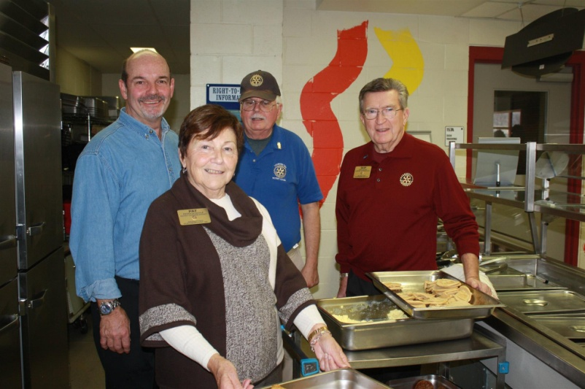

For 22 years, the Rotary Clubs of Fitchburg and Leominster have joined together to sponsor Breakfast for the Bands. Proceeds raised at this event are given to the Fitchburg High and Leominster High school band programs. The bands from both high schools entertained the attendees while members of the football teams help to serve the meals.

On November 24, the two teams met again for their 111th time on Thanksgiving Day and their 133d time overall. Leominster defeated Fitchburg by a score of 49-12, and now holds a six-game lead in this rivalry.

Left to right: Fitchburg Rotary event Chair Paul Gauvin; District Governor Pat Doyle; Leominster Rotary event Chair John Tata; and District Governor Skip Doyle.

READ SENTINEL & ENTERPRISE ARTICLE, WATCH 49- AND 23-SECOND VIDEOS

To learn more about Fitchburg Rotary, click here.

To learn more about Leominster Rotary, click here.

Framingham’s Quilt Auction Supports Service-Dog Initiative

By Liz Kaprielian
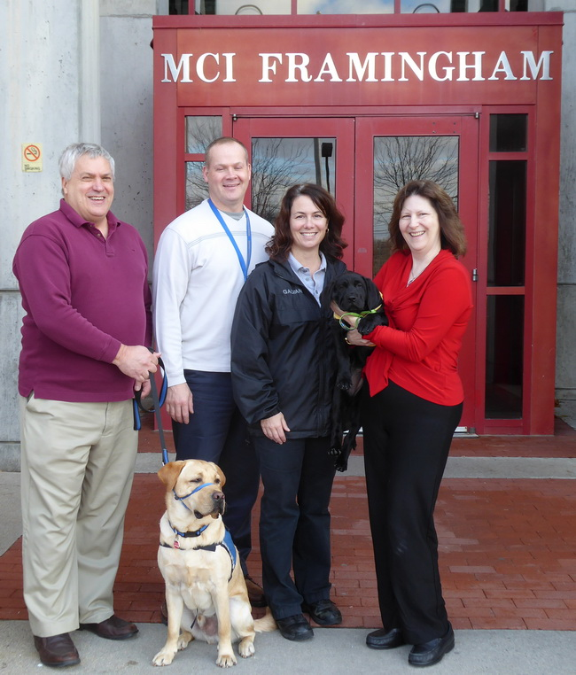

The 45th annual Online Auction fundraiser by the Rotary Club of Framingham, which went live on November 15, includes a very special item. The Delightful Dogslap quilt, Item No. 124, is a fun and colorful dog-themed quilt. Scattered throughout the quilt are various dogs with fun messages.

The quilt was created as a special auction item to support Framingham Rotary’s Service Dog Initiative. The club is sponsoring puppy Harris and his service-dog training through NEADS (National Education for Assistance Dog Services, also known as Dogs for Deaf and Disabled Americans) and its Prison Pup Partnershipat MCI-Framingham.

Shown, left to right, in 2015 are: Peter Harvell, director of veterans services and benefits for the Town of Framingham; Paul Henderson, prison superintendent of MCI Framingham; Laura Galvani, prison programs director of MCI Framingham; and Liz Kaprielian, a director of Framingham Rotary, holding a Prison Pup. Another Prison Pup is shown, sitting.

READ MORE

To watch a three-minute video about Framingham Rotary’s Service Dog Project, click here.

To learn more about Framingham Rotary, click here.

Groton-Pepperell Inducts Three Members
Left to right: New members Steve Jannes, Matt Evans and Cathy Crowley; President Duncan France; and District Governors Pat and Skip Doyle.

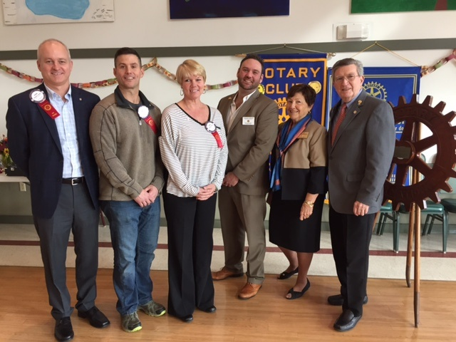

To learn more about Groton-Pepperell Rotary, click here.

Marlborough's Turkey Shoot a Huge Success

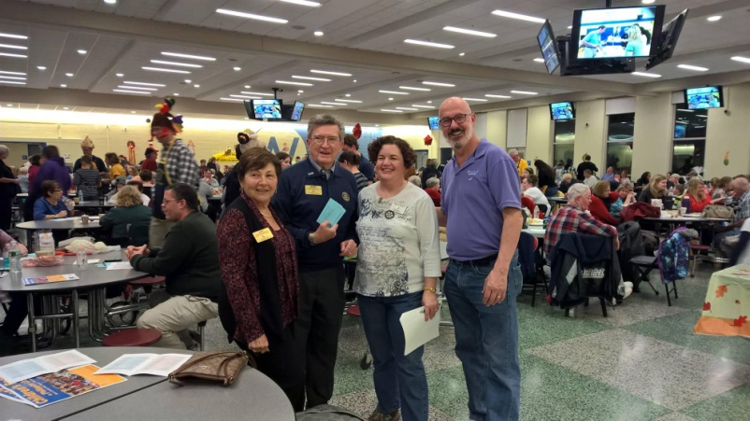

The Rotary Club of Marlborough held its 34rd Annual Turkey Shoot on November 19 at Assabet Valley Regional Technical High School in Marlborough. Through the money raised at the Turkey Shoot, the club can make a special holiday season for deserving children, teens, seniors, and families.

Left to right: District Governors Pat and Skip Doyle pose with President Peggy Shelton and Member Nick Kofos during the Turkey Shoot. Peggy and Nick co-chaired the event.

To learn more about Marlborough Rotary, click here.

Milford Distributes '16 Tab to 13,000 Homes - Record sales, 94 photos, 334 smiling faces

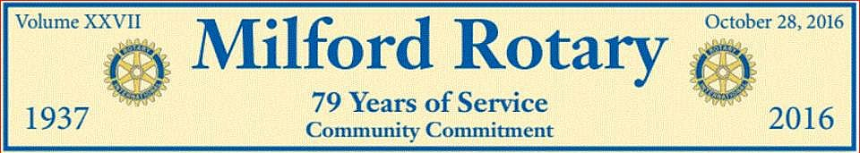

To read the Milford RotaryTab, click here.

Here’s an example of the content in the 2016 issue of Milford Rotary Tab:

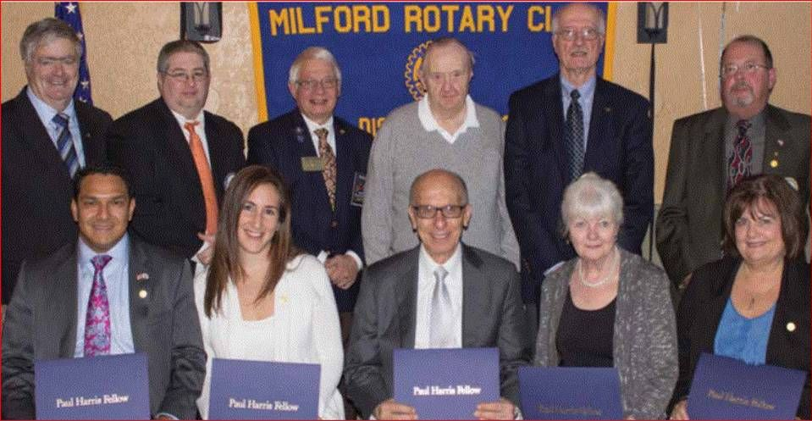

2015 Paul Harris Award Recipients

Front row, left to right: Allan and Lauren Villatoro; Frank Saba, since-retired CEO of Milford Regional Medical Center; Mary Ann Mastroianni; and Susan McWade Surapine.

Back row, left to right: Thomas C. Sawyer, Foundation chair; Michael DiCicco; Jim Fusco, then-district governor; Russ Dennett; Ralph Mastroianni; and Paul Surapine.

To learn more about Milford Rotary, click here.

Nashoba Valley's Breakfast Honors Veterans

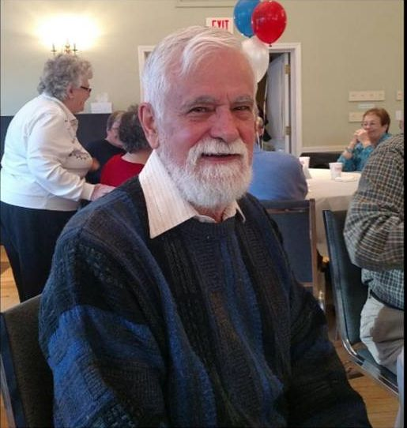
Veterans discussed the recent election and what they planned to do for the rest of the day over pancakes and eggs, at a Veterans Day breakfast at the First Parish Church of Stow and Acton, sponsored by the Rotary Club of Nashoba Valley.
Some reflected about their service.
Robert “Bob” Walrath (shown), 78, was in the 9th Regiment Marine Corps during the Cold War. As he sipped coffee, he spoke of his time in the service.
Photo: Jacquelyn Jarnagin, The Beacon-Villager
READ MORE
To learn more about Nashoba Valley Rotary, click here.

Newton Wishes Us Happy Holidays

By Paul Sullivan

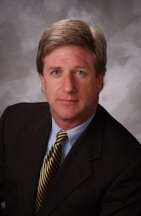

Thanksgiving is a time to reflect on all that is good in our lives, to be grateful for our friends and family, and to serve people in need. This year, more than ever, the Rotary Club of Newton urges you to help others this Thanksgiving, and we've got a couple of ideas to assist.

READ MORE

To learn more about Newton Rotary, click here.

Wachusett Area Rotary, Chamber to Host Economic-Development Breakfast
on December 2

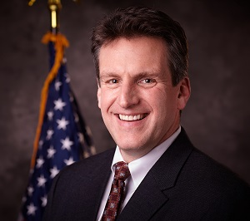

The Rotary Club of Wachusett and the Wachusett Area Chamber of Commerce will co-host an Economic Development Breakfast on Friday, December 2 from 7:30 to 9:00 a.m. at the Manor Banquet Facilities, located at 42 West Boylston St. in West Boylston. The guest speaker will be Jay Ash (shown), secretary of Housing and Economic Development for the Commonwealth of Massachusetts. The cost is $20 per person. The event is open to the public.

Guests will have an opportunity to hear the latest economic-development news from around the Commonwealth and learn what it means for the Wachusett area. Time will be allotted for questions and discussion. To register, either visit the Chamber’s websiteor e-mail the Chamber at info@wachusettareachamber.org.

To learn more about Wachusett Area Rotary, click here.

Wellesley Helps Sixth-Graders Students Learn of Rotary Four-Way Test, Interact Global Grant Project

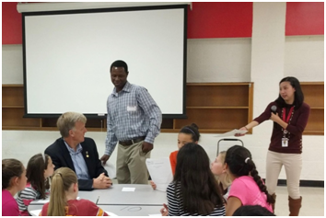

About 80 students from the Wellesley Middle School used a lesson plan developed by English teacher Claire Lee (standing, right) to exercise the iconic Rotary tool for decision-making. The Grade 6 students were invited to list good and bad decisions they remembered and weigh them using the Rotary Four-Way Test. They were also invited to participate in a writing contest expanding on the same topic. John Adams(seated, left), Cynthia Sibold and Bob Anthony represented the Rotary Club of Wellesley in offering the writers judged to be the top three prizes valued at $400.

To view the Rotary Four-Way Test Worksheet, click here.

To read the history of the Four-Way Test, click here.

READ MORE

To learn more about Wellesley Rotary, click here

Westborough Salutes Its Club’s War Veterans

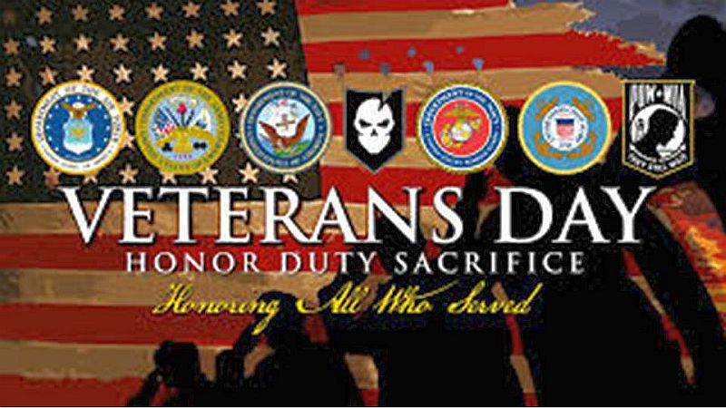

Shortly after the bell rang for the November 9 meeting of the Rotary Club of Westborough, President Gerry Gross took a moment to recognize and thank the club’s war veterans. Westborough Rotary is thankful to be among an honorable group of courageous men who have served our country over the years:
- Paul Gallagher: Army, Infantry, Korea
- Jim O’Connor: Army, New York National Guard, Captain
- Paul Reilly: Army, Captain, Desert Storm
- Jim Tepper: Marines, Colonel, Helicopter pilot, Vietnam
Thank you to these men and all men and women who have served to defend and protect the liberties we enjoy today!

To learn more about Westborough Rotary, click here.

On to Atlanta in 2017: Early-Registration Discount Ends December 15

Planning to attend? Contact District Chair Steve Glines.

More than 43,000 attendees left the Rotary International Convention in South Korea inspired to end polio for good, to celebrate The Rotary Foundation's centennial, and to champion changes that will help Rotary appeal to a broader audience. On the last day, RI President K.R. “Ravi” Ravindran shared a personal story of his mother’s triumph over polio.

To read the story, click here.

To register for the 2017 RI Convention in Atlanta, click here.

Pat and Skip Doyle Installed as '16-'17 DGs

District 7910's 2016 Rotary Youth Leadership Awards were held on June 24 through 26 at Fitchburg State University, ending with the installation of longtime RYLA supporters Pat and Skip Doyle as District Governors for 2016-2017. The three-day RYLA event was attended by 188 sophomores. To learn more about RYLA, visit ryla7910.org.

To watch a video of the installation, click here.

District Banners Available

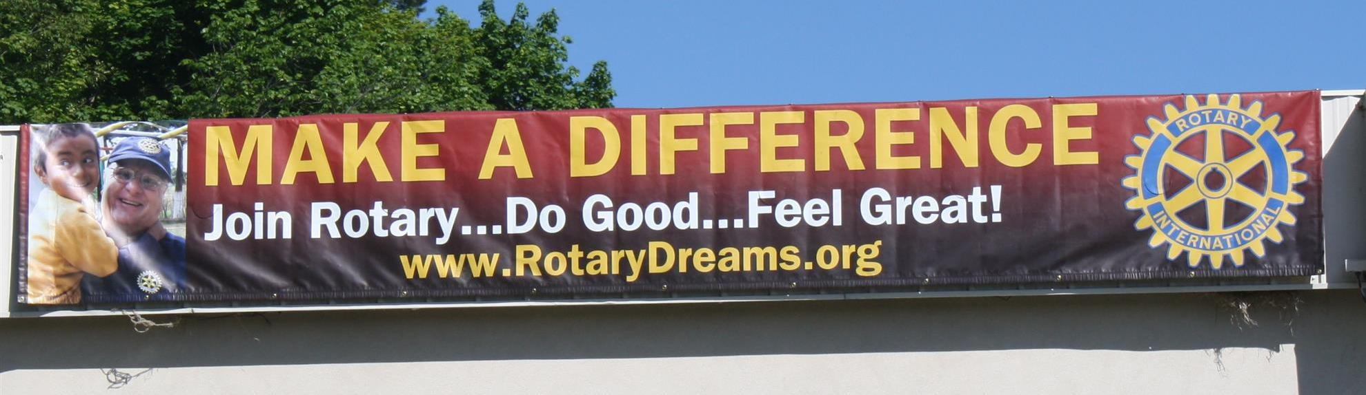

Our district banners are available for your use when you have an upcoming event or fundraiser.

If you want to reserve one of the banners, please contactPR Chair Laura Spear at laura@spear.net.

MAJOR DISTRICT & CLUB HAPPENINGS: FALL 2016

Today - Monday, December 5: Sturbridge Rotary - 'Lottery Ticket Raffle'

To download the event flyer, click here.

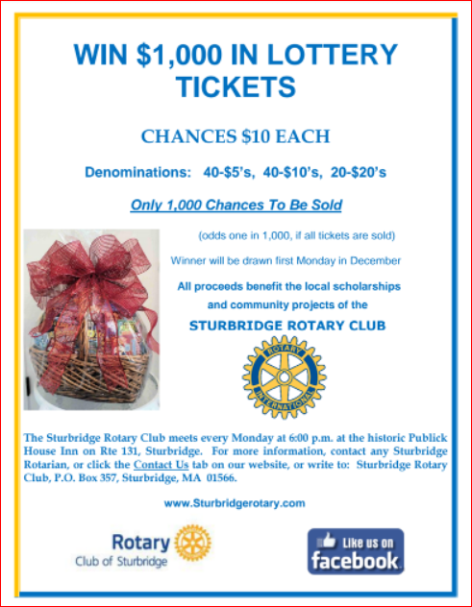

Through Wednesday, December 7: Framingham - 'Click & Bid 2016 Online Auction'

All proceeds benefit Framingham Rotary's community-service efforts.

To learn more and to bid, click here.

Wednesday, December 7: Rotary Means Business - 'Networking Fellowship for Rotarians and Friends'

To download the event flyer, click here.
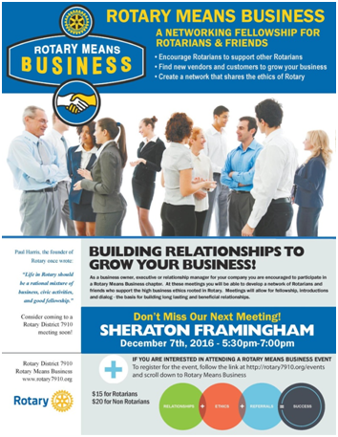

SUBMIT MAJOR CLUB HAPPENINGS

Send flyers of your club's major events and activities, in either JPEG or PDF format, to Immediate Past District
Governor/Newsletter Editor Jim Fusco at jim.fusco2@gmail.com.

