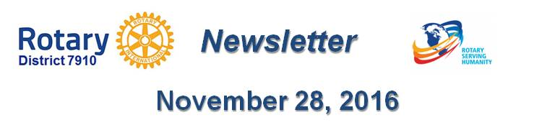

Needham, Wellesley Team Up for Annual Football Banquet
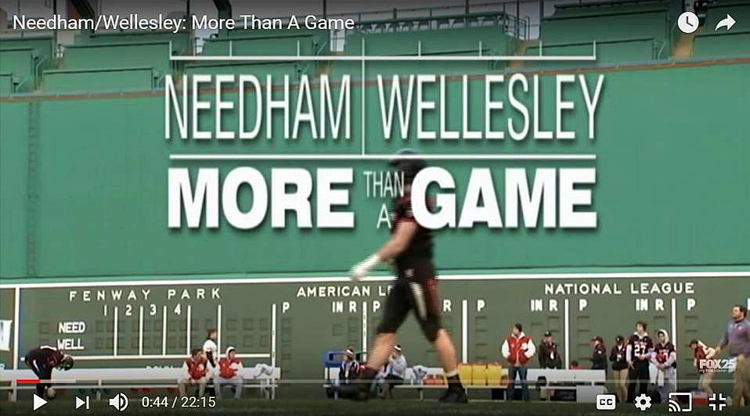In true Rotary spirit and camaraderie, The Rotary Clubs of Needham and Wellesley gathered recently at the Sheraton Hotel in Needham for their annual Football Banquet, hosted this year by Needham Rotary. After a welcome, the Pledge of Allegiance, song and prayer, Needham President Ted Shaughnessey and Wellesley President Scott Secrest gave the audience the background about Rotary and their respective clubs.

Guests were introduced, including the superintendents, principals and athletic directors of the Needham and Wellesley High Schools. Amid much applause, the head coached introduced their staff and senior players, including the captains.

Ted Shaughnessy then introduced guest speaker, Tom Leyden, sports director of Fox 25 News, who showed “Needham/Wellesley: More than a Game.” The superb 22-minute play-by-play video, which recalls the 2015 rivalry game played at Fenway Park, can be viewed on YouTube.

Leyden, who was the executive producer and narrator, made final comments, giving insight into making the production. Included were two views on “how to win:” one, from Wellesley’s point of view; and the other, from Needham’s.

Leyden spoke from the heart and from experience after “meeting, knowing and watching the kids,” he said. “On Thanksgiving morning, harness the power to understand. This is your final time. You know how to win.” As inspirational advice, he offered, “Soak in the emotion.” He concluded by urging the players to remember the details, remember the game, and “play your heart out.”
(On November 24, Thanksgiving Day, Wellesley defeated Needham by a score of 34-14.)
To learn more about Needham Rotary, click here.

To learn more about Wellesley Rotary, click here.

Return to November 28 Newsletter

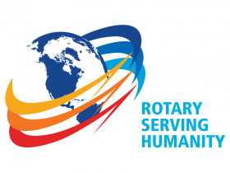
View past issues
Visit our website
'Like' our Facebook page
'Follow' us on Twitter

Needham, Wellesley Team Up for Annual Football Banquet

In true Rotary spirit and camaraderie, The Rotary Clubs of Needham and Wellesley gathered recently at the Sheraton Hotel in Needham for their annual Football Banquet, hosted this year by Needham Rotary. After a welcome, the Pledge of Allegiance, song and prayer, Needham President Ted Shaughnessey and Wellesley President Scott Secrest gave the audience the background about Rotary and their respective clubs.

Guests were introduced, including the superintendents, principals and athletic directors of the Needham and Wellesley High Schools. Amid much applause, the head coached introduced their staff and senior players, including the captains.

READ MORE

http://rotary7910.org/page/needham-wellesley-football-dinner-november-28-2016/

WATCH VIDEO

https://www.youtube.com/watch?v=4vs2MZ_BF7Q

To learn more about Needham Rotary, click here.

http://portal.clubrunner.ca/3694

To learn more about Wellesley Rotary, click here.

http://wellesleyrotary.org/

Ted Shaughnessy then introduced guest speaker, Tom Leyden, sports director of Fox 25 News, who showed “Needham/Wellesley: More than a Game.” The superb 22-minute play-by-play video, which recalls the 2015 rivalry game played at Fenway Park, can be viewed on YouTube.

https://www.youtube.com/watch?v=4vs2MZ_BF7Q

Leyden, who was the executive producer and narrator, made final comments, giving insight into making the production. Included were two views on “how to win:” one, from Wellesley’s point of view; and the other, from Needham’s.

Leyden spoke from the heart and from experience after “meeting, knowing and watching the kids,” he said. “On Thanksgiving morning, harness the power to understand. This is your final time. You know how to win.” As inspirational advice, he offered, “Soak in the emotion.” He concluded by urging the players to remember the details, remember the game, and “play your heart out.”

??? won this year’s rivaly by a score of ??? to ???.

To learn more about Needham Rotary, click here.

http://portal.clubrunner.ca/3694

To learn more about Wellesley Rotary, click here.

http://wellesleyrotary.org/

