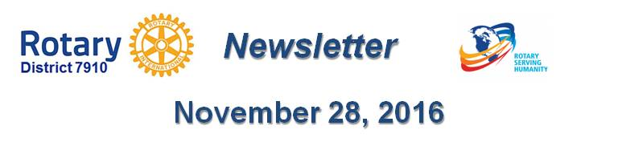

Make your press releases newsworthy
By Laura Spear

For a non-profit announcement to be considered newsworthy, it must have a broad, general interest to the target audience and a strong news angle (e.g. material information, new development, drama, human interest, local angle, consequence, etc.).

In addition, your release needs to be written in a journalistic, rather than marketing style. It should be objectively written as though a reporter were writing the story for you.

Most importantly, your release needs to “inform” people - not just sell them something. (From Network for Good.)

To learn more about PR for your club, click on the "Public Relations" section of the navigation bar of the District 7910 website.

Laura Spear, chair of District 7910's Public Relations Committee, may be reached at laura@spear.net.

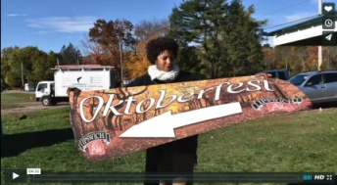Click here for an excellent example of a club-event promotional video by Concord President Steve Kirk.

Return to November 28 Newsletter

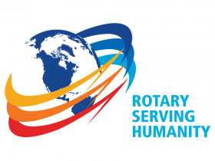
View past issues
Visit our website
'Like' our Facebook page
Follow' us on Twitter

