COMMITTEE REPORTS

'17 RI Convention in Atlanta: Discount ends December 15

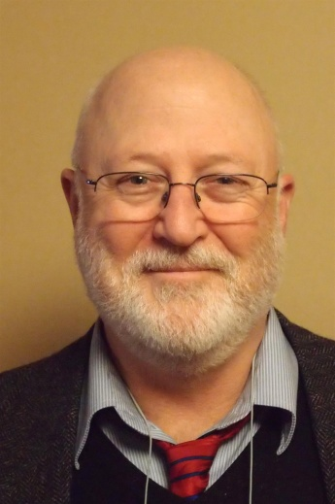

Here's a letter from Steve Glines, chair of the District International Convention Promotion Committee.

READ LETTER

To register and find hotel options, click here

For more information on the 2017 RI Convention in Atlanta, click here

Foundation Note: Update on Club-Qualification Status for Foundation Grants
By Sanjay Deshpande

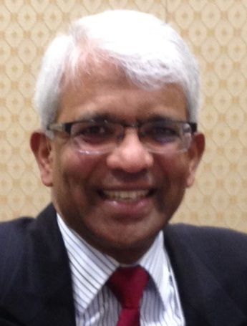
District 7910 conducted a third Grant Management Training session last week to help clubs, which had not participated in the earlier two training sessions, to qualify for Foundation grants during the rest of Rotary year 2016-2017, which ends next June 30.
As a result of last week’s session, our district now has 25 clubs that are fully qualified for participation in District and Global grants ‘16-‘17.

READ MORE

Rotary Means Business: First meeting on December 7

By Ron Bott

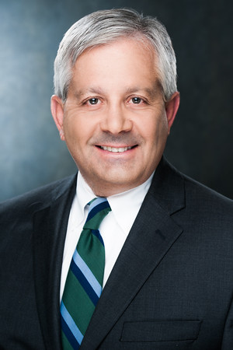

The first Rotary Means Business event in District 7910 will be held on Wednesday, December 7 from 5:30 to 7:30 p.m. at the Sheraton Hotel in Framingham. The cost is $15 for Rotarians and $20 for non-Rotarians. Light appetizers will be served and a cash bar will be available.

READ MORE

Polio Plus Update: Our goal is $35.60 per member

By Carl Good III

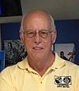

Our goal as a district is that each club can generate $35.60 per member for Polio Plus during the 2016-2017 Rotary year, which ends next June 30.

READ MORE

Membership Corner: How to Improve Membership in Rotary

By Tom Sturiale
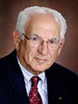

Our district has four important initiativesaimed at improving membership in our clubs. It is up to the clubs to take advantage of these efforts. A brief review follows:

READ MORE
To learn about the October 2016 Membership Workshops, click here.
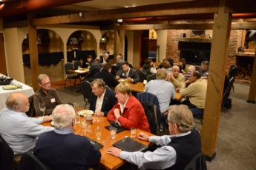

Membership Materials On Sale: Order now!
To order, click here

PR Tips: Make your press releases newsworthy

By Laura Spear
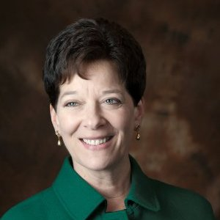

For a non-profit announcement to be considered newsworthy, it must have a broad, general interest to the target audience and a strong news angle (e.g. material information, new development, drama, human interest, local angle, consequence, etc.).

READ MORE

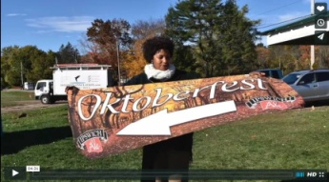

Click here for an excellent example of a club-event promotional video by Concord President Steve Kirk.

RAAGNE Newsletter: Update on visioning process

By Klaus Hachfeld

Hello, members and friends of the Rotary Alumni Association of Greater New England! Here is to the latest edition of the RAAGNE newsletter! Over the past year, we went through a visioning process to work out the future direction of RAAGNE.

READ MORE

Speaker's Bureau: Looking for good speaker for your club?

By Steve Levitsky

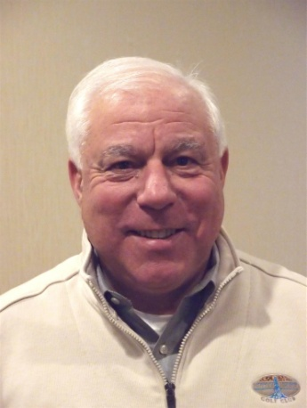

It's not always easy to come up with ideas week after week. We have many suggestions for you. Here are just a few:
- Rwandan genocide: Carine Boggis
- Elevator-pitch tips: Andy Winig
- Positive-results hypnosis: Bob Martel
- Differentiation and game-changing simplicity: Stephen Melanson
VIEW MORE

Interact Actions: How to launch an Interact club
By Bob Anthony
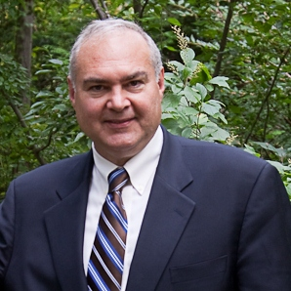

In Seminar 2 of the District Interact Teen and Advisor Training Seminar, held on September 17 in Needham, Bob Anthony, chair of the District Interact Committee, discusses “How to launch an Interact club,” including the certification letter, roles and responsibilities of the president, the Rotary advisor and, in the case of school-based clubs, the faculty advisor.

WATCH VIDEO

Treasurer's Report: Message about your dues

By Jack Hoell
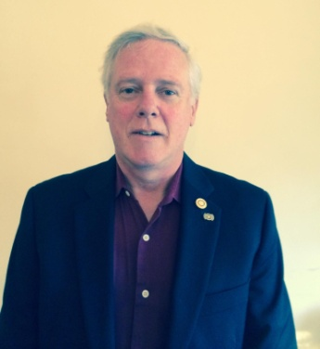

Rotary International dues bills will be invoiced in January based on membership numbers that are shown on your membership roster as of this December 31, so ensure that your membership numbers are accurate and up-to-date. District dues will be based on the same membership numbers that are used by Rotary International The RI and District dues bills will be sent to club presidents and secretaries in mid January.
READ MORE

District Charity Fund: How does DCF operate?

By Karin Gaffney
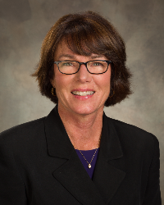

The District Charity Fund is a 501(c)3 charitable, non-profit that can be used by the Rotary clubs in District 7910.
READ MORE

Communications Link: Seeking club photo, video albums
By Steve Jones-D'Agostino
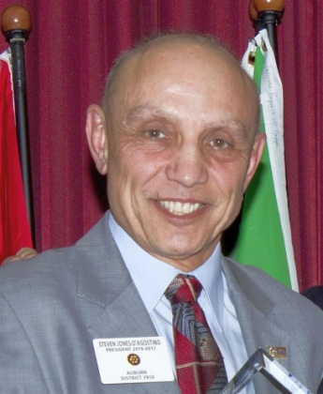

Does your District committee or Club have Rotary-related photo and/or video albums that you'd like to share with other Rotarians?
READ MORE

SUBMIT CONTENT
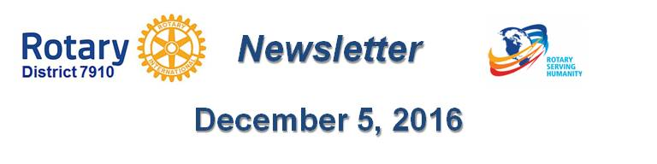

To submit content for consideration for the Monday, December 5 issue of Rotary District 7910 Newsletter, please e-mail it to Immediate Past District Governor and Newsletter Editor Jim Fusco at jim.fusco2@gmail.com.
The submission deadline for that issue is Friday, December 2. All text must be in Word format. All images must be in either JPEG or PDF format. Please identify the people, left to right, who are shown in your photos, including their first and last name as well as their club or other title.

PAST ISSUES
To view past issues of the weekly Rotary District 7910 Newsletter, click here
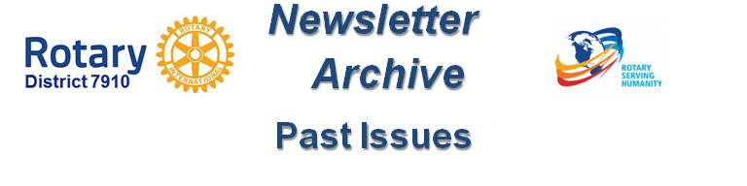

DISTRICT 7910 ONLINE

Visit our website
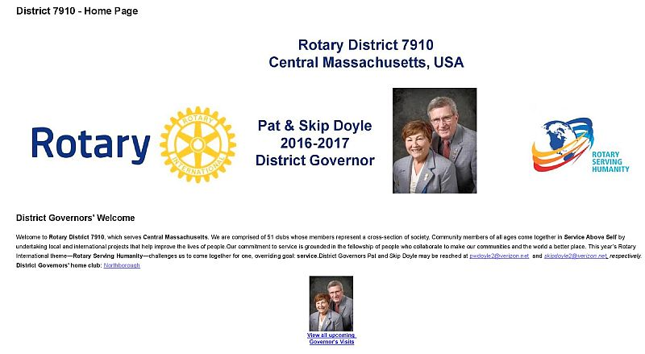

'Like' and share us on Facebook
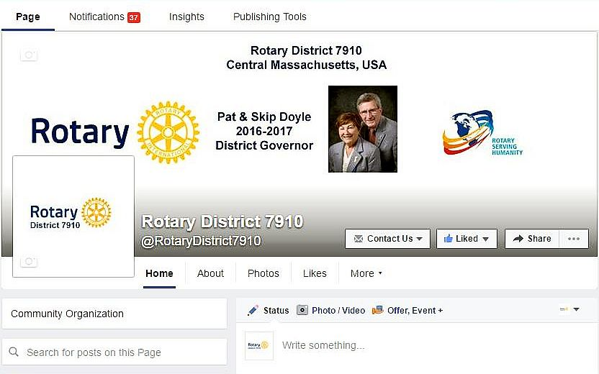

Watch our videos on YouTube
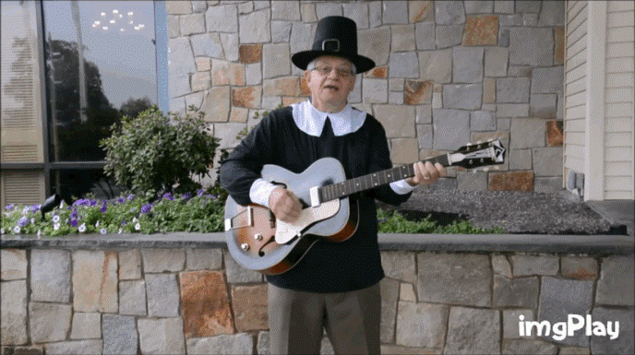

View our photos: on Google Photos, since May 2015; and on ClubRunner, before May 2015
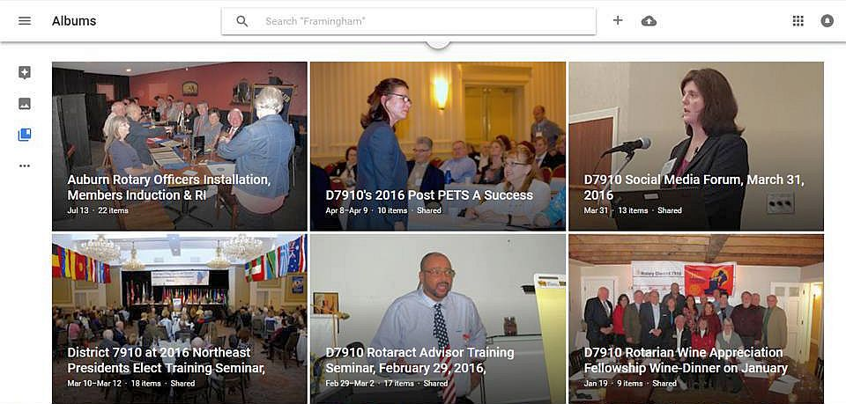

CONTACT US
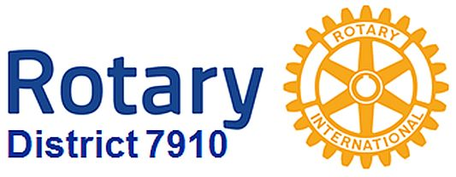

Jim Fusco, Immediate Past District Governor and Newsletter Editor
​jim.fusco2@gmail.com
Steve Jones-D'Agostino, District Webmaster and Newsletter Copyeditor
​srdagostino@icloud.com
© Copyright 2016-2017 - Rotary District 7910, Central Massachusetts, USA

