Dear $NICK_NAME$,

It is our pleasure to share with you the November 7 issue of Rotary District 7910 Newsletter.

For the complete issue, click here.

To explore past issues, click here.

Highlights of November 7 issue:

Governor's Message: District-wide Food Packaging Event in 5 days - By Pat and Skip Doyle

District-wide Food Packaging Event: Saturday, November 12 at Solomon Pond Mall in Marlborough - By Carol Toomey

District Governor-Elect Report: Linda Cargiulolo of Bedford Rotary, on why should we go to the Rotary International Convention - By Karin Gaffney

PolioPlus Update: Tracking World Polio Day events - By Carl Good III

Membership Corner: The Rotary 'why' factor - By Tom Sturiale

Rotary Leadership Institute: Next RLI in our area is scheduled for November 12 in Chicopee - By Doug Detweiler

RAAGNE Newsletter: Update on visioning process - By Klaus Hachfeld

Foundation Note: Available District Designated Funds for Global Grants - By Sanjay Deshpande

PR Tips: ??? - By Laura Spear

Interact Actions: How to launch an Interact club - By Bob Anthony

Speakers Bureau: Do you need a speaker for your club? By Steve Levitsky

Communications Link: Seeking club photo, video albums - By Steve Jones-D'Agostino

Treasurer's Report: Message about your dues - By Jack Hoell

District Charity Fund: How does DCF operate? - By Al Bowers

Our next newsletter will come out on Monday, November 14. The submission deadline is this Friday, November 11. Text content must be submitted in Word format. Image content must be submitted in either JPEG or PDF format. Send your content submissions to Immediate Past District Governor/Newsletter Editor Jim Fusco at jim.fusco2@gmail.com.

Governors Pat & Skip

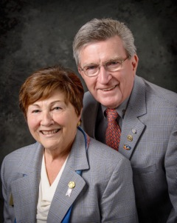Pat and Skip Doyle
2016-2017 Governors
Rotary District 7910
pwdoyle2@verizon.net
skipdoyle2@verizon.net

