SUBMIT EVENTS
You may submit event information per the District 7910 Promotional Guidelines. If your club does not use ClubRunner, please send your event information to Rotary District 7910 Newsletter. And make sure to add the e-mail address of Immediate Past Governor/Newsletter Editor Jim Fusco, jim.fusco2@gmail.com, to your club's distribution list.





DISTRICT EVENTS

NOVEMBER 14-28, 2016
Nomination Committee Conducts Interviews

Tonight - Monday, November 7

Hilton Garden Inn, Marlborough​​​

RC Tyngsboro-Dunstable Governor's Visit

Thursday, November 10
7:15-8:30 a.m.

RC Tewksbury Governor's Visit

Thursday, November 10
12:15-1:30 p.m.

Rotary Food Packaging Event - All Clubs in District 7910

Saturday, November 12
12:00 noon-3:00 p.m.

Solomon Pond Mall, Marlborough

Nomination Committee Conducts Interviews

Monday, November 14

Presidents-Elect Training Webinar

Monday, November 14
6:00-7:00 p.m.

Public Relations Committee Meeting

Wednesday, November 16
6:30-8:30 p.m.

Membership Committee Meeting

Tuesday, November 22
6:30-8:30 p.m.

Holiday Inn, Boxborough

Foundation Committee Meeting

Monday, November 28
6:30-8:30 p.m.

VIEW THESE PLUS MORE UPCOMING DISTRICT EVENTS - INCLUDING ALL GOVERNOR'S VISITS

RI SPOTLIGHT

Young Leaders in Action

To submit a video for the Interact Video Awards, click here

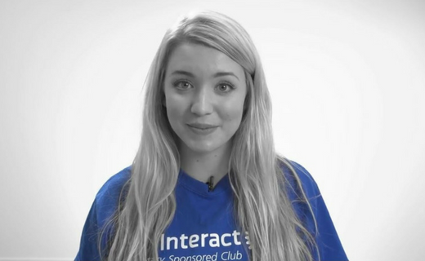

Medical Mission Brings a Healing Touch to Rwanda

READ MORE



Haiti Devastated by Hurricane Matthew

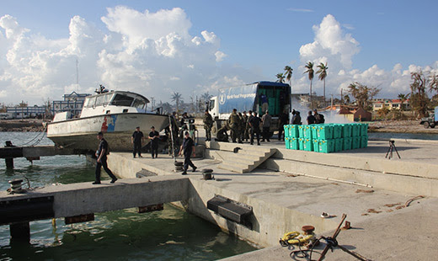

Even as parts of Haiti were still recovering from a catastrophic 2010 earthquake, Hurricane Matthew tore through the impoverished island country on October 4, leaving hundreds dead and many more homeless.

READ MORE

Did You Know: November 19 is UN World Toilet Day

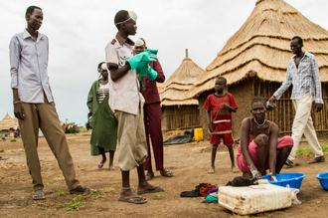

The United Nations estimates that 2.4 billion people do not have adequate sanitation, and that 1 billion of these people still defecate in the open.

READ MORE

'Rotary Leader' Newsletter: Highlights

Click on each box to go to that section

Building Peace and Helping Refugees in Nigeria

The Rotary Club of Yola-AUN is located on the campus of the American University of Nigeria, smack-dab in the region where Boko Haram is most active.
READ MORE
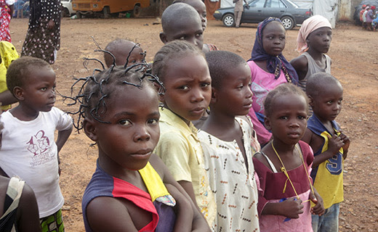

Membership Minute: Impact Begins with You

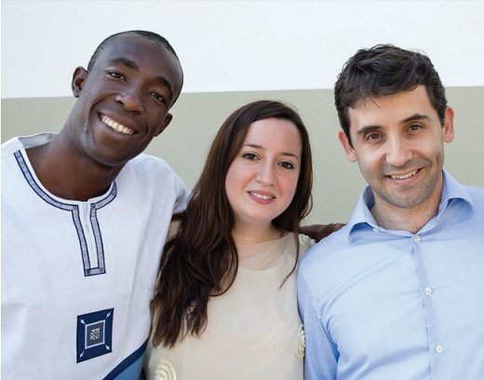

A positive member experience begins long before someone joins a Rotary club. Start by introducing prospective members to Rotary with the Impact Begins With You brochure.

READ MORE

Dean Rohrs: '16-'17 RI Director for Zones 24 & 32
Dean's November newsletter is here. <click here>
To read her highlights of the latest RI Board of Directors meeting, click here.
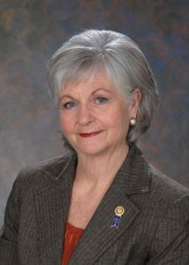

Meet Jeff Cadorette: Our New RI Director

READ MORE
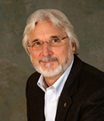

Sam Owori Selected as '18-'19 RI President

Sam Owon is a Ugandan businessman and a member of the Rotary Club of Kampala.

READ MORE

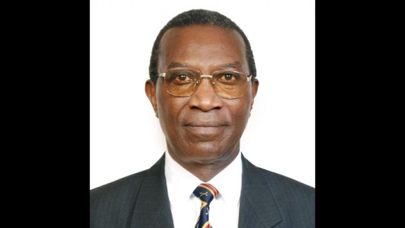

A Letter from '16-'17 RI President John Germ

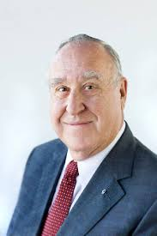

Dear Fellow Rotarians,

Part of moving Rotary forward means providing you and your clubs with the tools you need to succeed. A project that I’m proud to have launched this year is the upgrade of Rotary Club Central. READ MORE
Download the World Polio Day toolkit

For information on the April 2017 Rotary International Convention, click here.
Read John Germ's Membership Message

Read a profile of John Germ

Visit the President’s page

Great Video: Meet Your President

Campaign to End Polio: What you don't know
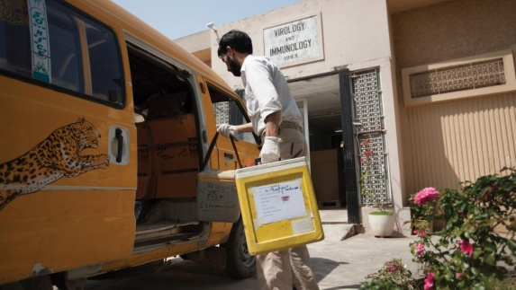

When was the last time there was polio in Europe?

READ MORE

What Millennials Love about Rotary

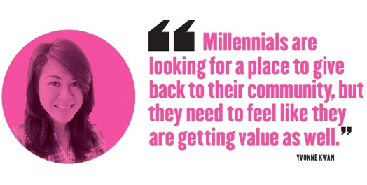

Millennials, an ethnically diverse, fiercely independent generation of digital natives, are doing more than just snapping selfies—they’re looking for a way to make a difference in their communities.

READ MORE

Get Ready for Your District Rotary Foundation Seminar
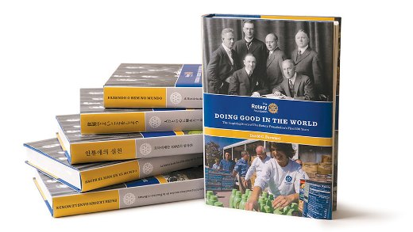

The Rotary Foundation is celebrating its 100th year of Doing Good in the World. Take the opportunity to strengthen your district and clubs during your district Rotary Foundation seminar by using resources from centennial.rotary.org.
Go to the Promotional resources tab to download the following Centennial Promotional Kit materials:
- Ideas and activities for clubs
- Doing Good in the World promotional flier
- Doing Good in the World bookmark
- Sample press release
- Centennial letterhead
- Centennial PowerPoint template
- History of the Rotary Foundation PowerPoint
- Centennial postcard
Let others know about these materials they can use to promote the Foundation in their clubs and communities.

Membership Materials on Sale: Order Now!

To order, click here

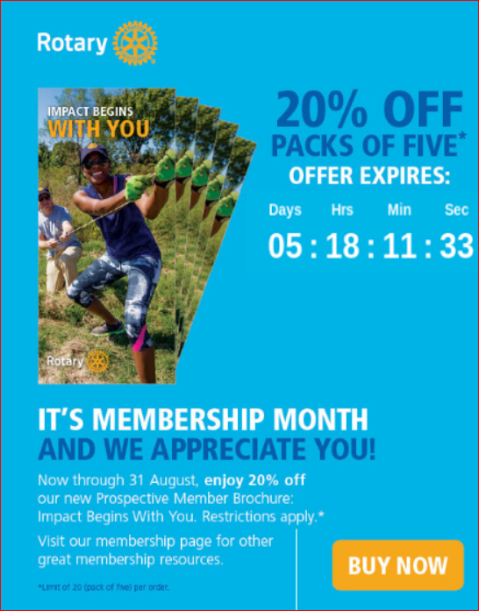

New Tools for Membership Tool Belt
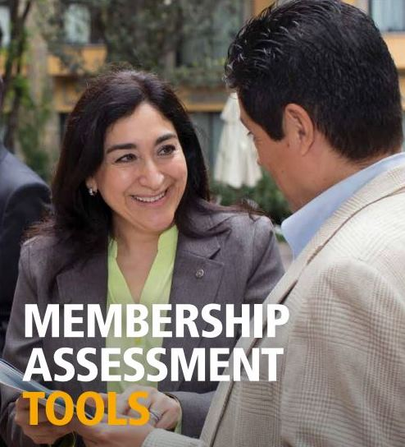

Looking to enhance your club membership experience?

READ MORE

A How-To Membership Leads Video
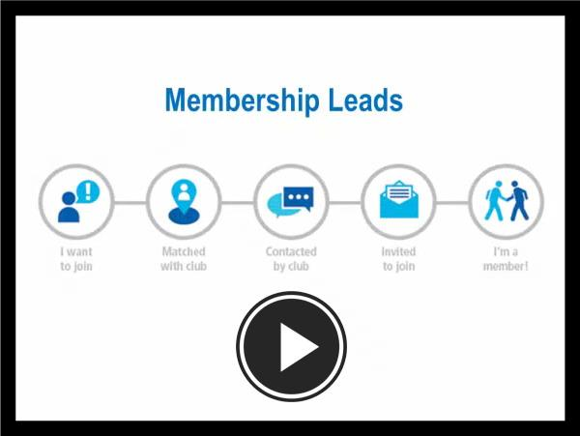

Click here for a new video that helps district and club leaders make the most of the recently enhanced Membership Leads resource. It shows how to track a prospective member from the initial membership-leads submission all the way to connection with a local club. It also outlines the role of club and district leaders in the redesigned process, highlighting how their participation will help strengthen membership, and features the new Rotary resources available to support them. Join the conversation in the Membership Best Practices discussion group to tell us how you’re using the new Membership Leads resource to grow and diversify membership.

RI Membership Resource Guide
To download in PDF format, click here
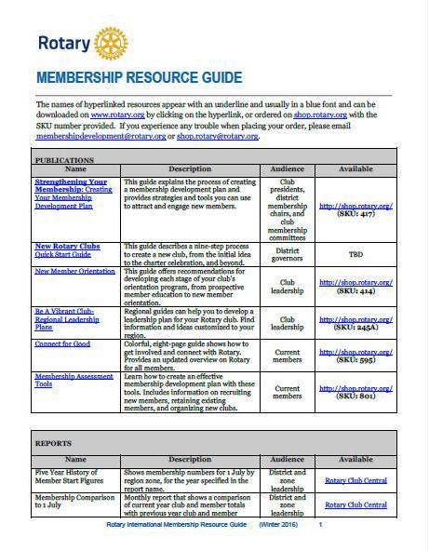

RI Makes Changes in 'Brand Center' Online Tool

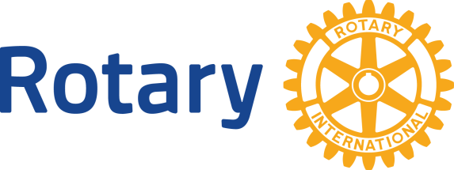

We hope that you've found Rotary International’s Brand Center a useful tool to createcustomized logos and brochures - and to tell Rotary's story in a consistent and engaging way. To gain access, you will need to login with your Rotary Membership ID.

Rotary Global Rewards: Sign-Up Today!
Click here for more information

Click here to e-mail District Chair Judy Merrimam

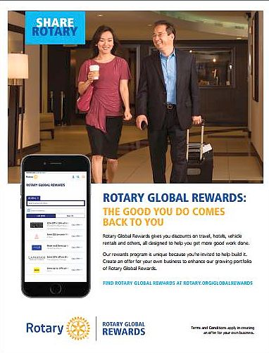

Have you tried Rotary Global Rewards — Rotary International’s new member-benefit program that offers discounts on travel, hotels, dining, entertainment and more? Rotary Global Rewards will make your Rotary membership even more rewarding.

'16-'17 Rotary Theme: 'Rotary Serving Humanity'
To download the image in JPEG format, click here.



Check Out 'Rotary Voices' Blog



Check out Rotary Voices, the official blog of Rotary International. This blog features stories by and about Rotary members, Rotary program alumni, and the people we partner and work with.

