These are the articles posted during Rotary 2016-2017

November 2016:

November 7: The Rotary 'why' factor

October 2016:

October 31: Membership Workshops Recap

October 17: Membership Workshops start on October 24

September 2016:

September 5: Corporate memberships in Rotary

September 19: What are our Rotary objectives? Membership! Membership! Membership!

September 26: Rotary club objectives

August 2016:

August 1: What would Paul Harris do?

August 8: Where will we find new members?

August 15: How do we approach prospective members?

August 22: Visioning

August 29: Unique approach to publicize Rotary by Northborough

July 2016:

July 4: RYLA is a great membership opportunity

July 11: Rotary - It's a New Year

July 25: Are we volunteers – or are we Rotarians? What’s the difference?

Please let Tom know any ideas, comments and/or stories for "Membership Corner" that you would like to share. E-mail Tom at tsturiale36@gmail.com.

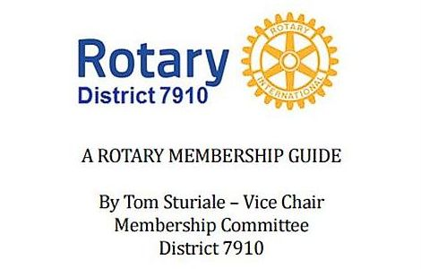"A Rotary Membership Guide" is a collection of "Membership Corner" articles written for this weekly newsletter during the 2015-2016 Rotary year, which began July 1, 2015. Each article is intended to offer an idea or thought aimed at stimulating discussions, questions and actions, to effectively increase membership at all our clubs.

Click here, to read and download this 52-page "Guide," in PDF format.

