GOVERNOR'S MESSAGE

COUNTDOWN TO OUR DISTRICT-WIDE FOOD PACKAGING EVENT: 5 DAYS LEFT
By Pat and Skip Doyle
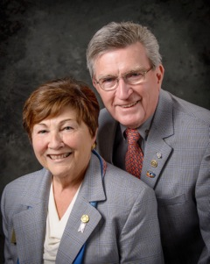What is our goal for the next 5 days? To raise as much money as possible to support our District Stop Hunger Now Food Packaging Event next Saturday, November 12 from 12:00 noon to 3:00 p.m. at the Solomon Pond Mall in Marlborough.
We are thankful for the many members, young and old, as well a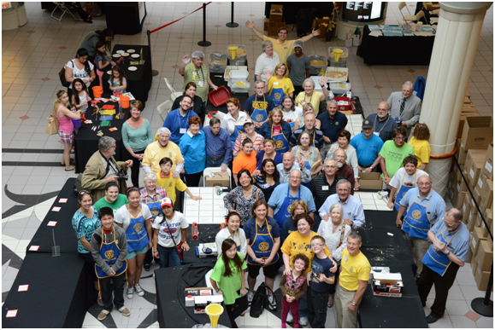s their families and friends who are volunteering to help us package the meals. But more help also means we need more food to package. And that means we need more monetary donations to provide the raw materials. Please visit our Stop Hunger Now website and make a donation. To both donate and volunteer,
click here.

We had fun last year! Join the fun this year!

Always remember, you can call us with questions at 508-393-9031.

District Governors Pat and Skip Doyle may be reached at pwdoyle2@verizon.net and skipdoyle2@verizon.net,
respectively.

Click here to submit content for the November 14 issue to Immediate Past District Governor/Newsletter Editor Jim Fusco. The submission deadline is November 18.

Click here for past issues.

WELCOME, NEW ROTARIAN
- John Bushnel, Gardner
- Daniel Cetrone, Marlborough
- Sarah Galvin, Gardner
- Matt Hollister, Concord
- Patt Kane, Uxbridge
- Madeline, Merchant, Montachusett Area
- Omisore Mobolaji, Natick
- Molly Mullen, Uxbridge
- Benjamin Ramsey, Marlborough
- David Smith, Worcester
- Rick Stock, Auburn

CLUB MEMBERSHIP GROWTH, ’16-‘17

We share with you the results of club-membership growth in our district during Rotary year 2016-2017, which began July 1.

This is a unique opportunity for Rotarians and friends to discuss partnering on humanitarian projects affecting our local communities.

READ MORE

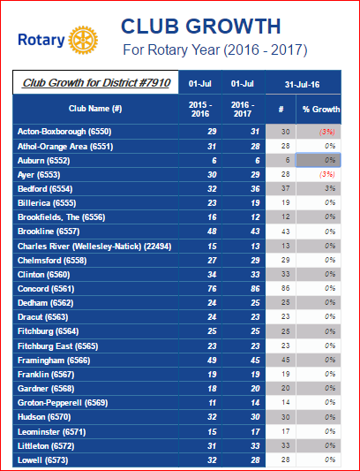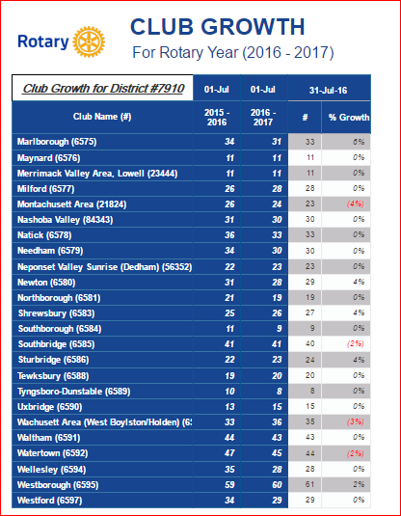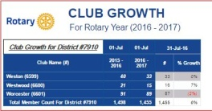

CLUB PLANNING WORKSHEET '16-'17
In both Excel and PDF formats, we share with you the Club Planning Worksheet for Rotary year 2016-2017, which began on July 1.
Please enter your club information in the indicated cells.

Excel Format

PDF Format

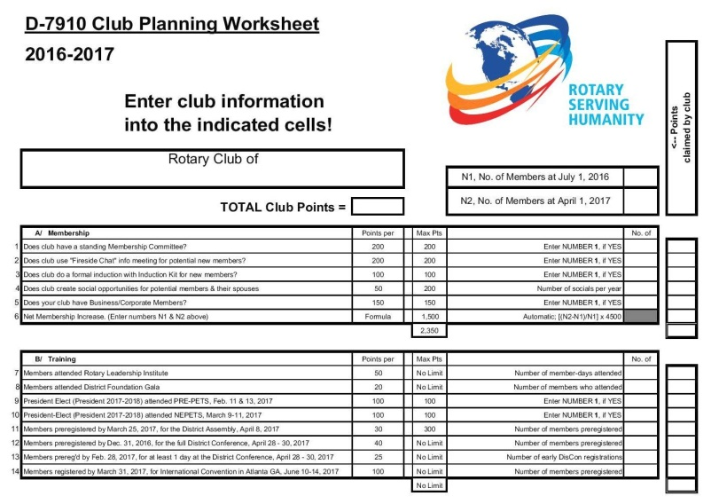

OUR PRESIDENTS SPEAK

Linda Cargiulolo of Bedford Rotary
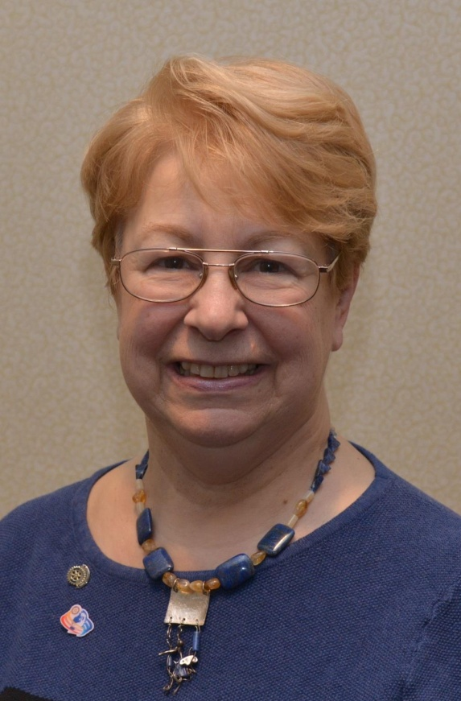

Please tell us what factors helped you decide to join Rotary.
My manager was president of the Rotary Club of Lexington and thought that it would be good experience for me. The projects kept me busy and involved.

READ MORE

DG VISITS LAST WEEK

Natick (chartered 1927)

Left to right: District Governor Skip Doyle; President Vincent Tingle; Assistant Governor Kevin Fry; and District Governor Pat Doyle.

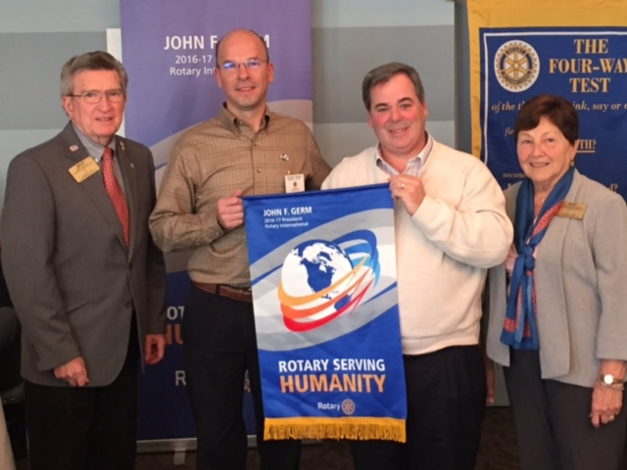

DISTRICT & CLUB ROUNDS

Framingham Helps Students with Real-life Finances

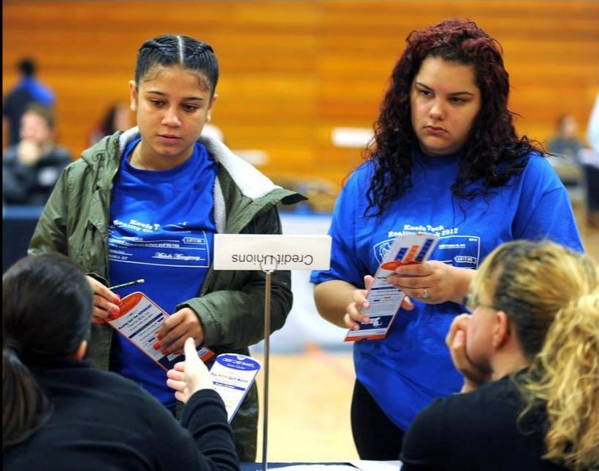

From student-loan debt to the soaring cost of housing, students got a glimpse of what their financial futures might hold during a Reality Check event on October 28 at Keefe Regional Technical School in Framingham. Reality Check is being started by the Rotary Club of Framingham with the assistance of the Keefe Tech chapter of Business Professionals of America and the MetroWest Regional Chamber of Commerce.

Left to right: Raissa Reis and Bianca Rodriquez learn about credit from Framingham Rotarians during Keefe Technical High School’s “2016 Reality Check” for seniors.

Photo: Alan Jung, MetroWest Daily News and Wicked Local.

READ MORE

LEARN MORE

Marlborough Reality Fair Opens Eyes and Doors

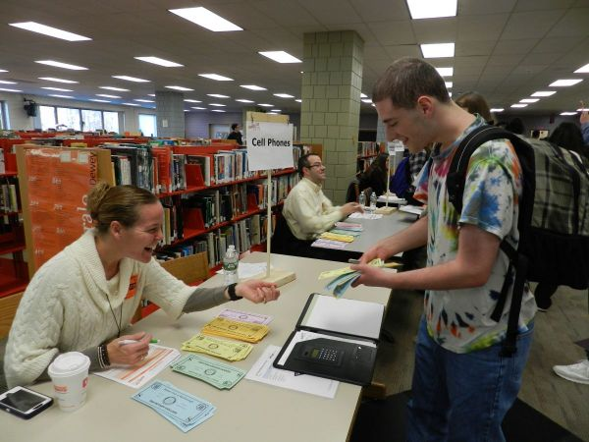

Marlborough High School seniors asked volunteers many career-related questions as they visited the various businesses and organizations at the annual Reality Fair held on November 1 at the high school. In its 12th year, the Reality Fair was brought to the high school by Peggy Thorsen, who established the fair during her first year as the president of the Rotary Club of Marlborough.

Photo: Marlborough Public Schools

READ MORE

Marlborough to Host Turkey Shoot: Saturday, November 19

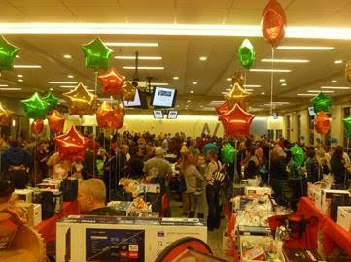

The Rotary Club of Marlborough will hold their 34rd Annual Turkey Shoot on Saturday, November 19 at 6:00 p.m. at Assabet Valley Regional Technical High School in Marlborough. The last prize should be won by 9:00 p.m.
READ MORE

Merrimack Valley Holds Eye Clinic in Chelmsford

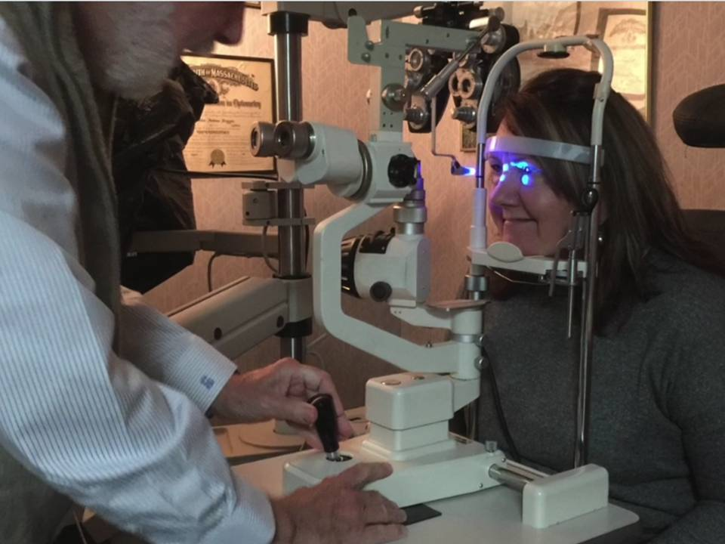

Drs. Florence Bejian and John Duggan of Valley Eye Associates with the help of fellow Rotarians from the Rotary Club of Merrimack Valley, recently provided eye testing and complimentary glasses, care of the generous sponsors Bausch & Lomb, Red Paris Optical and ABB/Digital Eye Lab, to 18 patients at their office in Chelmsford.

To watch a one-minute video, produced by Concord President Steve Kirk, click here.

Milford Helps Nipmuc Students Get Political

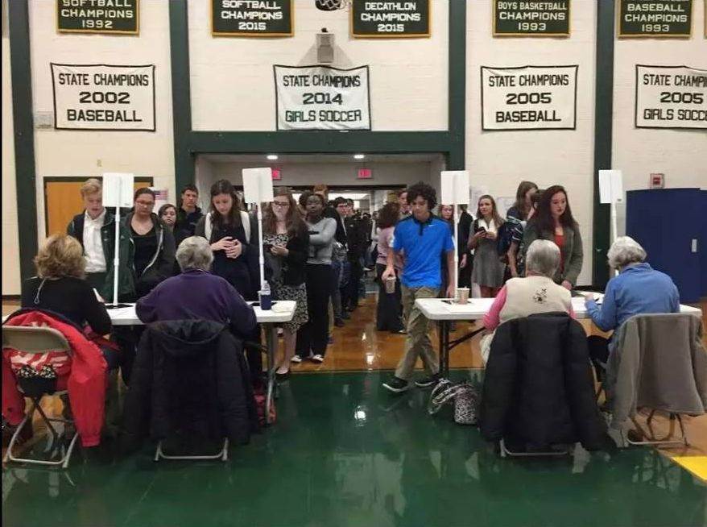

Although most students at Nipmuc Regional High School are not old enough to vote in the upcoming presidential election, they all received hands-on political experience on October 26 during several civics workshops, including a mock town meeting and election, in which the Rotary Club of Milford participated.

Photo: Corin Cook, Milford Daily News.

READ MORE

Needham to Host Thanksgiving Dinner

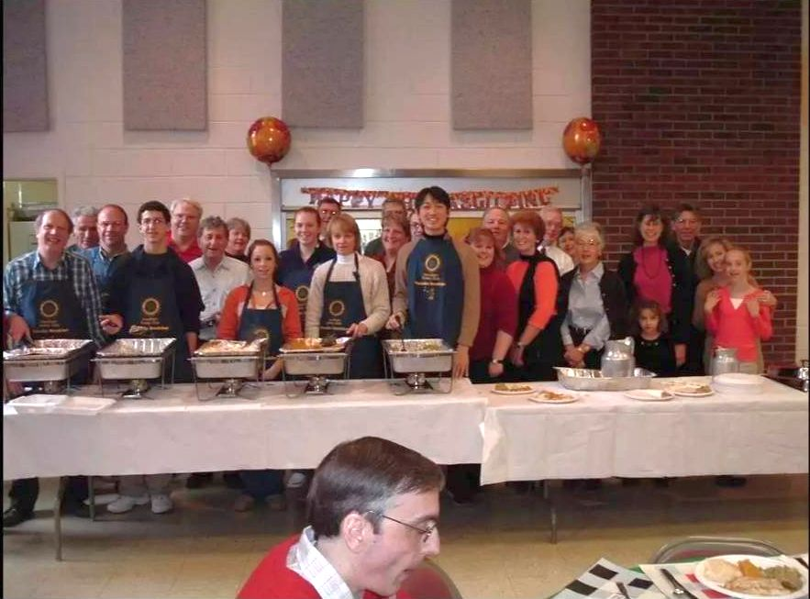

The Rotary Club of Needham Rotary will host a free Thanksgiving Dinner at 11:30 a.m. on Thursday, November 24 at 11:30 a.m. at the Masonic Hall, located at 1101 Highland Ave. in Needham.

Shown: Needham Rotarians volunteer to prepare and serve the turkey dinner.

READ MORE

Westborough Partners on Community Thanksgiving Dinner

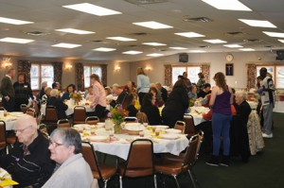

The Westborough Community Thanksgiving Dinner team, which includes the Rotary Club of Westborough, will hold its 46th annual free community gathering on Thursday, November 24 at 1:00 p.m. at the Knights of Columbus 85 Hall, located at 17 Willow St. in Westborough. A traditional Thanksgiving Dinner of turkey, stuffing, mashed potatoes, vegetables, cranberry sauce, apple cider, and pumpkin pie and assorted desserts will be served. Reservations are required by calling 508-366-3000. Free transportation may be scheduled, if necessary.

Shown: Guests at the 2013 community gathering enjoy a Thanksgiving dinner at the Knights of Columbus Council 85 hall in Westborough.

Photo: Knights of Columbus Council 85.

READ MORE

Westborough Readies for ‘16 Festival of Lights

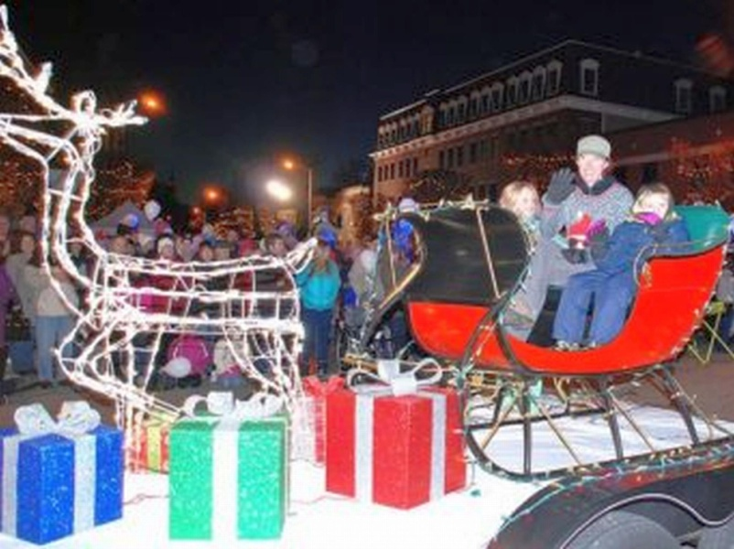

For the second year in a row, the Westborough Economic Development Committee is partnering with the town’s Recreation Department to host a Holiday Stroll on November 27, the Sunday of Thanksgiving weekend. That evening, the Rotary Club of Westborough will also sponsor its annual Festival of Lights, which has become a favorite for the town’s families and a beloved way to start the holiday season. For many years, the club has, as a service project, provided funding for the lights to be lit up in the trees in the downtown area.

Shown: A float sponsored by Uhlman’s Ice Cream rides by the rotary in downtown Westborough during the 2015 parade.
File photo: Ed Karvoski Jr., Community Advocate

READ MORE

Westborough Partners with Public Library for Repair Cafe

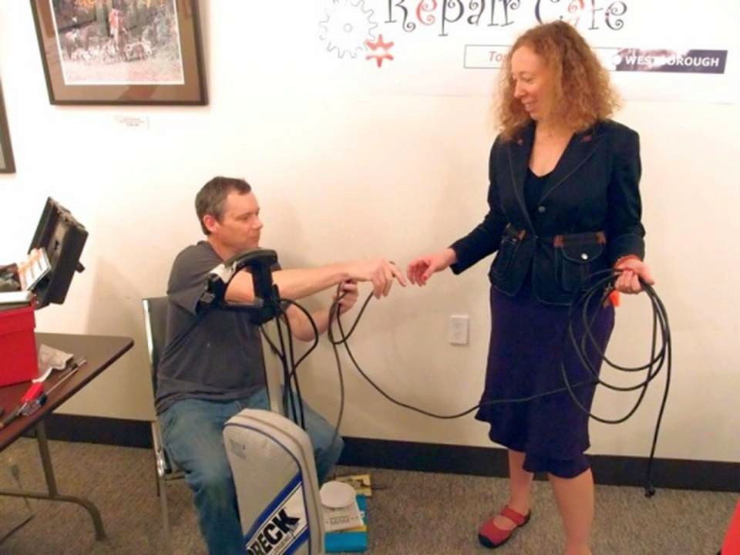

The Rotary Club of Westborough and the Westborough Public Library sponsored their third Repair Café on October 22 at the library. Twenty-five residents brought more than 50 items to be adjusted, sewn sharpened, tuned up and repaired. Although not every item was able to be fixed, everyone was appreciative of the opportunity to have a skilled volunteer determine if their “stuff” could be salvaged, or if it was time for the recycling bin.

Shown: Brian Martel (left) successfully repairs a vacuum-cleaner power cord for Corrine Rosseel (right).

VIEW PHOTOS (photo supplement produced by Westborough club photographer Ron Goodenow)

Westborough Presents Bandey Hefler Flags

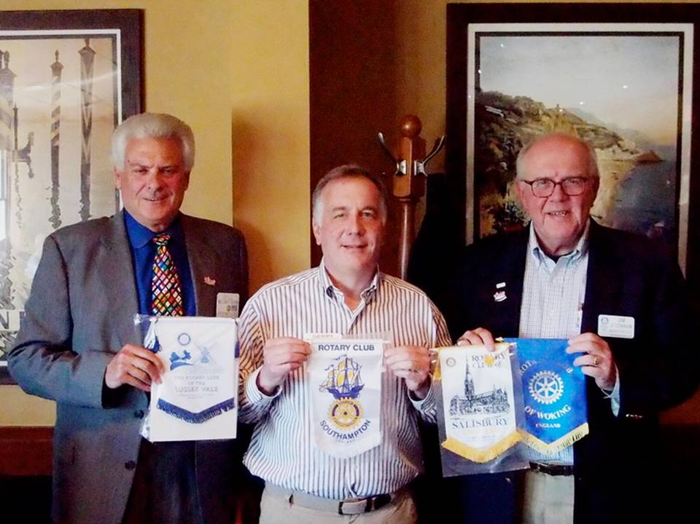

Sergeant at Arms Bill Bloom (left), President Gerry Gross (middle) and Immediate Past President Jim O’Connor (right) of the Rotary Club of Westborough are shown during a recent club meeting presenting the Rotary club flags they received during their Bandey Hefler Fellowship Exchange visit in September to England. Bill is holding the Sussex Vale flag, Gerry is displaying the Southhampton flag, and Jim is showing the Salisbury and Woking flags. “The Bandy Hefler Exchange is truly a rewarding experience, including the hosting in the U.S. and being hosted by Rotarians in Britain,” Jim states. “I recommend the experience to any fellow Rotarian in District 7910.”

READ MORE & VIEW PHOTOS OF SEPTEMBER TRIP

District Membership Workshops a Huge Success
District 7910 conducted a total of four regional Membership Workshops on October 24, 25 and 26. The workshops were a response to many requests for meeting locations nearer club bases and more interactive discussions rather than a forum-speech format. The workshops were well-attended and the discussions were wide-ranging and very interesting. The comments are being summarized and will be distributed to all participants.

Shown: The Membership Workshop on October 25 at Chuck's Steak House in Auburn, which was attended by members of the Auburn, Brookfields, Marlborough, Northborough, Shrewsbury, Southborough, Southbridge, Sturbridge, Uxbridge, Westborough and Worcester clubs.

READ MORE

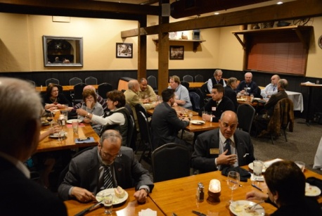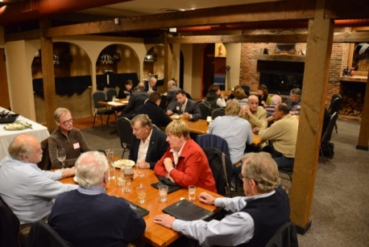

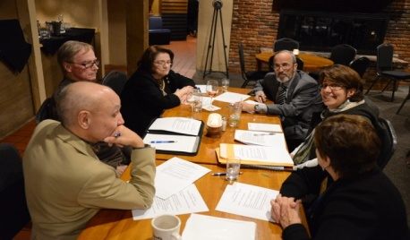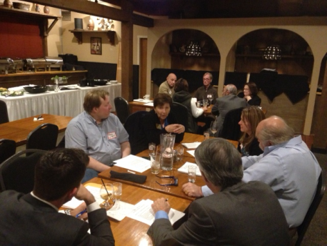

Acton-Boxborough, Littleton Raise $15,000 for Food Pantries

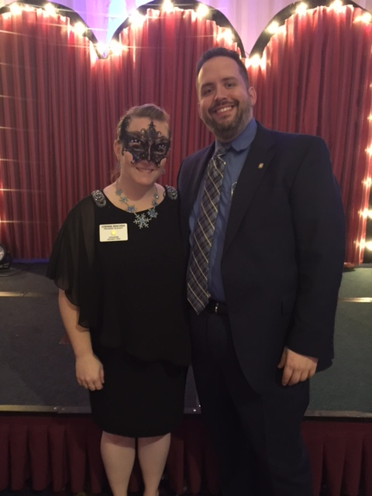

The Rotary Clubs of Acton-Boxborough and Littleton held their Annual Rotary Masquerade Ball on October 22 at the Holiday Inn in Boxborough to benefit two local food pantries: Loaves and Fishes Food Pantry; and The Acton Community Supper and Food Pantry.

Left to right: Littleton President Corinne Braciska, and Acton-Boxborough President Joe Badenhoff.

READ MORE & VIEW PHOTOS

To learn more and view event photos, click here.

Auburn Greets ESSEX Students At Pancake Breakfast

Left to right: Greg Reimonn, an ESSEX (Eastern States Student Exchange) student from Hopkinton, Worcester Railers Hockey Club mascot Trax; ESSEX student Yuka Ichikawa from Japan, and ESSEX student Kaitlyn Denson from Hopkinton.

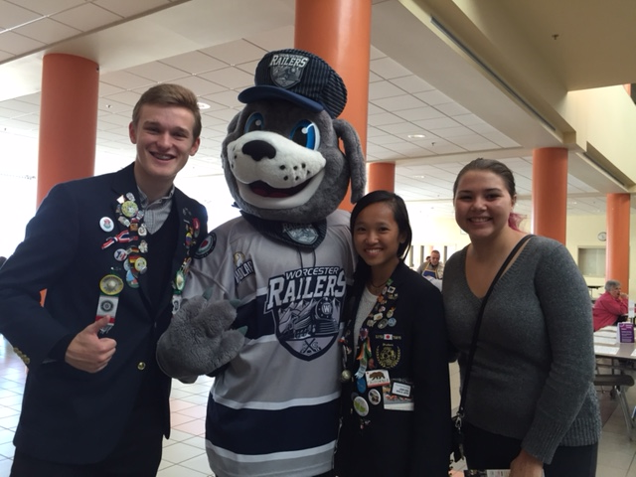

Franklin Chalks One Up for Charity

To view event photos, click here.

READ MORE

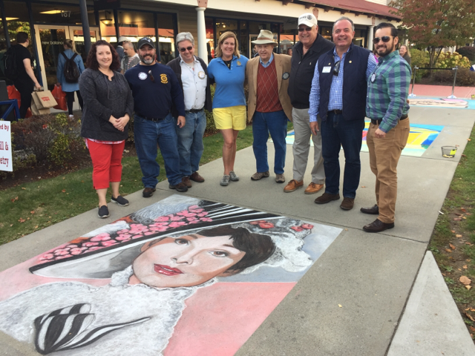

l

Left to right: First-place artist Kerry Wippie; President Elect Scott Martin; Past President and Board Member Fran McKeown; Past President and Vocational Services/RYLA Chair Julie Rougea; Past President Herb Hunter; Past President and Board Member Dan Gentile; President Terry Katsaros; and new Member Carlos Aguilera.

Sturbridge, Stoubridge Celebrate Sister Club ‘Rotary Friendship Day’

Since 1988, the presidents of the Rotary Club of Sturbridge and its Sister Club, the Rotary Club of Stourbridge, U.K., have exchanged letters of greetings and goodwill in October via snail-mail. The chair of the Sturbridge Board of Selectmen also mails a proclamation declaring October 16 as Stourbridge/Sturbridge Rotary Friendship Day and likewise, the mayor of Dudley in the U.K. does the same for the Sturbridge Club.

Shown on top, left to right: Sturbridge President Otto Prohaska and Sturbridge Selectmen Chair Mary Blanchard.

Shown on bottom, left to right: Stourbridge President Rob Franks, Dudley Mayor Mohammed Hanif, and Dudley Mayoress Zabeda Khanam.

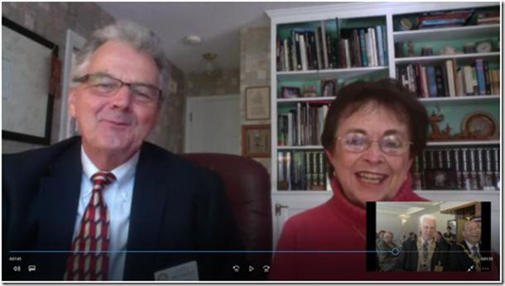

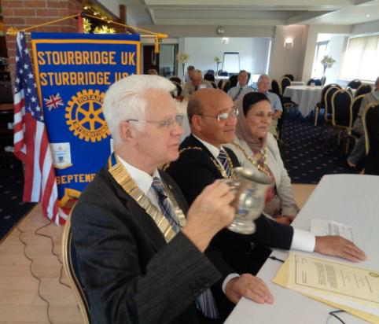

This year for the first time, the greetings were exchanged live via Skype. Mary Blanchard, chair of the Sturbridge Selectmen, and Sturbridge Rotary President Otto Prohaska arrived early at the home of Past District Governor Klaus Hachfeld and his wife and fellow Sturbridge Rotarian, Glenys Hachfeld, to deliver their messages during the regular weekly luncheon meeting of the Stourbridge Club. Similar messages from the Stourbridge President Rob Franks and Dudley Mayor Mohammed Hanif were reciprocated.

The meeting concluded with President Franks toasting the health of the Sturbridge members using the tankard that Sturbridge had presented to them 28 years ago. The friendship has remained strong with nine visits alternating between clubs. Note the twinning banner in the background of the U.K. photo.

Wellesley Hears from Polish Senator Anna Maria Anders-Costa

The Rotary Club of Wellesley was glad to recently welcome Wellesley resident Anna Maria Anders-Costa (shown), who was a Wellesley Rotarian from 2009 to 2011. Member-at-Large Vincent Spoto introduced Anna Maria. In a personal and engaging presentation Anna Maria spoke of her background (born of Polish parents in London, traveling the world, and presently an elected Polish senator and a minister in the Republic of Poland).

READ MORE

On to Atlanta in 2017: Early-Registration Discount Ends December 15

Planning to attend? Contact District Chair Steve Glines.

More than 43,000 attendees left the Rotary International Convention in South Korea inspired to end polio for good, to celebrate The Rotary Foundation's centennial, and to champion changes that will help Rotary appeal to a broader audience. On the last day, RI President K.R. “Ravi” Ravindran shared a personal story of his mother’s triumph over polio.

To read the story, click here.

To register for the 2017 RI Convention in Atlanta, click here.

Pat and Skip Doyle Installed as '16-'17 DGs

District 7910's 2016 Rotary Youth Leadership Awards were held on June 24 through 26 at Fitchburg State University, ending with the installation of longtime RYLA supporters Pat and Skip Doyle as District Governors for 2016-2017. The three-day RYLA event was attended by 188 sophomores. To learn more about RYLA, visit ryla7910.org.

To watch a video of the installation, click here.

District Banners Available

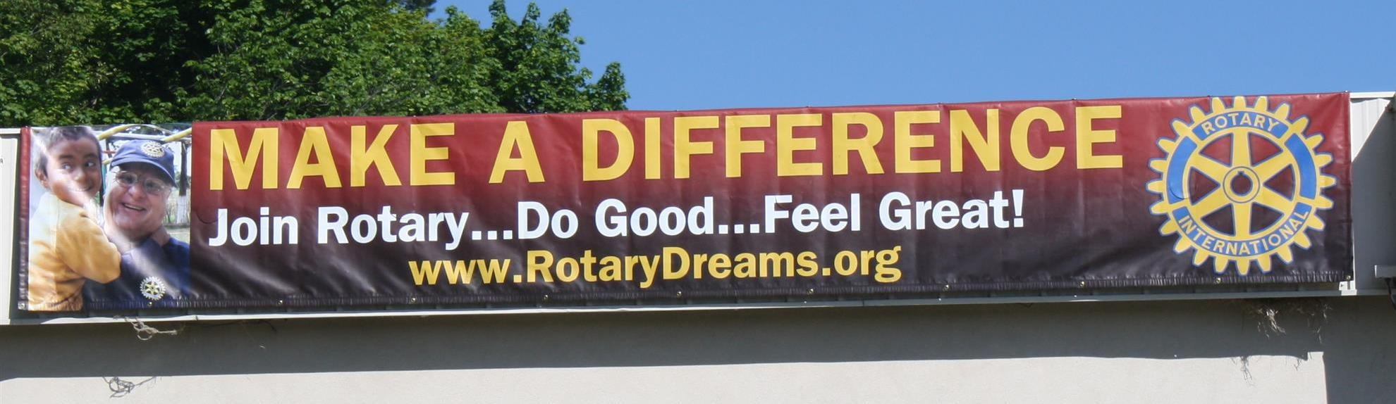

Our district banners are available for your to use when you have an upcoming event or fundraiser.

If you want to reserve one of the banners, please contact PR Chair Laura Spear at laura@spear.net.

MAJOR DISTRICT & CLUB HAPPENINGS: FALL 2016

Saturday, November 12: District 7910 - 'Food Packaging Event,' Solomon Pond Mall, Marlborough

To either donate or volunteer, click here

To view the event flyer, click here

To learn more about Stop Hunger Now, click here

Saturday, November 19: Ayer - 'Joey & Maria's Comedy Italian Wedding'

Saturday, November 19: Billerica - 'Cribbage Tournament'

For more information, click here, or contact Brian Goguen at 978-667-4595

Monday, December 5: Sturbridge Rotary - 'Lottery Ticket Raffle'

To download the event flyer, click here.

SUBMIT MAJOR CLUB HAPPENINGS

Send flyers of your club's major events and activities, in either JPEG or PDF format, to Immediate Past District
Governor/Newsletter Editor Jim Fusco at jim.fusco2@gmail.com.

