Dear $NICK_NAME$,

It is our pleasure to share with you the October 10 issue of Rotary District 7910 Newsletter.

For the complete issue, click here.

To explore past issues, click here.

Highlights of October 10 issue:

Governor's Message: Nominations Are Due in 5 Days; Membership Workshops Begin in 14 Days; and District Food Packaging Event in 32 Days - By Pat and Skip Doyle

Rotary Leadership Institute: RLI on October 15 in Boxborough is cancelled due to an insufficient number of attendees, and the next RLI is scheduled for Saturday,November 12 in Chicopee - By Doug Detweiler

Membership Corner: Member Workshops start in 14 days - By Tom Sturiale
Rotary Means Business: District’s New Networking Group to Hold First Organizational Meeting on October 20 - By Ron Bott
District Governor-Elect Report - Why should I go to the Rotary International Convention? By Karin Gaffney

Foundation Note: Club qualification status for foundation grants - By Sanjay Deshpande

Women in Rotary: A radio interview on 'Women in Rotary: Not (Just) Your Grandfather’s Rotary Club' - By Steve Jones-D'Agostino

Bandey Hefler Report: In full swing in London - By Victor Tom

Interact Actions: How to launch an Interact club - By Bob Anthony

PR Tips: Get visual - By Laura Spear

PolioPlus Update: October an important month for Foundation, PolioPlus
- By Carl Good III

Speakers Bureau: Do you need a speaker for your club? By Steve Levitsky

Communications Link: Seeking club photo, video albums - By Steve Jones-D'Agostino

Treasurer's Report: Message about your dues - By Jack Hoell

District Charity Fund: How does DCF operate? - By Al Bowers
Our next newsletter will come out on Monday, October 17. The submission deadline is this Friday, October 14. Text content must be submitted in Word format. Image content must be submitted in either JPEG or PDF format. Send your content submissions to Immediate Past District Governor/Newsletter Editor Jim Fusco at jim.fusco2@gmail.com.

Governors Pat & Skip

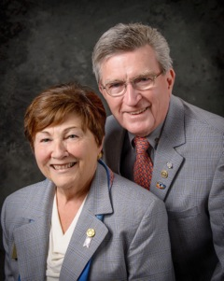Pat and Skip Doyle
2016-2017 Governors
Rotary District 7910
pwdoyle2@verizon.net
skipdoyle2@verizon.net

