GOVERNOR'S MESSAGE
Nominations Are Due in 5 Days
Membership Workshops Begin in 14 Days
District Food Packaging Event in 32 Days
By Pat and Skip Doyle
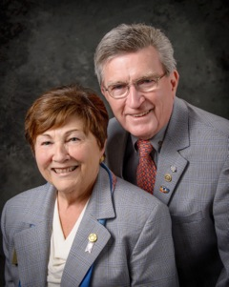
Important! Important! Important!
You asked! We Listened!
Two District-Wide Events: Membership Workshops and District Food Packaging
Membership Workshops

They will be held this month on three dates infour locations:

- Area D: Monday, October 24, 6:30-8:30 p.m., Brookline VFW, Brookline. To register, click here
- Area B: Monday, October 24, 6:30-8:30 p.m., Concord Academy, Concord. To register, click here
- Area C: Tuesday, October 25, 6:30-8:30 p.m., Chuck's Steak House, Auburn. To register, click here
- Area A: Wednesday, October 26, 6:30-8:30 p.m., The Manor, West Boylston. To register, click here
To find your club's area, click here.

District Food Packaging

Saturday, November 12
11:00 a.m. – 2:00 p.m.
Solomon Pond Mall
Marlborough

To volunteer and donate, click here.

See next week's newsletter for highlights of the Zone Institute, highlights of our club visits this week, and details of these exciting upcoming events.

Nomination Process for '19-'20 District Governor
Pat is very disturbed with the current lack of knowledge exhibited by voters concerning our election process. She feels this should not be the case for Rotarians in District 7910 when it comes to our process for choosing a District Governor. This has led us to develop a crash course: Nomination Process 101 District 7910.
An invitation is sent by August 15 each year to all clubs in the district to propose qualified candidates for District Governor Nominee, for 2018-2019. The invitation will outline the procedures to follow, the qualifications required and the necessary form to fill out. The deadline for receiving these nominations is this Saturday, October 15.

Regarding District Governor for '19-'20, all applicants must have served as a club president and have been in Rotary for a minimum of seven years.

The District Nominating Committee shall schedule and conduct interviews of the candidates proposed by the clubs. The committee may nominate additional candidates it feels would also fulfill the requirements. The committee submits its selection to the governor no later than this December 1.

Further guidelines can be found on page 177 of the District Directory or in the District Resolutions.

It is a fundamental principle in Rotary that the best-qualified candidate should be selected for service in Rotary’s elective offices. Therefore, any effort to influence the selection process in either a positive or negative manner by campaigning, canvassing, electioneering or otherwise is prohibited under the Rotary International Bylaws.

Remember that even though the Nominating Committee can only choose one District Governor each year, all Past Presidents are eligible to be considered. We have met so many qualified Past Presidents as we visited Clubs, and as we say any one of you could be District Governor. Give it a try. The application deadline is this Saturday, October 15.
More than likely, all of you are just as tired as we are about elections, voting and candidates. But this reminder is for all Rotarians. Now is the time for clubs to nominate candidates for the very important positions of District Governor andTrustee. Please review the nomination details and nomination forms, below. We hope to hear from many clubs because there are so many potential candidates among our members.
- Nomination Details
- Nominating Form Supplemental Statement
- District Governor Nomination Form
- Trustee Nominating Form
Always remember, you can call us with questions at 508-393-9031.

District Governors Pat and Skip Doyle may be reached at pwdoyle2@verizon.net and skipdoyle2@verizon.net,
respectively.

Click here to submit content for the October 17 issue to Immediate Past District Governor/Newsletter Editor Jim Fusco.

Click here for past issues.

WELCOME, NEW ROTARIANS
No New Members: Ask! Ask! Ask!

Sign up for one of the District's four Membership Workshops: Coming this month to your area our district! To learn more, click here.

CLUB MEMBERSHIP GROWTH, ’16-‘17
We share with you the results of club-membership growth in our district during Rotary year 2016-2017, which began July 1.

This is a unique opportunity for Rotarians and friends to discuss partnering on humanitarian projects affecting our local communities.

READ MORE

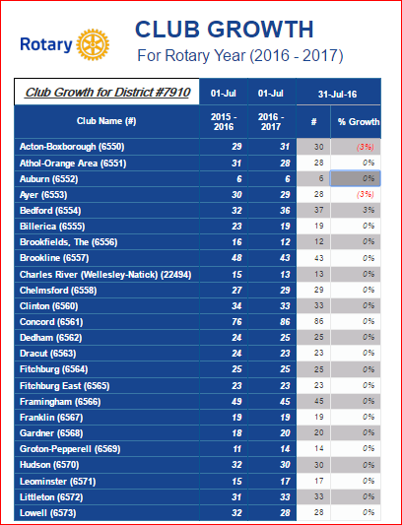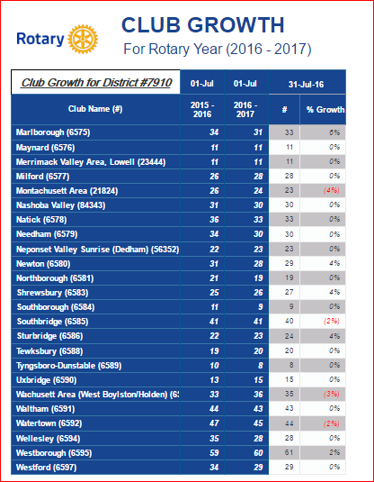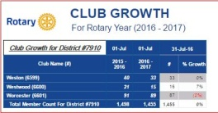

CLUB PLANNING WORKSHEET '16-'17
In both Excel and PDF formats, we share with you the Club Planning Worksheet for Rotary year 2016-2017, which began on July 1.
Please enter your club information in the indicated cells.

Excel Format

PDF Format

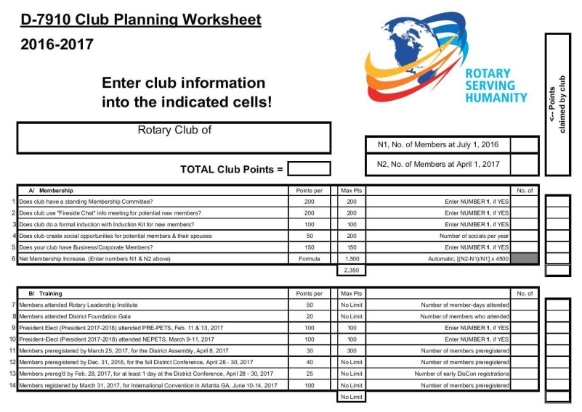

DG VISITS LAST WEEK
Auburn

Front, left to right: Secretary Heather Chivallatti, President Steve Jones-D'Agostinoand Treasurer Marcia Davis, the club's immediate past president

Back, left to right: Members Tom Dufour and Jon Manning, District Governor Pat Doyle, District Governor Skip Doyle, Member John Convent and Assistant Governor Cliff Gerber

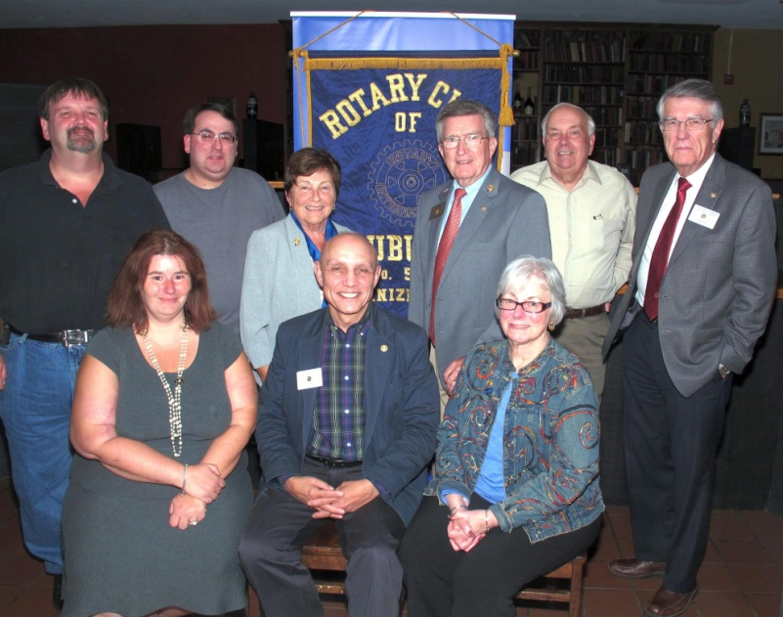

Brookfields

Front, left to right: Member John Krusell, Treasurer Luanne Mcleod, Executive Director Lynn Duffer-O'Shea, and Member Judy Rice

Back, left to right: Member Don Howard, District Governor Skip Doyle, President Chet Lubelczyk, District Governor Pat Doyle, and Members Armand Dimo and Charlie Haddock

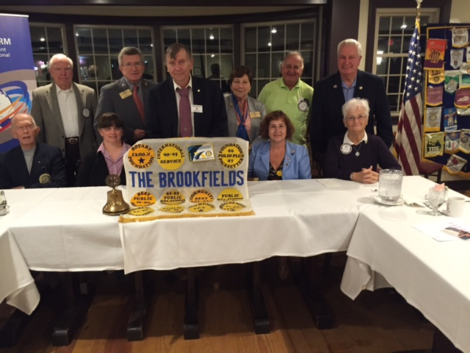

Concord

Left to right: District Governors Skip and Pat Doyle, President Steve Kirk, and Assistant Governor Bob Gurnsey

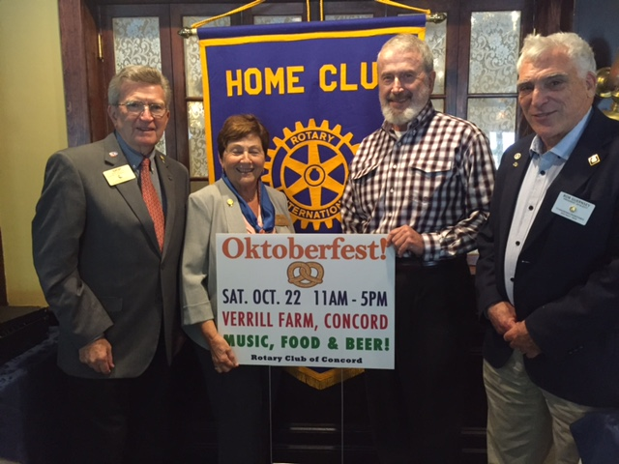

Fitchburg

Left to right: District Governors Skip and Pat Doyle
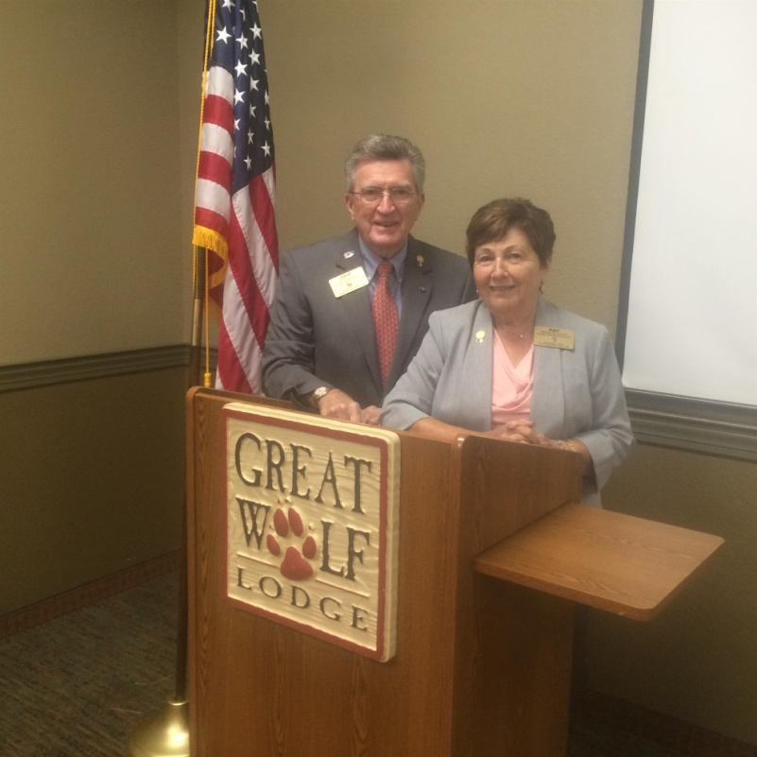

Northborough

Front, left to right: Members Joe Marco, Larry McLeod andCheryl Scali, and Assistant Governor Peggie Thorsen

Back, left to right: District Governor Skip Doyle, PresidentEd King, District Governor Pat Doyle, and Member Steve Georgeson

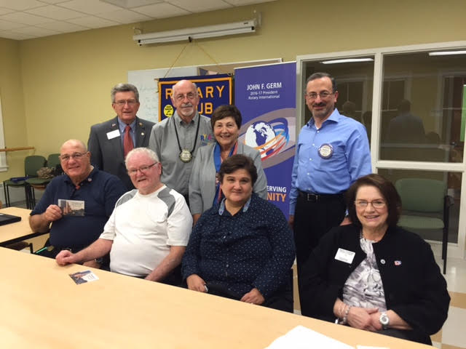

DISTRICT & CLUB ROUNDS
Concord Rotary's 2016 Oktoberfest Is Going to Rock

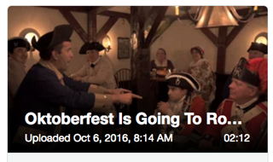

The Rotary Club of Concord is hosting its first outdoor fall festival, Oktoberfest, a celebration of autumn in the Bavarian tradition with a Concordian twist. This fundraiser for Concord Rotary’s service projects takes place on Saturday, October 22 from 11:00 a.m. to 5:00 p.m. atVerrill Farm in Concord. The event will have something for everyone, including five live bands, local food and amazing craft beer.

Ticket costs:
- Adults (21 and older): $25 per person online, and $35 at the door
- Juniors (12 -20): $5 online and at door.
- Children (under 12): Free!
Price includes access to music and festival events and, for those 21 and older, beer samples.
​
To purchase tickets, click here.

To learn more about Oktoberfest, click here.

To watch a two-minute promotional video produced by club President Steve Kirk,click here.

To learn more about Concord Rotary, click here.

Auburn Rotary 'Flips For Scholars' Pancake Breakfast on October 23

The Rotary Club of Auburn will fire up the griddles for a worthy cause with its "Flips For Scholars" Pancake Breakfast on Sunday, October 23 from 8:00 a.m. to 12:00 noon in the cafeteria of Auburn High School. Net proceeds will go to scholarships for recent graduates of Auburn High School and Bay Path Regional Vocational Technical High School. Over the course of more than 50 years, Auburn Rotary has raised in excess of $420,000 for scholarships. Tickets, which will be available at the door, cost $7 for adults, $5 for seniors and $3 for kids 12 and under. Free parking will be available.

For kids of all ages, special appearances will be made by Jake the Lion, the mascot of the Worcester Braveheartsbaseball team, by Trax, the mascot of the Worcester Railers hockey club, and by Marshall, the firedog of the Paws Patrol TV show. Celebrity flippers will include State Rep. Paul Frost (R-Auburn), Auburn Middle School Principal Joseph Gagnon, Auburn Fire Chief Stephen Coleman Jr., and Auburn Town Clerk Debra Gremo. The Pancake Breakfast $250-level Triple-Stack sponsors areAuburn Council of the Knights of Columbus, Auburn MA Daily, Best Rate of Climb, Diamond Auto Group, Holiday Inn Express & Suites in Auburn, and The Law Offices of Scott C. Wrenn, P.C.

To RSVP, click here.

For more information, contact Marcia Davis, immediate president of Auburn Rotary, at 508-254-1214or largotutor@verizon.net.

To download the Pancake Breakfast flyer, in PDF format, click here.

To watch a Pancake Breakfast public service announcement by Marcia Davis and club Secretary Heather Chivallatti, produced by and airing on Auburn Community Television, click here.

To learn more about Auburn Rotary, click here.

Westborough Rotary Inducts Two New Members

Left to right: President Gerry Gross, Sponsor Peter Gardner, new Members Harold Pinkham and Hollie Alderon, and Sponsor Maureen Ambrosino

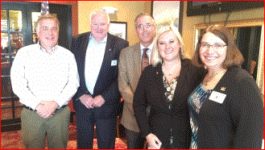

Southborough Rotary Sponsors Four RYLA Participants

Four high school juniors were able to participate in a Rotary Youth leadership Awards conference this summer thanks to the Rotary Club of Southborough. The club is thanking a fund donor and reaching out for more businesses to step up.

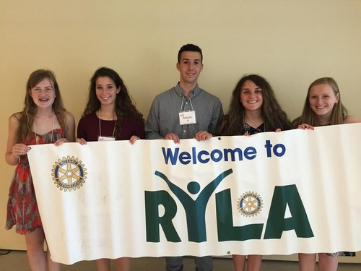

Governor Baker Hosted at 'Meet & Greet' by Bedford, Billerica, Lowell, Newton and Shrewsbury Rotary

Left to right: Immediate Past District Governor Jim Fusco; Charles River RotarianJon Fetherston; Littleton Gino Frattalone Rotarian; Governor Charlie Baker; and Billerica Rotarian John Peterson.
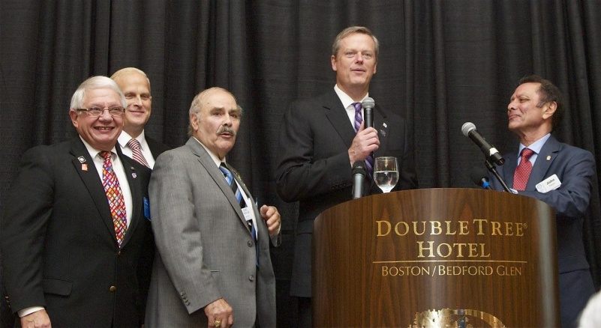

Jim Fusco (left) informs Governor Baker (right) of the presence of Rotary in Massachusetts (158 clubs with 1,580 Rotarians), while Gino Frattalone (center)looks on.
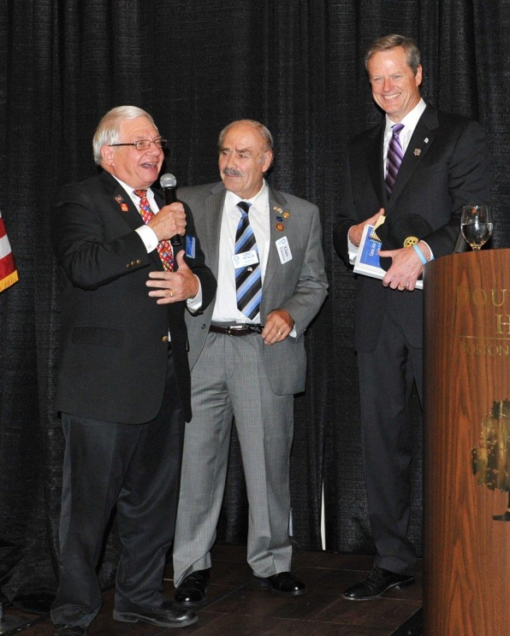

To view these and other photos of this event, taken by Frank Sibley of Acton-Boxborough Rotary and Rich Prager of Worcester Rotary, click here.
To watch a video by Concord Rotarian Steve Kirk, which was played during this event, click here.

Zone Institute in Winnipeg

Left to right: Assistant Governor Satya Mitra; District Governor-Elect Karin Gaffney; District Governors Pat and Skip Doyle; District Governor-Nominee Steve Sager; and Past District Governor Carol Toomey.

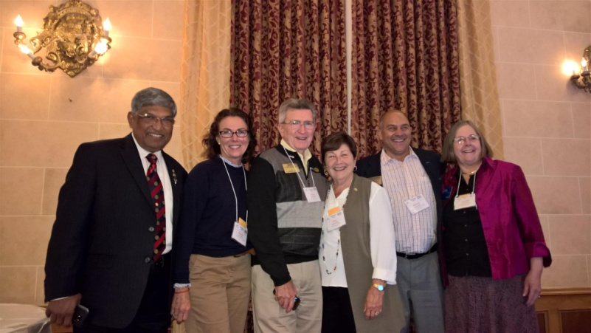

Our District was well-represented at the Zone Institute in Winnipeg, Manitoba, Canada. The Institute included intensive training for our future District leaders.

Steering Committee Meets in Winnipeg

Left to right: District Governors Skip and Pat Doyle, District Governor-elect Karin Gaffney and District Governor-nominee Steve Sager.

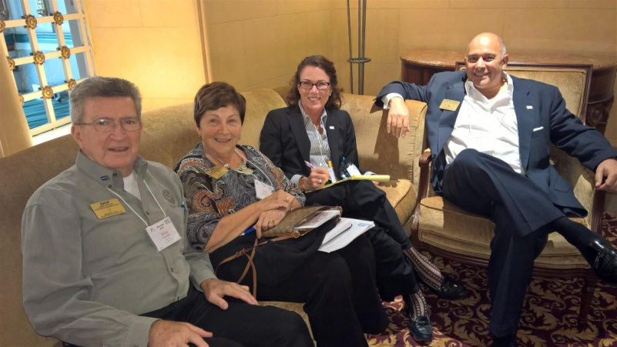

Your District Steering Committee, consisting of the District Governor, District Governor-Elect and District Governor-Nominee, meets monthly to guide your District. Last month, they took time out at the Zone Institute to hold their September meeting.

Women in Rotary: A Radio Interview

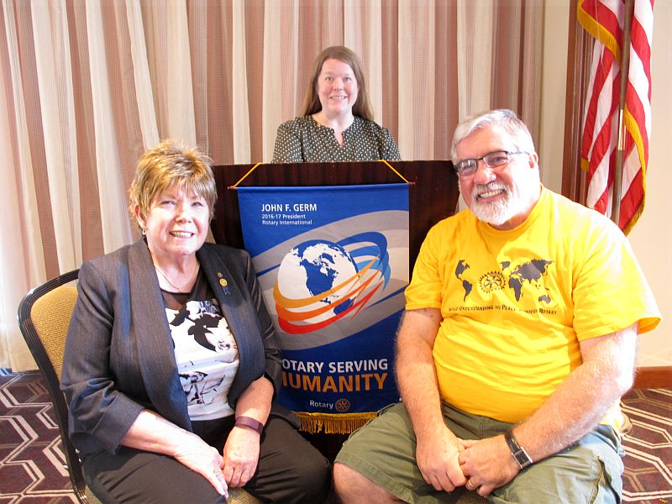

Boston Rotaract will host the Women in Rotary: Not (Just) Your Grandfather’s Rotary Club forum this Wednesday, October 5 from 6:30 8:30 p.m. at the Back Bay Social Club in Boston. READ MORE

Left to right: District Governor Sheryl Meehan of District 7930; Boston Rotaract President Amy Collinsworth; and District Governor-Elect Dave Gardner of D7930.

District Interact Teen and Advisor Training Seminar A Huge Success
Nearly 50 participants from 14 Rotary communities took part in a District Interact Teen and Advisor Training Seminar, which was held on Saturday, September 17 at the Sheraton Hotel in Needham.

READ MORE (including links to Seminar videos and photos)

Framingham's Liz Kaprielian Awarded Bill Rabkin Volunteer of Year Award

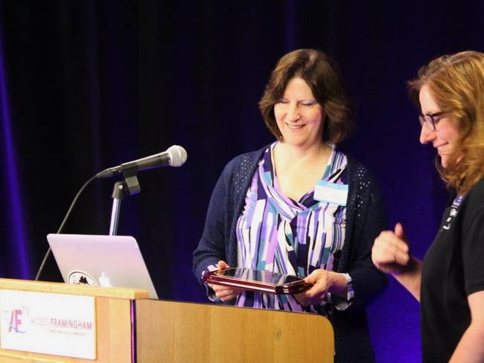

Liz Kaprielian, a member of the Rotary Club of Framingham, was surprised when she was was awarded the Bill Rabkin Volunteer of the Year award at Access Framingham.

READ MORE

Bandey Hefler in Full Swing in England

Our District 7910 Bandey Hefler Fellowship Exchange has been in full swing and receiving rave reviews from all travelers and hosts. Shown, are American travelersSze-Wen Kuo (fourth from right) and Mina and Paul Femino (first and second from right) enjoying lunch with their British hosts at the Lions Pub in London.

READ MORE

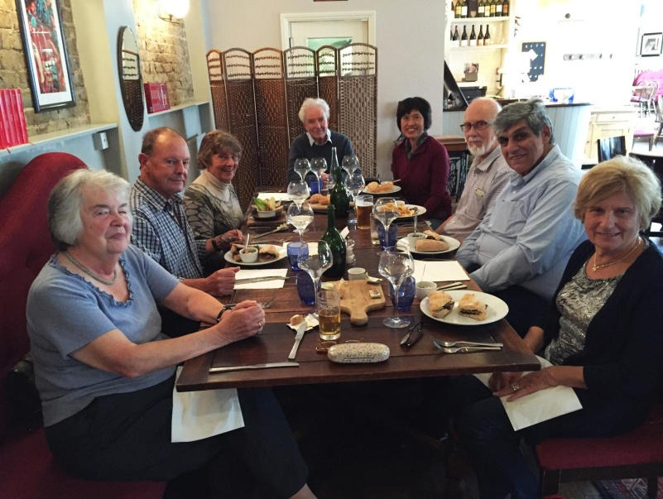

Sturbridge Participates in Day of Caring

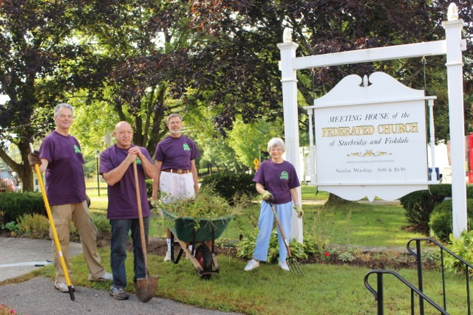

For the seventh year, Sturbridge Rotary has participated in United Way's annual Day of Caring. Nine club members were part of the 130 volunteers working at 14 project sites.

READ MORE

Westborough Sponsors Down Syndrome Buddy Walk

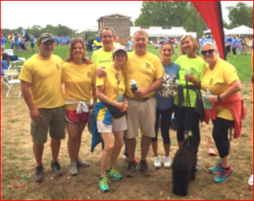

One of Westborough Rotary's giving requests was to be a sponsor of the Down Syndrome Buddy Walk and Harvest Festival, which was held on Sunday, September 18. A group of Rotarians (shown here) participated in the walk and had a great time supporting a wonderful cause.

District Polio Team Visits Lowell Rotary

Carl Good III, chair of the District Polio Committee, and his polio team continue to visit clubs. Recently, he visitedAyer & Westford Rotary Clubs to spread the polio message.
If you would to join the polio team, just let Carl know at carlgood@yahoo.com or 978-273-7880.

Carl Good III (left) posing with Ayer Chris Lilly.

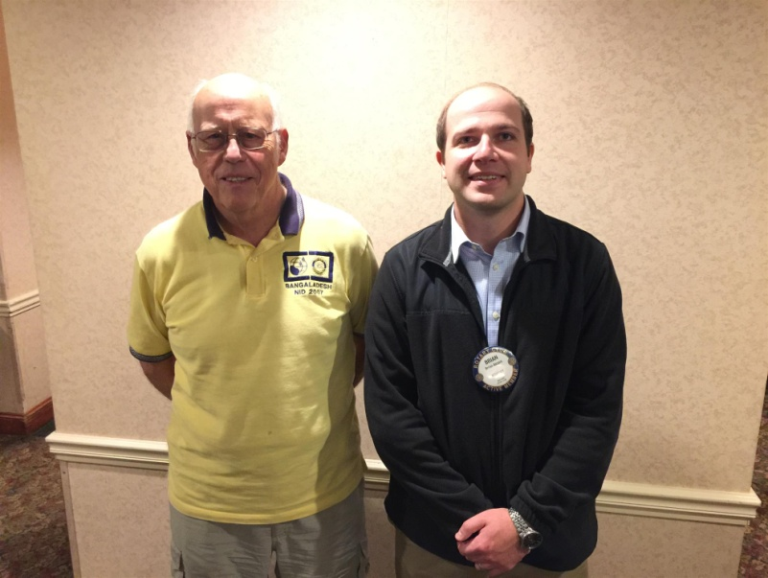

Nashoba Valley Sponsors Razia's Ray of Hope Event on October 27

The Rotary Club of Nashoba Valley is proud to sponsor the local premiere of What Tomorrow Brings, event to benefit Razia’s Ray of Hope, on Thursday, October 27 from 7:00 to 9:00 p.m. at the Warn Hall of the Fenn School, located at 6 Monument St. in Concord.

READ MORE

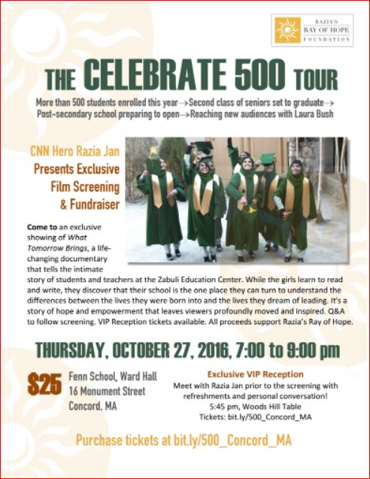

Presidents-Elect Start Pre-PETS Training

District Governor-Elect Karin Gaffney recently kicked off the training for presidents-elect at Concord Academy. Karin is shown motivating the PEs.

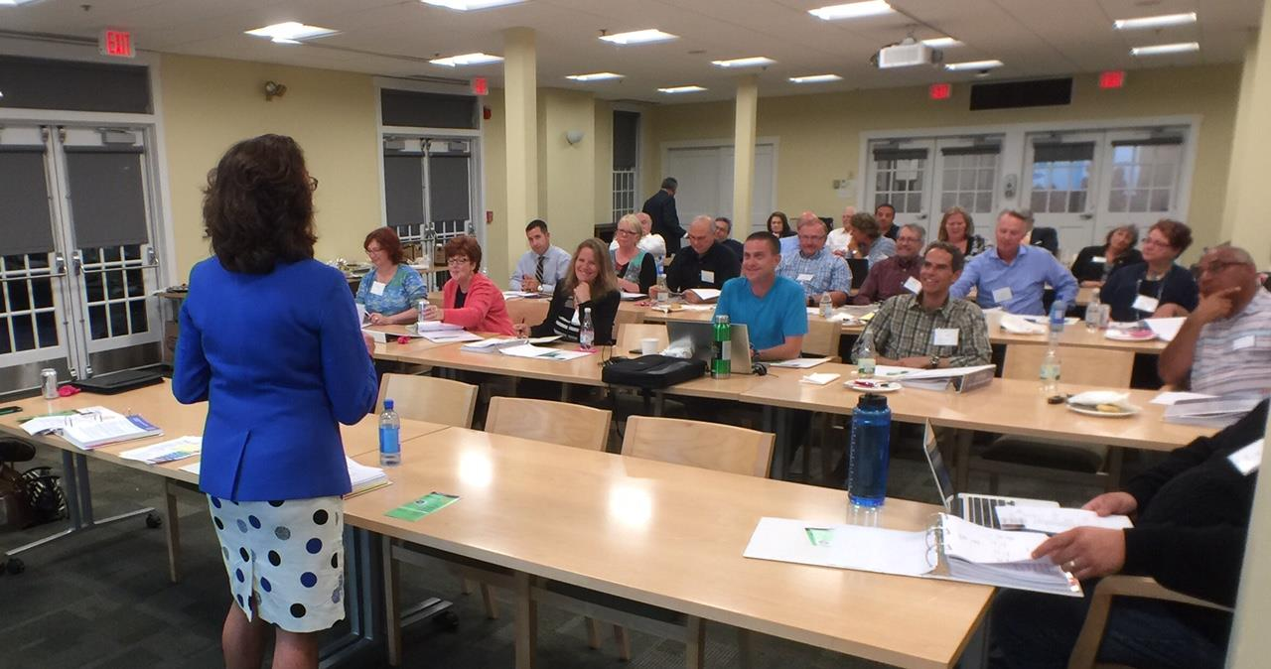

Pat and Skip Doyle Installed as '16-'17 DGs

District 7910's 2016 Rotary Youth Leadership Awards were held on June 24 through 26 at Fitchburg State University, ending with the installation of longtime RYLA supporters Pat and Skip Doyle as District Governors for 2016-2017. The three-day RYLA event was attended by 188 sophomores. To learn more about RYLA, visit ryla7910.org.

Click on the image, to view a video of the installation of Pat and Skip Doyle as '16-'17 DGs

District Leadership Meeting A Huge Success

How HUGE? So HUGE that another is planned for nextMonday, October 17!

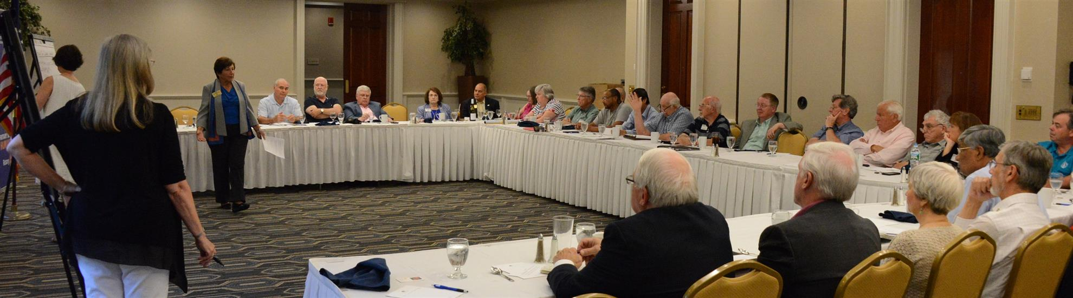
District Governors Pat and Skip Doyle held their Leadership Meeting on July 19 at the DoubleTree Hotel in Leominster. This is an annual event for which DGs bring their District leaders and committee chairs together to review the goals for the new Rotary year.

This, year the event was presented in a facilitated format. The results will be consolidated and sent to all attendees so that the District Goals for each committee can be set.

District Banners Available

Our district banners are available for your to use when you have an upcoming event or fundraiser.

If you want to reserve one of the banners, please contact PR Chair Laura Spear at laura@spear.net.

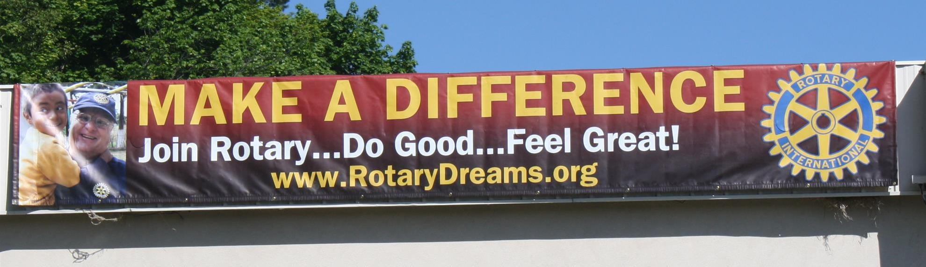

On to Atlanta in 2017

Planning to attend? Contact District Chair Steve Glines.

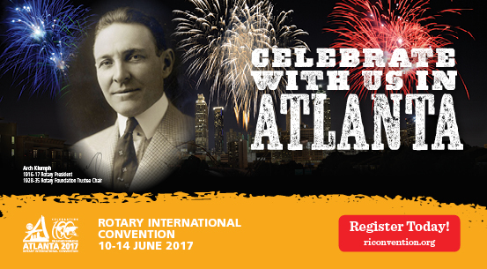

More than 43,000 attendees left the Rotary International Convention in South Korea inspired to end polio for good, to celebrate The Rotary Foundation's centennial, and to champion changes that will help Rotary appeal to a broader audience.
On the last day, RI President K.R. “Ravi” Ravindran shared a personal story of his mother’s triumph over polio.

To read the story, click here.

To register for the 2017 RI Convention in Atlanta, click here

MAJOR DISTRICT & CLUB HAPPENINGS: FALL
Friday, October 14: Montachusett Area Rotary - 'Comedy Night,' Knights of Columbus, Leominster

For tickets and information, contact club President Jennifer Peck at montachusettarearotary@gmail.com.

Saturday October 15: Franklin Rotary in conjunction with Simon Properties - 'Chalkfest,' Wrentham Outlets, Wrentham

READ MORE

Saturday, October 22: Fitchburg Rotary - 'Roast The Mayor Night'

Fitchburg has a new mayor, Steve DiNatale, and to celebrate his first year in office, Fitchburg Rotary will sponsor a Roast the Mayor Night.

For more information, contact club President Dan Cunnimham atdanc1@comcast.net.

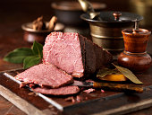

Saturday, October 22: Concord - 'Octoberfest'

You’ll hear five live bands, sample food and beer, enter a pie-eating contest, create the best scarecrow, show off hula-hoop skills, jump in the bouncy house, shop craft vendors, visit community organization booths, and more.

For more Information, click here.

To watch the two-minute promotional video, click here.

Sunday, October 23: Auburn Rotary - 'Flips for Scholars Pancake Breakfast'

To download the event flyer, click here
For more information and to RSVP, click here

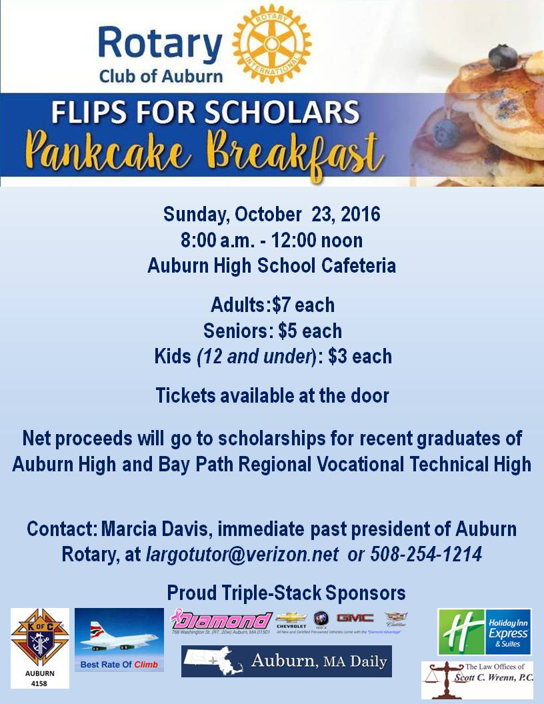

Sunday, October 23: Westborough Rotary - 'Trivia Bee'

Westborough Rotary has accepted an invitation from the Westborough Education Foundation to sponsor a team for this Trivia Bee, will provide three Rotarians and an alternate, and hopes to bring back a trophy this year!

For more information, contact club President Gerry Gross atgerrygross@gmail.com.
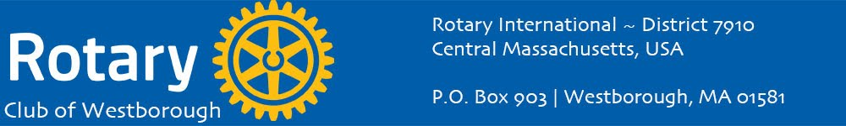

Saturday, October 29: Sturbridge Rotary - 'Antique Appraisal Show'

To download the event flyer, click here

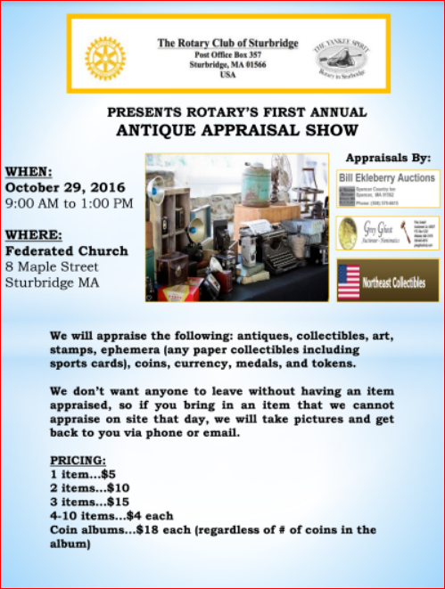

Tuesday, November 1: Marlborough Rotary - 'Reality Fair 2016'

Download the Confirmation of Participation form: click here for PDF format; and, click here for Word format

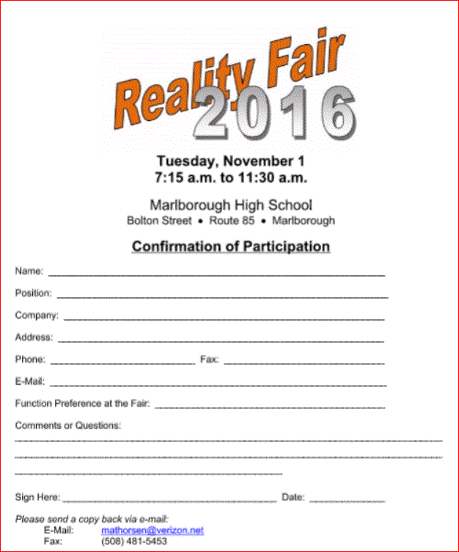

Monday, December 5: Sturbridge Rotary - 'Lottery Ticket Raffle'

To download the event flyer, click here.

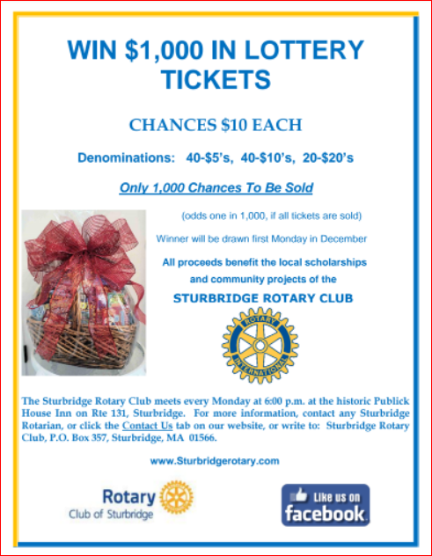

SUBMIT MAJOR CLUB HAPPENINGS

Send flyers of your club's major events and activities, in either JPEG or PDF format, to Immediate Past District
Governor/Newsletter Editor Jim Fusco at jim.fusco2@gmail.com.

