COMMITTEE REPORTS
Why Should I Go to The Rotary International Convention?

By Karin Gaffney
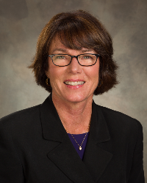

I am providing testimonials from our Rotarians who have attended a Rotary International Convention. Here's a testimonial from Steve Glines of Littleton Rotary.
READ MORE
Next week, I'll have a testimonial from Satya Mitra of Worcester Rotary.

Rotary Leadership Institute on October 15 in Boxborough Cancelled!

By Doug Detweiler

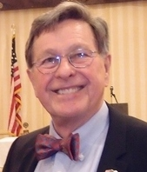

Unfortunately, the Rotary Leadership Institute scheduled for Saturday, October 15 has been cancelled due to an insufficient number of attendees. The next RLI is scheduled for Saturday, November 12 in Chicopee.

RLI recommends that candidates should have those qualities that mark them as potential club leaders, not necessarily future presidents.

READ MORE

Membership Workshops Start in 14 Days
By Tom Sturiale
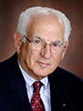

Instead of a District Membership Forum this year, we are featuring Membership Workshops in our district's four areas.

READ MORE

Membership Materials on Sale: Order Now!
To order, click here

District’s New ‘Rotary Means Business’ Networking Group to Hold First Organizational Meeting on October 20
By Ron Bott

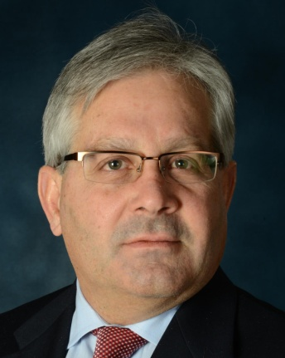

Interested in business networking? Can you help us organize events?

READ MORE

October An Important Month for Foundation, PolioPlus

By Carl Good III

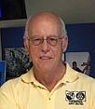

October is an important month for both The Rotary Foundation and PolioPlus.

READ MORE

Club Qualification Status for Foundation Grants

By Sanjay Deshpande

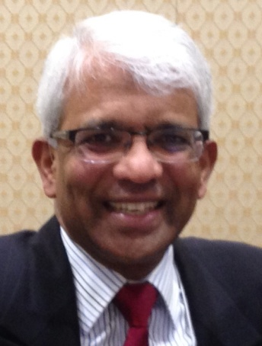

District 7910 adopted three qualification criteria that its clubs must satisfy in Rotary Year 2016-2017for being eligible for participation in Foundation grants, which include District Grants (DG) and Global Grants (GG).
READ MORE

How to Launch An Interact club

By Bob Anthony
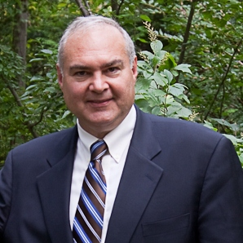

In Seminar 2 of the District Interact Teen and Advisor Training Seminar, held on September 17 in Needham,Bob Anthony, chair of the District Interact Committee, discusses “How to launch an Interact club,” including the certification letter, roles and responsibilities of the president, the Rotary advisor and, in the case of school-based clubs, the faculty advisor.

WATCH VIDEO

Pictures: Show Something Awesome!
By Laura Spear
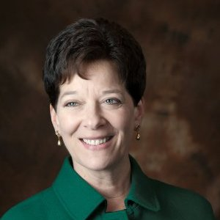

Don’t use a cookiecutter picture of people shaking hands.
READ MORE

Message about Your Dues

By Jack Hoell
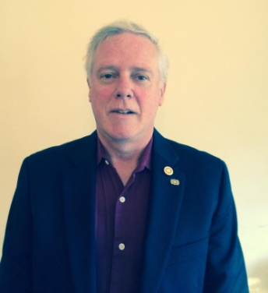

The Rotary International dues bills were e-mailed to the 51 clubs in our District on July 22 and the District dues bills were e-mailed to clubs on July 26.
READ MORE

Looking for A Good Speaker for Your Club?

By Steve Levitsky

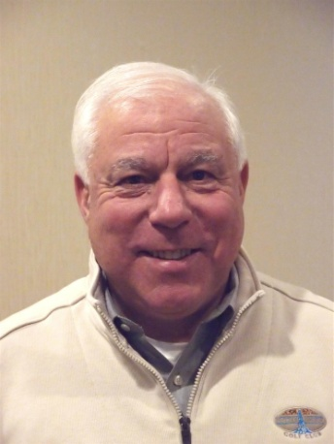

It's not always easy to come up with ideas week after week. We have many suggestions for you. Here are just a few:
- Rwandan genocide: Carine Boggis
- Elevator-pitch tips: Andy Winig
- Positive-results hypnosis: Bob Martel
- Differentiation and game-changing simplicity: Stephen Melanson
VIEW MORE

District Charity Fund: How does DCF operate?
By Al Bowers

The District Charity Fund is a 501(c)3 charitable, non-profit that can be used by the Rotary clubs in District 7910.
READ MORE

Communications Link: Seeking club photo, video albums
By Steve Jones-D'Agostino
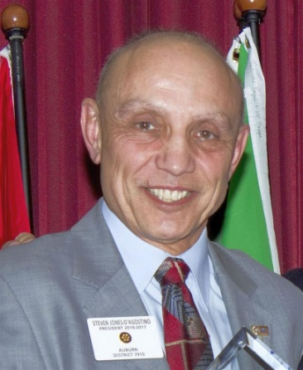

Does your District committee or Club have Rotary-related photo and/or video albums that you'd like to share with other Rotarians?
READ MORE

Bandey Hefler: Having another Week in England!
By Victor Tom
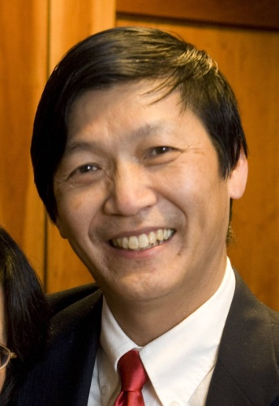

Our District 7910 Bandey-Hefler Fellowship Exchange has been in full swing and receiving rave reviews from all travelers and hosts.
READ MORE

SUBMIT CONTENT
To submit content for consideration for the Monday, October 17 issue of Rotary District 7910 Newsletter, please e-mail it to Immediate Past District Governor and Newsletter Editor Jim Fusco at jim.fusco2@gmail.com.
The submission deadline for that issue is Friday, October 14. All text must be in Word format. All images must be in either JPEG or PDF format. Please identify the people, left to right, who are shown in your photos, including their first and last name as well as their club or other title.

PAST ISSUES
To view past issues of the weekly Rotary District 7910 Newsletter, click here

DISTRICT 7910 ONLINE
Visit our website
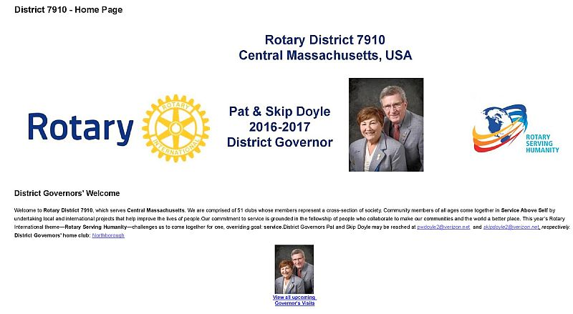

'Like' and share us on Facebook
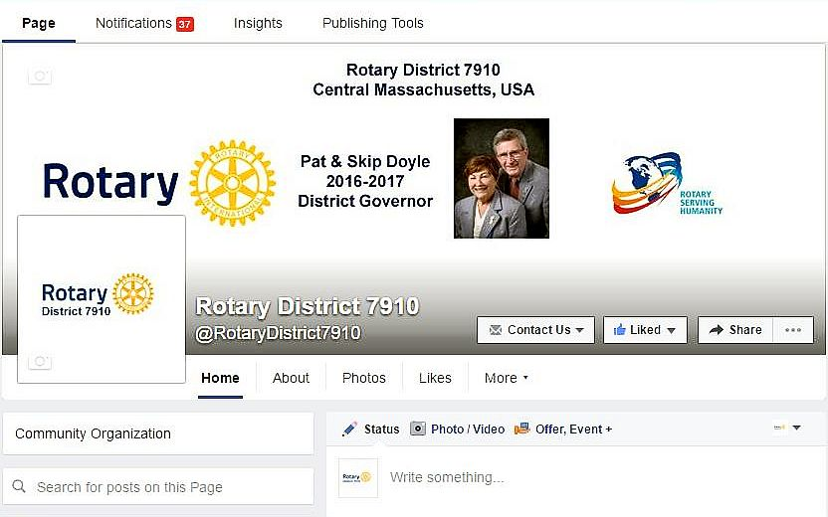

Watch our videos on YouTube
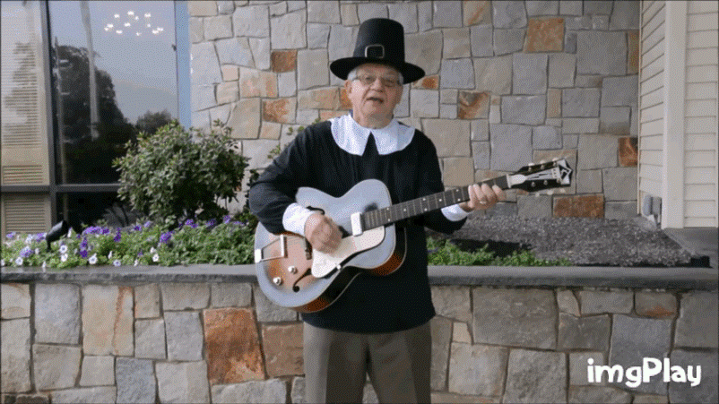

View our photos on Google Photos (since May 2015) and ClubRunner (before May 2015)
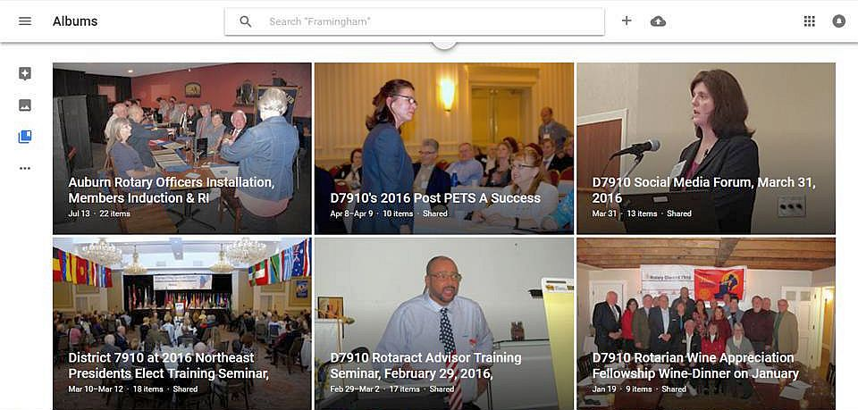

CONTACT US
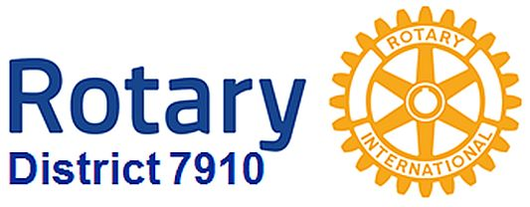

Immediate Past District Governor and Newsletter Editor Jim Fusco
​jim.fusco2@gmail.com
District Webmaster Steve Jones-D'Agostino
​srdagostino@icloud.com

© Copyright 2016-2017 - Rotary District 7910, Central Massachusetts, USA

