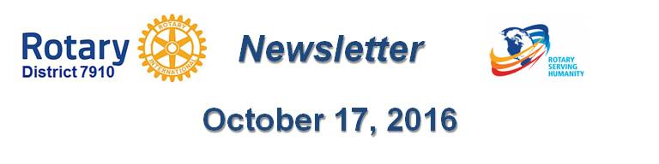

Dear $NICK_NAME$,

It is our pleasure to share with you the October 17 issue of Rotary District 7910 Newsletter.

For the complete issue, click here.

To explore past issues, click here.

Highlights of October 17 issue:

Governor's Message: - Membership Workshops begin in 7 days; District Food Packaging event in 25 days; and Zone 24/32 Institute highlights - By Pat and Skip Doyle

District Governor-Elect Report - Satya Mitra, on why should we go to the Rotary International Convention - By Karin Gaffney

Rotary Means Business: Networking group to hold first organizational meeting on October 20 - By Ron Bott

PolioPlus Update: Important live-streaming event on October 24 - By Carl Good III

Membership Corner: Member Workshops start in 7 days - By Tom Sturiale

Rotary Leadership Institute: Next RLI in our area is scheduled for November 12 in Chicopee - By Doug Detweiler

Foundation Note: Club qualification status for Foundation grants - Update - By Sanjay Deshpande

Bandey Hefler Report: We're back from England - By Victor Tom

Speakers Bureau: Do you need a speaker for your club? By Steve Levitsky

Interact Actions: How to launch an Interact club - By Bob Anthony

Followup: Governor Baker 'Meet & Greet' - By Marty Heilman

Women in Rotary: A radio interview on 'Women in Rotary’ - By Steve Jones-D'Agostino

PR Tips: More about pictures - By Laura Spear

Communications Link: Seeking club photo, video albums - By Steve Jones-D'Agostino

Treasurer's Report: Message about your dues - By Jack Hoell

District Charity Fund: How does DCF operate? - By Al Bowers
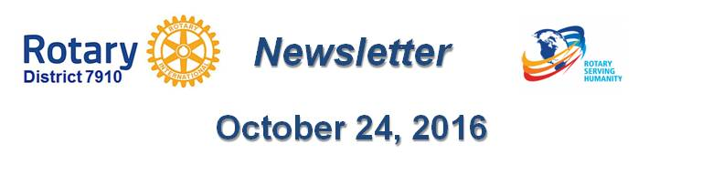Our next newsletter will come out on Monday, October 24. The submission deadline is this Friday, October 21. Text content must be submitted in Word format. Image content must be submitted in either JPEG or PDF format. Send your content submissions to Immediate Past District Governor/Newsletter Editor Jim Fusco at jim.fusco2@gmail.com.

Governors Pat & Skip

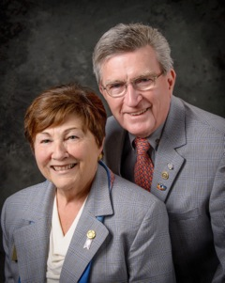Pat and Skip Doyle
2016-2017 Governors
Rotary District 7910
pwdoyle2@verizon.net
skipdoyle2@verizon.net

