CLUB QUALIFICATION STATUS FOR FOUNDATION GRANTS - AN UPDATE
By Sanjay Deshpande
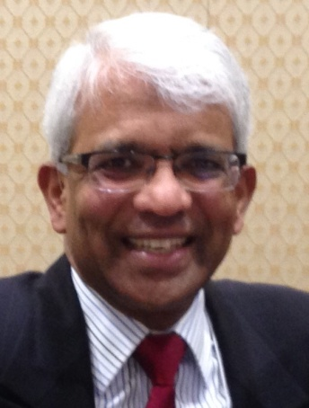District 7910 adopted three qualification criteria that its clubs must satisfy in Rotary Year 2016-2017 for being eligible for participation in Foundation grants, which include District Grants (DG) and Global Grants (GG).
- Per Capita Contribution to Foundation Funds in ‘15-16: Clubs are required to have met or exceeded the threshold of $100 in per-capita contributions to all Foundation funds by June 30, 2016. Thirty-seven clubs did comply with this eligibility criterion while 14 clubs did not. Those 14 clubs will not be eligible to undertake either DGs or GGs on their own in Rotary Year ‘16-‘17.
- Memorandum of Understanding: Clubs are required to submit the fully executed ‘16-‘17 Memorandum of Understanding (MOU) wherein clubs agree to comply with The Rotary Foundation’s requirements for participation in DGs and GGs. Only 20 clubs had done so as of September 25 per Stewardship Chair Ed King. The other 17 clubs that have met the per-capita contribution criterion are urged to do so ASAP so that they retain their eligibility to undertake DGs and GGs.
- Grant Management Training: Clubs are required to have at least one member (preferably two) receive Grant Management Training. Two training sessions were conducted last April and May. Twenty-seven clubs did get at least one member trained. Ten more clubs can avail of a future training session to be arranged when they do submit their fully executed ‘16-‘17 MOU.
Based on the eligibility criteria met, D7910 clubs can be sorted into several groups, as shown below. Last week, Shrewsbury Rotary submitted its signed MOU andmoved from Group II-A to Group I-A.

Group | Eligibility Criteria Met | Clubs in Group | Remarks
I-A | All Three | Athol-Orange, Bedford, Billerica, Brookline, Concord, Framingham, Leominster, Lowell, Marlborough, Montachusett Area, Nashoba Valley, Natick, Needham, Neponset Valley Sunrise, Northborough, Shrewsbury, Sturbridge, Wachusett Area, and Westborough | Qualified for all Foundation Grants – DGs and GGs. Are engaged in DGs. Seven are engaged in GGs.
I-B | All Three | Worcester | Not engaged in DG or GG
II | 1 and 2 | Newton | Must receive Grant Management Training
III-A | 1 and 3 | Auburn, Ayer, Gardner, Milford, and Wellesley | Must sign MOU and then proceed with DG or engage in GG
III-B | 1 and 3 | Fitchburg, and Hudson | Must sign MOU and engage in DG or GG
IV | 1 only | Acton-Boxborough, Charles River, Fitchburg East, Franklin, Littleton, Merrimack Valley, Newton, Southborough, Westford, and Westwood | Must sign MOU and receive Grant Management Training

D7910 has $45,000 available for District Grants. Only four grants have been awarded so far and there are seven applications in the approval queue. If the clubs in groups I-B through IV above do not complete their qualification and/or engage in DGs, the district could elect to allocate DG funds to GGs and PolioPlus. Interest is strong in GGs this year and the seven GG proposals already are sure to exhaust the $46,436 available for GGs.

The District Foundation Committee will consider reallocation of DG funds for GGs at this November’s quarterly meeting. Reallocation to PolioPlus will be considered in next February’s quarterly meeting.

Additional Note from District Annual Fund Subcommittee Chair

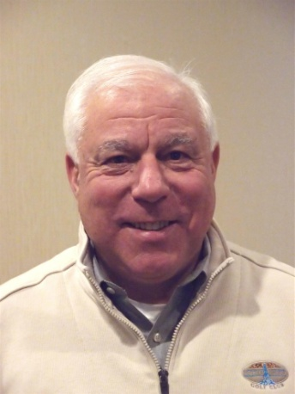It is not too soon to start working on the eligibility criterion 1 for the next Rotary year. Steve Levitsky (left), chair of the District Annual Fund Subcommittee, would like all clubs to consider the following:

- Has your club set a goal for your annual Rotary Foundation giving for this Rotary year?
- Are you looking for ideas for new projects?
- Do you want to learn more about how donations raised can be multiplied by matching dollars from the Rotary Foundation?
If your answer to any of these questions is "yes," or if you're just interested in the Foundation, a member of a team of interested Rotarians would be available to attend one of your meetings to describe ways you can benefit from participating in a District Grant. Indeed, November is Foundation Month and it will be most appropriate for all clubs to devote one of their meetings in November to have a member of this team make a presentation on the Rotary Foundation to your club's membership.

District 7910 is committing additional resources to help spread the word as this year marks the 100th anniversary of the Rotary Foundation! You can also hear about the goals that the District has set for Foundation giving this year. Perhaps this will serve as an opportunity for the members of your club to brainstorm ways that they can be even more successful and have fun while raising funds for the Rotary Foundation and by doing good either in your community or somewhere else in the world.
if you would like to invite a member of the Annual Foundation Committee to attend one of your meetings, please email contact Steve Levitsky at stevey50@aol.com or978-337-4050.

If you have any questions about the District Foundation Committee, contact either District Grants Subcommittee Chair Jorge Yarzebski at yj.rotary@gmail.com or me, District Foundation Committee Chair Sanjay Deshpande, sanjdesh51@aol.com.

For the Foundation Notes archive, click here

Learn more about District 7910 Foundation Grants:
- Rotary Areas of Focus Policy Statements (PDF Format)
- District 7910 Eligible and Ineligible Activities in a District Grant (Word Format)
- Timeline for District 7910 Foundation Grants (Web Page)
- District 7910 Grant Qualification Table (Excel Format)
- District 7910 Grant Proposals and Qualifications Status (Web Page)
- District 7910 2015-2016 Foundation Contributions Report - (Excel Format)
- Foundation Grants in 2016-'17 and Beyond (PDF Format)
- District 7910 2016-2017 District Grant Proposal Template (PDF Format)
- District Grant Proposal Form (Word Format)
- Global Grant Proposal Form (Word Format)
- District 7910 District Grants Scoring Rubric (PDF format)
- District 7910 Club Memorandum of Understanding (PDF Format)
Return to October 17 Newsletter

View past issues
Visit our website
'Like' our Facebook page
'Follow' our Twitter page

