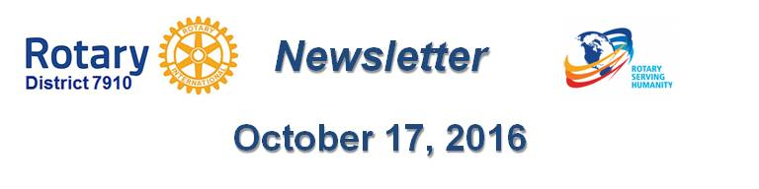

WHY SHOULD I GO TO THE ROTARY INTERNATIONAL CONVENTION?
By Karin Gaffney
I a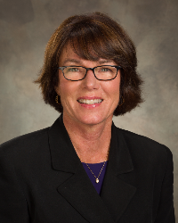m providing testimonials from our Rotarians who have attended a Rotary International Convention. Here's a testimonial from Assistant Governor Satya Mitra (shown, below, on right), past president of Worcester Rotary:
My wife, Sheema Mitra (shown, below, on left), and I first attended the RI Convention in 2014 in Sydney, Australia. Our first experience after attending this profoundly stimulating event was so impactful that thereafter we have attended the 2015 Convention in Sau Paulo, Brazil, and the 2016 Convention in Seoul, South Korea. Of course, we have already registered for the upcoming and one of the most memorable to be, the 2017 Convention in Atlanta. We have also decided that this will continue to be an annual event in our life as long as we can travel and stay healthy. That’s how attractive, inspiring and fascinating the Rotary International Conventions are!
Every year when we see thousands of fellow Rotarians coming together from so many different countries, in their national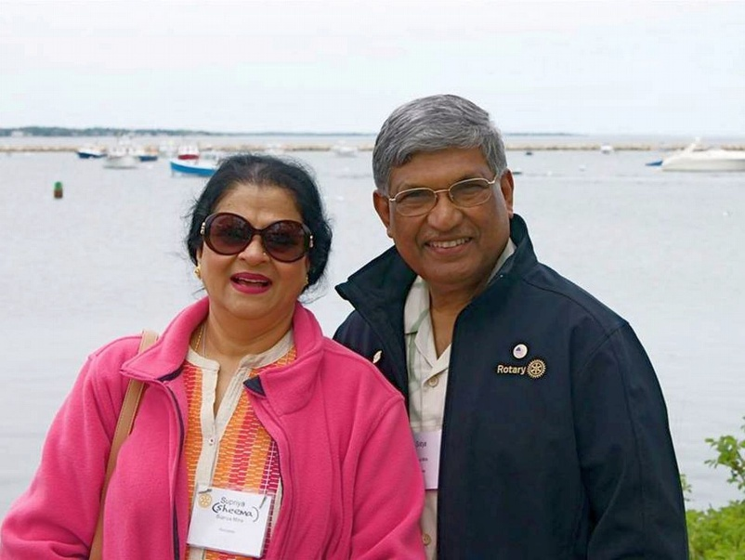 costumes, reflecting different cultures, different traditions, different ethnicity, speaking different languages, but absolutely focused to achieve one common goal “helping others,” we feel so proud to be one of them and so proud to be a Rotarians!

The RI Convention is such a powerful institution that one could find a defining moment. As a matter of fact, Sheema, who was not a Rotarian before, felt so much inspired after listening to many speakers and finding their extraordinary good deeds, that she decided to join Rotary after attending the RI Convention in Sydney. It is amazing to see and comprehend that how so many people from all over the world come together - mostly, spending their own money - just to learn how many great projects are being done by Rotarians worldwide, just to extend their deep fellowship with so many international friends, and just to get immensely motivated to go back and dedicate serving the humanity.

The RI Convention in each country is so unique. From the opening ceremony through the closing, there are various fascinating and entertaining events, highly informative breakout sessions, an affable house of friendship, so many varieties of delicious food, enormous number of interesting stalls, and sight-visit opportunities, which altogether are so enriching. Keynote speakers in plenary sessions are world-renowned and every one of them touches your within. They inspire you and ignite your leadership.

In Seoul, an event was organized where you were given an opportunity to meet with past RI presidents and their spouses. Meeting them in person was such a lifetime experience - it was so thrilling. The ceremony of handing over the presidency from the current RI president to the RI president-elect with all their relatives on the stage is heartfelt, touching, emotional, fascinating and always unique!

I believe today I am a better Rotarian because of the experience and inspirations I have treasured by attending RI Conventions. It made me realize why Rotary is the largest, the richest and the most powerful service organization in the world, and I feel so proud to be a member of this world-famous forum. It makes one dream high, it makes one believe that this organization will someday in future be recognized in a huge way as a distributor of peace to the world. You feel blessed to be a contributor to such a noble cause.

Next year being the centennial of The Rotary Foundation, I am certain the RI Convention in Atlanta is going to be a huge birthday bash - and probably the best RI Convention ever! Don’t miss this opportunity. Let’s all go together, get excited and celebrate!

For more information on the 2017 RI Convention in Atlanta, click here.

District Membership Chair Satya Mitra may be reached at satya@thegurutax.com.

Next week, I'll have a testimonial from Carol Toomey of Nashoba Valley Rotary.

District Governor-Elect Karin Gaffney may be reached at karin.gaffney@rocklandtrust.com.

Return to October 17 Newsletter

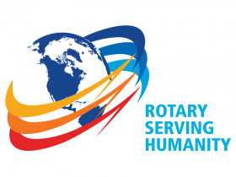
View past issues
Visit our website
'Like' our Facebook page
'Follow' our Twitter page

