membership Workshops Begin in 7 Days

District Food Packaging Event in 25 Days

Zone 24/32 Institute Highlights
By Pat and Skip Doyle
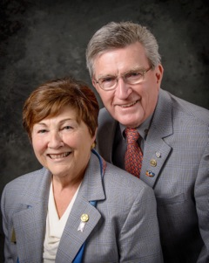
Important! Important! Important!
You asked! We Listened!
Two District-Wide Events: Membership Workshops and District Food Packaging
Membership Workshops

They will be held this month on three dates in four location:

- Area D: Monday, October 24, 6:30-8:30 p.m., Brookline VFW, Brookline. To register, click here
- Area B: Monday, October 24, 6:30-8:30 p.m., Concord Academy, Concord. To register, click here
- Area C: Tuesday, October 25, 6:30-8:30 p.m., Chuck's Steak House, Auburn. To register, click here
- Area A: Wednesday, October 26, 6:30-8:30 p.m., The Manor, West Boylston. To register, click here
To find your club's area, click here.

District Food Packaging

Saturday, November 12
11:00 a.m. – 2:00 p.m.
Solomon Pond Mall
Marlborough

To volunteer and donate, click here.

Highlights of Zone 24/32 Institute in Winnipeg, Canada

From September 28 through October 1, we were privileged to attend the Zone 24 and 32 Institute in Winnipeg, Manitoba, Canada. Before we give you a report, we feel that many of you may not be aware of what the term "zone" refers to in Rotary. We were members ourselves for many years before we knew.

The Rotary Manual of Procedure gives an excellent and definitive explanation. Just as the 34,000 Rotary clubs belong to more than 530 districts, the districts belong to 34 zones. These zones have experts assigned to them to help district governors, and other district leaders connect to Rotary resources. One of the ways this takes place is at informational meetings held in zones. These Zone Institutes provide current, incoming and past Rotary International officers with updates on RI's and The Rotary Foundation's policies and programs.

Our four days in Winnipeg were jam-packed with opportunities to learn. The theme was "Rotary Rohrs for Human Rights" in honor of Zone 24/32 Director Dean Rohr. We visited the Canadian Museum of Human Rights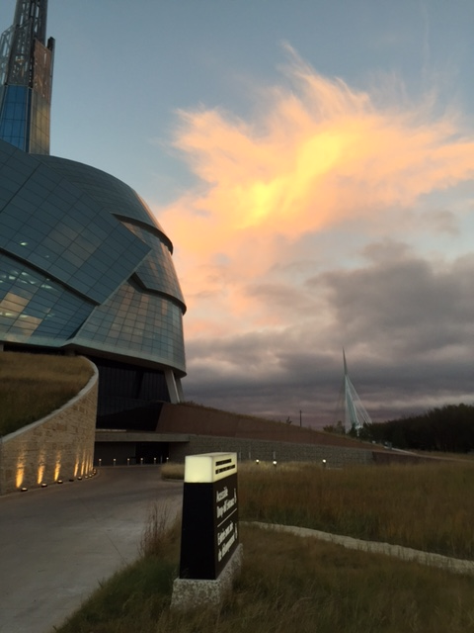 and heard Nobel Prize winner Dr. Oscar Arias Sanchez speak on the Central American Peace Process. We heard Archbishop Desmond Tutu's daughter speak about the Tutudesk initiative to provide school desks for two million school children. Breakout sessions were held on all six areas of Rotary focus. Forums were held on membership, foundation and future leaders. Our heads were spinning with information.

Our take away from this event: Rotary is alive and well - albeit, getting a little gray around the edges. Many people from across the Northeastern United States and Canada are reaching out to younger generations, asking them to join us in the amazing things we do and their far-reaching results.

One thing we learned: Our district must grow membership. We must do all we can to enroll and engage, as RI President John Germ has said, younger members, recent retirees and working people. Please join us at the membership workshops to be held next week at a location near you.

Always remember, you can call us with questions at 508-393-9031.

District Governors Pat and Skip Doyle may be reached at pwdoyle2@verizon.net and skipdoyle2@verizon.net,
respectively.

Click here to submit content for the October 24 issue. The submission deadline for this issue is Friday, October 21.

Click here for past issues.

Return to October 17 Newsletter

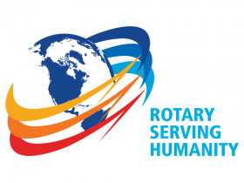Visit our website
'Like' our Facebook page
'Follow us on Twitter

