COMMITTEE REPORTS
PolioPlus Update: Important live-streaming event on October 24

By Carl Good III

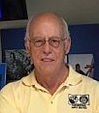

October is an important month for both The Rotary Foundation and PolioPlus.

READ MORE

See the article in the left column of this newsletter. For more information on this important month, click here.

Membership Corner: Membership workshops start in 7 days
By Tom Sturiale
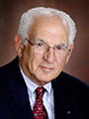

Instead of a District Membership Forum this year, we are featuring Membership Workshops in our district's four areas.

READ MORE

Membership Materials On Sale: Order now!
To order, click here

Rotary Means Business to Hold First Organizational Meeting on October 20
By Ron Bott

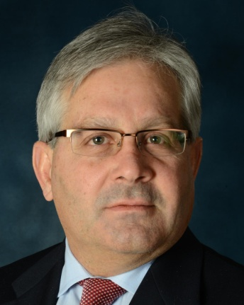

Interested in business networking? Can you help us organize events?

READ MORE

Rotary Leadership Institute on November 12 in Chicopee

By Doug Detweiler

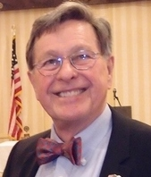

RLI recommends that candidates should have those qualities that mark them as potential club leaders - not necessarily future presidents.

READ MORE

District Governor-Elect Report: Why should I go to the Rotary International Convention?

For more information on the 2017 RI Convention in Atlanta, click here

By Karin Gaffney
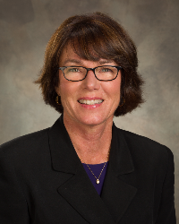

I am providing testimonials from our Rotarians who have attended a Rotary International Convention. Here's a testimonial from Assistant Governor Satya Mitra, past president of Worcester Rotary:
READ MORE
Next week, I'll have a testimonial from Carol Toomey of Nashoba Valley Rotary.

Foundation Note: Club qualification status for Foundation grants - Update

By Sanjay Deshpande
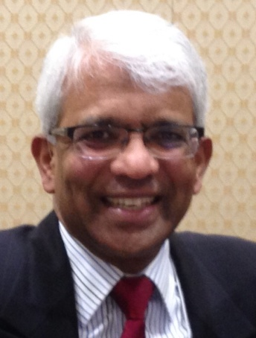

District 7910 adopted three qualification criteria that its clubs must satisfy in Rotary Year 2016-2017for being eligible for participation in Foundation grants, which include District Grants (DG) and Global Grants (GG).
READ MORE

Speaker's Bureau: Looking for good speaker for your club?

By Steve Levitsky

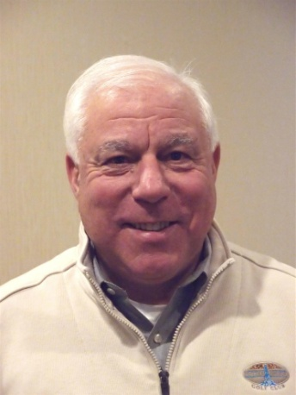

It's not always easy to come up with ideas week after week. We have many suggestions for you. Here are just a few:
- Rwandan genocide: Carine Boggis
- Elevator-pitch tips: Andy Winig
- Positive-results hypnosis: Bob Martel
- Differentiation and game-changing simplicity: Stephen Melanson
VIEW MORE

How to Launch An Interact club

By Bob Anthony
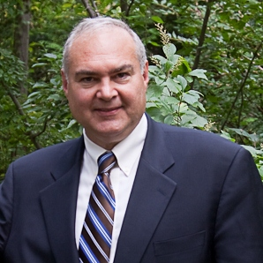

In Seminar 2 of the District Interact Teen and Advisor Training Seminar, held on September 17 in Needham,Bob Anthony, chair of the District Interact Committee, discusses “How to launch an Interact club,” including the certification letter, roles and responsibilities of the president, the Rotary advisor and, in the case of school-based clubs, the faculty advisor.

WATCH VIDEO

PR Tips: More about pictures
By Laura Spear
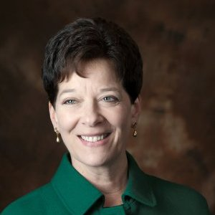

Make sure your photos reflect connections and community and are not staged.

READ MORE

Treasurer's Report: Message about your dues

By Jack Hoell
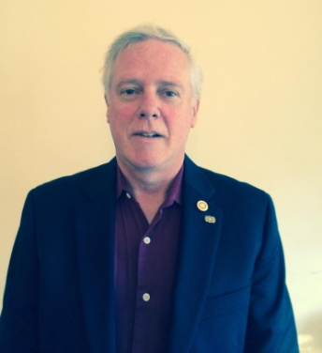

The Rotary International dues bills were e-mailed to the 51 clubs in our District on July 22 and the District dues bills were e-mailed to clubs on July 26.
READ MORE

District Charity Fund: How does DCF operate?

By Al Bowers
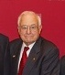

The District Charity Fund is a 501(c)3 charitable, non-profit that can be used by the Rotary clubs in District 7910.
READ MORE

Communications Link: Seeking club photo, video albums
By Steve Jones-D'Agostino
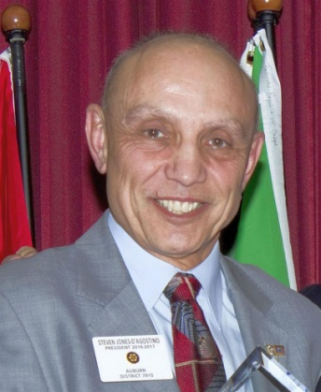

Does your District committee or Club have Rotary-related photo and/or video albums that you'd like to share with other Rotarians?
READ MORE

Bandey Hefler: We're back from England
By Victor Tom
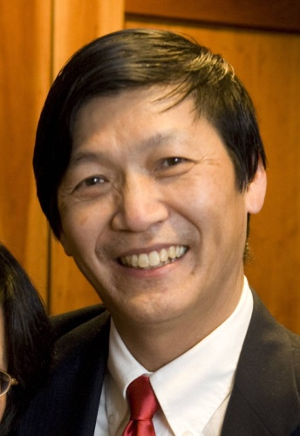

Our District 7910 Bandey-Hefler Fellowship Exchange received rave reviews from all travelers and hosts.
READ MORE
Next week, I will have a detailed article on our two-week trip to England!

SUBMIT CONTENT
To submit content for consideration for the Monday, October 24 issue of Rotary District 7910 Newsletter, please e-mail it to Immediate Past District Governor and Newsletter Editor Jim Fusco at jim.fusco2@gmail.com.
The submission deadline for that issue is Friday, October 21. All text must be in Word format. All images must be in either JPEG or PDF format. Please identify the people, left to right, who are shown in your photos, including their first and last name as well as their club or other title.

PAST ISSUES
To view past issues of the weekly Rotary District 7910 Newsletter, click here

DISTRICT 7910 ONLINE
Visit our website
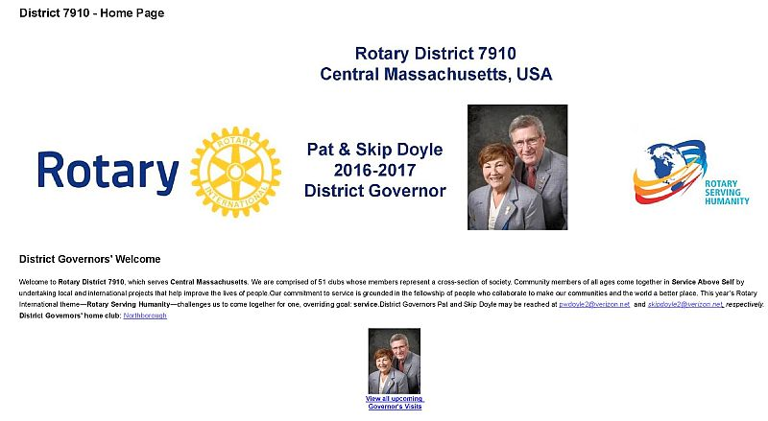

'Like' and share us on Facebook
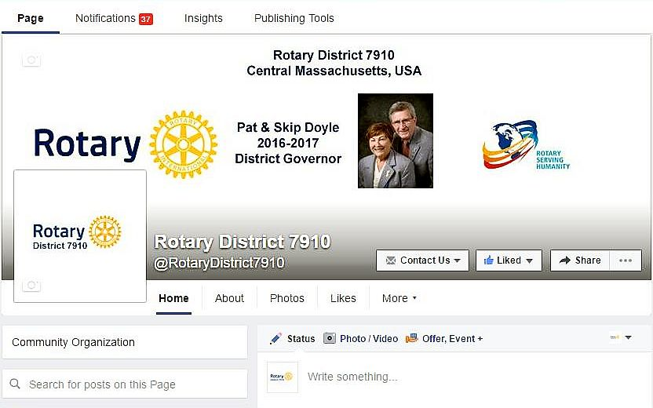

Watch our videos on YouTube
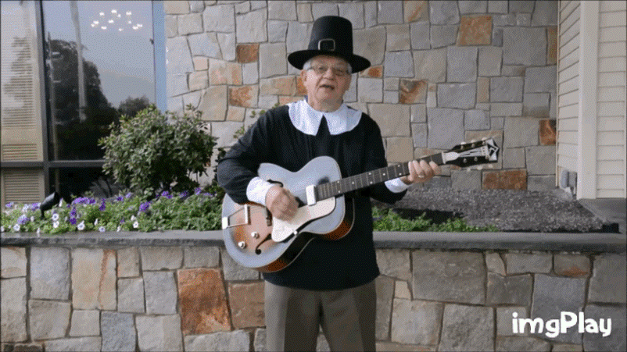

View our photos on Google Photos (since May 2015) and ClubRunner (before May 2015)
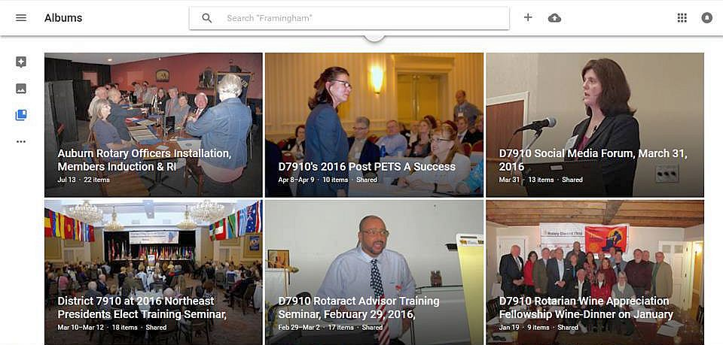

CONTACT US
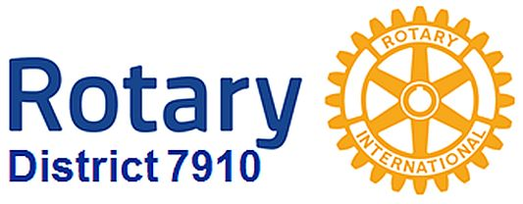

Immediate Past District Governor and Newsletter Editor Jim Fusco
​jim.fusco2@gmail.com
District Webmaster Steve Jones-D'Agostino
​srdagostino@icloud.com

© Copyright 2016-2017 - Rotary District 7910, Central Massachusetts, USA

