Dear $NICK_NAME$,

It is our pleasure to share with you the October 24 issue of Rotary District 7910 Newsletter.

For the complete issue, click here.

To explore past issues, click here.

Highlights of October 24 issue:

Governor's Message - Membership Workshops begin today; District Food Packaging event in 18 days - By Pat and Skip Doyle

District-wide Food Packaging Event: Saturday, November 12 at Solomon Pond Mall in Marlborough - By Carol Toomey

District Governor-Elect Report: Carol Tomey, on why should we go to the Rotary International Convention - By Karin Gaffney

PolioPlus Update: Important live-streaming event today - By Carl Good III

Membership Corner: Member Workshops start today - By Tom Sturiale

Rotary Leadership Institute: Next RLI in our area is scheduled for November 12 in Chicopee - By Doug Detweiler

Foundation Note: Available District Designated Funds for Global Grants - By Sanjay Deshpande

Bandey Hefler Report: Our district's travelers are back from England - By Victor Tom

PR Tips: Rotary Blue is not just any blue - By Laura Spear

Speakers Bureau: Do you need a speaker for your club? By Steve Levitsky

Interact Actions: How to launch an Interact club - By Bob Anthony

Followup: Governor Baker 'Meet & Greet' - By Marty Heilman

Women in Rotary: A radio interview on 'Women in Rotary’ - By Steve Jones-D'Agostino

Communications Link: Seeking club photo, video albums - By Steve Jones-D'Agostino

Treasurer's Report: Message about your dues - By Jack Hoell

District Charity Fund: How does DCF operate? - By Al Bowers

Our next newsletter will come out on Monday, October 31. The submission deadline is this Friday, October 28. Text content must be submitted in Word format. Image content must be submitted in either JPEG or PDF format. Send your content submissions to Immediate Past District Governor/Newsletter Editor Jim Fusco at jim.fusco2@gmail.com.

Governors Pat & Skip

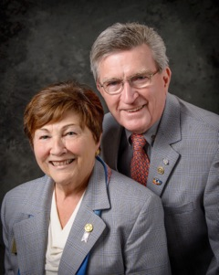Pat and Skip Doyle
2016-2017 Governors
Rotary District 7910
pwdoyle2@verizon.net
skipdoyle2@verizon.net
