District MEMBERSHIP WORKSHOPS
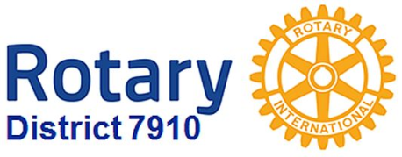

They will be held this month on three dates in four locations, shown in date order:

Area D: Monday, October 24, 6:30-8:30 p.m., Brookline VFW, Brookline. To register, click here
Area B: Monday, October 24, 6:30-8:30 p.m., Concord Academy, Concord. To register, click here
Area C: Tuesday, October 25, 6:30-8:30 p.m., Chuck's Steak House, Auburn. To register, click here
Area A: Wednesday, October 26, 6:30-8:30 p.m., The Manor, West Boylston. To register, click here

To find your club's area in our district, click here.

Governors' Welcome
Welcome to Rotary District 7910, which serves Central Massachusetts. We are comprised of 51 clubs whose members represent a cross-section of society. Community members of all ages come together in Service Above Self by undertaking local and international projects that help improve the lives of people.

Our commitment to service is grounded in the fellowship of people who collaborate to make our communities and the world a better place. This year’s Rotary International theme—Rotary Serving Humanity—challenges us to come together for one, overriding goal: service.

District Governors Pat and Skip Doyle may be reached at pwdoyle2@verizon.net and
skipdoyle2@verizon.net, respectively.

District Governors' home club: Northborough

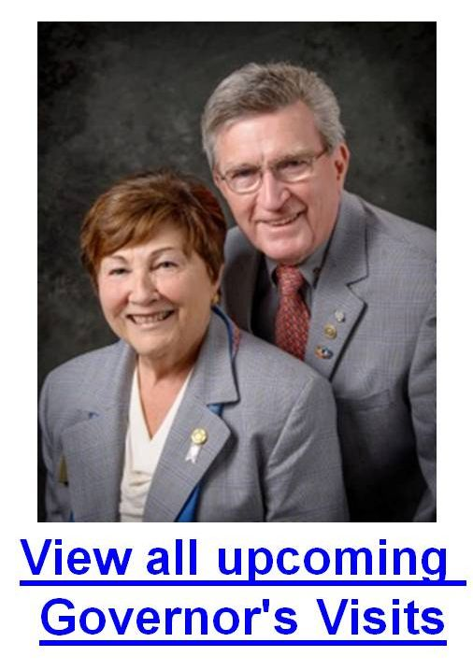

DISTRICT CONFERENCE 2017 REGISTRATION IS OPEN!
Dis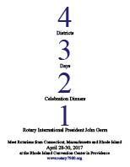tricts 7890, 7910, 7950 & 7980
April 28, 29 & 30, 2017
Rhode Island Conference Center, Providence
To register now for this '4 Districts, 3 Days, 2 Celebration Dinners, 1 Rotary International President John Germ' event, click here

After you register, be sure to make reservations at the hotel of your choice

District RESOLUTIONS

For District 7910 Resolutions approved during the Business Meeting of the 2016 District Conference, click here

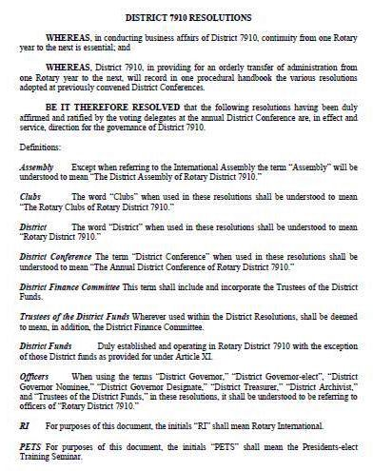

District at a glance

Click on each one

District SOCIAL MEDIA

Click on each one

View Live: Our Facebook Page!
Rotary District 7910

Click here for the complete issue

Or, click on each of these issue highlights:

Governor's Message: - Membership Workshops begin today; District Food Packaging event in 18 days - By Pat and Skip Doyle

District Governor-Elect Report - Carol Tomey, on why should we go to the Rotary International Convention - By Karin Gaffney

PolioPlus Update: Important live-streaming event today - By Carl Good III

Membership Corner: Member Workshops start today - By Tom Sturiale

Rotary Leadership Institute: Next RLI in our area is scheduled for November 12 in Chicopee - By Doug Detweiler

Foundation Note: Available District Designated Funds for Global Grants - By Sanjay Deshpande

Bandey Hefler Report: Our district's travelers are back - By Victor Tom

PR Tips: Rotary Blue is not just any blue - By Laura Spear

Speakers Bureau: Do you need a speaker for your club? By Steve Levitsky

Interact Actions: How to launch an Interact club - By Bob Anthony

Followup: Governor Baker 'Meet & Greet' - By Marty Heilman

Women in Rotary: A radio interview on 'Women in Rotary’ - By Steve Jones-D'Agostino

Communications Link: Seeking club photo, video albums - By Steve Jones-D'Agostino

Treasurer's Report: Message about your dues - By Jack Hoell

District Charity Fund: How does DCF operate? - By Al Bowers

