Click on each link to read that week's "Membership Corner" article:

October 2016 articles:

October 3: A review of membership best practices from eight of our clubs

October 17: Membership workshops start on October 24

September 2016 articles:

September 5: Corporate Memberships in Rotary

September 19: What Are Our Rotary Objectives? Membership! Membership! Membership!

September 26: Rotary Club Objectives

August 2016 articles:

August 1: What would Paul Harris do?

August 8: Where will we find new members?

August 15: How do we approach prospective members?

August 22: Visioning

August 29: Unique Approach to Publicize Rotary by Northborough

Please let Tom know any ideas, comments and/or stories for "Membership Corner" that you would like to share. E-mail Tom at tsturiale36@gmail.com.

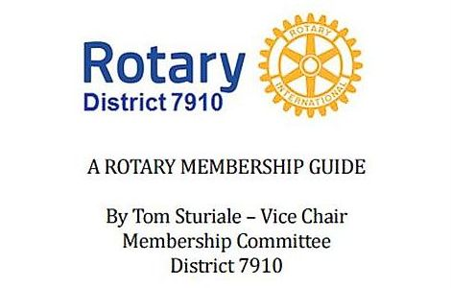"A Rotary Membership Guide" is a collection of "Membership Corner" articles written for this weekly newsletter during the 2015-2016 Rotary year, which began July 1, 2015. Each article is intended to offer an idea or thought aimed at stimulating discussions, questions and actions, to effectively increase membership at all our clubs.

Click here, to read and download this 52-page"Guide," in PDF format.

