GoVERNOR'S MESSAGE
Did You Miss this Message the Past Two Weeks?
Membership Workshops Begin Tonight
District Food Packaging Event in 18 Days
By Pat and Skip Doyle
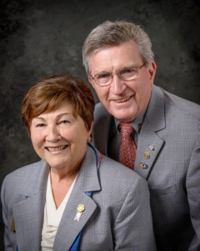Important! Important! Important!
You asked! We Listened!
Two District-Wide Events: Membership Workshops and District Food Packaging
Membership Workshops

They will be held this month on three dates in four locations, starting tonight:

- Area D: Tonight, October 24, 6:30-8:30 p.m., Brookline VFW, Brookline. To register, click here
- Area B: Tonight, October 24, 6:30-8:30 p.m., Concord Academy, Concord. To register, click here
- Area C: Tomorrow night, October 25, 6:30-8:30 p.m., Chuck's Steak House, Auburn. To register, click here
- Area A: Wednesday night, October 26, 6:30-8:30 p.m., The Manor, West Boylston. To register, click here
To find your club's area, click here.

District Food Packaging

Saturday, November 12
11:00 a.m. – 2:00 p.m.
Solomon Pond Mall
Marlborough

To volunteer and donate, click here.

Always remember, you can call us with questions at 508-393-9031.

District Governors Pat and Skip Doyle may be reached at pwdoyle2@verizon.net and skipdoyle2@verizon.net,
respectively.

Click here to submit content for the October 24 issue to Immediate Past District Governor/Newsletter Editor Jim Fusco.

Click here for past issues.

WELCOME, NEW ROTARIANS
No New Members. Ask! Ask! Ask!

Sign up for one of the District's four Membership Workshops:Coming this month to your area our district! To learn more, click here.

Do You Know Who They Are?

See Next Week's Newsletter for the Answer!

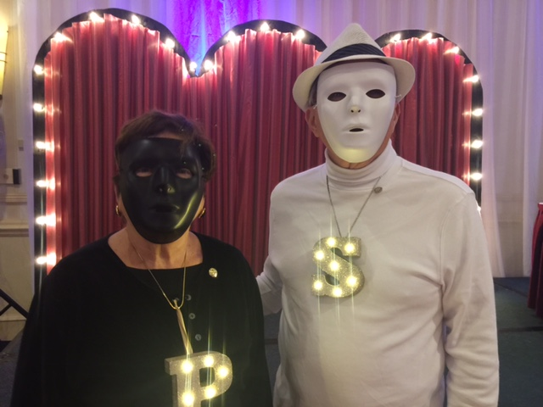

Leadership Meetings with AGs a Huge Success

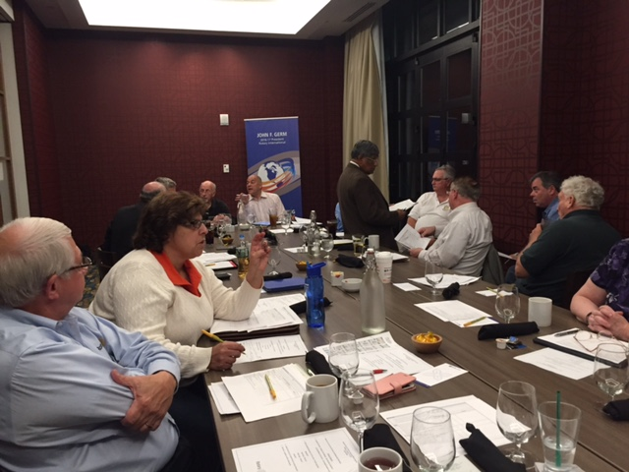

The first Leadership Meeting, held in July, was so great that another one took place on October 17 at the Hilton Garden Inn in Marlborough. During the latest meeting, shown above, the assistant governors were present to assist in formulating goals for this 2016-2017 Rotary year.

Bandey Hefler Travelers Are Back Home from England

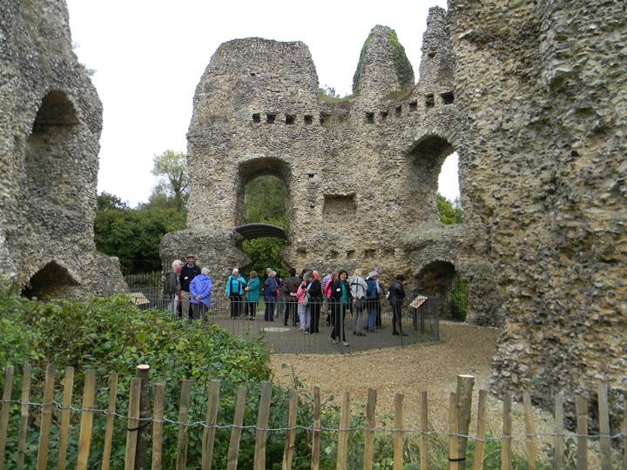

Shown, are Bandey Hefler travelers at Odiham Castle in England.

To read an article by Victor Tom, co-chair of District 7910's Bandey Hefler Fellowship Exchange, click here

CLUB MEMBERSHIP GROWTH, ’16-‘17
We share with you the results of club-membership growth in our district during Rotary year 2016-2017, which began July 1.

This is a unique opportunity for Rotarians and friends to discuss partnering on humanitarian projects affecting our local communities.

READ MORE

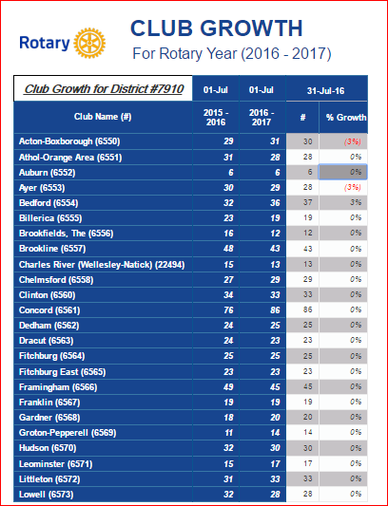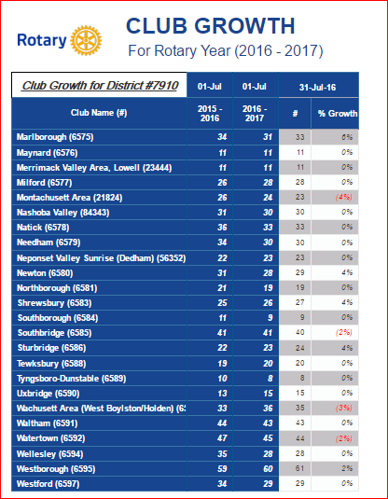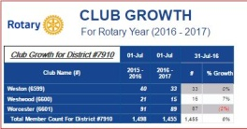

CLUB PLANNING WORKSHEET '16-'17
In both Excel and PDF formats, we share with you the Club Planning Worksheet for Rotary year 2016-2017, which began on July 1.
Please enter your club information in the indicated cells.

Excel Format

PDF Format

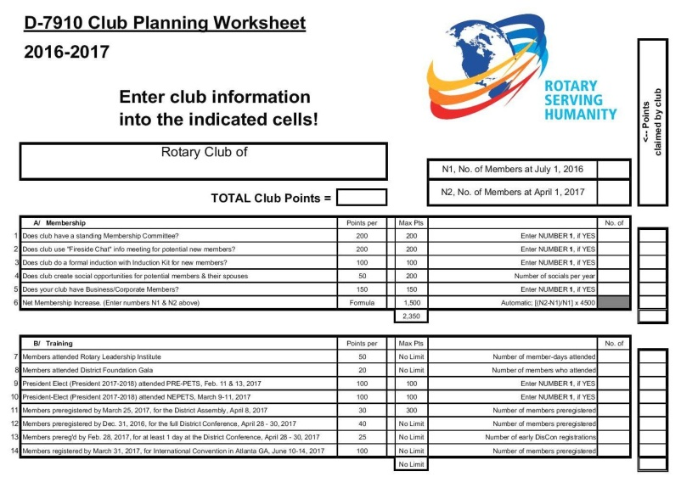

OUR PRESIDENTS SPEAK
Jennifer Peck, Montachusett Area

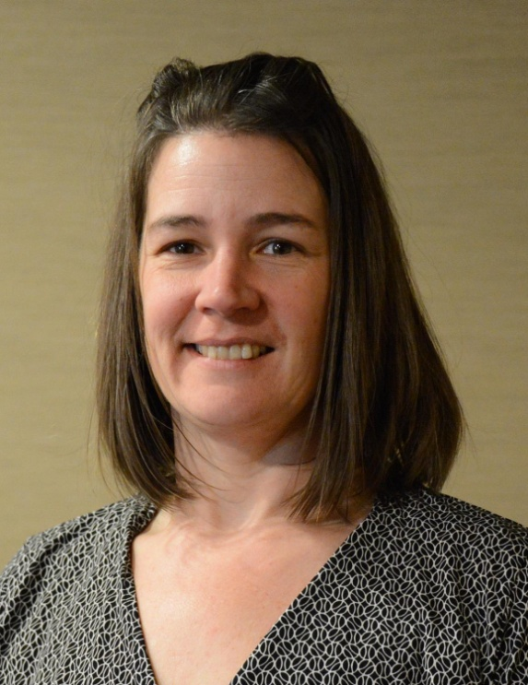

Please tell us what factors helped you decide to join Rotary.

I joined Rotary as a requirement of a new job that I took six-and-a-half years ago.

READ MORE

DG VISITS LAST WEEk
Groton-Pepperell (chartered 1941)

Left to right: President Duncan France, and District Governors Pat and Skip Doyle.

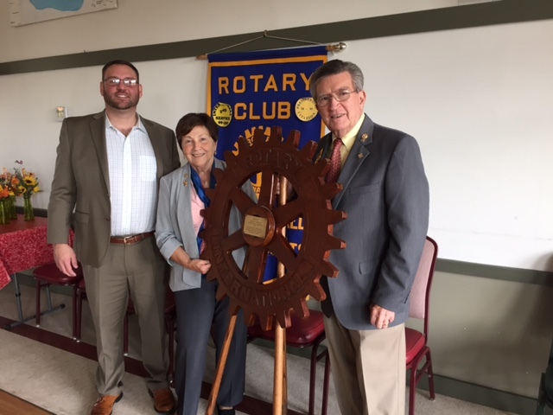

Groton-Pepperell has a wood Rotary wheel that was hand-carved in 1947. Shown, is the plaque on the wheel.

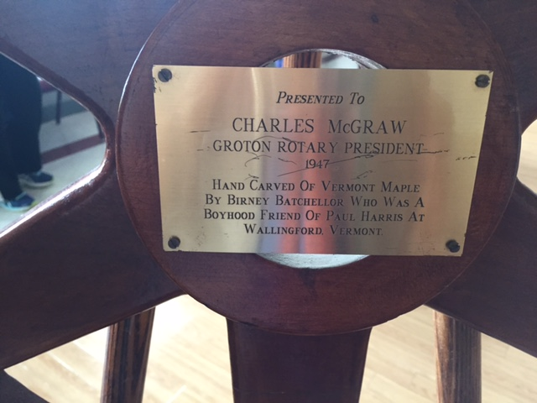

Montachusett Area (chartered 1984)

Left to right: District Governors Pat and Skip Doyle, President Jennifer Peck, and Assistant Governor Karen Fusco.

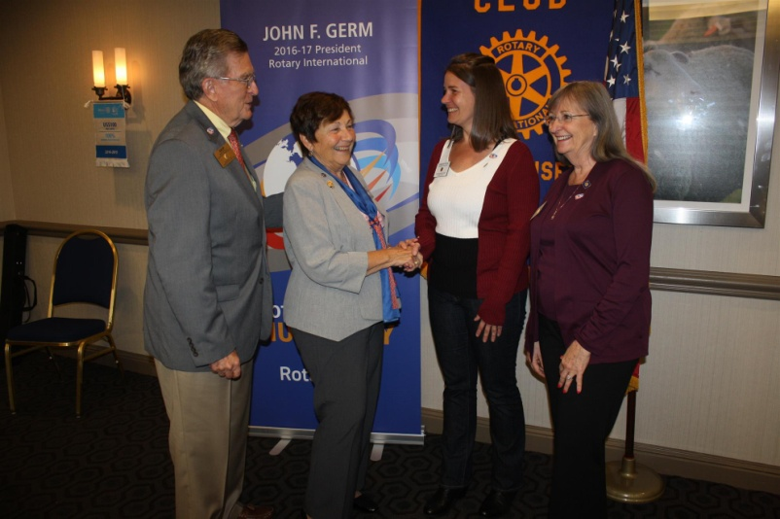

l

Shrewsbury (chartered 1957)

Left to right: District Governor Skip Doyle, President Frank Jelinch, District Governor Pat Doyle, and Assistant Governor Peggie Thorsen.

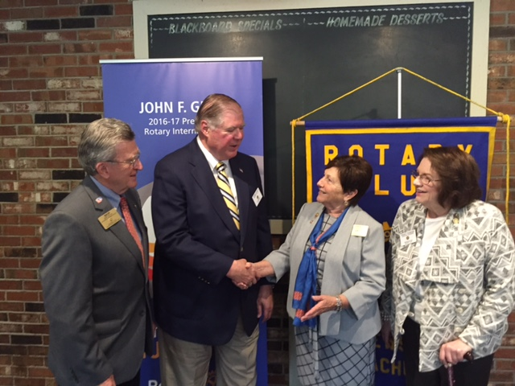

Westwood (chartered 1960)

Left to right: President Dottie Powers, and District Governors Pat and Skip Doyle.

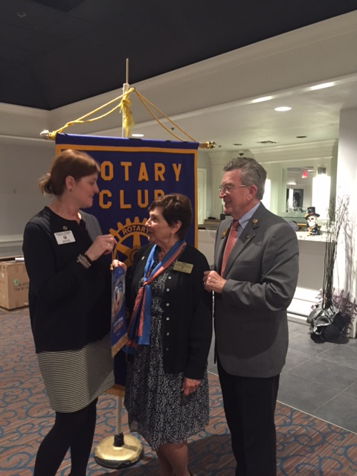

What a great surprise by the Westwood club: A Rotary cake to celebrate The Rotary Foundation

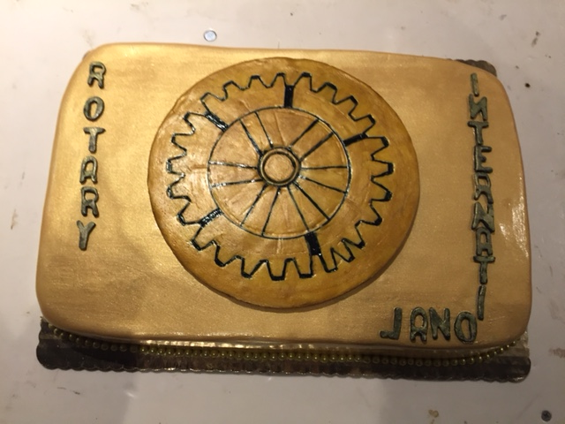

DISTRICT & CLUB ROUNDS
Nashoba Valley Sponsors Razia's Ray of Hope Benefit This Thursday



The Rotary Club of Nashoba Valley is proud to sponsor the local premiere of What Tomorrow Brings, event to benefit Razia’s Ray of Hope, this Thursday, October 27 from 7:00 to 9:00 p.m. at the Warn Hall of the Fenn School, located at 6 Monument St. in Concord.

To learn more and RSVP, click here

Fitchburg Rotary Roasts the Mayor

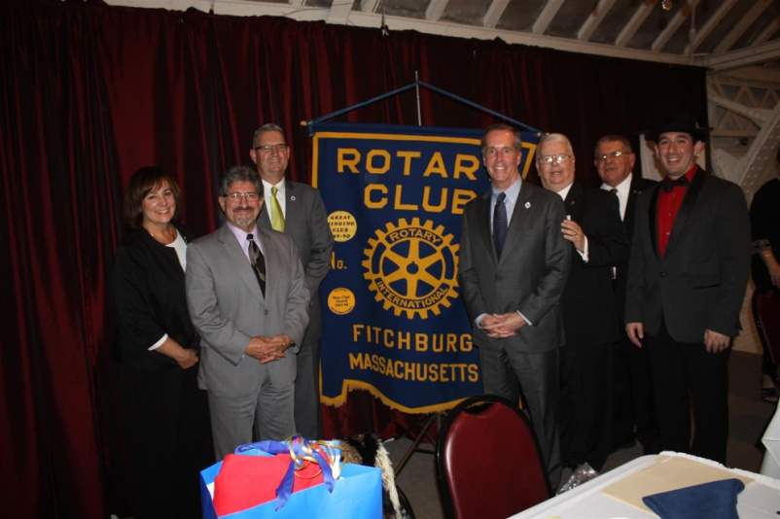

Fitchburg has a new mayor this year and a Mayoral Roast was in order.

Left to right: Mayor's Administrative Assistant Joan David; Mayor Stephen DiNatale; State Representative Stephan Hay; State Representative William "Smitty" Pignatelli; club President Dan Cunningham; Tony Gasbarro, a member of Montachusett Area Rotary; and Emcee Travis Condon of radio station WPKZ.

To watch promotional video, click here.

Acton-Boxborough and Littleton Raise $15,000 for Local Food Pantries

The Rotary Clubs of Acton-Boxborough and Littleton held their Annual Rotary Masquerade Ball on October 22 at the Holiday Inn in Boxborough to benefit two local food pantries: Loaves and Fishes Food Pantry; and The Acton Community Supper and Food Pantry.

READ MORE & VIEW PHOTOS

Left to right: Littleton President Corinne Braciska, and Acton-Boxborough President Joe Badenhoff.

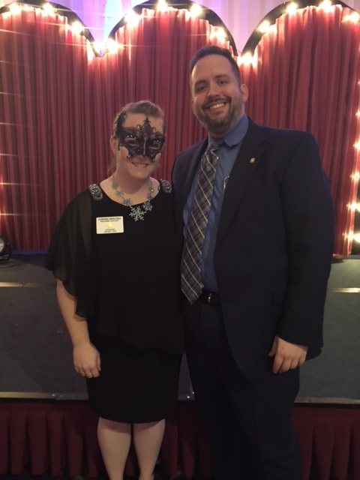
l

Auburn Holds 'Flips for Scholars' Pancake Breakfast

To learn more and view event photos, click here.

Standing, left to right: President Steve Jones-D'Agostino; Member Tom Dufour; Secretary Heather Chivallatti; Member Jon Manning; District Governor Pat Doyle; Member John Convent; District Governor Skip Doyle; Treasurer and Immediate Past President Marcia Davis, who chairs the District ESSEX (Eastern States Student Exchange) Committee; and Member Jennifer Reil.

Kneeling, left to right: ESSEX students Greg Reimonn from Hopkinton, Yuka Ichikawa from Japan, and Kaitlyn Denson from Hopkinton.
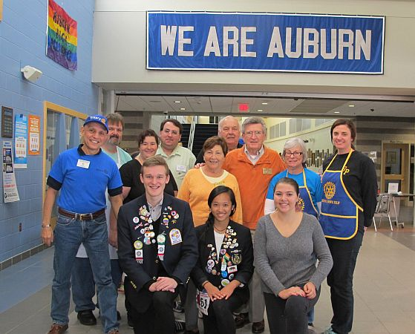

Franklin Holds Chalkfest for Charity

To view event photos, click here.

READ MORE

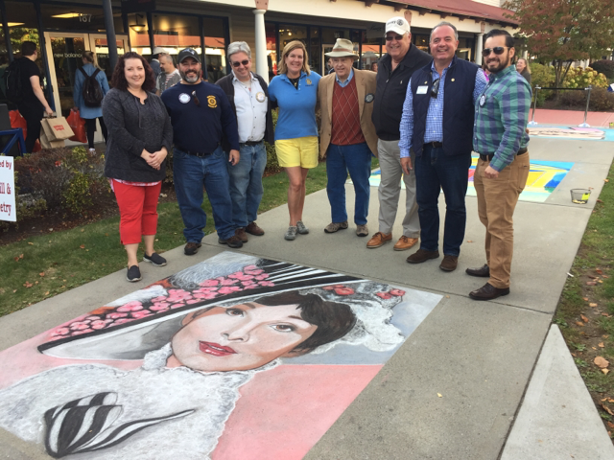

l

Left to right: First-place artist Kerry Wippie; President Elect Scott Martin; Past President and Board Member Fran McKeown; Past President and Vocational Services/RYLA Chair Julie Rougea; Past President Herb Hunter; Past President and Board Member Dan Gentile; President Terry Katsaros; and new Member Carlos Aguilera.

Milford Holds Fall Family Fun Day


Locals gathered on Saturday, October 15 at Milford Town Park for an event designed to raise awareness of and money for Alternatives Unlimited, a charitable organization dedicated to people with physical and emotional disabilities. The fourth annual Fall Family Fun Day was a collaboration of Alternatives Unlimited and the Milford Rotary Club.
READ MORE﻿
Shown: Jessica Mayancela, 5, of Milford, look at her freshly painted face in a mirror during Fall Family Fun Day. Photo: Dan Holmes, Wicked Local.

Sturbridge Takes Part in Harvest Festival

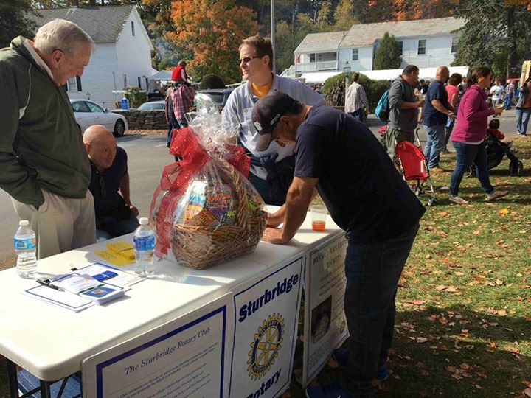

During the annual Sturbridge Harvest Festival, held October 15 and 16 on Sturbridge Common and the grounds of the Publick House, Sturbridge Rotarians staffed a table selling chances on winning a basket of $1,000 worth of lottery tickets. The Festival included countless local crafters, artisans, specialty-food vendors and farm fresh harvests. The Publick House's Scarecrow Contest was a perennial favorite.

Left to right: Member Maurice Poirier, Past President Larry Mandell, Member Scott Peckins, and an unidentified attendee.

Followup: Governor Baker 'Meet & Greet'

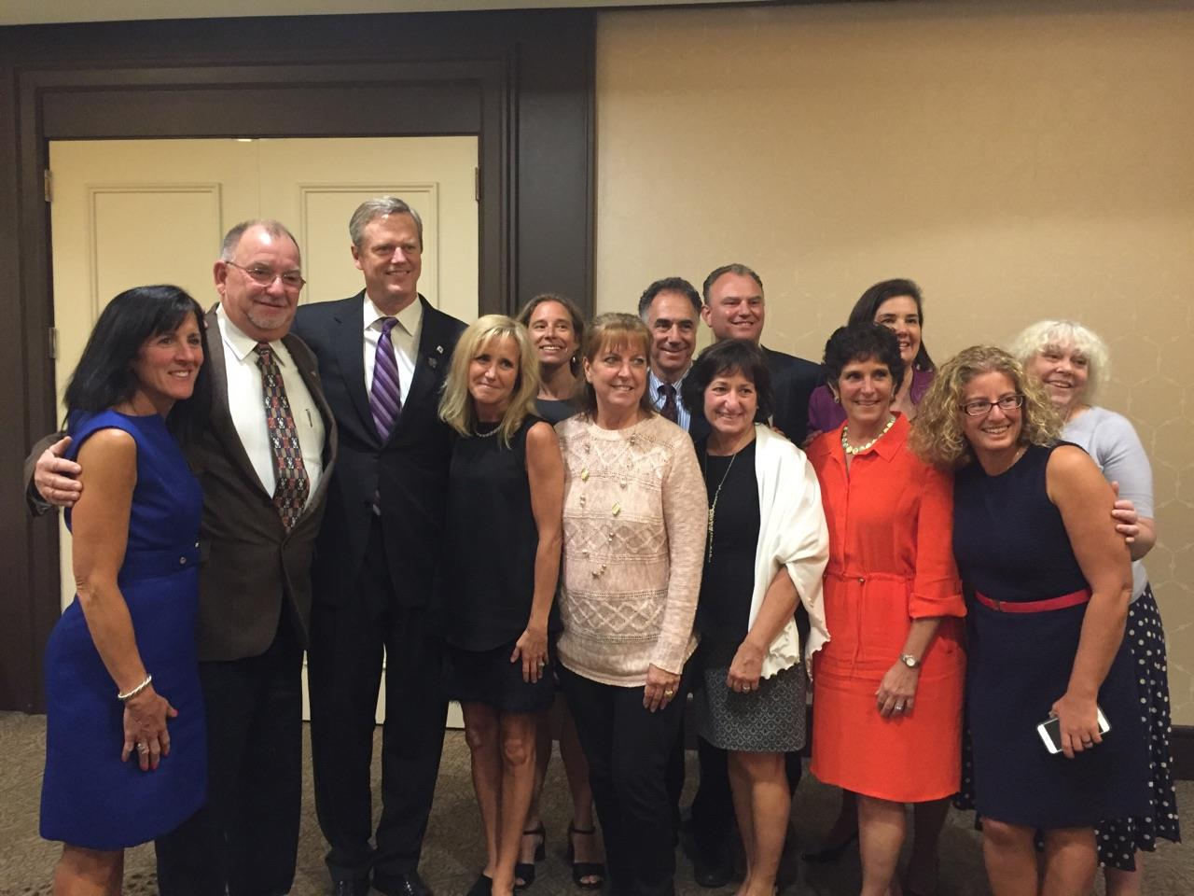

Governor Charlie Baker (third from left) poses with members of the Massachusetts Prevention Alliance on September 27 in Bedford. He was the featured speaker at an event sponsored by the Rotary clubs of Bedford, Billerica, Lowell, Newton and Shrewsbury.
READ MORE (article by Heidi Heilman of Weston-Wayland Rotary)
Left to right: Carol Read, Needham Public Health Department; Peter Juaire, Marlborough City Council; Charlie Baker; Heidi Heilman, Massachusetts Prevention Alliance; Amy Turncliff, A Decision at Every Turn, in Ashland; Cheryl Juaire, Magnolia New Beginnings;John Scheft, Law Enforcement Dimensions; Lynn Frano, Organizing Against Substance Abuse, in Stoughton; Lester Hensley, Westborough Planning Board; Beverly Madden, Substance Prevention & Awareness Network, in Dover-Sherborn; Jody Hensley, Westborough School Committee; Stephanie Patten, Organizing Against Substance Abuse Stoughton; and Karen Walsh, South Hadley Drug & Alcohol Prevention Coalition.

Watertown Holds Senior Citizen Cookout

Left to right: Members Dr. Lee and Kitty Mennilli; and Honorary Members Dottie Morgan and Debbie Boyajian.

READ MORE
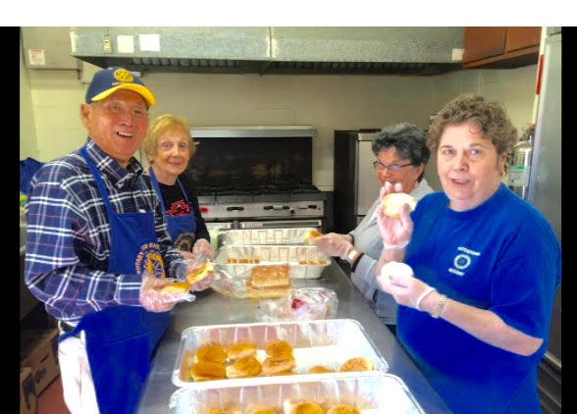

Southborough Sponsors Four RYLA Participants

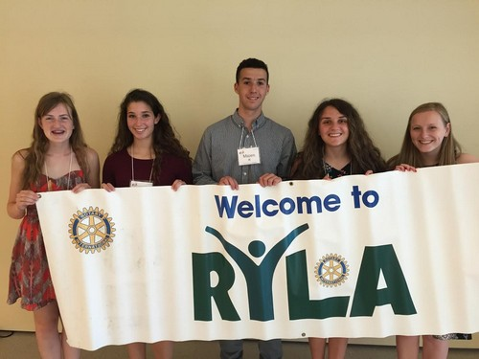

Four high school juniors were able to participate in a Rotary Youth Leadership Awards conference this summer thanks to the Rotary Club of Southborough. The club is thanking a fund donor and reaching out for more businesses to step up.

District Interact Training Seminar A Huge Success

Nearly 50 participants from 14 Rotary communities took part in a District Interact Teen and Advisor Training Seminar, which was held on September 17 at the Sheraton Hotel in Needham.

READ MORE (including links to Seminar videos and photos)

Women in Rotary: A Radio Interview

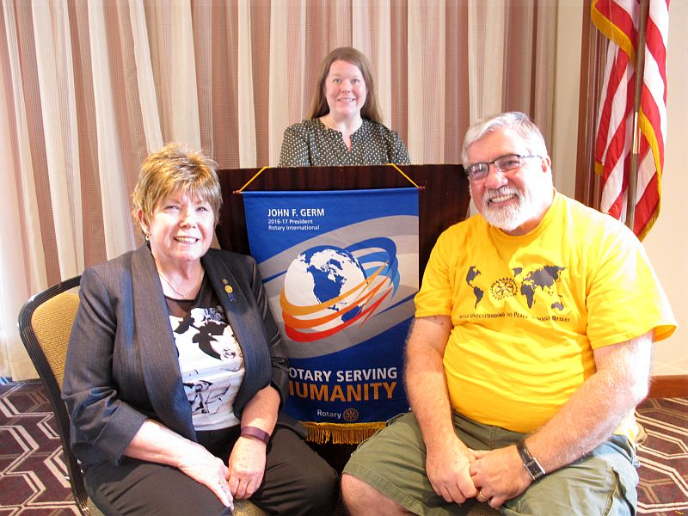

Boston Rotaract hosted the Women in Rotary: Not (Just) Your Grandfather’s Rotary Club forum on October 5 at the Back Bay Social Club in Boston. Prior to the event, Auburn Rotarian Steve Jones-D'Agostino interviewed Boston Rotaract President Amy Collinsworth (shown, middle), District 7930 Governor Sheryl Meehan(shown, left) and District 7930 Governor-Elect Dave Gardner(shown, right) for The Business Beat, which he produces and hosts for Worcester radio station WICN-FM.

READ MORE

Pat and Skip Doyle Installed as '16-'17 DGs

District 7910's 2016 Rotary Youth Leadership Awards were held on June 24 through 26 at Fitchburg State University, ending with the installation of longtime RYLA supporters Pat and Skip Doyle as District Governors for 2016-2017. The three-day RYLA event was attended by 188 sophomores. To learn more about RYLA, visit ryla7910.org.

Click on the image, to view a video of the installation of Pat and Skip Doyle as '16-'17 DGs

District Banners Available

Our district banners are available for your to use when you have an upcoming event or fundraiser.

If you want to reserve one of the banners, please contact PR Chair Laura Spear at laura@spear.net.

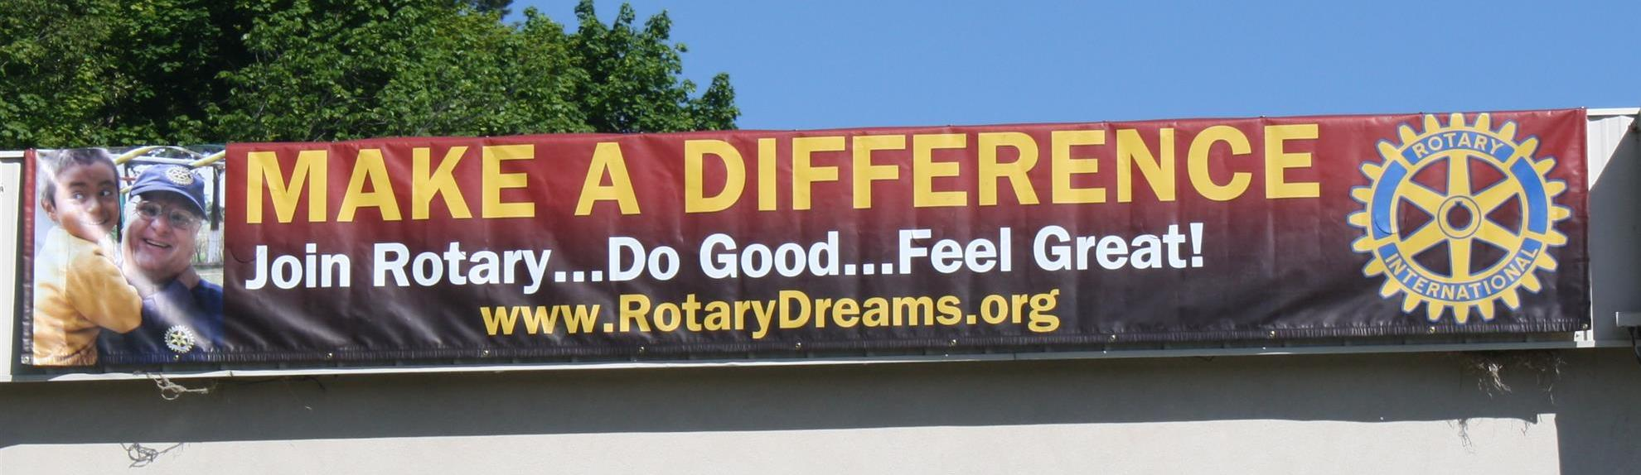

On to Atlanta in 2017

Early-Registration Discount Ends December 15

Planning to attend? Contact District Chair Steve Glines.



More than 43,000 attendees left the Rotary International Convention in South Korea inspired to end polio for good, to celebrate The Rotary Foundation's centennial, and to champion changes that will help Rotary appeal to a broader audience. On the last day, RI President K.R. “Ravi” Ravindran shared a personal story of his mother’s triumph over polio.

To read the story, click here.

To register for the 2017 RI Convention in Atlanta, click here

MAJOR DISTRICT & CLUB HAPPENINGS: FALL 2016
Tuesday, October 25: Hudson - 'Local Ghost Hunting'

To download the event flyer, click here

To learn more about MassConn Paranormal, click here

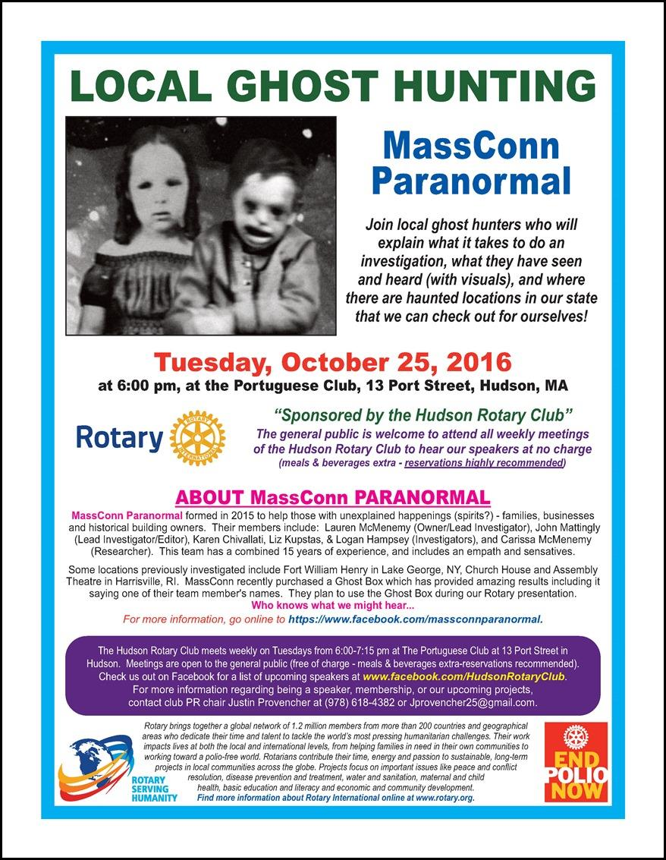

Saturday, October 29: Sturbridge - 'Antique Appraisal Show'

To download the event flyer, click here

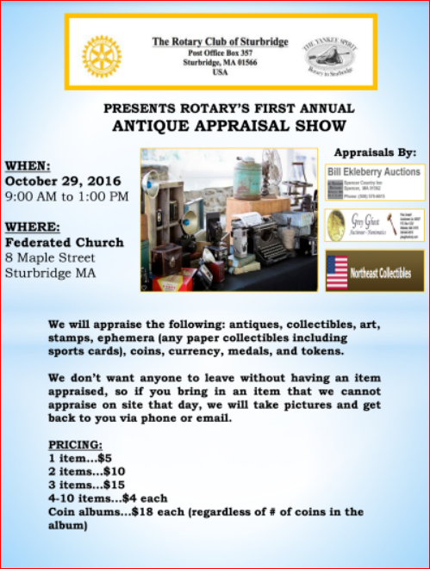

Tuesday, November 1: Marlborough - 'Reality Fair 2016'

Download the Confirmation of Participation form: click here for PDF format; and, click here for Word format

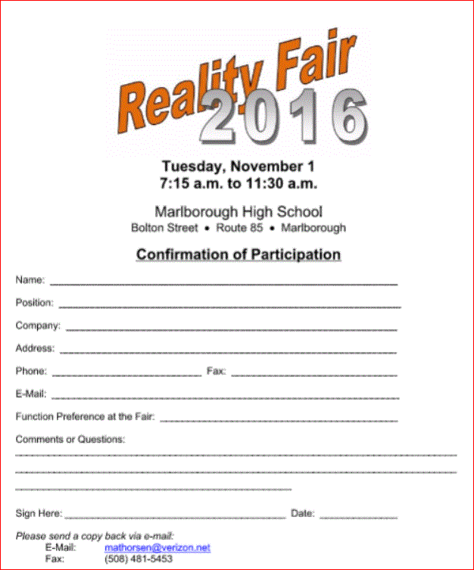

Saturday, November 5: Needham - 'Pancake Breakfast'

For more information and to purchase tickets, click here

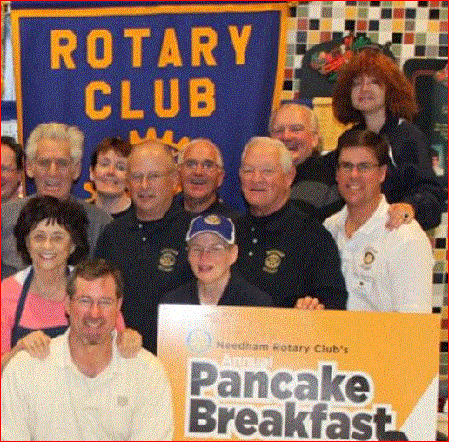

Saturday, November 12: District 7910 'Food Packaging Event,' Solomon Pond Mall, Marlborough

To either donate or volunteer, click here

To view the event flyer, click here

To learn more about Stop Hunger Now, click here



Saturday, November 19: Ayer - 'Joey & Maria's Comedy Italian Wedding'



Saturday, November 19: Billerica - 'Cribbage Tournament'

For more information, click here, or contact Brian Goguen at 978-667-4595



Monday, December 5: Sturbridge Rotary - 'Lottery Ticket Raffle'

To download the event flyer, click here.



SUBMIT MAJOR CLUB HAPPENINGS


Send flyers of your club's major events and activities, in either JPEG or PDF format, to Immediate Past District
Governor/Newsletter Editor Jim Fusco at jim.fusco2@gmail.com.

