COMMITTEE REPORTS
District Food Packaging Event: Saturday, November 12 at Solomon Pond Mall in Marlborough

By Carol Toomey

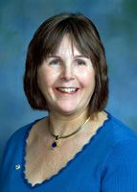

Hunger. Starvation. Food insecurity. Not having enough to eat. And worrying about where the next meal comes from. All, have long-term impacts on educational achievement, workforce productivity, chronic-disease risk, and mental health.

READ MORE

RAAGNE Newsletter: Update on visioning process

By Klaus Hachfeld

Hello, members and friends of the Rotary Alumni Association of Greater New England! Here is to the latest edition of the RAAGNE newsletter! Over the past year, we went through a visioning process to work out the future direction of RAAGNE.

READ MORE

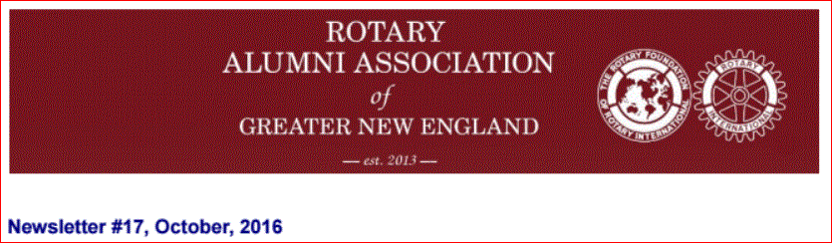

PolioPlus Update: Celebrate World Polio Day today with important live-streaming event

By Carl Good III

Please read this message and pass it on to your club's Polio Committee chair. If you are having an event for World Polio Day (or Week), please send me a brief description. We are keeping track of the events.

READ MORE

Thank you for all you do to erase this terrible disease from the face of the Earth.

October is an important month for both The Rotary Foundation and PolioPlus.

READ MORE

See the article in the left column of this newsletter.

For more information on this important month, click here.

District Governor-Elect Report: Why Should I Go to the Rotary International Convention?

For more information on the 2017 RI Convention in Atlanta, click here

By Karin Gaffney
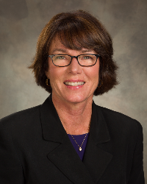

I am providing testimonials from our Rotarians who have attended a Rotary International Convention.
Here's a testimonial from Past District Governor Carol Toomey of Nashoba Valley Rotary.
READ MORE
Next week, I'll have a testimonial from Karen Fusco of Fitchburg Rotary.

Membership Corner: Membership workshops start today
By Tom Sturiale
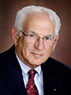

Instead of a District Membership Forum this year, we are featuring Membership Workshops in our district's four areas.

READ MORE

Membership Materials On Sale: Order now!
To order, click here

Foundation Note: Available District Designated Funds for Global Grants

By Sanjay Deshpande
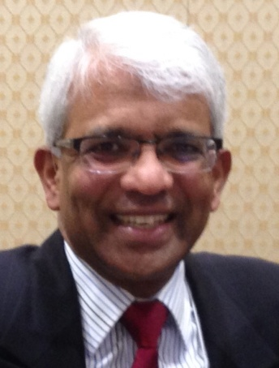

The District 7910 Foundation Advisory Board of the District Foundation Committee requires that there should be full transparency in the administration of foundation grants, which include District and Global Grants. Accordingly, this quarterly report of available District Designated Funds (DDF) for Global Grants is being published.
READ MORE

Bandey Hefler: Our district's travelers are back
By Victor Tom
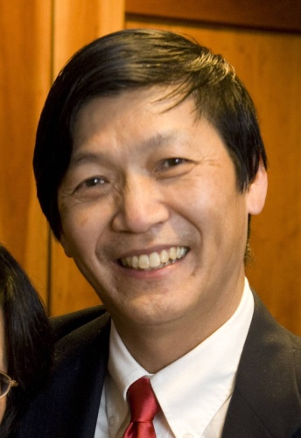

On Sunday night, October 2, we gathered one last time as a group to say goodbye to our hosts and newfound Bandey Hefler family.
READ MORE

PR Tips: Rotary Blue is not just any blue
By Laura Spear
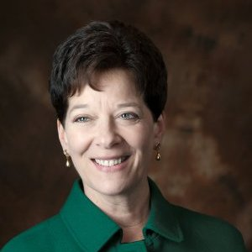

Rotarians are smart, compassionate, persevering, and inspiring, and Rotary International has chosen a set of colors to express those attributes.
READ MORE

Rotary Leadership: Next Institute on November 12 in Chicopee
By Doug Detweiler

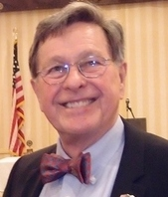

RLI recommends that candidates should have those qualities that mark them as potential club leaders - not necessarily future presidents.

READ MORE

Speaker's Bureau: Looking for good speaker for your club?

By Steve Levitsky

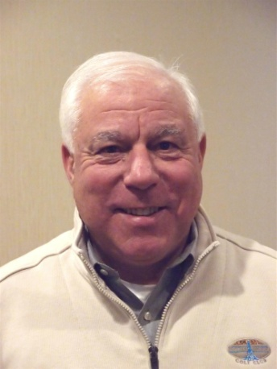

It's not always easy to come up with ideas week after week. We have many suggestions for you. Here are just a few:
- Rwandan genocide: Carine Boggis
- Elevator-pitch tips: Andy Winig
- Positive-results hypnosis: Bob Martel
- Differentiation and game-changing simplicity: Stephen Melanson
VIEW MORE

Interact Actions: How to launch an Interact club

By Bob Anthony
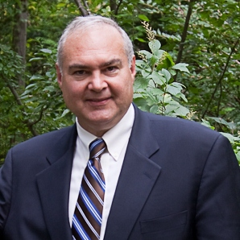

In Seminar 2 of the District Interact Teen and Advisor Training Seminar, held on September 17 in Needham, Bob Anthony, chair of the District Interact Committee, discusses “How to launch an Interact club,” including the certification letter, roles and responsibilities of the president, the Rotary advisor and, in the case of school-based clubs, the faculty advisor.

WATCH VIDEO

Treasurer's Report: Message about your dues

By Jack Hoell
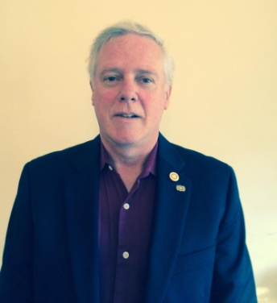

The Rotary International dues bills were e-mailed to the 51 clubs in our District on July 22 and the District dues bills were e-mailed to clubs on July 26.
READ MORE

District Charity Fund: How does DCF operate?

By Al Bowers

The District Charity Fund is a 501(c)3 charitable, non-profit that can be used by the Rotary clubs in District 7910.
READ MORE

Communications Link: Seeking club photo, video albums
By Steve Jones-D'Agostino
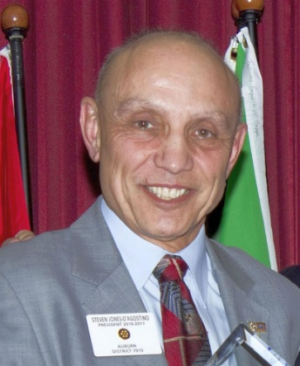

Does your District committee or Club have Rotary-related photo and/or video albums that you'd like to share with other Rotarians?
READ MORE

SUBMIT CONTENT
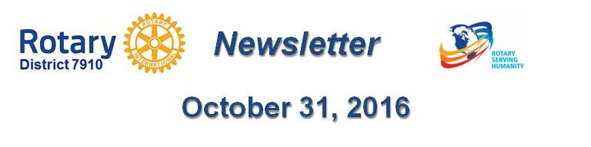To submit content for consideration for the Monday, October 31 issue of Rotary District 7910 Newsletter, please e-mail it to Immediate Past District Governor and Newsletter Editor Jim Fusco at jim.fusco2@gmail.com.
The submission deadline for that issue is Friday, October 28. All text must be in Word format. All images must be in either JPEG or PDF format. Please identify the people, left to right, who are shown in your photos, including their first and last name as well as their club or other title.

PAST ISSUES
To view past issues of the weekly Rotary District 7910 Newsletter, click here
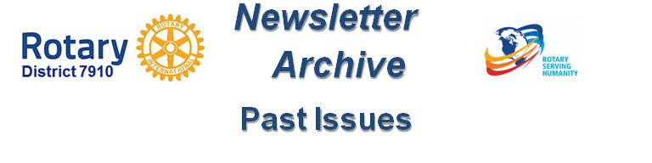

DISTRICT 7910 ONLINE
Visit our website
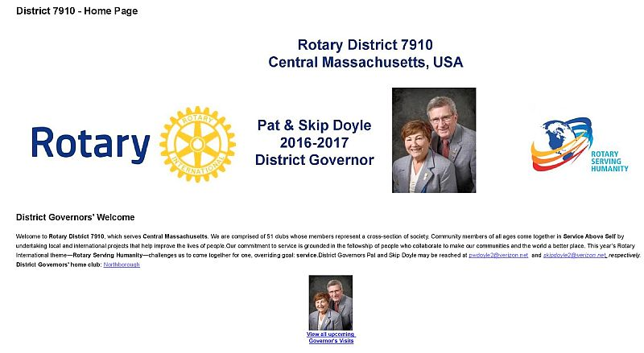

'Like' and share us on Facebook
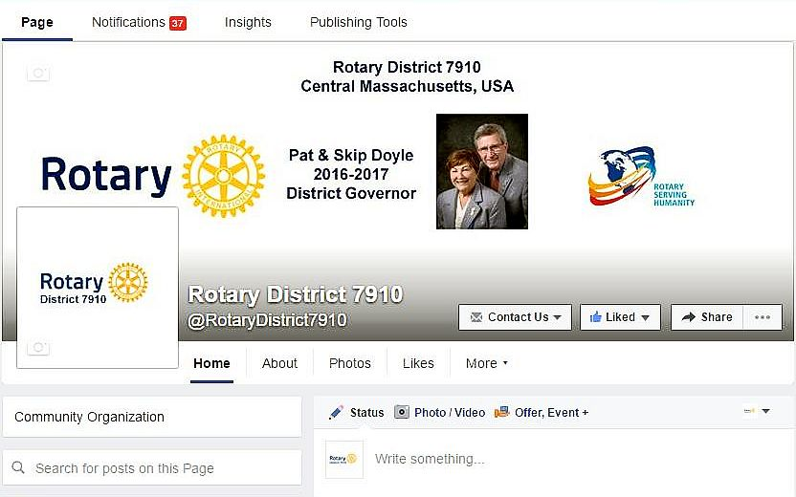

Watch our videos on YouTube
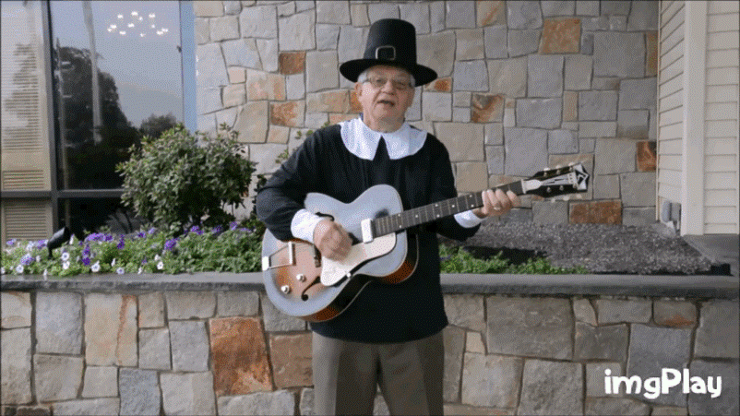

View our photos on Google Photos (since May 2015) and ClubRunner (before May 2015)
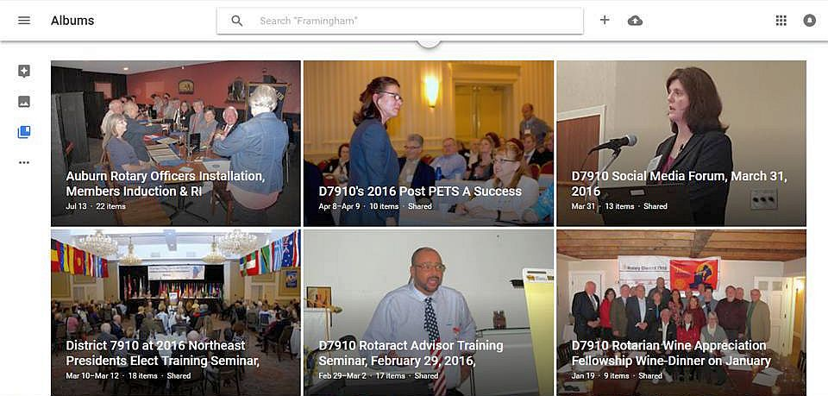

CONTACT US
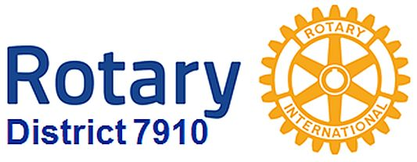

Jim Fusco, Immediate Past District Governor and Newsletter Editor
​jim.fusco2@gmail.com
Steve Jones-D'Agostino, District Webmaster
​srdagostino@icloud.com
© Copyright 2016-2017 - Rotary District 7910, Central Massachusetts, USA

