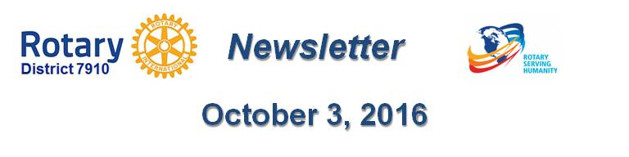

Dear $NICK_NAME$,

It is our pleasure to share with you the October 3 issue of Rotary District 7910 Newsletter.

For the complete issue, click here.

To explore past issues, click here.

Highlights of October 3 issue:

Governor's Message: Nomination Process 101 - By Pat and Skip Doyle

Our Presidents Speak: Q&A with Chris Spear of Nashoba Valley Rotary

Women in Rotary: A radio interview on 'Women in Rotary: Not (Just) Your Grandfather’s Rotary Club'

District Governor-Elect Report - Why should I go to the Rotary International Convention? By Karin Gaffney

Rotary Leadership Institute: In just 12 days in Boxborough! - By Doug Detweiler

Bandey Hefler Report: District 7910 travelers have safely arrived at Heathrow Airport - By Victor Tom

PolioPlus Update: October an important month for Foundation, PolioPlus - By Carl Good III

Speakers Bureau: Do you need a speaker for your club? By Steve Levitsky

Membership Corner: A review of membership best practices from eight of our clubs - By Tom Sturiale

Membership Materials on Sale: Order now!

Foundation Note: Club qualification status for foundation grants - By Sanjay Deshpande

Interact Actions: How to launch an Interact club - By Bob Anthony

PR Tips: Get visual - By Laura Spear

Treasurer's Report: Message about your dues - By Jack Hoell

District Charity Fund: How does DCF operate? - By Al Bowers

Communications Link: Seeking club photo, video albums - By Steve Jones-D'Agostino

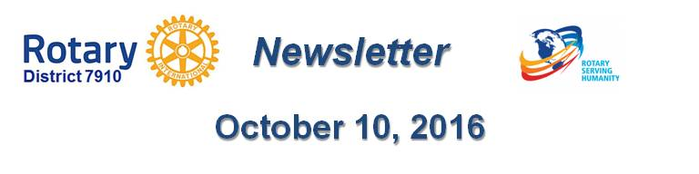Our next newsletter will come out on Monday, October 10. The submission deadline is this Friday, October 7. Text content must be submitted in Word format. Image content must be submitted in either JPEG or PDF format. Send your content submissions to Immediate Past District Governor/Newsletter Editor Jim Fusco at jim.fusco2@gmail.com.

Governors Pat & Skip

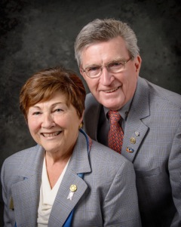Pat and Skip Doyle
2016-2017 Governors
Rotary District 7910
pwdoyle2@verizon.net
skipdoyle2@verizon.net
